

Topic : Online Market Store

Group no : MLB_PRO_15

Campus : Malabe

Submission Date :17/05/2022

We declare that this is our own work and this Assignment does not incorporate without acknowledgment any material previously submitted by anyone else in SLIIT or any other university/Institute. And we declare that each one of us equally contributed to the completion of this Assignment.

|  |  |  |
| --- | --- | --- |
| **Registration No** | **Name** | **Contact Number** |
| IT19037066 | De Silva W A D S | 0769054835 |
| IT19145112 | Karunarathne K Y | 0774308504 |
| IT21046520 | Nipuna H K | 0771803088 |

**1)**

**System Requirements for Online Market Store**

* This system allows all users to look for online market store.
* Firstly, user can login to the system by providing their details such as user id and password.
* Any customer can sign up to become a member.
* User can view, update, and delete their user details.
* Admin can login by using admin name, contact number and email.
* Admin can view, update, and delete details.
* Once a customer filled the form, they can add their own information to the website.
* Customer can select any order available in the store.
* Customer can purchase and add to cart.
* Customer can update details.
* Customer can add items from the order list.
* Deliverers delivers orders.
* Customer can do their payments of order through the system as pay pal and credit card.
* User can add coupon details and change the total payment.
* Admin also needs to login to the system before do the activities.
* Allows account holders to track the order, view order details, get invoice in history.

**Nouns/Verbs analysis**

# 2)

Noun Analysis (Nouns are in red color)

* This system allows all users to look for online market store.
* Firstly, user can login to the system by providing their user details such as user id and password.
* Any customer can sign up and become a member.
* User can view, update, and delete their user details.
* Admin can login by using admin name, contact number and email.
* Admin can view, update, and delete details.
* Once a customer filled the form, they can add their own information to the website.
* Customer can select any order available in the store.
* Customer can purchase and add to cart.
* Customer can update details.
* Customer can add items from the order list.
* Deliverers delivers orders.
* Customer can do their payments of order through the system as pay pal and credit card.
* User can add coupon details and change the total payment.
* Admin also needs to login to the system before do the activities.
* Allows account holders to track the order, view order details, get invoice in history.

Verb Analysis (Verbs are in blue color)

* This system allows all users to look for online market store.
* Firstly, user can login to the system by providing their details such as user id and password.
* Any customer can sign up to become a member.
* User can view, update, and delete their user details.
* Admin can login by using admin name, contact number and email.
* Admin can view, update, and delete details.
* Once a customer filled the form, they can add their own information to the website.
* Customer can select any order available in the store.
* Customer can purchase and add to cart.
* Customer can update details.
* Customer can add items from the order list.
* Deliverers delivers orders.
* Customer can do their payments of order through the system as pay pal and credit card.
* User can add coupon details and change the total payment.
* Admin also needs to login to the system before do the activities.
* Allows account holders to track the order, view order details, get invoice in history.

**Identified Classes using Noun Verb Analysis**

**Identified Classes:**

* Admin
* User
* Customer
* Item
* Cart
* Order
* Payment
* History
* Delivery Information

# Attributes:

* User ID
* Password
* Admin name
* Contact number
* Email

# Out of scope:

* Pay pal
* Credit card
* Purchase

# Redundant:

* User details
* Sign up

**3) CRC Cards for Online Market Store**

|  |  |
| --- | --- |
| Admin | |
| Responsibilities | Collaborations |
| login to the system |  |
| Verify user accounts | User |
| View User Accounts |  |
| Search User |  |
| Delete User Accounts |  |
| logout |  |

|  |  |
| --- | --- |
| User | |
| Responsibilities | Responsibilities |
| Account verification  and Login to the system | Admin |
| Create User Account |  |
| Account Update |  |
| View Account |  |
| Account Delete |  |

|  |  |
| --- | --- |
| Customer | |
| Responsibilities | Collaborations |
| Pay Total Amount | Payment |
| Get Customer Details |  |
| Update Profile |  |

|  |  |
| --- | --- |
| Order | |
| Responsibilities | Collaborations |
| Add Item to the cart | Cart |
| Calculate Total Price |  |

|  |  |
| --- | --- |
| Cart | |
| Responsibilities | Collaborations |
| Add Item | Item |
| View Cart Details |  |
| Update Quantity |  |
| Delete Cart |  |
| Checkout |  |

|  |  |
| --- | --- |
| Payment | |
| Responsibilities | Collaborations |
| Set Payment ID |  |
| Calculate Total Amount |  |
| Pay Refund Amount |  |
| Get Payment Details | Customer, History |

|  |  |
| --- | --- |
| Delivery Information | |
| Responsibilities | Collaborations |
| Update Delivery time |  |
| Cancel delivery |  |

|  |  |
| --- | --- |
| History | |
| Responsibilities | Collaborations |
| Get Payment Details | Payment |
| Get Order Details | Order |

|  |  |
| --- | --- |
| Item | |
| Responsibilities | Collaborations |
| Set Details |  |
| Calculate total Amount | Order |

# Exercise 1

**Class Diagram for the** **Online Market Store**

**Exercise 2**

**Coding for the Classes in Class Diagram**

**IT19037066 – De Silva W.A.D.S.**

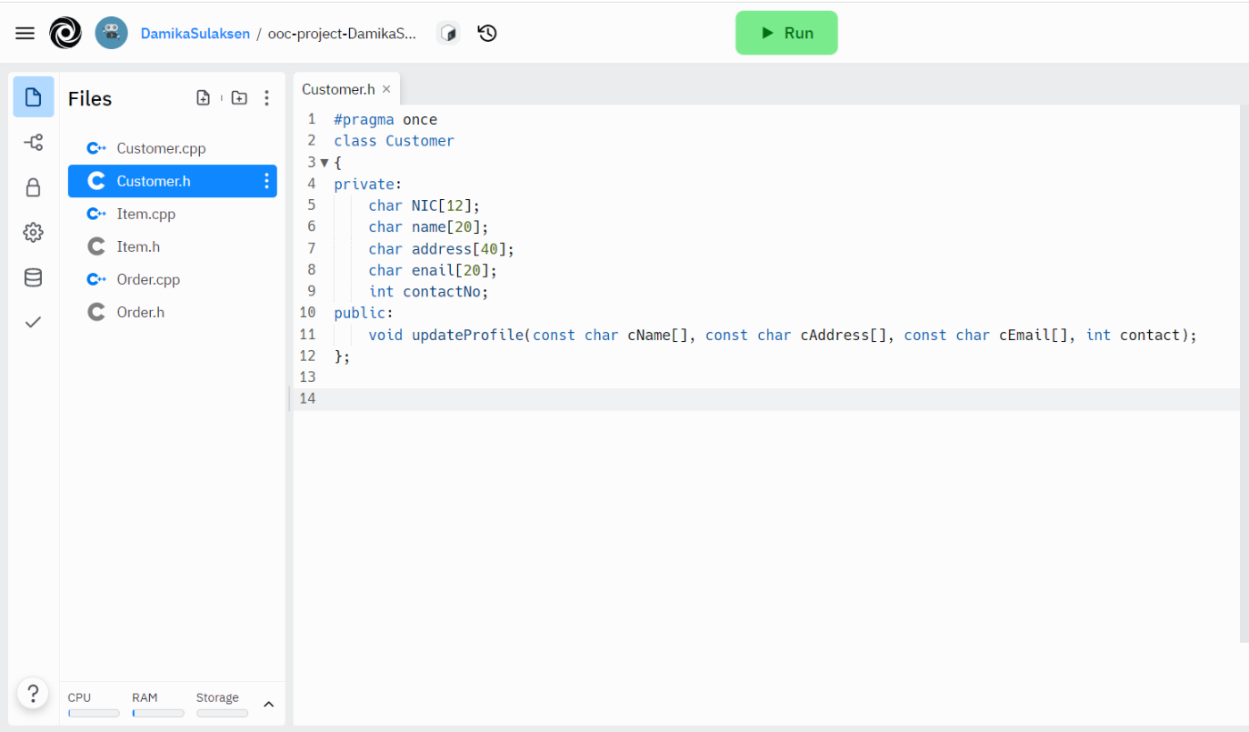

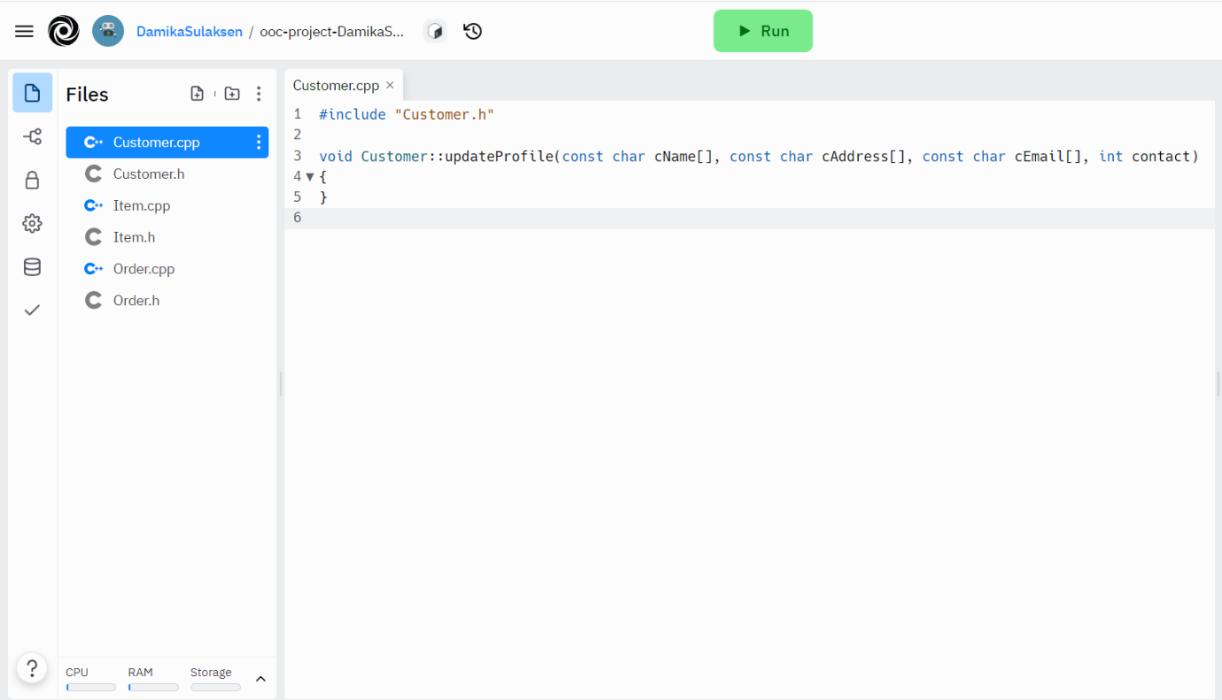

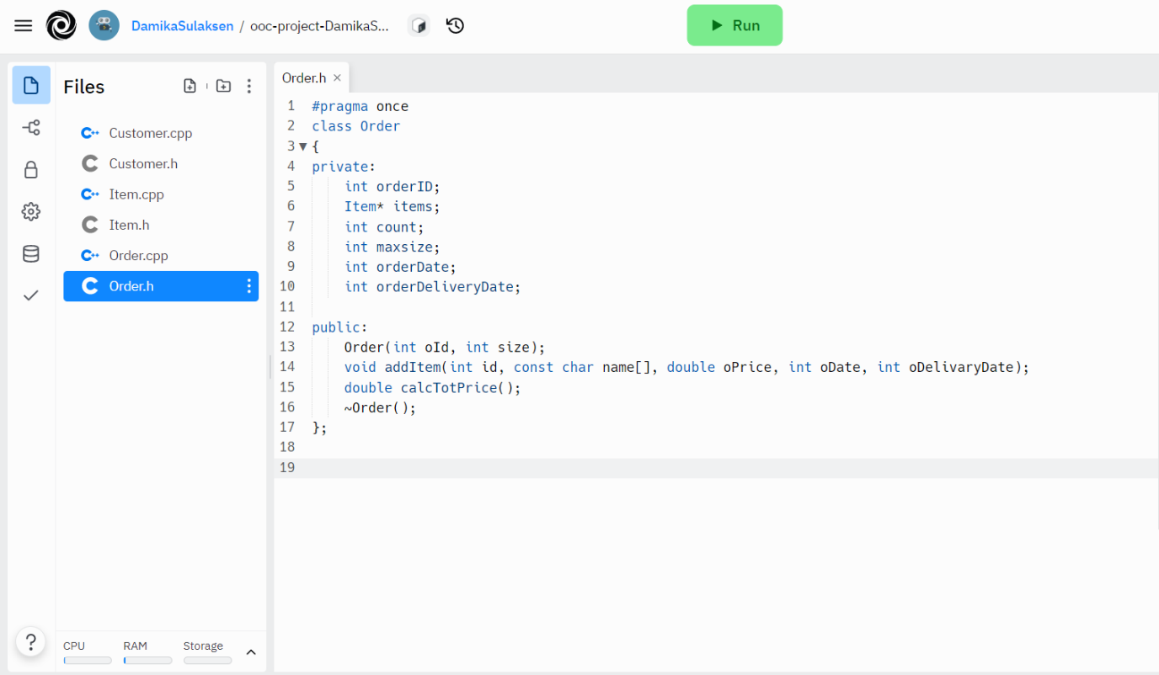

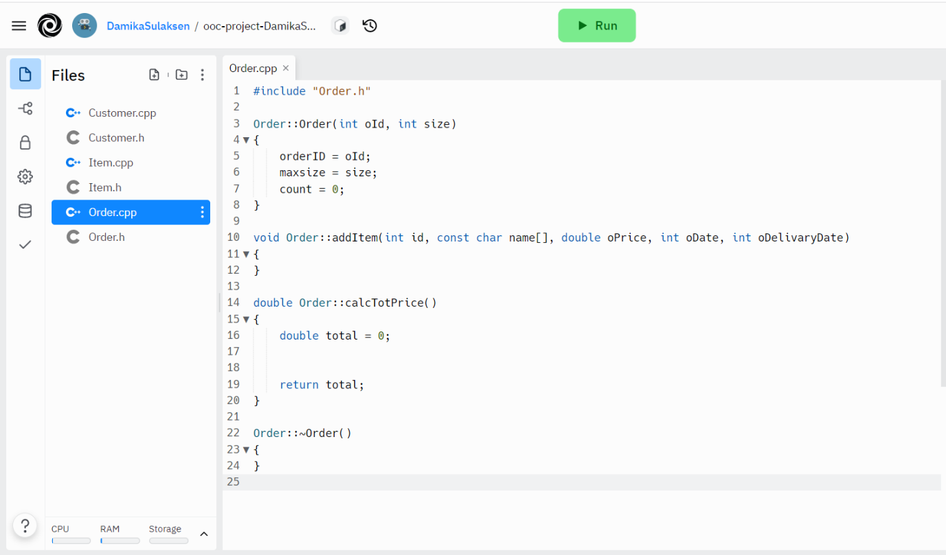

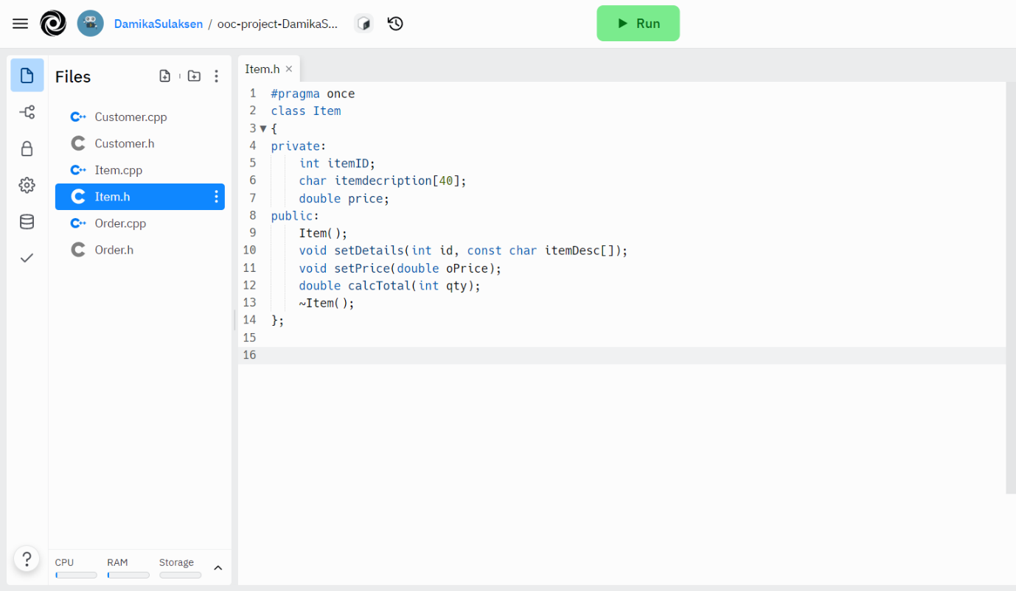

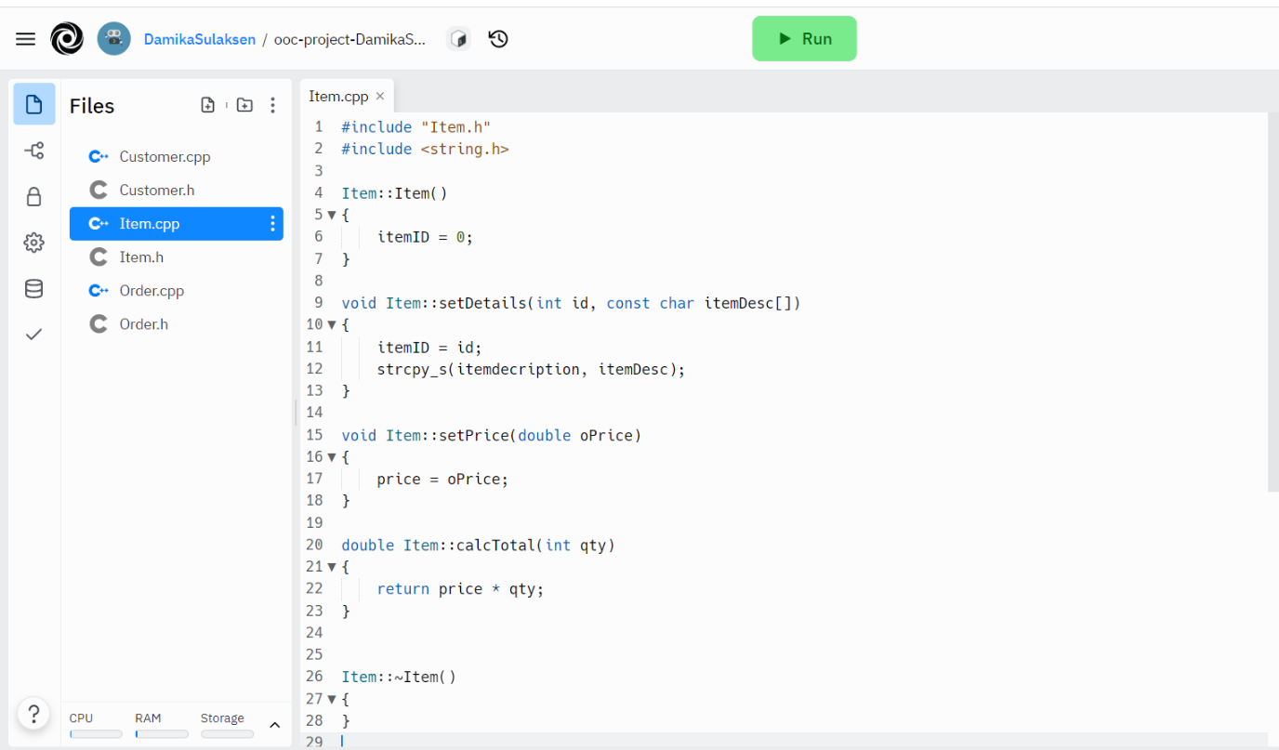

**IT19145112 – Karunarathne K Y**

**IT21046520 – Nipuna H K**

