

Topic : Online Educational Games

Group no : KDY_11

Campus : Kandy

Submission Date: 20/05/2022

We declare that this is our own work and this Assignment does not incorporate without acknowledgment any material previously submitted by anyone else in SLIIT or any other university/Institute. And we declare that each one of us equally contributed to the completion of this Assignment.

|  |  |  |
| --- | --- | --- |
| **Registration No** | **Name** | **Contact Number** |
| IT21344824 | Ekanayake T. E. M. A. P. | 0770864008 |
| IT21233630 | Ismail M.A.U. | 0760081256 |
| IT21339424 | Wickramarathna W.G.T.A. | 0740236985 |
| IT21220524 | Bandara P.H.W.M.N.S. | 0752719455 |
| IT21333934 | Vimansika A.P. | 0767081034 |

**Exercise 01**

1. Requirements

1. A guest can register to the system.
2. Guests can view games and news.
3. User can login to the system.
4. Users can select game to purchase.
5. Users can view games and news.
6. Users can add games to their lobby.
7. User can make payments.
8. System can verify users.
9. System admin can manage the website.
10. Payment gateway can receive payments.
11. Payment gateway can verify transactions.

2. Noun-verb analysis

1. A guest can register to the ~~system~~. (Out of scope/Whole system is not a class)
2. ~~Guests~~ (Redundant) can game and news.
3. User can login to the ~~system~~. (Out of scope/Whole system is not a class)
4. ~~Users~~ (Redundant) can select ~~games~~ (Redundant) to purchase.
5. ~~Users~~ (Redundant) can view ~~games~~ and ~~news.~~ (Redundant).
6. ~~Users~~ (Redundant) can add ~~games~~ to their lobby.
7. ~~User~~ (Redundant) can make payments.
8. ~~System~~ can verify ~~users~~ (Out of scope/ Redundant).
9. System admin can manage the website.
10. ~~Payment gateway~~ (Redundant) can receive ~~payments~~ (Redundant).
11. ~~Payment gateway~~ (Redundant) can verify transactions.

3. Classes:

* Guest
* Game
* News
* User
* Payment
* Admin
* Lobby

**Exercise 2**

|  |  |
| --- | --- |
| **Class Name: Admin** | |
| **Responsibility** | **Collaborations** |
| Manage website |  |
| Editing game | Game |
| Editing news | News |

|  |  |
| --- | --- |
| **Class Name: Game** | |
| **Responsibility** | **Collaborations** |
| Store details of Games | Admin |
| Show games details for admin | Admin |
| Show games details for user | User |
| Show games details for guest | Guest |

|  |  |
| --- | --- |
| **Class Name: News** | |
| **Responsibility** | **Collaborations** |
| Store details of news | Admin |
| Show news about Games for admin | Admin |
| Show news about Games for user | User |
| Show news about Games for guest | Guest |

|  |  |
| --- | --- |
| **Class Name: Payment** |  |
| **Responsibilities** | **Collaborations** |
| Store details of payment information |  |
| Provide credit card details | User |
| Purchasing game | Game |

|  |  |
| --- | --- |
| **Class Name: Guest** |  |
| **Responsibilities** | **Collaborations** |
| Should register to the system to buy games |  |
| Should be able to view Games | Game |
| Should be able to view News | News |

|  |  |
| --- | --- |
| **Class Name: User** |  |
| **Responsibilities** | **Collaborations** |
| Manage user profile |  |
| Can view games | Game |
| Can view news | News |
| Can purchase games | payment |

|  |  |
| --- | --- |
| **Class Name: Lobby** |  |
| **Responsibilities** | **Collaborations** |
| Adding the purchased game to lobby | Payment |

Exercise 03

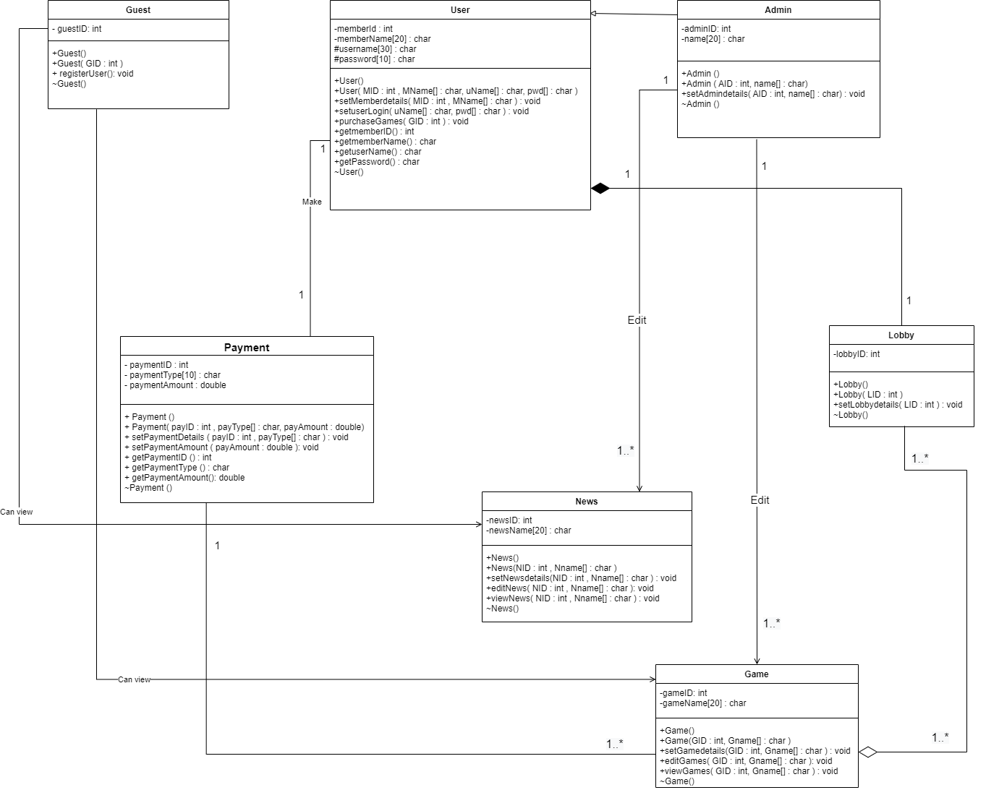

**Exercise 4**

Main.cpp

//header file

#include <iostream>

#include "User.h"

#include "Guest.h"

#include "Admin.h"

#include "Game.h"

#include "News.h"

#include "Payment.h"

#include "Lobby.h"

using namespace std;

int main() {

//creating object

User U1;

User U2( 01, (char *) "Samith", (char *) "samithperera", (char *) "samith@2022" );

Admin A1;

Admin A2( 03, (char *) "Akidu" );

Guest Gu1;

Guest Gu2( 04 );

Game G1;

Game G2( 10, (char *) "COD4" );

News N1;

News N2( 12, (char *) "Populer games in 2022") ;

Payment P1;

Payment P2( 01344, (char *) "Visa", 3000.00 );

Lobby L1;

Lobby L2( 1003 );

return 0;

//end main

}

User.h

//User class implementation

class User {

protected:

char username[30];

char password[10];

private:

int memberId;

char memberName[20];

public:

User();

User( int MID, char MName[], char uName[], char pwd[] );

void setMemberdetails( int MID, char MName[] );

void setuserLogin( char uName[], char pwd[] );

void purchaseGames( int GID );

int getmemberID();

char getmemberName();

char getuserName();

char getPassword();

~User();

};

User.cpp

#include <iostream>

#include "User.h"

#include <cstring>

using namespace std;

//defalt constructor

User::User()

{

memberId = 0;

strcpy( memberName , "" );

strcpy( username , "" );

strcpy( password , "" );

}

//overloaded constructor

User::User( int MID, char MName[], char uName[], char pwd[] )

{

memberId = MID;

strcpy( memberName , "MName" );

strcpy( username , "uName" );

strcpy( password , "pwd" );

}

//Destructor

User::~User()

{

cout<< "User Destructor called" << endl;

}

Admin.h

//Admin class implementation

class Admin {

private:

int adminID;

char name[20];

public:

Admin();

Admin( int AID , char name[] );

void setAdmindetails( int AID , char name[] );

~Admin();

};

Admin.cpp

#include <iostream>

#include "Admin.h"

#include <cstring>

using namespace std;

//defalt constructor

Admin::Admin()

{

adminID = 0;

strcpy( name , "" );

}

//overloaded constructor

Admin::Admin( int AID , char name[] )

{

adminID = AID;

strcpy( name , "name");

}

//Destructor

Admin::~Admin()

{

cout<<"Admin Destructor called" << endl;

}

Guest.h

//Guest class implementation

class Guest{

private:

int guestID ;

public:

Guest();

Guest(int GID);

~Guest();

void registerUser();

};

Guest.cpp

#include <iostream>

#include "Guest.h"

using namespace std;

//defalt constructor

Guest::Guest()

{

guestID = 0;

}

//overloaded constructor

Guest::Guest(int GID)

{

guestID = GID;

}

//Destructor

Guest::~Guest()

{

cout<<"Guest Destructor called" << endl;

}

Game.h

//Game class implementation

class Game{

private:

int gameID;

char gameName[20];

public:

Game();

Game( int GID , char Gname[] );

void setGamedetails( int GID , char Gname[] );

void editGames( int GID , char Gname[] );

void viewGames( int GID , char Gname[] );

~Game();

};

Game.cpp

#include <iostream>

#include "Game.h"

#include <cstring>

using namespace std;

//defalt constructor

Game::Game()

{

gameID = 0;

strcpy( gameName , "" );

}

//overloaded constructor

Game::Game( int GID , char Gname[] )

{

gameID = 0;

strcpy( gameName , "Gname" );

}

//Destructor

Game::~Game()

{

cout<<"Game Destructor called" << endl;

}

News.h

//News class implementation

class News{

private:

int newsID;

char newsName[20];

public:

News();

News( int NID , char Nname[] );

void setNewsdetails( int NID , char Nname[] );

void editNews( int NID , char Nname[] );

void viewNews( int NID , char Nname[] );

~News();

};

News.cpp

#include <iostream>

#include "News.h"

#include <cstring>

using namespace std;

//defalt constructor

News::News()

{

newsID = 0;

strcpy( newsName , "" );

}

//overloaded constructor

News::News( int NID , char Nname[] )

{

newsID = 0;

strcpy( newsName , "Nname" );

}

//Destructor

News::~News()

{

cout<<"News Destructor called" << endl;

}

Payment.h

//Payment class implementation

class Payment{

private:

int paymentID;

char paymentType[10];

double paymentAmount;

public:

Payment();

Payment( int payID , char payType[], double payAmount );

void setPaymentDetails( int payID , char payType[] );

void setPaymentAmount( double payAmount );

int getPaymentID();

char getPaymentType();

double getPaymentAmount();

~Payment();

};

Payment.cpp

#include <iostream>

#include "Payment.h"

#include <cstring>

using namespace std;

//defalt constructor

Payment::Payment()

{

paymentID = 0;

strcpy( paymentType , "" );

paymentAmount = 0;

}

//overloaded constructor

Payment::Payment( int payID , char payType[], double payAmount )

{

paymentID = payID;

strcpy( paymentType , "payType" );

paymentAmount = payAmount;

}

//Destructor

Payment::~Payment()

{

cout<<"Payment Destructor called" << endl;

}

Lobby.h

//Lobby class implementation

class Lobby{

private:

int lobbyID;

public:

Lobby();

Lobby(int LID);

void setLobbydetails(int LID);

~Lobby();

};

Lobby.cpp

#include <iostream>

#include "Lobby.h"

using namespace std;

//defalt constructor

Lobby::Lobby()

{

lobbyID = 0;

}

//overloaded constructor

Lobby::Lobby(int LID)

{

lobbyID = LID;

}

//Destructor

Lobby::~Lobby()

{

cout<<"Lobby Destructor called" << endl;

}