**1050 Programming Logic**Lab 09 (25 points total)

Name: Aaron Osowski

*1. Create a project called Lab09.*

*2. Create a class called MyMath. Implement the following properties and methods:*

|  |
| --- |
| **MyMath** |
| *double result*  *double operand1*  *double operand2* |
| *public void Multiply (double operand1, double operand2)*  *public void Divide (double operand1, operand2)*  *public void Subtract (double operand1, double operand2)*  *public void Add (double operand1, operand2)*  *public double GetResult()* |

3. *Create an object or type MyMath in Program.cs and call each of your methods to test them. Output the value of GetResult each time.*

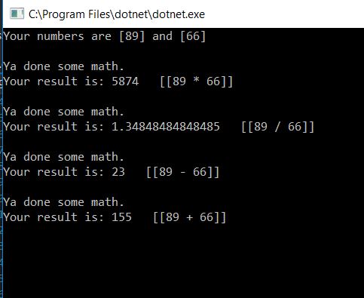

*Once complete, push your project to github and submit the URL to your repository in Blackboard.*