**1050 Programming Logic**

Lab 11 - Arrays

Name: Aaron Osowski

***Instructions:*** *Complete the following exercises. Push your code to github and share the URL to your repository by submitting it to Blackboard.*

1. *Fill in the blanks in the following statement (2 points):*

*Given the following code, output the 2nd element (not index 2) and the last element.*

*string[] names = { "Al Dente", "Anna Graham", "Earle Bird", "Ginger Rayle", "Iona Ford" };*



1. Create a 12-element array called months. Set each element to the name of each month.

*For example months[0] = “January”. Use a for loop to display the number and name of each month. (4 points)*

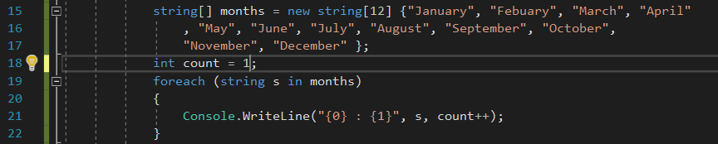

1. *Create a 4-element array to store the names of 4 seasons. Use a foreach loop to display the name of each season. (4 points)*

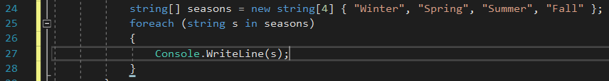

1. *Create an array of integers with 1000 elements. Fill the array with random numbers. Use a foreach loop to print all integers in the array (4 points).*

*Random random = new Random();  
int randomNumber*

*randomNumber = random.Next(0, 100); // place this line in the loop*

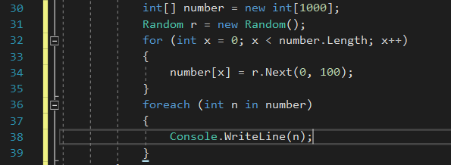

1. *Paste the following code into the main() method. Modify the code; so that it works (You’ll have to make 2 small modifications). It should output the value of each string in the array called names (2 points).*

*string[] names = { "Al Dente", "Anna Graham", "Earle Bird", "Ginger Rayle", "Iona Ford" };*

*int i = 0;*

*while (i < names.Length)*

*{*

*Console.WriteLine(names[0]);*

*}*

