**1050 Programming Logic**

Lab 6 (14 points total)

Name: Aaron Osowski

*Paste your code and screenshots below.*

1. *Use a while loop and if statement to write a program that prints the next 20 leap years (2 points).*

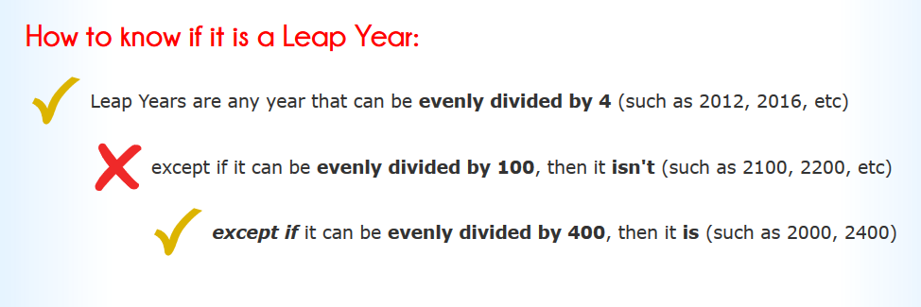

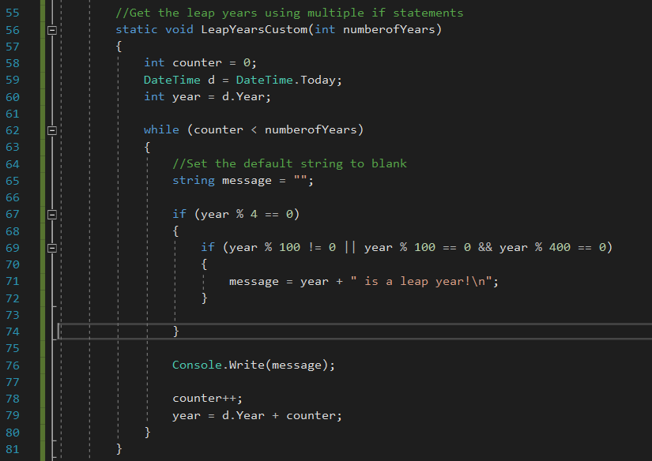

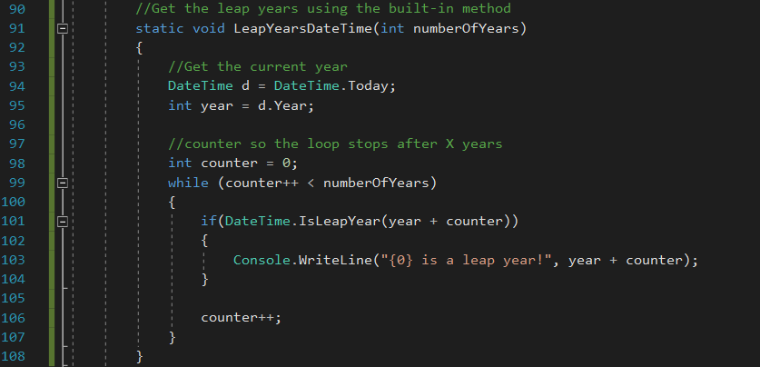

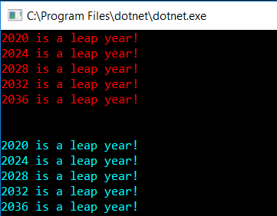

1. Write a guessing game where the user has to guess a secret number. After every guess the program tells the user whether their number was too large or too small. At the end the number of tries needed should be printed. To keep it simple, input the number at the beginning of the game. (6 points)

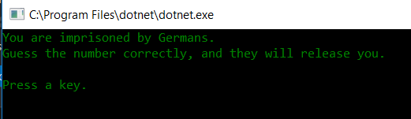

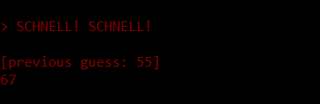

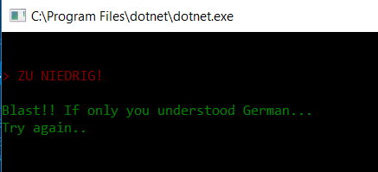

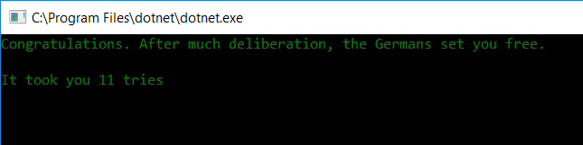

1. Create a while loop. The while loop will continue to run until the user inputs a value of “E”. During the loop, accept two other inputs: grocery item and cost. Keep a running total of the cost. Also, add the item to a string. When the loop is complete, display the items and the total cost. (6 points)

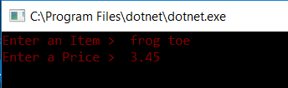

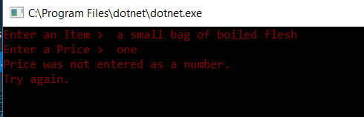

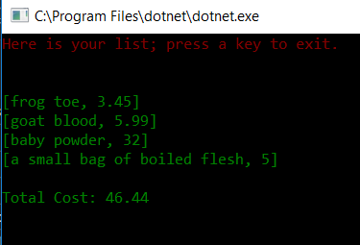

**Deliverables:**

When Complete, please push to GitHub and submit the URL to your repository in Blackboard.