**Deep Dream**

Deep Dream is a computer vision program. It makes use of a convolutional neural network to detect and intensify patterns in images using algorithmic pareidolia, giving the images a dream-like hallucinogenic appearance. I customized my code as follows.

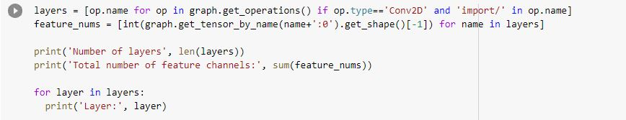

Figure 1.1: Get the layer list of our model

Here I use the pre-trained inception 5h model to produce deep dream images. In inception model has lot of layers such as conv2d0_pre_relu, mixed3a_3x3_bottleneck_pre_relu, mixed3b_1x1_pre_relu, mixed3b_pool_reduce_pre_relu, mixed4c_5x5_bottleneck_pre_relu and etc. we can get the list of the layer by running the Fig 1.1. Each layer will produce a very different result when used in deep dreaming. In my code, I use mixed4d_3x3_bottleneck_pre_relu layer and mixed4c layer**.** we can customize the layer name of the below codes as we want.

**mixed4c Layer**

In Fig 1.2, we use parameters as Octave number, the scale of the octave, No. Of iterations and strength. Then I customized the parameters as our requirement output. Octave means how many times this layer runs. So, we can customize this parameter as we want. So, if we want more details in the input image, we have to put an octave below this. In here I use octave as 3 so, I got the output image with the dog faces. If we decrease the number, we don’t get that many dog faces. Then I customized the No of iterations. It means how many times; the layer iterates to the image. If we have fewer iterations of our output, we get the same as the input image. If we increase the iterations, we get the different images from the input image. When we change the strength, we can change the colors in the image. If we have high strength, we can get a colorful image than the input image. We can change the layer name also. If we change it, we can get different outputs.

.

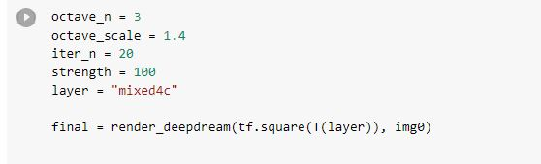

Figure 1.2: mixed4c layer

**mixed4d_3x3_bottleneck_pre_relu Layer**

In Fig 1.3, try to optimize just one neuron's activity using a feature channel. I customized the feature channel of each image to get different outputs.

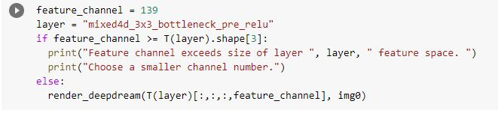

Fig 1.3: mixed4d_3x3_bottleneck_pre_relu layer

Then, I customized my parameters in Figure 1.4. We use the Number of iterations, Strength, zooming steps, and zoom factors as parameters. Zooming steps means how many times we zoom the input image. So, we can increase the no of steps if we want the output image with zoom than input images so we can see more details of the texture that applied according to the layer we used. Then I customized the zoom factor which is changing the smoothness of the image. If we give the low number to the factor, we can get a smooth image as output.

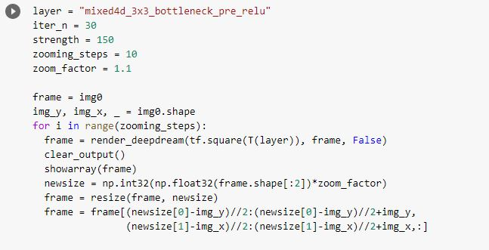Figure 1.4: mixed4d_3x3_bottleneck_pre_relu layer

Then we can customize the layer in Fig 1.5 to get different results. Each layer will produce a very different result when used in deep dreaming.



Figure 1.5: Use layers

**Unique Code**

I add a code to convert our deep dream images to pencil art. First, we have to download the deep dream images that we want and upload them into the project. The first step of this is we have to convert our image to a grayscale image as shown in Fig 1.6. Converting an image into grayscale gives us black & white pixels in the image which is used for creating a pencil sketch.

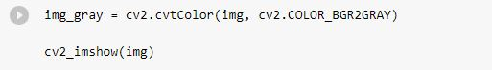

Figure 1.6: Convert to a grayscale image

Then as shown in Fig 1.7, we invert the image color using cv2.bitwise. This helps to identify the edges that we want to create the pencil art.

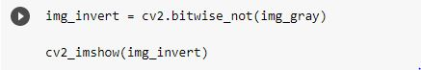

Figure 1.7: Inverting the image

To smooth our image, we used the gaussian blur technique with 21 x 21 pixels and the default sigma values filter on the image. We can create thin lines for our sketch by increasing the filter size, which is also used to reduce image noise (Fig 1.8).

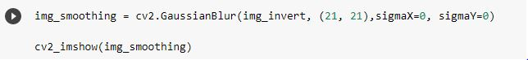

Figure 1.8: Smooth the image

Then we got the pencil art of the deep dream image that we want.