

Sri Lanka Institute of Information Technology

**Company Management System**

Project Proposal

Information Technology Project (IT2080)

2018

ITP_KDY_01

Submitted by:

1. IT17181402 – D. G. Y. C. K. Alwis
2. IT17182188 – R. M. M. G. Rathnayake
3. IT17267632 – A. S. De Zoyza
4. IT17187206 – H. M. H. G. B. Amarasinghe
5. IT17142960 – P. K. S. L. C. Gamage
6. IT17184090 – G. R. N. M. Bandara
7. IT17183628 – K. W. H. M. R. I. B. Abeykoon
8. IT17370974 – K. A. R. N. Aththnayake

Submitted to:

Ms. Chathurika Pinnaduwage

…………………………..

(Supervisor’s signature)

21/02/2019

Contents

1. Introduction
   1. About Client 01
   2. Problem statement 01
   3. Benefits of our system 02
2. System Overview Diagram 03
3. Functions 04
   1. Raw Material Inventory 05
   2. Product Inventory 06
   3. Employee Management 07
   4. Leave & Attendance 08
   5. Transport Management 09
   6. In Payments & Vehicle Management 10
   7. Out Payments & Maintenance Management 11
   8. Supplier, Customer & Order Handling 12
4. Technologies 13
5. Work distribution & Gantt chart 14
6. References 15
7. Introduction

Sinhanada fireworks is a local fireworks company that was driven on hand labor for generations. The company owner is willing to expand his business in the hope of automating the process. The company has more than 30 permanent employees working & more than 50 contract base employees. The company also a chemical supplier which supply explosives to the customers at request.

* 1. Problem statement

The company faced different types of lots of difficulties because of manual process .

* Problems in salary calculation and lots of time-consuming to pay employees’ salary.
* Transport problems
* They don’t have record about product quantities loads to the vehicle before transport. So, products can be misplaced but management doesn’t aware about it.
* Arise conflicts allocating drivers and vehicles.
* Tend to make human errors
* Calculations are done manually.
* Employee write records in the log books, if done something wrong by mistake, that can be cause to big problem.
* Company face big problem when storing large number of log books, which contain the details of the company works in previous years.
* If manager need to get some details about employees in an emergency, he must refer bulky log books till he fulfills his requirement. That is lots of time-consuming process.
* Expired cheques are managed poorly.
  1. Solution

Our team did a research about our client and gather additional requirements for the application. After the analyzing our team decided to implement a windows desktop application using C# & .Net framework. For the databases we will use MYSQL database management system.

1.3.Benefits of our system

What is mainly expected from this system is to effectively manage all the work and further improve the finance sector.

* Employees can be easily managed by the help of this system. Employee attendance and leave entitlements can be done according to a proper procedure without allowing any conflicts to arise.
* This system makes it easier to quickly calculate the employee’s salary and pay them. System calculation accuracy is high and fast.
* The human errors that are prone to happen in a manual process can be avoided in an automated process.
* Since this system alerts the supplier when a certain raw material is being used up, the raw materials can be provided without any delay.
* Because the records are properly maintained the difference between delivered products and products remaining is very less.
* If client need a detail, he can get it without consuming more time. Because he doesn’t need to huge bulk of log books.
* System operator can easily place an order by looking at the inventory. If no of product not enough to fulfill the order operator can inform to the management.

1. 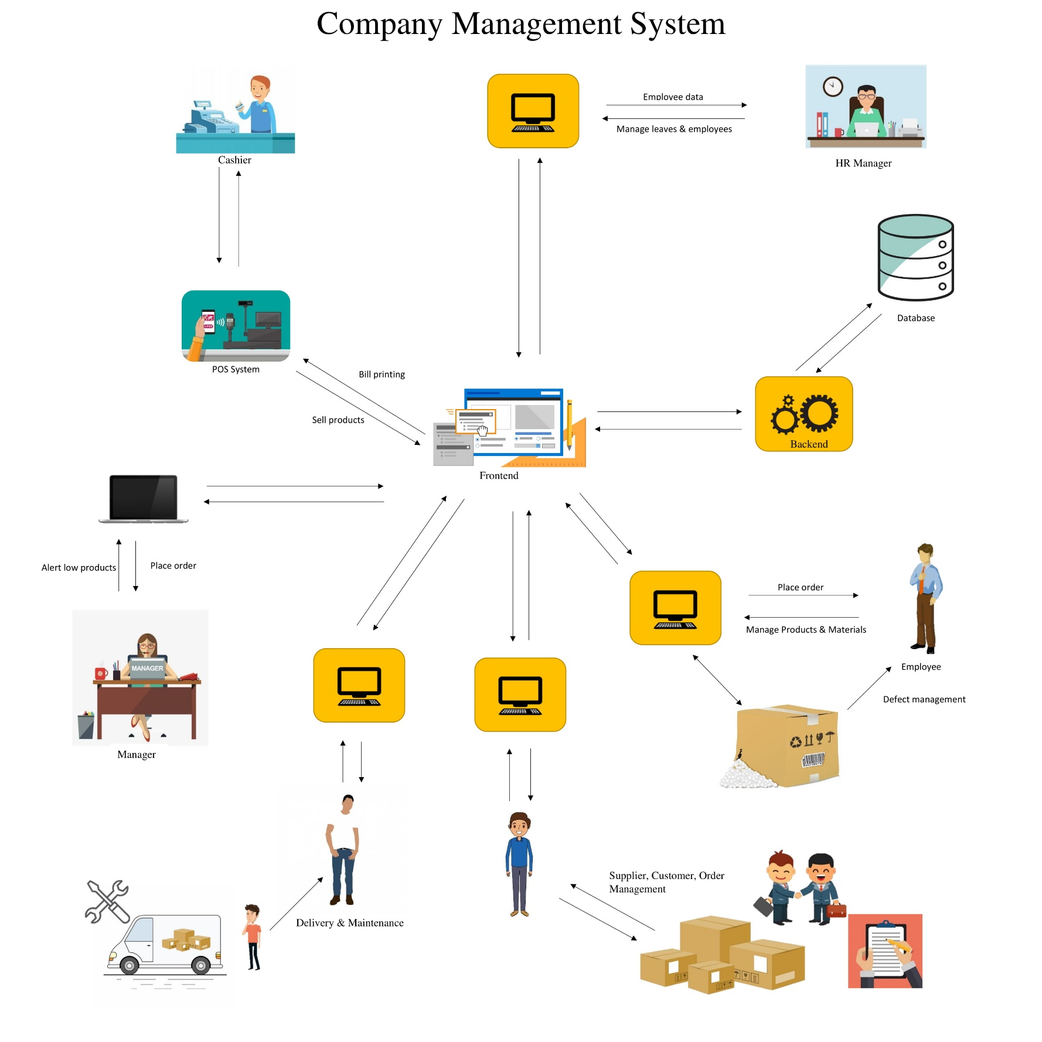Overview Diagram

Image provider [1].

1. Functions

After analyzing the client’s requirements our team able to identify the main functions in the system. The functions are,

1. Raw Material Inventory Management
2. Product Inventory Management
3. Employee Management
4. Leave & Attendance Management
5. In Payments & Vehicle Management
6. Out Payments & Maintenance Management
7. Transport Management
8. Customer, Supplier & Order Management

Above identified functions are design & implement by our team members. Each function describes thoroughly in the next chapters.

* 1. Raw Material Inventory Management

-From this function our client gain benefit of managing raw materials [2]. This include,

* Add new raw materials.
* The company has many different types of raw materials. User can add new raw materials to the inventory . Application save new raw material including raw material Id, Name, Type, Description etc.

* Edit existing raw materials.
* Application will provide an interface to edit errors such as Name, Type.
* Delete exiting raw materials from the inventory.
* Application will remove the raw material from main table and place in a backup table for future use or reference.
* Stock is a collection of same material take from the supplier on a day.
* Add new stock .
* User can add new raw material stock to the Inventory. System will autogenerate stock Id. Application will get unit price, quantity, expire date. User can select supplier and material by clicking drop down.
* Edit stock.
* User correct errors or change values of stock details by select update option using drop down and add new value.
* Manager can generate monthly report.
* A report of stock can be generated in click of a button.
* Alert system
* When item is low on quantity application will automatically send SMS/Email to the manager.
  1. Product Inventory Management

-In this function our client can manage Product [3] inventory. The company produce different type of products such as crackers, sparklers .etc.

* Add new Product to the inventory.
* User can add new product by using the application. System will autogenerate item no, product id. Application will get product name, status of product which mean product finished or not, payout for employee to make that item.
* Update existing Product
* User can alter existing values of Product details.
* Delete existing Product
* User can delete product from the product inventory.
* Stock is a collection of one same type of products made in a day.
* Add new Stock to the inventory.
* Manager or employee can add new stock by using the application. System will automatically generate stock id and get the system date. Application will take qty, stock type, arrival date, expire date, unit price. User can add new stock by searching the product name and enter the product quantity.
* Update , Delete Stock
* User can alter existing values of stock details.
* User can delete stock from the product inventory.
* Add no of products made by each employee
* System will keep record of quantity made by each employee.
* Summery Reports

- report of can be generated by clicking the button.

* Total Quantity made by each employee.
* Stock report
  1. Employee Management
* Add employee
* The manager can add new employees to the system by filling the form.

The employee no will automatically generate. employee’s first name & last name, address, NIC, birthday, contact no, daily rate, account no, bank, bank branch …etc.

* Edit employee
* The manager can edit exist employee details in the system.
* Remove Employee
* The manager can remove employees. The application will save those details on the backup table for future reference.
* Calculate salary
* The manager can generate employee salary by clicking button. The application will generate the using employee’s attendance and employee category.
* Salary report
* The manager can print/generate salary report of all the employee by clicking button.
* The manager can print/generate salary slip of each employee by clicking button.
  1. Leave & Attendance

This function includes,

* Add Leave
* Manager enters approved leaves to the System.
* Application checks employee’s annual leave count and update it automatically.
* Delete Leave
* The manager can delete already entered leaves using the application.
* Update Leave
* The manager can edit already entered leaves using the application.
* Check dates
* The manager can check all other leaves on the selected date.
* Mark attendance
* The manager can mark attendance by clicking buttons in front of employee name in the application.
* Reports
* Leave Report

The manager can generate monthly/annually leave report by clicking button.

* Late report

The manager can generate monthly/annually late report by clicking button.

* 1. Transport Management

This client sells products. This company transport their raw materials and products to their customers.

* Add Transport
* This company keeps records about item details before transport and after transport. It means no of items, names load in to the vehicle before transport and remaining item quantity after the transport.
* First, user need to select item type, (product) the vehicle is going to transport. System will autogenerate transport id. System will get product quantities. Vehicle, driver, transport area can choose using the drop down. If user search product, productid, available quantities, unit prices automatically retrieve from the database and load to the interface.
* After transport system will take vehicle id and date. Then system automatically loads details about before transport such as transport id, transport area, transport date, driver and no of quantities and names of each quantity. Secondly user needs to add details of remaining quantities. Product name can get by search. Other details automatically load in to the interface.
* Update Transport
* User can alter existing values of transport details.
* Delete Transport
* User doesn’t need transport which can delete transport from the system.
* Vehicle and driver allocation
* Using the application manager or employee can allocate a driver to a vehicle. One driver or vehicle cannot allocate for more than one delivery on same time in a same date.
* Manager solve allocation problem easily by using this application.
* If user need to allocate driver or vehicle to the delivery, he can select driver or by clicking drop down. System only show available drivers or vehicle on that date.
* Summery Reports
* Report about total income of a transport can be generated by using the application.

* Calculate daily income
* After the delivery manager or employee can calculate the income by clicking button.

* 1. In payments & Vehicle Management
     1. Vehicle Management
* The company has vehicles to fulfill transport requirement of their company.
* Add new vehicle
* User can add new vehicle by using the application. Vehicle Type can select by using drop down. Application will get vehicle no, mileage of the vehicle.

* Update Vehicle
* User can alter existing values of vehicle details.
* Delete Vehicle
* User can delete vehicle detail. (Details of the deleted vehicle will send to the separate table.)
  + 1. In Payments

* Cheques handling
* The company uses lots of cheques. Because of that they need to keep track of all the Cheaque details.
* Add, Edit, Delete Cheaque
* System save finance id, cheque no, bank, bank branch, cheque type, amount, due date, Status of cheque (returned or not).
* Cheque validate or return.
* Add third party transfer details.
* application will help to add the third-party transfer details to the system.
* Billing
* Add, Edit, Delete billing information
* Application will keep track of billing information of the business. Manager or employee can add billing details by using the application.
* Using the application user can alter existing values of billing details.
* User can delete from the system.
* Summery Reports
* Manager or employee can generate monthly in payment details, total bill details using the application.
  1. Out Payments & Maintenance Management
     1. Out Payment

This function serves on handling all the expenses of the company. The company mainly expenses for raw materials, employee salaries.

.

* Add, Edit, Delete out payment details
* System will get finance id, date, description, amount. Payment type can select using drop down (cash or cheque).
* Manager requests the generation of a monthly report
* This contains details of total out payments occurred within a month.
  + 1. Maintenance.
* The company has different types of maintenance such as vehicle repairing, machine maintenance, building repairing ...etc.
* Add Maintenance
* Manager or employee can add new maintenance details by using the application. System will autogenerated maintenance id. Maintenance type can select drop down. Application will get maintenance cost, maintenance part, maintenance date.
* Update Maintenance
* Using the application user can alter existing values maintenance details.

* Delete Maintenance
* The employee can delete it by clicking the button.
  1. Supplier, Customer and Order management

-This function focuses on management of orders, customers, and suppliers

* + 1. Customer or Supplier

In here we only keep track of long-time customers who did big deal with the company frequently and details of all the suppliers.

* Add new customer or supplier
* Application will automatically generate customer Id or Supplier id. User needs to add customer’s name or supplier’s name, email, address, contact numb

* Updates customer
* User can alter existing values of customer or supplier details.

* Deletes customer
* User can delete existing customer details.
  + 1. Order
* Add new order.
* Application sets order id automatically. User must set advanced amount, due date, advanced amount, customer’s name, need products or raw materials, required quantity.
* Updates order
* User can alter order details.

* Deletes order
* User can delete it order when it canceled.

* Upon placing a new order or purchasing from a supplier system does a Loyalty check
* Update the loyalty attribute upon completion of either several orders by one customer or a supplier accordingly and awards loyalty upon meeting threshold level.

* Manager generates monthly report.
* Detailed report containing

- customer and supplier data pertaining an order

- Data of any of the above entities separately

|  |  |  |  |
| --- | --- | --- | --- |
|  | **IT number** | **Name** | **Function** |
| 01 | IT17181402 | D. G. Y. C. K. Alwis | Raw material inventory |
| 02 | IT17182188 | R. M. M. G. Rathnayake | Product inventory |
| 03 | IT17267632 | A. S. De Zoyza | Out Payments |
| 04 | IT17187206 | H. M. H. G. B. Amarasinghe | Supplier, Customer & Order management |
| 05 | IT17142960 | P. K. S. L. C. Gamage | Leave and attendance |
| 06 | IT17370974 | K. A. R. N. Aththanayake | Employee management |
| 07 | IT17183628 | K. W. H. M. R. I. B. Abeykoon | Out Payments |
| 08 | IT17184090 | G. R. N. M. Bandara | Delivery and maintenance |

1. Work breakdown and Gantt chart



1. Technologies

After requirement phase our team decided to implement a Windows® Forms Application using Microsoft .NET framework [4] & C# programming language [5]. The benefit of the Windows Forms application is there are no additional programs to be installed to run the application and can be installed in any Windows base computer.

Our client’s business runs in separate locations such that Our team decided to interconnect the application with MYSQL database [6]. MYSQL is open source and free to use under GNU Public License (GPL) [7]. This will reduce the cost of the project and client can spend less capital on the project.

For developing the application, we are using Microsoft Visual Studio 2017 Community edition [8]. Visual studio community edition is free for individual developers.

# References

|  |  |
| --- | --- |
| [1] | VectorStock, "www.vectorstock.com," VectorStock Media, 01 01 2007. [Online]. Available: www.vectorstock.com. [Accessed 17 02 2019]. |
| [2] | Wikimedia Foundation, Inc., "Raw material," 25 April 2003. [Online]. Available: https://en.wikipedia.org/wiki/Raw_material. [Accessed 21 02 2019]. |
| [3] | Wikimedia Foundation, Inc., "Product (business)," 05 June 2003. [Online]. Available: https://en.wikipedia.org/wiki/Product_(business). [Accessed 21 02 2019]. |
| [4] | J. Ziegler, ".NET Framework," Wikimedia Foundation, Inc., 19 December 2001. [Online]. Available: https://en.wikipedia.org/wiki/.NET_Framework. [Accessed 10 01 2019]. |
| [5] | B. Derksen, "C Sharp (programming language)," Wikimedia Foundation, Inc., 25 October 2001. [Online]. Available: https://en.wikipedia.org/wiki/C_Sharp_(programming_language). [Accessed 17 02 2019]. |
| [6] | Wikimedia Foundation, Inc., "MySQL," Wikimedia Foundation, Inc., 04 September 2001. [Online]. Available: https://en.wikipedia.org/wiki/MySQL. [Accessed 10 10 2017]. |
| [7] | Wikimedia Foundation, Inc., "GNU General Public License," 06 August 2001. [Online]. Available: https://en.wikipedia.org/wiki/GNU_General_Public_License. [Accessed 21 02 2019]. |
| [8] | Wikimedia Foundation, Inc., "Microsoft Visual Studio," 22 August 2003. [Online]. Available: https://en.wikipedia.org/wiki/Microsoft_Visual_Studio. [Accessed 05 December 2018]. |