

Programming Application and Frameworks (IT 3030)

3rd Year, 1st Semester

Assignment 1

**ElectroGrid (EG)**

Sri Lanka Institute of Information Technology

Group Number: 26

Batch: Y3.S1.WE.IT.02.02

Group Members:

|  |  |
| --- | --- |
| **Registration Number** | **Name** |
| IT20211950 | Amarasekara M.G.V.C |
| IT20146238 | Jayathunga T.M. |
| IT20173104 | Shavinda Y.A.D.P |
| IT20272654 | Rajapaksha R.P.S.V |

Contents

1. Introduction 3

2. Work Distribution 3

3. GitHub Repository Link 4

4. Time schedule (Gantt Chart) 4

5. Requirements Analysis 4

6. Technical Requirements 4

7. Functional Requirements 5

8. Requirements Modelling (Use Case Diagram) 5

9. Overall DB Design (ER) 6

10. Overall, Class Diagram 6

11. Overall, Activity Diagram 7

12. Service Development and Testing 7

13. Individual Section 8

i) Bill Service 8

ii) Customer Service 12

iii) Payment Service 16

# Introduction

ElectroGrid is an online system which allow customers to pay their power bills directly through an online platform. First, the customer should register to the system as a valid user and then they can pay power bills as they wish. Through this system generates the monthly bills and automatically send to the users. The customer was given the opportunity to select the payment method according to their preference.

# Work Distribution

|  |  |  |
| --- | --- | --- |
| **Member** | **Web Service** | **Function** |
| IT20146238  Jayathunga T.M. | Bill Management | * Add Bill Details * View Bill Details * Update Bill Details * Delete Bill Details |
| IT20173104  Shavinda Y.A.D.P | Payment Manage | * Add new payment * View payment History * Update payment * Delete payment |
| IT20272654  Rajapaksha R.P.S.V | Customer Management | * Add Customer * View Customer * Update Customer * Delete Customer |
| IT20211950  Amarasekara M.G.V.C | Power Failure Management | * Add Power Failure * View Power Failure * Update Power Failure * Delete Power Failure |

# GitHub Repository Link

[**https://github.com/IT20146238/ElectroGridSystem**](https://github.com/IT20146238/ElectroGridSystem)

# Time schedule (Gantt Chart)

|  |  |  |  |  |  |  |  |  |  |  |
| --- | --- | --- | --- | --- | --- | --- | --- | --- | --- | --- |
|  | **Week**  **1** | **Week**  **2** | **Week**  **3** | **Week**  **4** | **Week**  **5** | **Week**  **6** | **Week**  **7** | **Week**  **8** | **Week**  **9** | **Week**  **10** |
| **1)Gathering of information and requirements** |  |  |  |  |  |  |  |  |  |  |
| **2)Installation of**  **Software** |  |  |  |  |  |  |  |  |  |  |
| **3)Designing the**  **Database** |  |  |  |  |  |  |  |  |  |  |
| **4)Implementation** |  |  |  |  |  |  |  |  |  |  |
| **5)Feedback session** |  |  |  |  |  |  |  |  |  |  |
| **6)Integration and**  **Testing** |  |  |  |  |  |  |  |  |  |  |
| **7)Finalizing system and documents** |  |  |  |  |  |  |  |  |  |  |

# Requirements Analysis

Requirement analysis includes both user requirements and system requirements. Electro Grid (EG) system has four main stake holders. Bill Management, Payment Management, Customer Management and Power Failure management.

# Technical Requirements

* Technical requirements are the technical issues that must be considered to make the system successful.
* Bills, Payment, Customer, and Power Failure detail can be updated, deleted, and view when needed, and sensitive details should be encrypted.

# Functional Requirements

* **Bill Management**
  + **Add Bill to the system**
  + **View Bill**
  + **Update Bill Details**
  + **Delete Bill Details**
* **Payment Management**
  + **Add a new payment to the system**
  + **View payment history**
  + **Update payment**
  + **Delete payment**
* **Customer Management**
  + **Add a new customer to the system**
  + **View customer details**
  + **Update customer**
  + **Delete customer**
* **Power Failure Management**

# Requirements Modelling (Use Case Diagram)

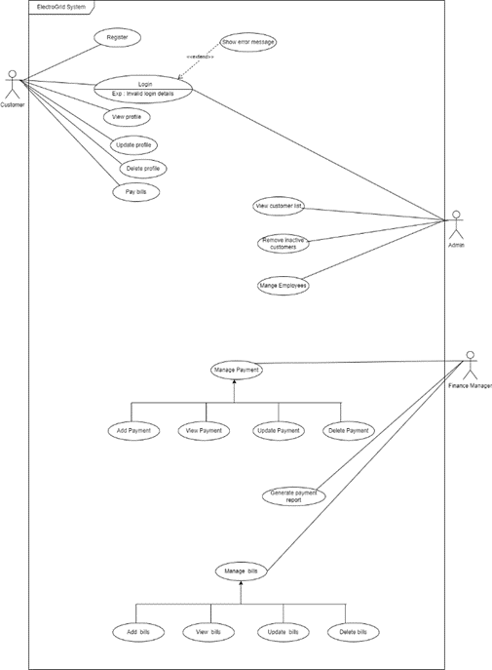

# Overall DB Design (ER)

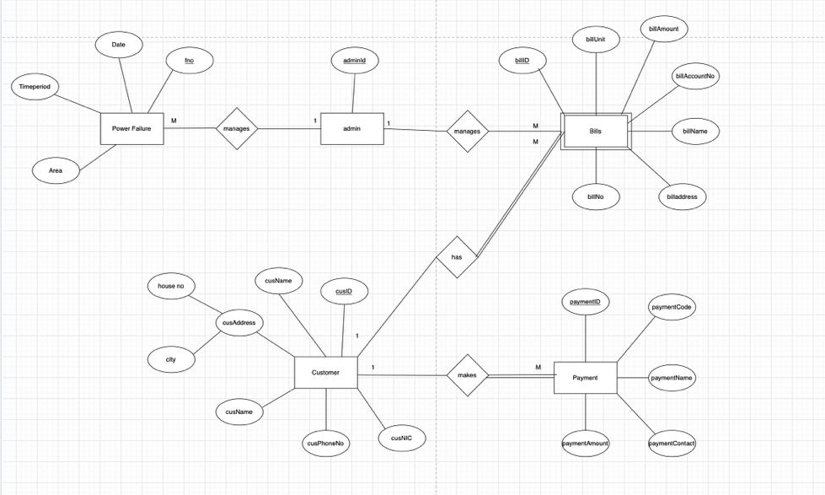

# Overall, Class Diagram

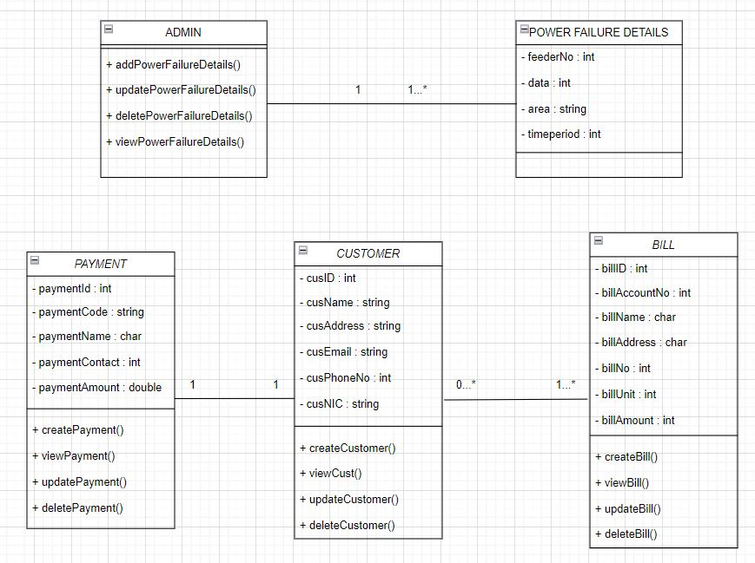

# Overall, Activity Diagram

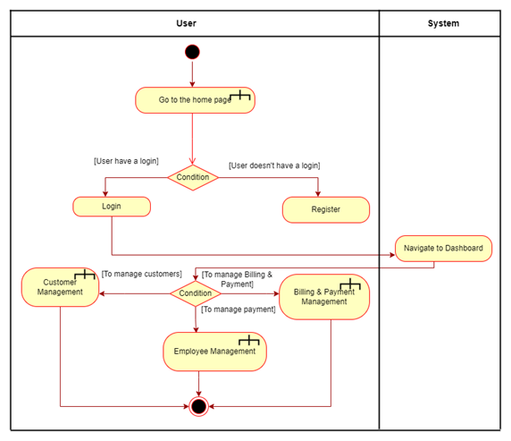

# Service Development and Testing

* **Tools Used**

1. **Dependency** **Management** **Tool**: Maven – Provides a uniform build system and quality project information
2. **Testing** **Tool**: Postman – Easy to test server-side development projects without having proper frontend.
3. **Version** **Control** **System**: Git
4. **IDE**: Eclipse
5. **Programming** **Language**: Java with Jersey Framework (JAX-RS) – Good development framework for Restful web services.
6. **Database**: MySQL Work Bench
7. **Server**: Apache Tomcat Server

# Individual Section

# Bill Service

The billing service part is handled by the meter reader and bill manager. User can see their monthly bill details (no of units use, arrears, monthly bill amount, total bill amount) in this section.

* + **API of the Server**

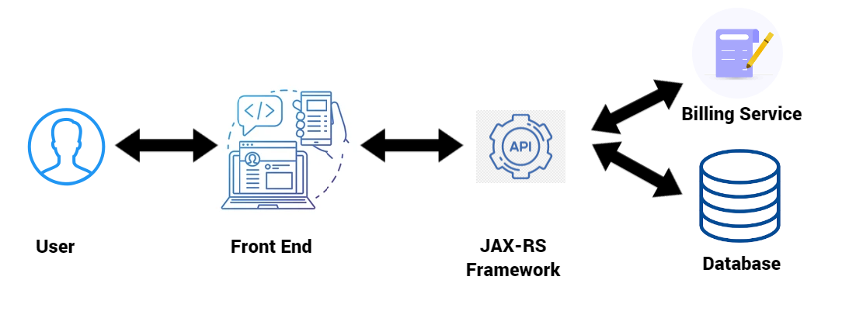

* + - **View Bill Details (GET)**

**Resource –** Bills

**Request –** GETOnlineElectricGrid/myService/Bills/

**Media –** Form Data

**Response –** HTML Table with All Bill Details in “billing service” Table of “Error while connecting to the database for deleting."

**URL -** <http://localhost:8899/OnlineElectricGrid/myService/Bills/>

* + - **Insert Bill Details (POST)**

**Resource –** Bills

**Request –** POSTOnlineElectricGrid/myService/Bills/

**Media –** URL Encoded Form

**Data - KEY VALUE**

billAccountNo 30528630

billName Nisal

billAddress Matara

billNo 2541

billUnit 81

billtAmount 2456

**Response –** "Bill Added successfully" or "Error occur during inserting"

**URL -** <http://localhost:8899/OnlineElectricGrid/myService/Bills/>

* + - **Update Bill Details (PUT)**

**Resource –** Bills

**Request –** PUTOnlineElectricGrid/myService/Bills/

**Media –** Application JSON

**Data -** {

    "billID":"1",

    "billAccountNo":"74589632",

    "billName":"Devidu",

    "billAddress":"Gampaha",

    "billNo":"8001",

    "billUnit":"202",

    "billtAmount":"4578"

}

**Response –** "Updated Bill successfully “or "Error while updating the billing details."

**URL -** http://localhost:8899/OnlineElectricGrid/myService/Bills/

* + - **Delete Bill Details (DELETE)**

**Resource –** Bills

**Request –** DELETEOnlineElectricGrid/myService/Bills/

**Media –** Application XML

**Data -** <billData>

< billID >1</ billID >

</billData>

**Response –** "Deleted Bill successfully" or "Error while deleting the bill"

**URL -** http://localhost:8899/OnlineElectricGrid/myService/Bills/

* + **Use Case Diagram**

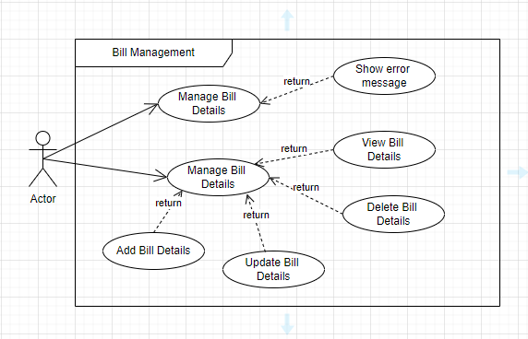

* + **ER Diagram**

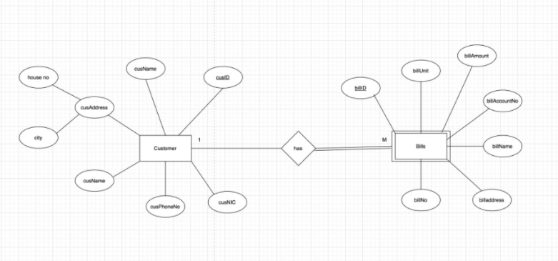

**Class Diagram Flow Chart**

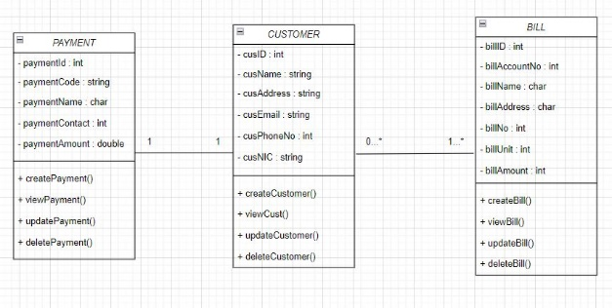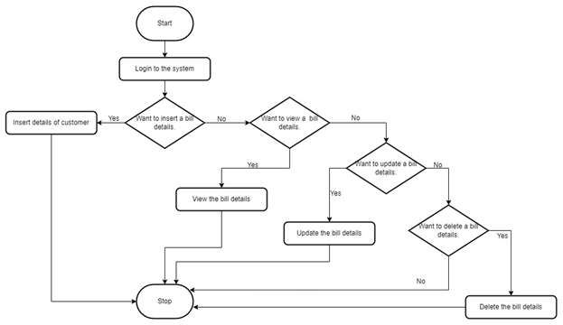

* + **Testing Methodology and Results**

|  |  |  |  |  |  |
| --- | --- | --- | --- | --- | --- |
| **Test ID** | **Description** | **Input** | **Expected Output** | **Actual Output** | **Result** |
| **1** | Add Bill | Bill Id: TNL2002  Account_no: 2592290912  Bill_no: 3003  Name: Rasika  Address: Colombo  Units: 180  T_Amount: 4000 | Bill added successfully | Bill data added Successfully | Pass |
| **2** | View Bill |  | Display a HTML table with all the attributes in bill table | Displayed HTML Table  with all the attributes in bill table | Pass |
| **3** | Update Bill | Bill Id: TNL2002  Account_no: 2592290912  Bill_no: 3003  Name: Dilshan  Address: Galle  Units: 150  T_Amount: 3500 | Updated Successfully | Updated Successfully | **Pass** |
| **4** | Delete Bill | Bill id: “TNL2002” | Deleted Successfully | Deleted Successfully | **Pass** |

# Customer Service

* + - **View Customer Details (GET)**

**Resource –** customer

**Request –** GETOnlineEG/myService/Customer/

**Media –** Form Data

**Response –** HTML Table with All Customer Details in “customer service” Table of "Error while connecting to the database for inserting."

**URL -** http://localhost:8088/OnlineEG/myService/Customer/

* + - **Insert Customer Details (POST)**

**Resource –** customer

**Request –** POSTOnlineEG /myService/Customer/

**Media –** URL Encoded Form

**Data - KEY VALUE**

cusName Pamal Weerasooriya

cusAddress No 32, Jaffna

cusPhoneNo 0786543868

cusEmail pamal@gmail.com

cusNIC 890354306V

**Response –** "Customer Added successfully" or " Error occur during inserting "

**URL -** http://localhost:8088/OnlineEG/myService/Customer/

* + - **Update Customer Details (PUT)**

**Resource –** customer

**Request –** PUTOnlineEG /myService/Customer/

**Media –** Application JSON

**Data -** {

"cusID":"4",

"cusName":"Kamal Ranasingha",

"cusAddress":"No 45, Kandy",

"cusPhoneNo":"0723234998",

"[cusEmail":"ranil@gmail.com](mailto:cusEmail%22:%22ranil@gmail.com)",

"cusNIC":"792132346V"

}

**Response –** "Error while updating the customer details."or "Updated successfully"

**URL -** http://localhost:8899/ OnlineEG /myService/Bills/

* + - **Delete Customer Details (DELETE)**

**Resource –** customer

**Request –** DELETEOnlineEG /myService/Customer/

**Media –** Application XML

**Data -** < customerData >

<cusID>4</cusID>

</ customerData >

**Response –** "Deleted successfully" or "Error while deleting the customer"

**URL -** http://localhost:8088/OnlineEG/myService/Customer/

* + **Er Diagram**

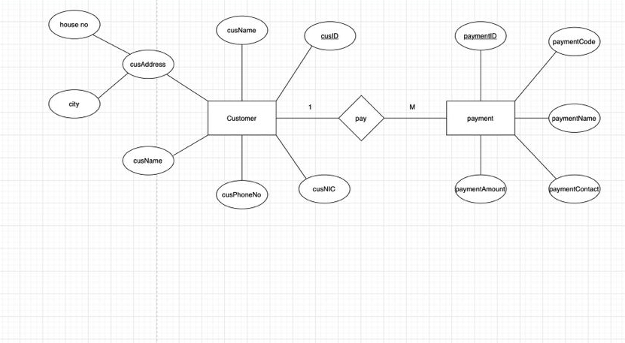

* + **Class Diagram**

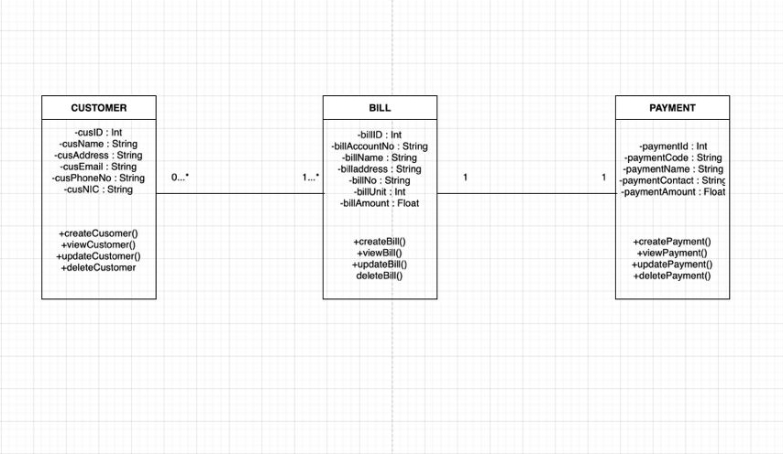

* + **Testing Methodology and Results**

|  |  |  |  |  |  |
| --- | --- | --- | --- | --- | --- |
| **Test ID** | **Description** | **Input** | **Expected Output** | **Actual Output** | **Result** |
| **1** | Add Customer | cusName : Pamal Weerasooriya  cusAddress : No 32, Jaffna  cusPhoneNo :  cusEmail : pamal@gmail.com  cusNiC : 890354306V | Customer added successfully | Customer data added Successfully | Pass |
| **2** | View Customer |  | Display a HTML table with all the attributes in customer table | Display a HTML table with all the attributes in customer table | Pass |
| **3** | Update Customer | cusName : Kamal Ranasingha  cusAddress : No 45, Kandy  cusPhoneNo : 0723234998  cusEmail : [ranil@gmail.com](mailto:cusEmail%22:%22ranil@gmail.com)  cusNiC : 792132346V | Updated Successfully | Updated Successfully | Pass |
| **4** | Delete Customer | cusID: “4” | Deleted Successfully | Deleted Successfully | Pass |

# Payment Service

This is an e-payment function that is a way of allowing customers to pay their electricity bills thru ElectricGrid system. Using this function customers can pay their bills and read payment history. Also, admins can read payment history, update admin remarks on the payment history and delete the payment history.

* + - **View Payment Details (GET)**

**Resource -** payments

**Request –** Get PaymentManagement/myService/payment/

**Media –** Form Data

**Response –** HTML Table with All payment Details in “payments” Table of "Error while connecting to the database for inserting."

URL:<http://localhost:8080/PaymentManagement/myService/Payment>

* + - **Insert Payment Details (POST)**

**Resource –** payments

**Request –** POST PaymentManagement/myService/payment/

**Media –** URL Encoded Form

**Data - KEY VALUE**

paymentCode 7635

paymentName Y.A.D.P Shavinda

paymentAmount 1245

paymentContact 758652356

**Response –** "Payment done successfully" or " Error occur during inserting "

URL:<http://localhost:8080/PaymentManagement/myService/Payment>

* + - **Update Payment Details (PUT)**

**Resource –** payments

**Request –** PUT PaymentManagement/myService/payment/

**Media –** Application JSON

**Data -** {

"paymentID":"1",

"adminRemark":"no remark"

}

URL:<http://localhost:8080/PaymentManagement/myService/Payment>

* + - **Delete Payment Details (DELETE)**

**Resource –** payments

**Request –** DELETEPaymentManagement/myService/payment/

**Media –** Application XML

**Data -** < paymentData>

<paymentID>4</ paymentID >

</ paymentData>

**Response –** "Deleted successfully" or "Error while deleting the payment

URL:<http://localhost:8080/PaymentManagement/myService/Payment>

* + **ER Diagram**

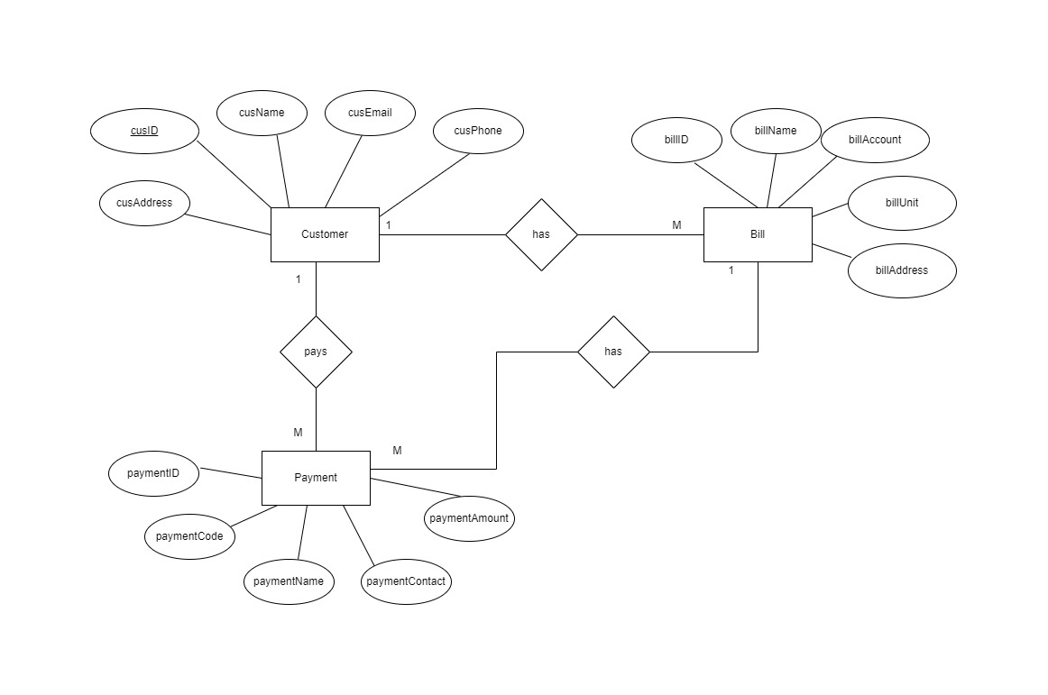

* + **Class diagram**

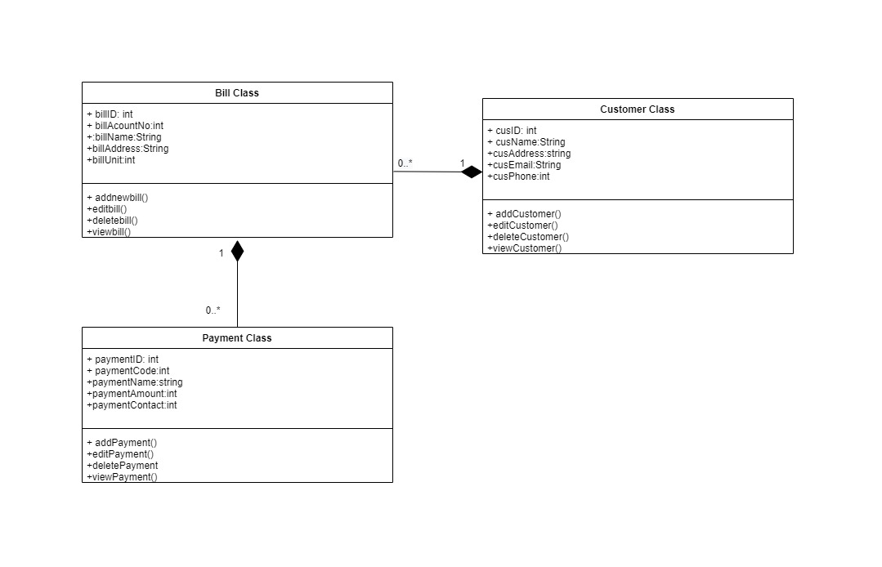

* + **Testing Methodology and Results**

|  |  |  |  |  |  |
| --- | --- | --- | --- | --- | --- |
| **Test ID** | **Description** | **Input** | **Expected Output** | **Actual Output** | **Result** |
| **1** | Add Payment | paymentCode:7635  PaymentName:Y.A.D.P Shavinda  PaymentAmount: 1245  PaymentContact: 758652356 | payment added successfully | payment added Successfully | Pass |
| **2** | View Payment |  | Display a HTML table with all the attributes in payment table | Displayed HTML Table  with all the attributes in payment table | Pass |
| **3** | Update payment | PaymentID:2  AdminRemark:Invalide | Updated  Successfully | Updated Successfully | pass |
| **4** | Delete payment | Payment ID:2 | Deleted Successfully | Delete Unsuccessfully | fail |

* + 1. **Powe Failure Service**
    2. **View Power Failure Details (GET)**

Resource: - Power Failure

Request: - GET http://localhost:8180/ ElectricGrid /PowerFailure.

Media: - Form Data

Response: - HTML table with all attributes in funds table

URL: - http://localhost:8180/ ElectricGrid /PowerFailure

* + 1. **Insert Power Failure Details (POST)**

Resource: - Power Failure

Request: - POST http://localhost:8180/ ElectricGrid /PowerFailure.

Media: - URL Form

Response: - "Add Details successfully" or "Error while Insering”

URL: - http://localhost:8180/ ElectricGrid /PowerFailure.

* + 1. **Update Power Failure Details (PUT)**

Resource: - Power Failure

Request: - PUT http://localhost:8180/ ElectricGrid /PowerFailure.

Media: - Application JSON

Response: - "Update successfully" or "Error while updating”

URL: - http://localhost:8180/ ElectricGrid /PowerFailure.

* + 1. **Delete Power Failure Details (DELETE)**

Resource: - Power Failure

Request: - DELETE http://localhost:8180/ ElectricGrid /PowerFailure.

Media: - Application XML

Response: - "Deleted successfully" or "Error while deleting”

URL: - http://localhost:8180/ ElectricGrid /PowerFailure.

* 1. **ER Diagram**

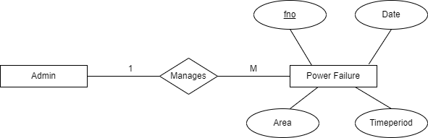

* 1. **Class Diagram**

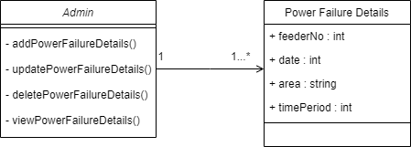

* 1. **Activity Diagram**

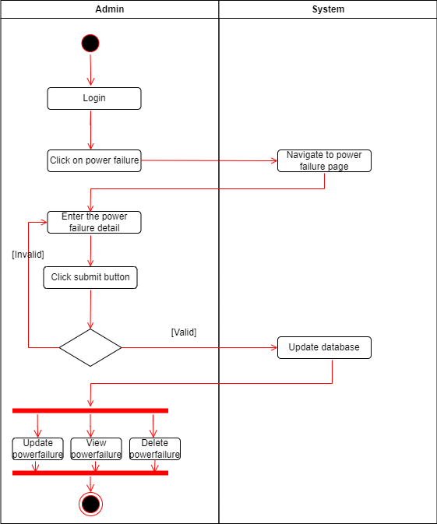

* 1. **Flow Chart**

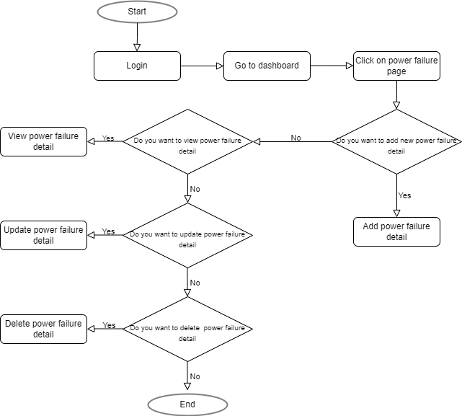

* 1. **Testing Methodology and Results**

|  |  |  |  |  |  |
| --- | --- | --- | --- | --- | --- |
| **Test ID** | **Description** | **Input** | **Expected Output** | **Actual Output** | **Result** |
| **1** | Add Power Failure Detail | Feeder No:  008  Date:  2022.05.22  Area: Malabe  Time Period: 8.00 - 10.00 | Power Failure Detail added successfully | Power Failure Detail data added Successfully | Pass |
| **2** | View Power Failure Detail |  | Display a HTML table with all the attributes in Power Failure Detail table | Displayed HTML Table  with all the attributes in Power Failure Detail table | Pass |
| **3** | Update Power Failure Detail | Feeder No: 005  Date: 2022.05.25  Area: Kaduwela  Time Period:13.00-15.00 | Updated Successfully | Updated Successfully | Pass |
| **4** | Delete Power Failure Detail | Feeder No : 006 | Deleted Successfully | Deleted Successfully | Pass |

1. **Postman Services Screenshots**
   1. **Bill Management**
      1. **Insert Bill Screenshot**

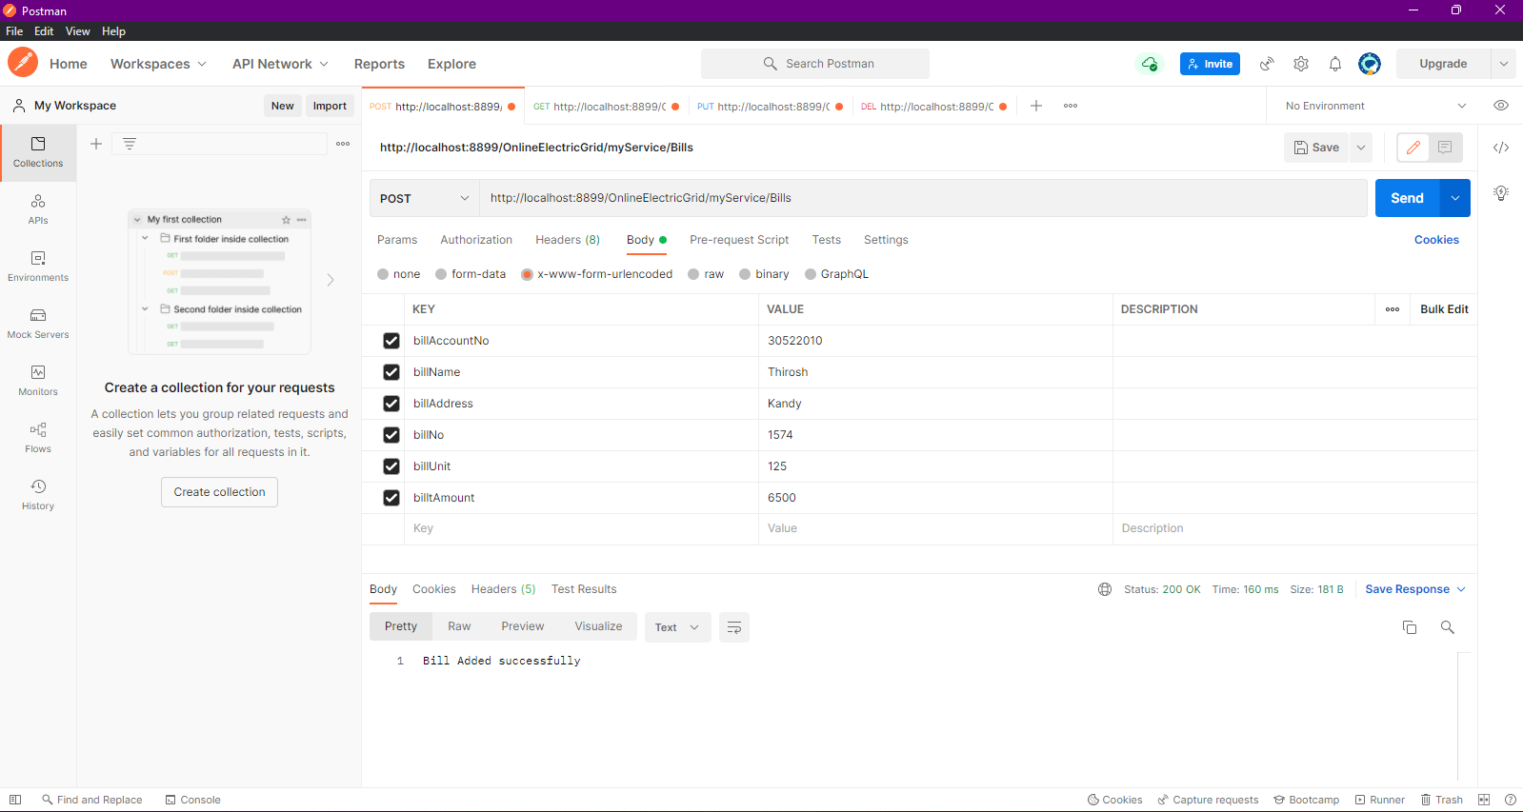

* + 1. **View Bill Screenshot**

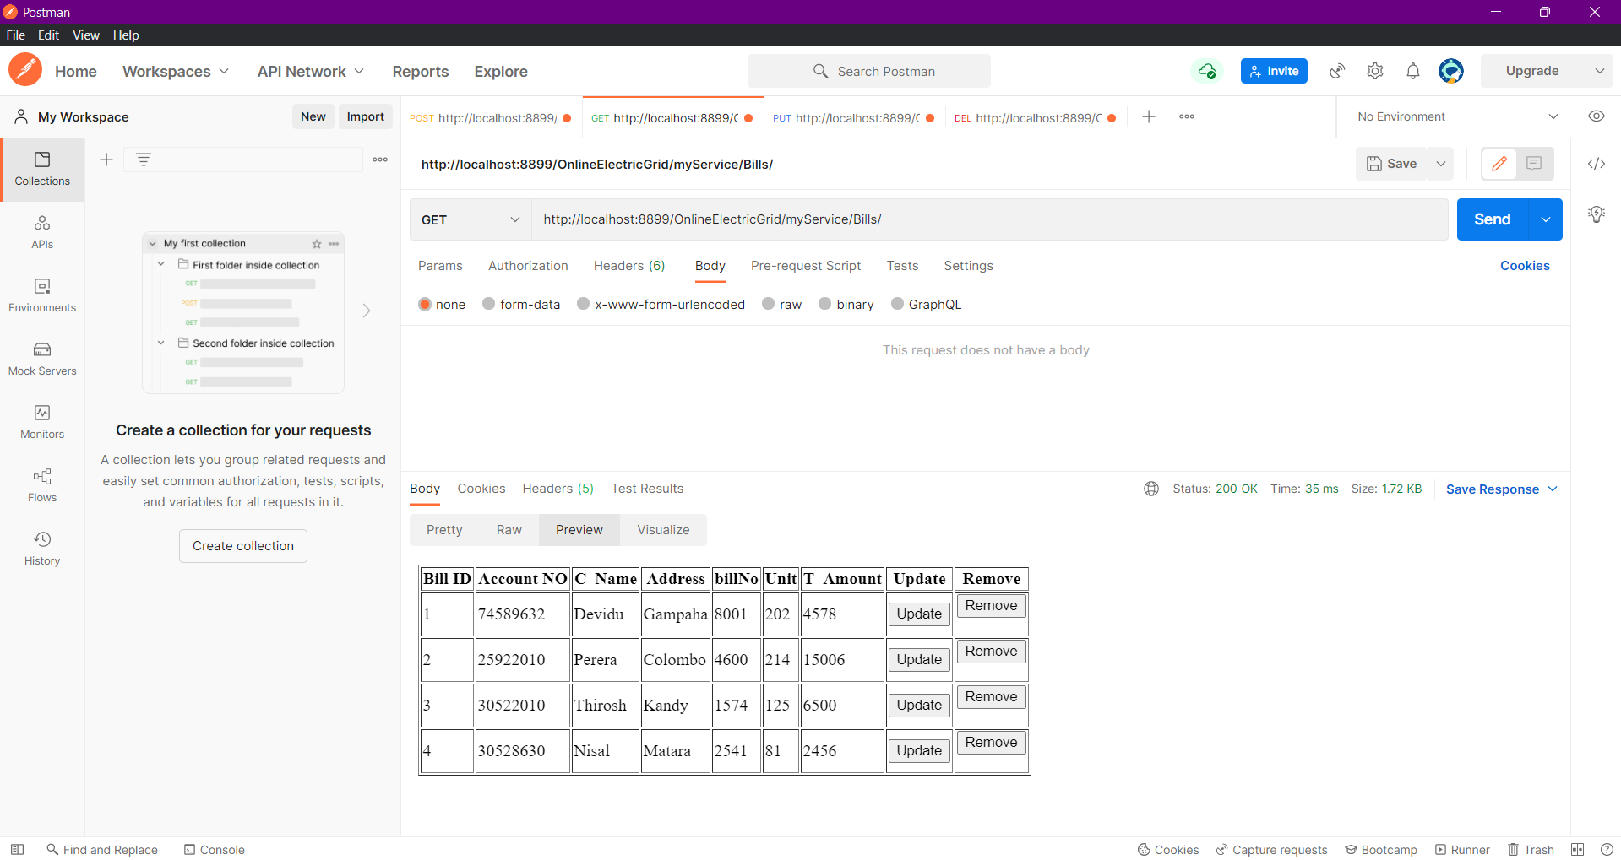

* + 1. **Update Bill Screenshot**

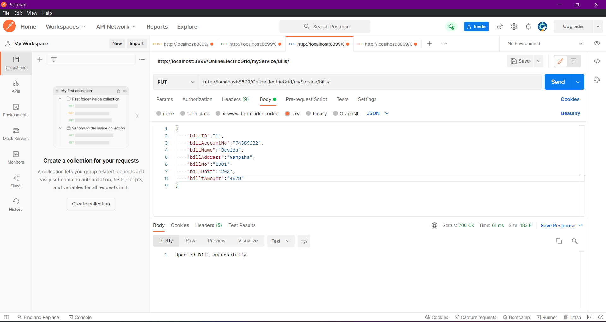

**After Update Check GET Method**



* + 1. **Delete Bill Screenshot**

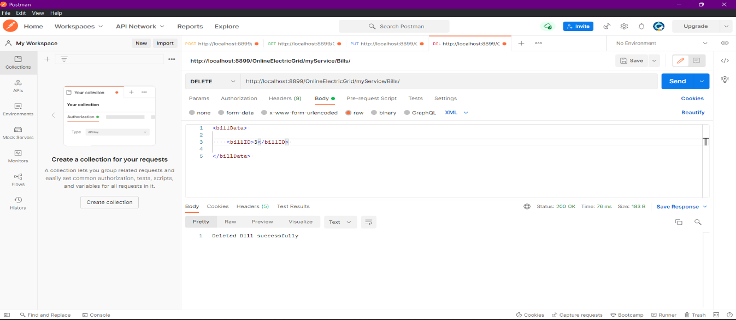

After Deleting Bill ID

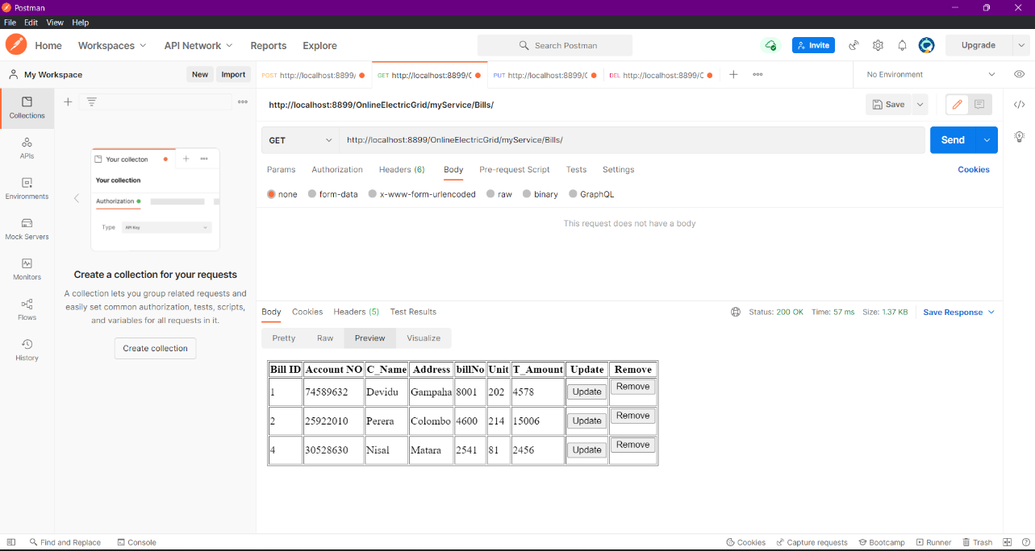

* 1. **Customer Management**
     1. **Insert Customer Screenshot**

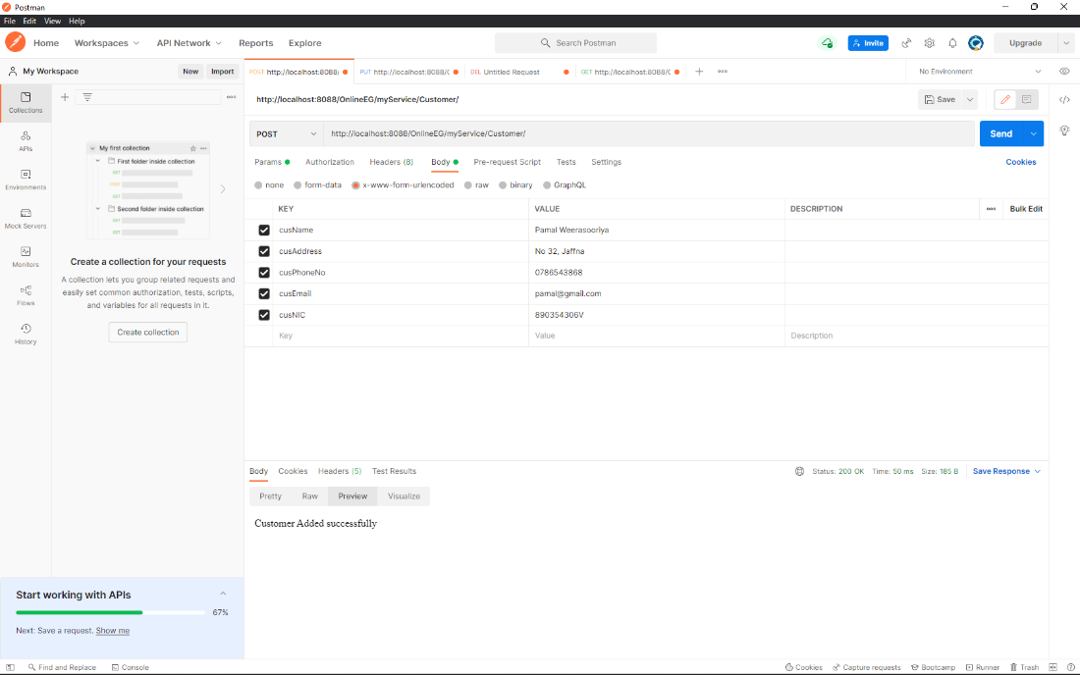

* + 1. **View Customer Screenshot**

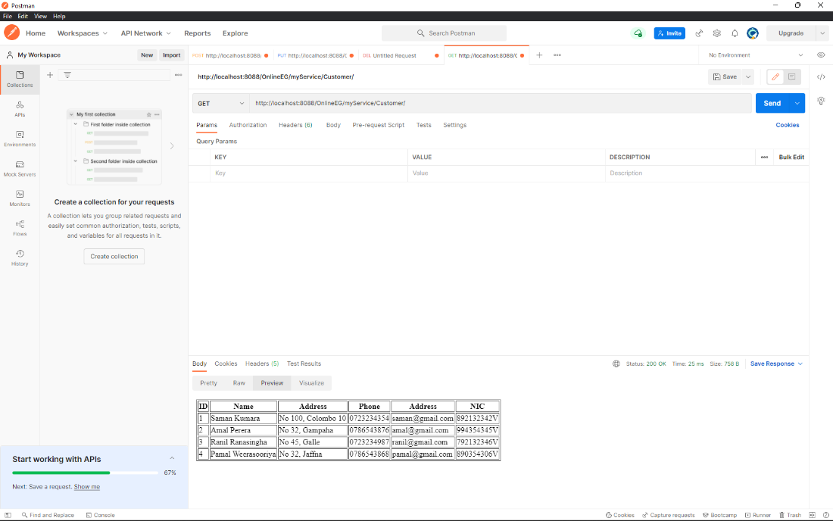

* + 1. **Update Customer Screenshot**

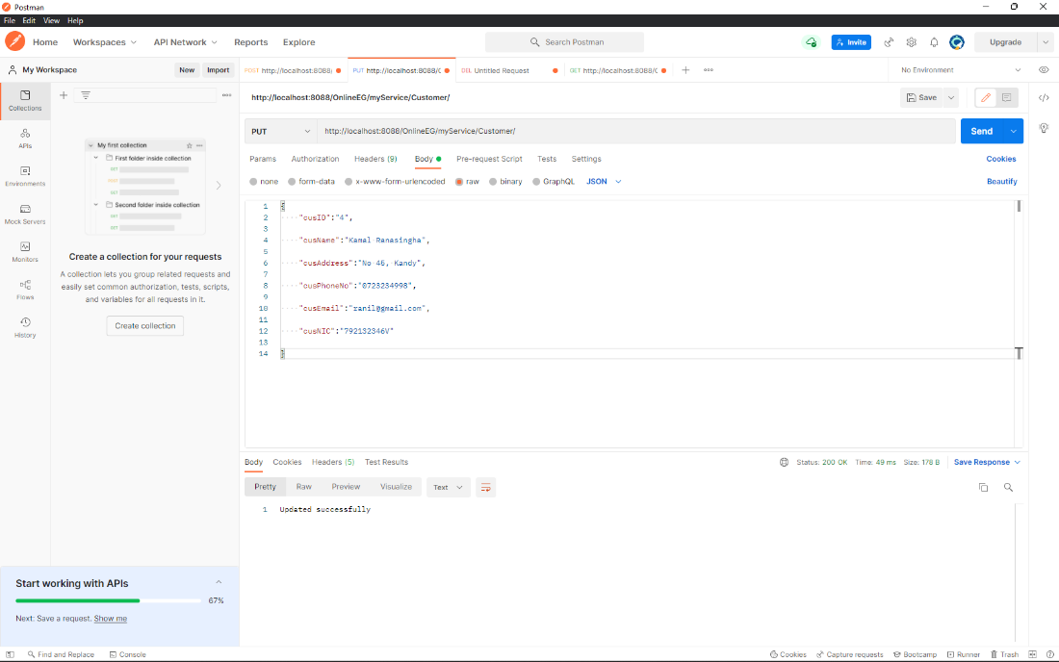

Updated successfully

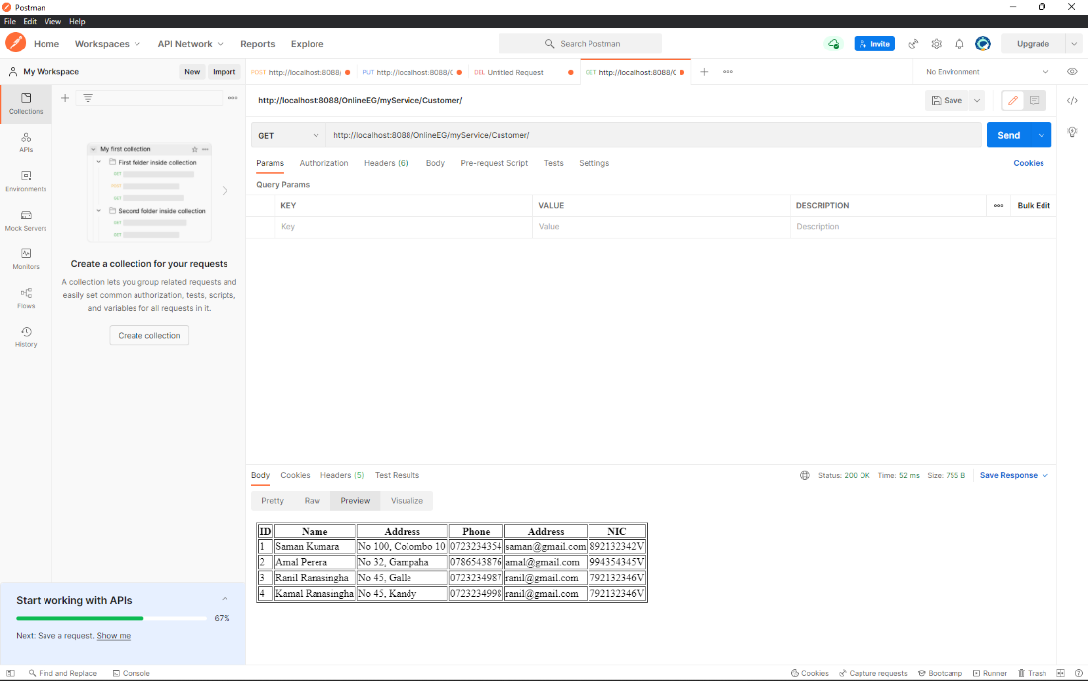

* + 1. **Delete Customer screenshot**

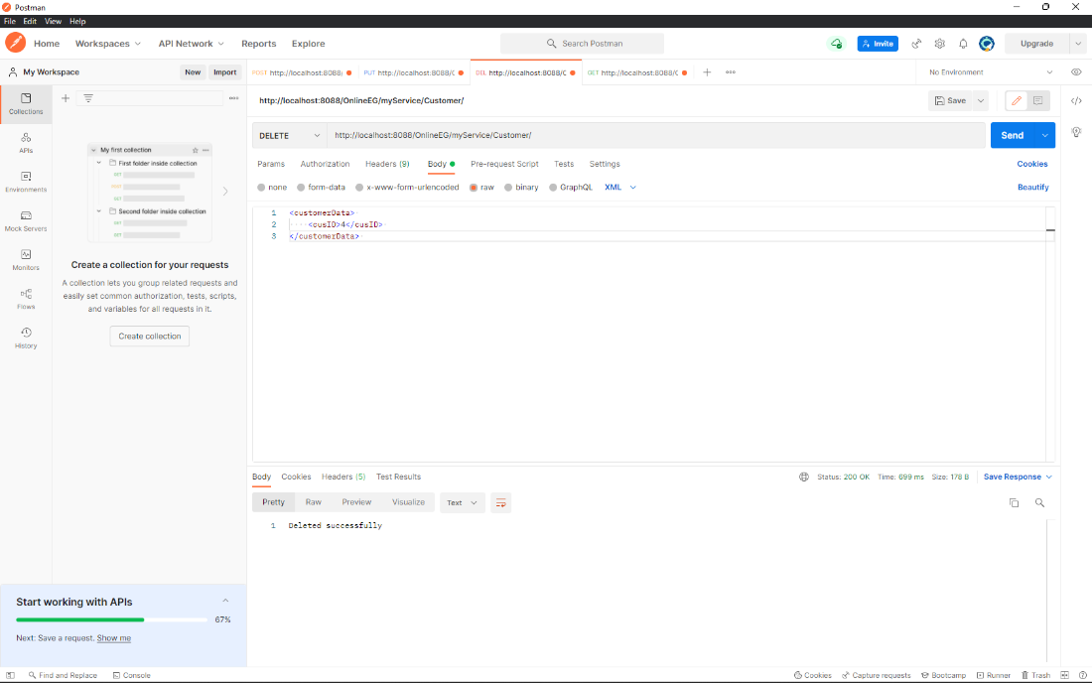

Deleted successfully

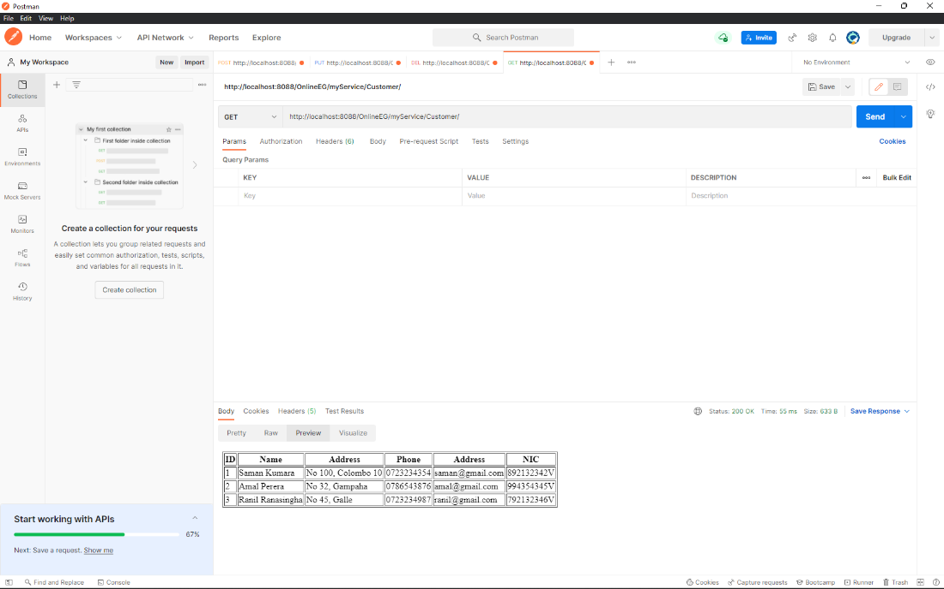

* 1. **Payment Management**
     1. **Insert Payment Screenshot**

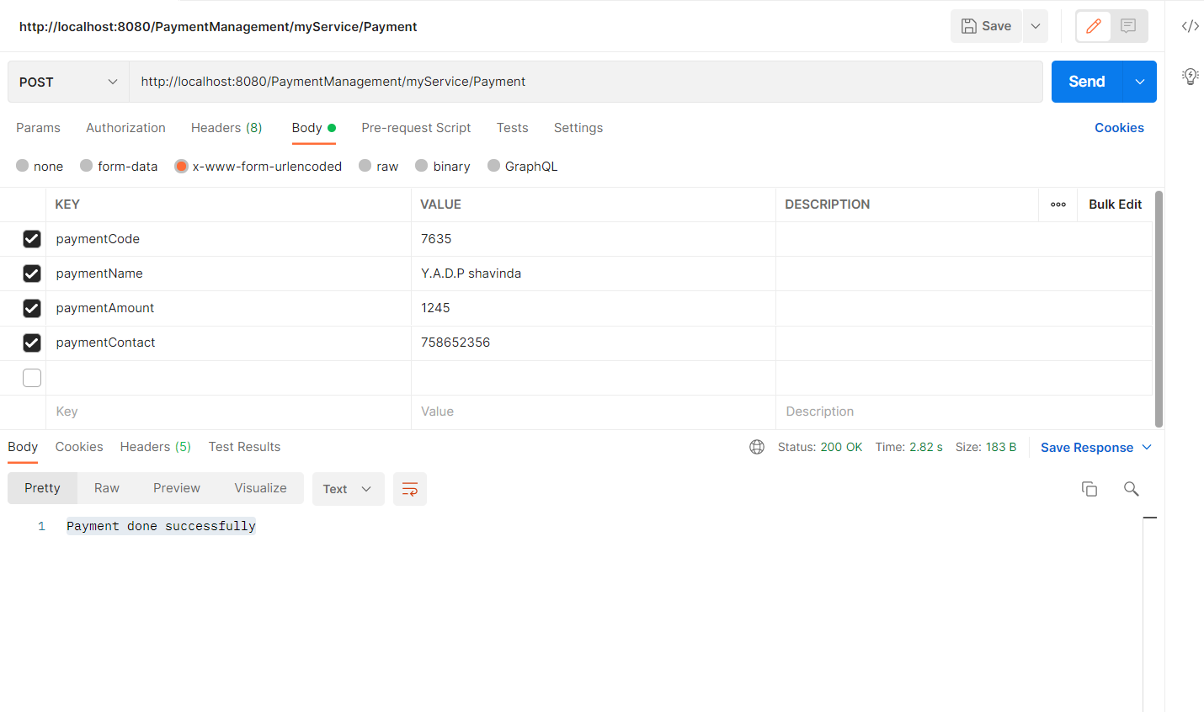

* + 1. **View Payment Screenshot**

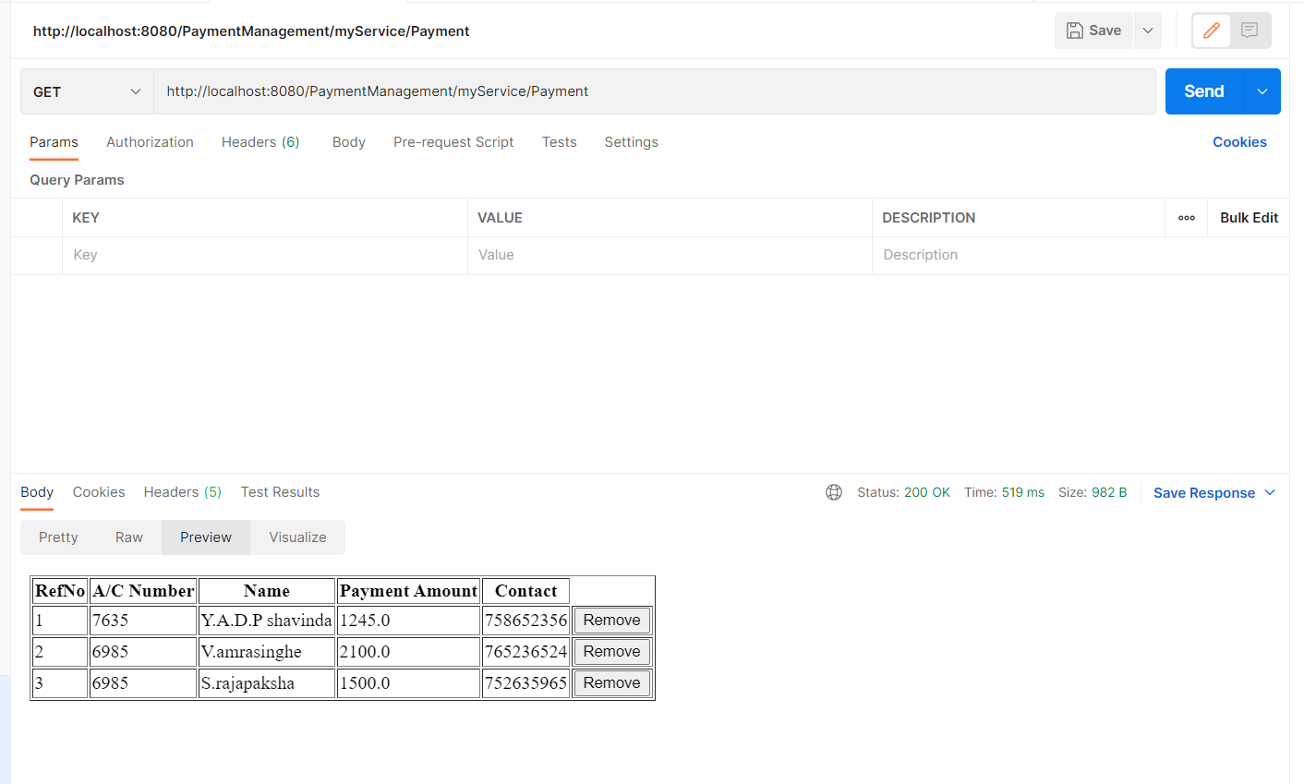

* + 1. **Update Payment Screenshot**

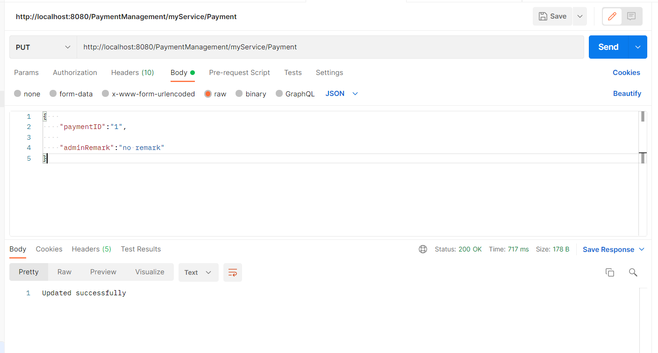

1. **Reference**
   1. Refer Lab sheet
   2. JAX-RS Documentation - <https://docs.oracle.com/javaee/6/tutorial/doc/giepu.html>
   3. SE Methodologies - <https://acodez.in/12-best-software-development-methodologies-pros-cons/>
   4. Maven Documentation - <https://maven.apache.org/guides/>
2. **Appendices**

* **Git Commit Log**

