Sri Lanka Institute of Information Technology



Assignment 1

MLB_05.02_01

Textile And Garment Management System

2021

**Internet and Web Technologies – IT1100**

B.Sc. (Hons) in Information Technology

**Group Details**

Group Number: MLB_05.02_01

Project Title: Textile and garment management system.

|  |  |  |  |  |
| --- | --- | --- | --- | --- |
|  | **Student ID** | **Student Name** | **Email** | **Contact Number** |
| 1 | IT20652296 | R.M.K.I Bandara | IT20652296@my.sliit.lk | 0702906086 |
| 2 | IT20626938 | A.L.Chanuka | IT20626938@my.sliit.lk | 0767158821 |
| 3 | IT20620752 | Ryan Melan | IT20620752@my.sliit.lk | 0771121210 |
| 4 | IT20667146 | R.Kinash Raja | IT20667146@my.sliit.lk | 0775188231 |
| 5 | IT20660116 | N.Sulaxshayan | IT20660116@my.sliit.lk | 0757496760 |

**INTRODUCTION.**

Textile and garment products of our country have been facing an issue for a while is selling our products to the Global merchandise. The reason of this act is, in our country buyer and seller are only meet by physical environment to buy or sell the products. If we want our product to be sold in the Global merchandise, we need to adapt to the modern goods selling and buying way. This is the website create to sell and buy products with global customers and sellers. Through this website purveyor comfortably can get rid of their product to the purchaser.

The purchaser able to see product’s details and their purveyor’s details also. we have designed this website to seller and buyer friendly. If any products buy and sell happens First both participants should register to the website. If purveyor sells of this product’s, she/he needs to register on this website. One that way we have created a form to get the corresponding details of purveyor. If seller new user to the website, he must click sign-up button to get the portal of form. There are few questions we have created for clearly identify the details of purveyor to purchaser and verify the purveyor’s details which will be given by them is truly as it is. Then after verification is purveyor’s given details are true seller will have been got sign-up verification code. If a seller current user, he/she can enter the website by log-in. Customers can find the prefer product of them by using search option. We have showed the products of their materials by which material designs have been sold on peak, therefore customers easily find the good purveyors also. Some new features have been added by us to website, that is about buyers can add them prefer products to the Cart and when they have enough money to buy after that they can go for it. If buyers want to know about new arrivals, they can go for it by providing them current “e-mail”, so our system sends notification mails about new products details. This facilities and features can be helpful to interact sellers and buyers in the globalization.

|  |  |
| --- | --- |
| Person name -kumara | Age - 28  Occupation – Fashion designer  Status - single  Location - Colombo  Income – 60,000/= |
| Bio.  Kumara lives in amphara. he has 3 years of experience in fashion designing. He used to watch newly textile’s websites. | Frustration.   * All the time have been blamed by the clothes material. |
| Personality.   * Explorer * Innocent * Creator | Motivation.   * Access to variety of quality textiles |

**2.personas**

|  |  |
| --- | --- |
| Person name -Chole | Age - 30  Occupation – System operator  Status - single  Location - Malabe  Income – 55,000/= |
| Bio.  Ramiya lives in malabe. She finished his degree program recently on while she was working at the same time. She is searching a new vacancy on system operator field. | Frustration.   * Monthly payment is not enough to run the family. |
| Personality.   * Kind * Helping mind * Quite | Motivation.   * Find a new job. |

|  |  |
| --- | --- |
| Person name;- Angelina | Age - 26  Occupation – Financial adviser  Status - single  Location - Kandy  Income – 64,000/= |
| Bio.  Angelina lives in kandy. She is working as a financial adviser in people leasing company in kandy. She wants to change her working environment, reason is she spends less time with her family. | Frustration.   * Work overload. |
| Personality.   * talkative * confidence * Active | Motivation.   * Wants to stand out boring workplace |

|  |  |
| --- | --- |
| Person Name :- S.K. Alex | Age:- 32  Occupation:- Software Developer  Status:- Married  Location:- San Francisco  Income:- 550$  Tax Paying:- 50$  Email:- Alex25@outlook.com |
| Bio :-  Completed a degree in Software developing.  Instagram ID:-alex66  Facebook :-Alex KS | Extra activities :-  Interested in Networking , Part time job in Software Developing , Web Designing . |
| Personality :-  Matured person.  Thinkers.  Friendly neighbor.  Hardworking visionary. | Motivation :-  “ If you’re offered a seat on a Rocket ship ,  Don’t ask what seat! Just get on ;” |

|  |  |
| --- | --- |
| K.namal | Age - 23  Occupation - Entrepreneur  Status - single  Location - Batticaloa  Income – 45,000/=  Dressing style - Casual |
| Bio.  Namal lives in Batticaloa. He has own textile and he manages designing phase in his textile. According to people’s information, he has been done good job for his customers and his own work too. He wants to way up his business to global market. | Frustration.   * His products quite vend on market because of the pandemic. |
| Personality.   * Optimistic * Active * Patient * Generous | Motivation.   * Creativity thinking on designing. |

**3.User journey**

* Customer - products.

Buying product journey

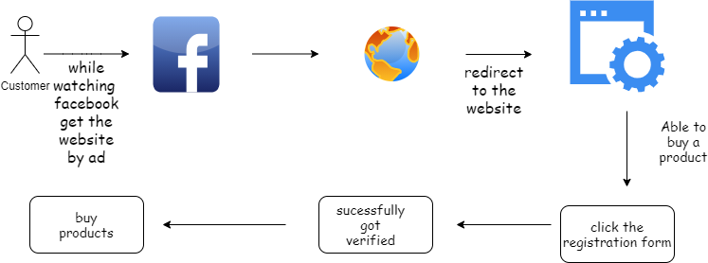

* Exist user – upload product details

Upload product details of product journey

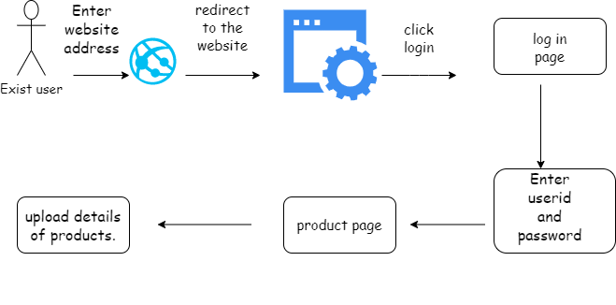

* Exist user - get updates

Exist user get updates about new product

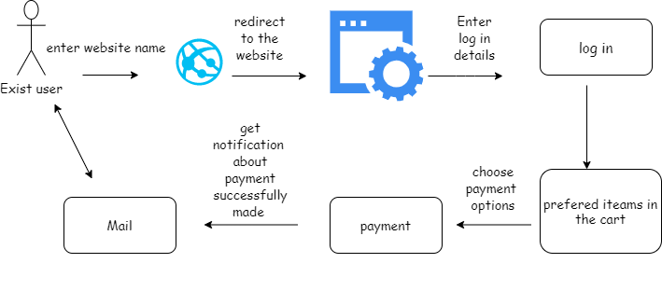

* New user – registration

New user registration journey

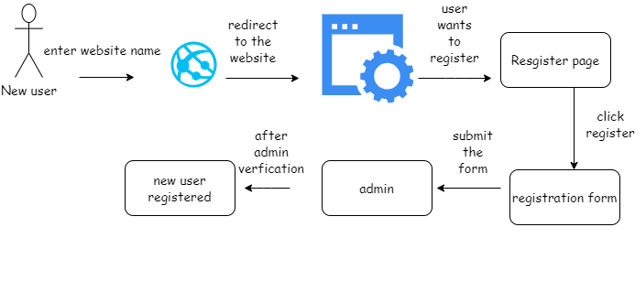

* Seller – customer

Customer gets update about new product

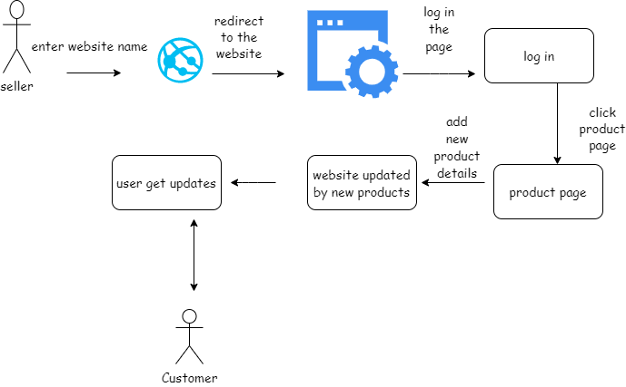

**4.wireframes**

* Homepage

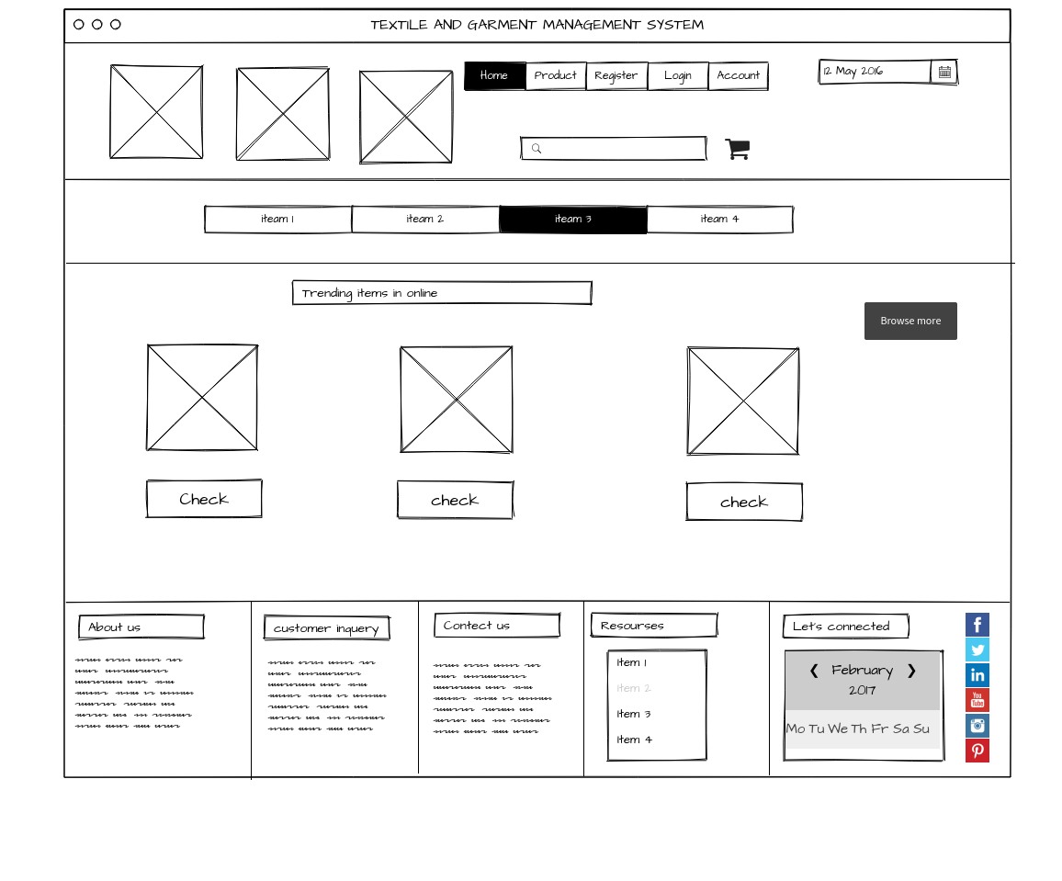

* Log in page

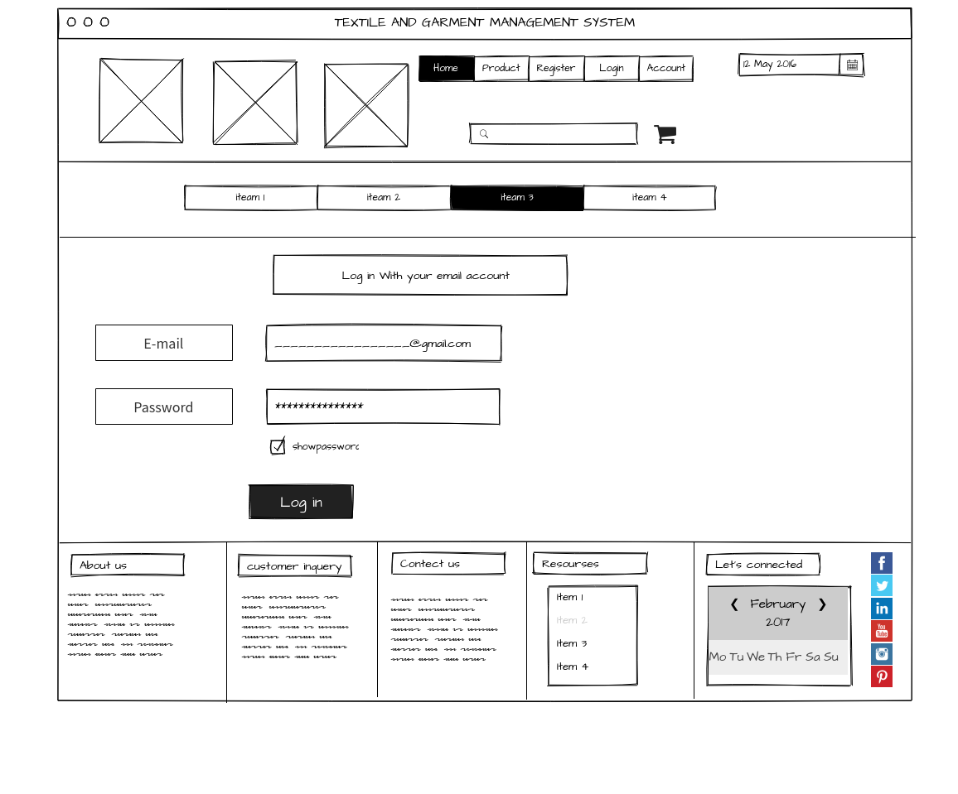

* User account page

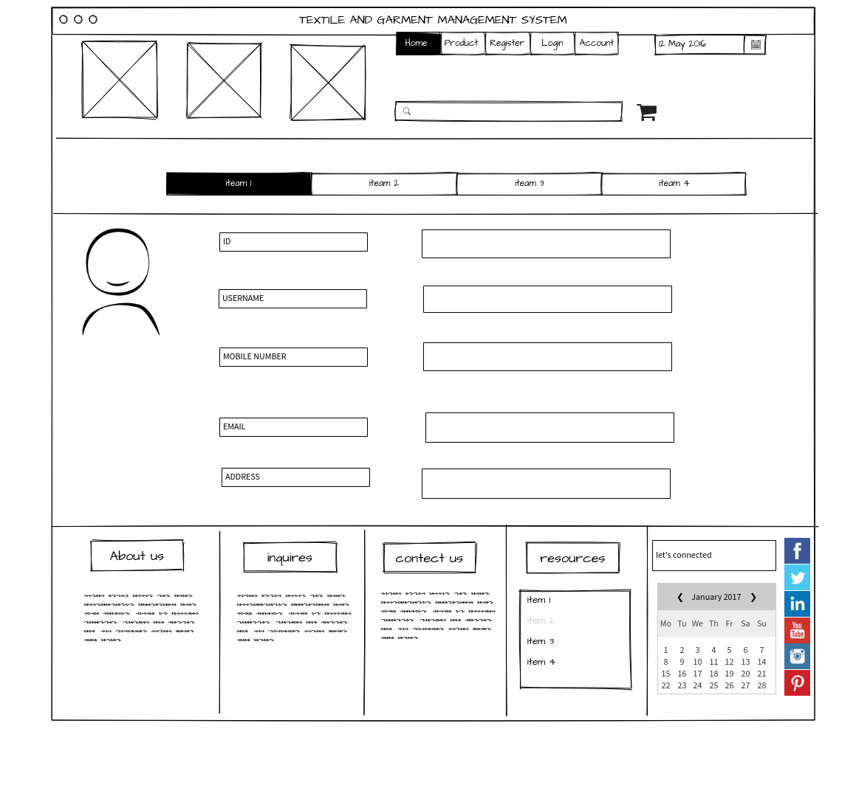

* Registration page

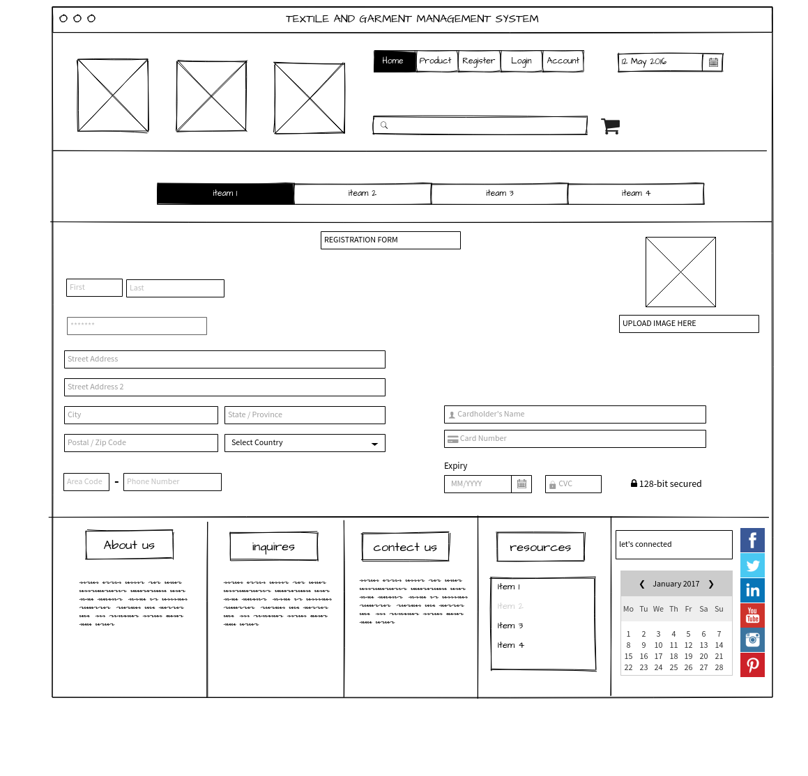

* Product’s details page

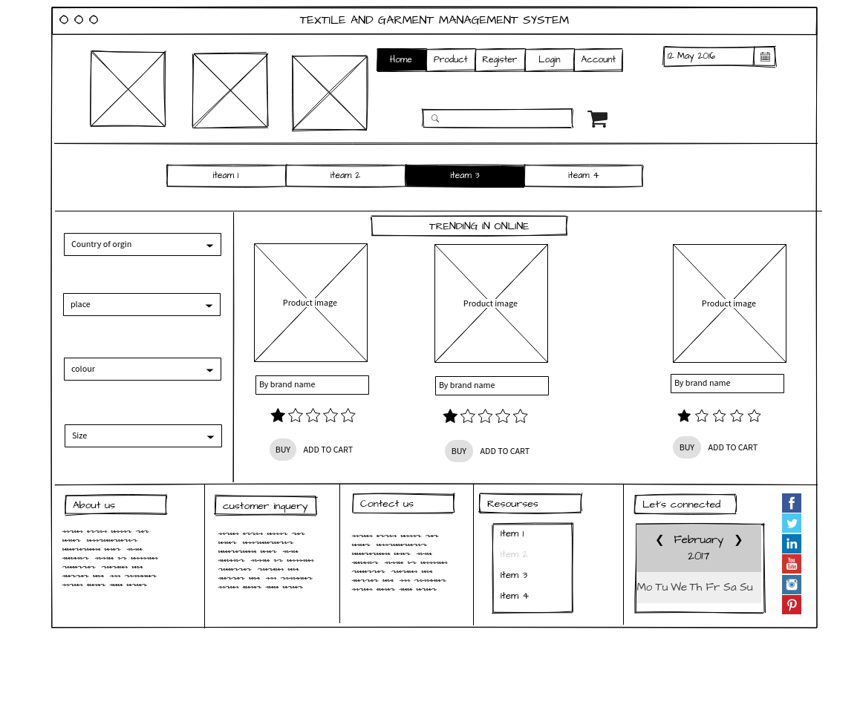

**5. Individual Contribution**

|  |  |  |  |
| --- | --- | --- | --- |
|  | Student ID | Student name | Individual Contribution |
| 1 | IT20652296 | R.M.K.I Bandara | * Persons: kumara’s persona * User journey:   Customer – products journey   * Wireframe:   Home page |
| 2 | IT206269938 | A.L.Chanuka | * Personas:   Angelina’s persona   * User journey:   Exist user – upload product details journey   * Wireframe:   Login page |
| 3 | IT20620752 | Ryan Melan | * Persons: chole’s persona * User journey:   Exist user - get updates journey   * Wireframe:   Registration page |
| 4 | IT20667146 | R.Kinash Raja | * Persons: S.K.Alex’s persona * User journey: New user – registration journey * Wireframe: User account page |
| 5 | IT20660116 | N.Sulaxshayan | * Persons: K.namal’s persona * User journey: Customer gets update about new product journey * Wireframe:   Product’s details page |

**<<Note: Include wireframes for all the pages in your proposed web application. If you have identified more pages other than above pages, please include them as well. >>**

**<<IMPORTANT: Please upload the format of your document only by one person from the group >>**

*Official Use only: Filled by your Lecturers/Instructors*

**Marks for Project Proposals**

Acceptable: Mark/select as necessary

|  |  |  |
| --- | --- | --- |
| Acceptance/  Rejection | Correction State | |
| Minor Correction / Marks | Major Corrections |
| Accepted |  |  |
| Resubmit |  |  |
| Rejected |  | |

Corrections (if necessary)

Major changes proposed:

Any other Comments:

Supervisor Name:

Signature:

Date: