**“DreamIT”**

**Multi-Model Approach to Recommend**

**Personalized Music Playlist**

**.**

**Project ID** - **TMP-2023-24-065**

**Status Document - 1**

**Supervised by –** Mr. Thusithanjana Thilakarathne

Name – Gunasekara C.M

Registration Number - IT20665852

B.Sc. Special (Hons) in Information Technology Specializing in information technology.

Department of Information Technology.

Sri Lanka Institute of Information Technology

## Declaration

I declare that this is my work, and this proposal does not incorporate without acknowledgment any material previously submitted for a degree or diploma in any other university or institute of higher learning, and to the best of our knowledge and belief, it does not contain any material previously published or written by another person except where the acknowledgment is made in the text.

|  |  |  |
| --- | --- | --- |
| **Name** | **Student ID** | **Signature** |
| Gunasekara C.M | It20665852 |  |

The above candidate is carrying out research for the undergraduate Dissertation under my supervision.

............................................. ...................................

Signature of the supervisor Date

Table of Contents

Declaration 2

1.Screenshots of calls of ms teams 4

2.Sample works 9

3.Grantt chart 10

10

Work breakdown chart 11

## A screenshot of a computer1.Screenshots of calls of ms teams

**Figure : meetings conducted through teams**

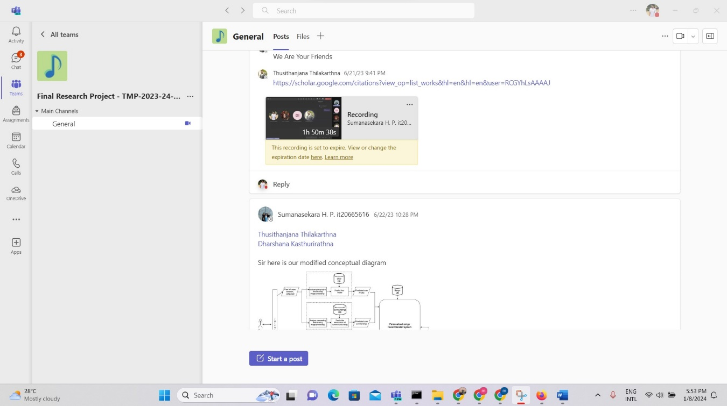

**Figure : meetings conducted through teams**

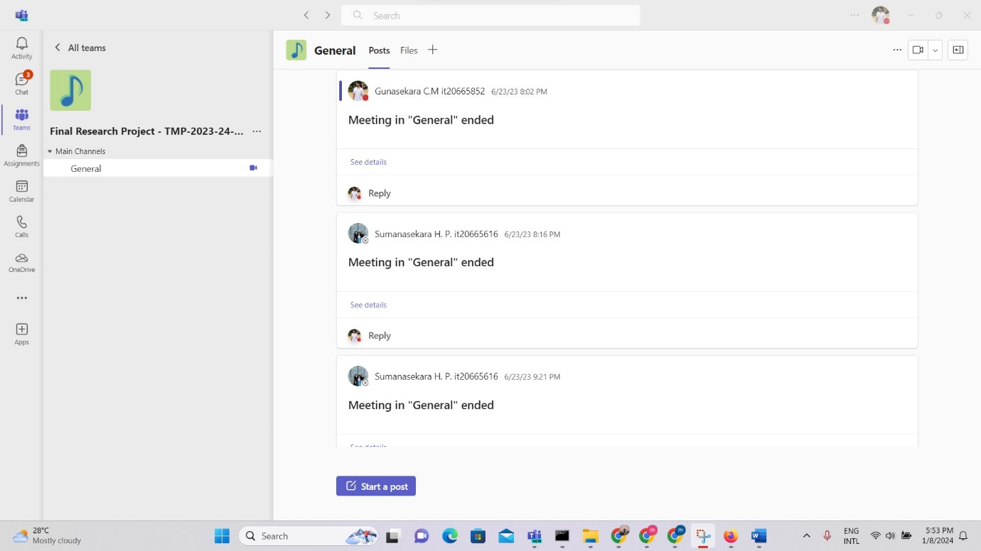

**Figure : meetings conducted through teams**

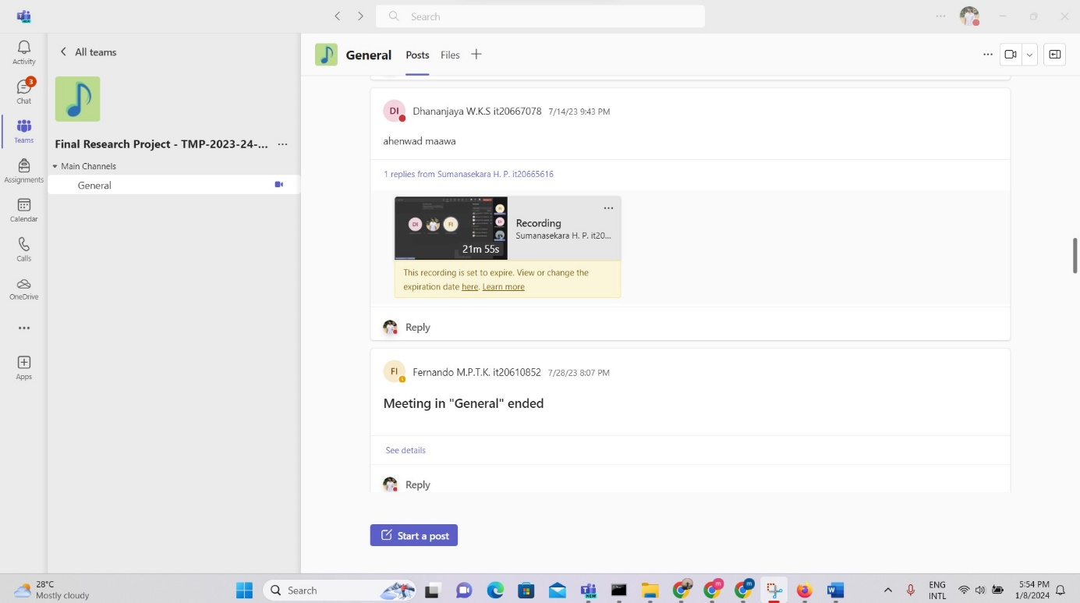

**Figure : meetings conducted through teams**

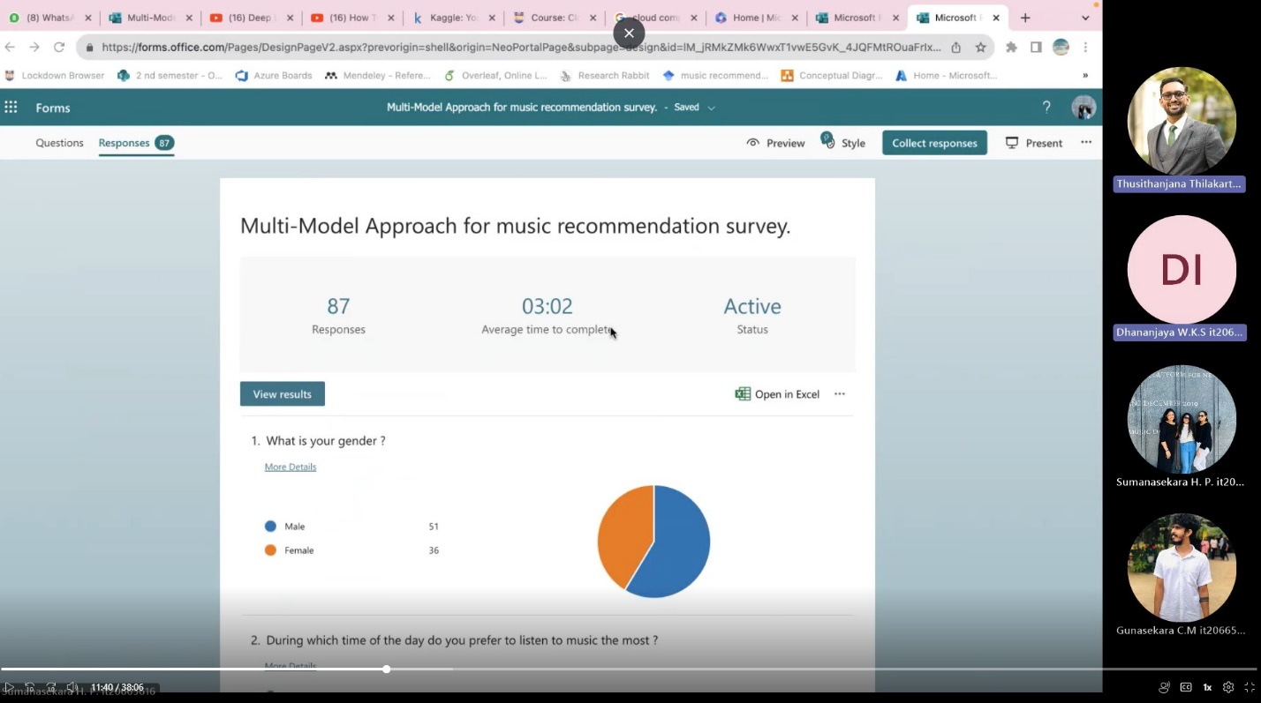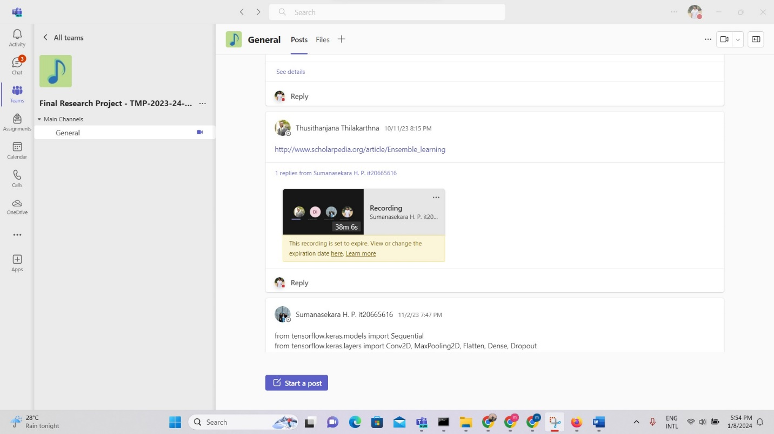

**Figure: meetings conducted through teams**

**Figure : meetings conducted through teams**

**Figure: meetings conducted through teams**

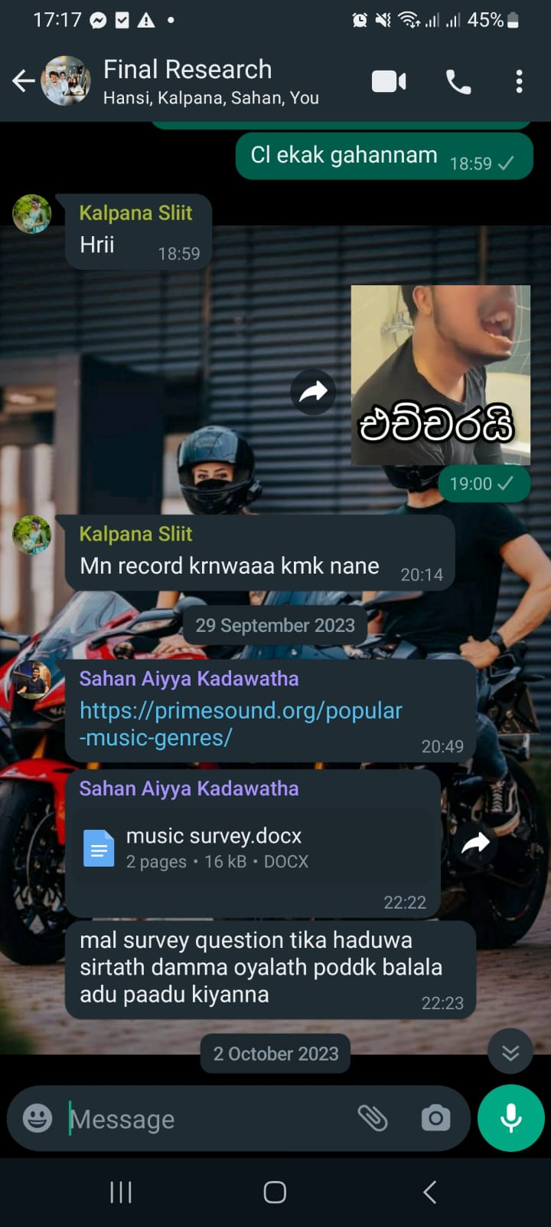

Figure : **whatsapp chat**

Figure : **whatsapp chat**

Figure : **whatsapp chat**

## A screenshot of a computer programA screenshot of a computer2.Sample works

## 3.Grantt chart

## A screenshot of a computer

## Work breakdown chart

