Deep Learning - Lab 4 – YOLO object detection

1. In the below given cell, shape of the boxes.eval() is (1783,4). Why are there 1783 boxes? Explain the reason for it. What is the maximum number and minimum number you can get for that? Write these answers in a word file.
   * Because only 1783 boxes out of the possible 1805 met the condition box_class_scores >= threshold (with a threshold of 0.5).
   * Maximum Number: The maximum number of boxes you can get is 1805, which occurs if all the predicted boxes meet or exceed the threshold criteria.
   * Minimum Number: The minimum number of boxes is 0, which happens if none of the boxes meet the threshold, meaning no boxes are retained after filtering.
   * 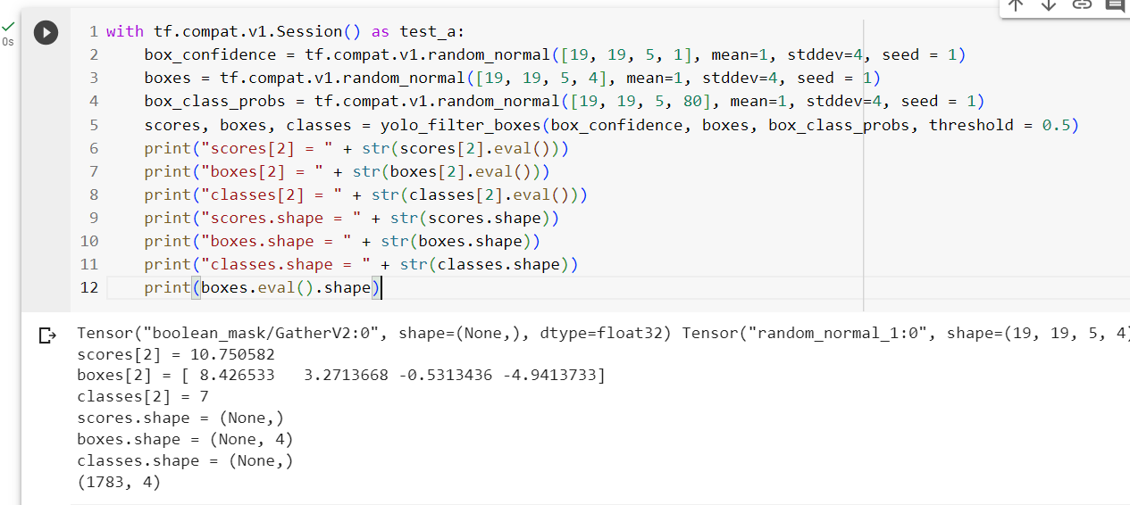Change the values like mean and stddev in lines 2 and 4 as well as threshold value in line 5 and observe the different values you get for the boxes.eval().shape.
2. yolo_anchors.txt contains 10 values. They can be considered as height and width of 5 anchor boxes. What is the advantage of using such anchor boxes? What was the method used to determine the sizes of these anchor boxes? Give the answers to these questions in the word file.

* Anchor Boxes: These are predefined boxes of certain widths and heights that are used by the model to predict the location and size of objects in an image. Each grid cell in YOLO predicts the adjustments to these anchor boxes to match the actual objects.
* The advantage of using predefined height and width (anchor boxes) is that they allow the model to predict objects of different sizes and aspect ratios more efficiently. They also help in dealing with overlapping objects and reduce the complexity of training.
* Method to Determine Anchor Box Sizes: The sizes of the anchor boxes are often determined by applying a clustering algorithm like K-means on the bounding box dimensions of objects in the dataset. The resulting cluster centroids give the most representative anchor box sizes for the objects in the dataset.

1. Upload a new traffic image to images and edit the code as needed to detect vehicles in that image.
2. Download the output images zip file from the google drive and observe the bounding boxes in the autonomous driving dataset (i.e., 21 images from 0100.jpg to 0120.jpg). Select 2 images from these 21 images and,
   * Write what you observe regarding correctly detected objects, incorrectly detected objects, undetected objects and incorrect bounding boxes in the word file.
     + No objects were detected in image 1.
     + Only 1 car and a fire hydrant were detected in image 2.
     + No objects were incorrectly detected in both images.
   * 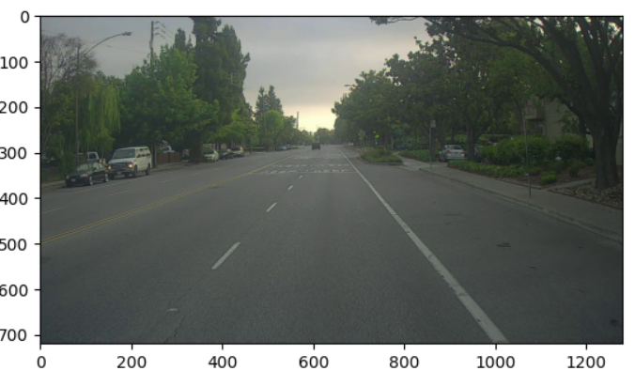Include these output 2 images as well as the original 2 images in the word file.

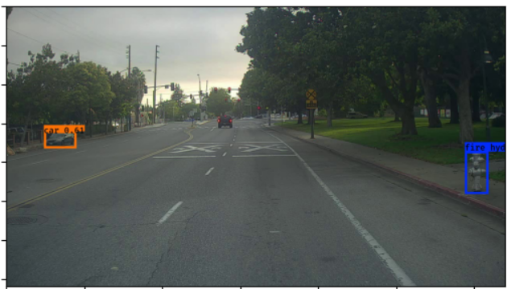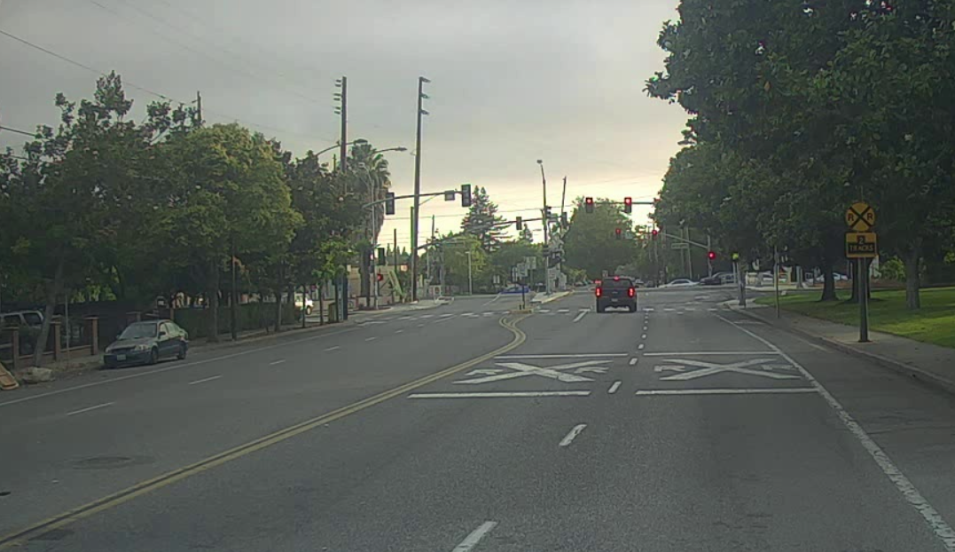

1. Adjusting parameters like max_boxes, score_threshold, and iou_threshold of the yolo_eval function can potentially address the limitations you noticed in step 10.
   * Change the max_boxes [integer value] to a different value but use the original values for other 2 variables. Rerun the required cells to get the output images for the autonomous driving dataset. Observe if this result in improvement compared to step 10 for the same two images. If there are any improvements, write them in the word file. Include the new 2 output images in the word file.
     + There are no improvements by just adjusting the max_boxes value
   * Change the score_threshold [value between 0-1] to a different value but use the original values for other 2 variables. Rerun the required cells to get the output images for the autonomous driving dataset. Observe if this result in improvement compared to step 10 for the same two images. If there are any improvements, write them in the word file. Include the new 2 output images in the word file.
     + A road with a sign on it

       Description automatically generatedA road with trees and signs

       Description automatically generatedScore_threshold = 0.2
   * Change the iou_threshold [value between 0-1] to a different value but use the original values for other 2 variables. Rerun the required cells to get the output images for the autonomous driving dataset. Observe if this result in improvement compared to step 10 for the same two images. If there are any improvements, write them in the word file. Include the new 2 output images in the word file.
     + Score_thresold = 0.2-0.4. No changes in the image were dectected compared to the original in both images.