Sri Lanka Institute of Information Technology



SE2030 – SOFTWARE ENGINEERING
Year 2, Semester 1 – 2026
LAB REPORT 05 – SEQUENCE DIAGRAMS

Group ID: Group No 2
Project Topic: Web-Based Library Management System

Group Members:
Student ID | Name | Module
IT21047756 | Weerasekara W.B.M.K.D | Reporting Module
IT21054372 | Samarasinghe P.D.P | Book Management Module
IT21060144 | Rathnayake R.M.I | Issue & Return Management Module
IT21077524 | Pathirana A.P.C.E | Search & Availability Module
IT21101274 | Dolawatta T.Y.R | Fine Management Module
IT21158872 | Vimukthi W.M.B.V | User Management Module

Github link :- https://github.com/IT21060144/SE2030-Group2-LibrarySystem

1. Introduction

This report presents the Sequence Diagrams developed for Lab Sheet 05 of SE2030 – Software Engineering. The diagrams are based on the Web-Based Library Management System project assigned to Group 2.
Each group member designed and drew a sequence diagram for their respective main use case scenario, using boundary, control, and entity classes as directed in the lab sheet.

Lab Session: Lab Sheet 05 – Sequence Diagrams
Tool Used: Draw.io (https://www.draw.io/)
Date Submitted: 6th April 2026

2. Sequence Diagrams

The following sections present each member's use case scenario and corresponding sequence diagram. Diagrams were created using Draw.io and exported as screenshots.

1. Weerasekara W.B.M.K.D

Student ID: IT21047756
Stakeholder Role: Library Manager
Module: Reporting Module

Sequence Diagram:
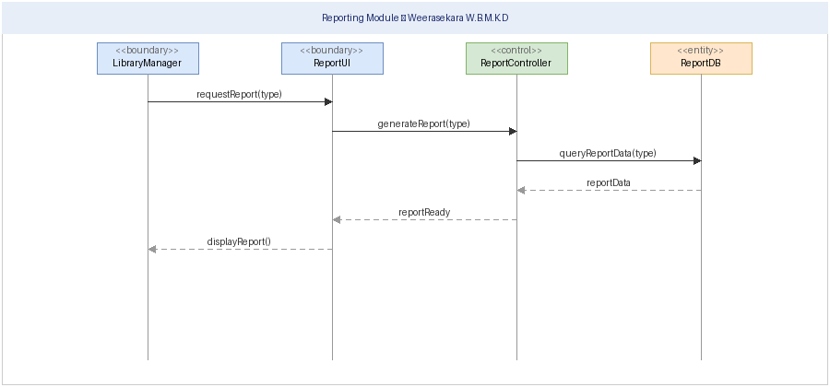
Use Case Description:
The Library Manager accesses the Reporting Module to generate system-level reports. The manager requests a report via the ReportUI, which forwards the request to the ReportController. The controller queries the ReportDB for data. If data is found, the report is compiled and displayed to the manager. If no records are available, an appropriate error message is shown.

2. Samarasinghe P.D.P

Student ID: IT21054372
Stakeholder Role: Assistant Librarian
Module: Book Management Module

Sequence Diagram:
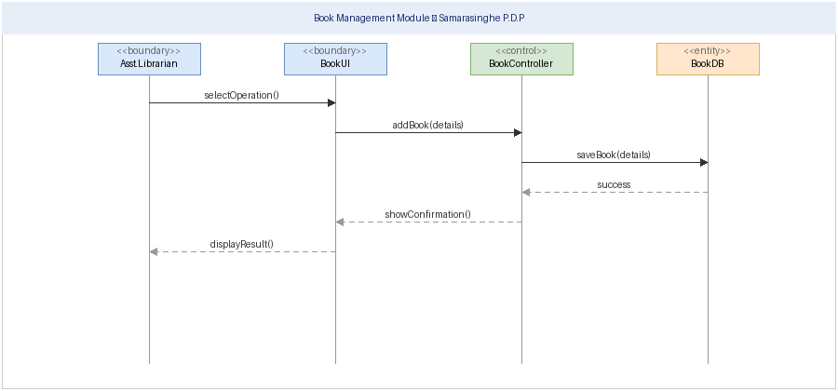
Use Case Description:
The Assistant Librarian uses the Book Management Module to add, update, and delete book records. The librarian selects an operation via BookUI, which forwards the request to the BookController. The controller processes the request and interacts with BookDB to save or update the record. A confirmation message is returned and displayed upon completion.

3. Rathnayake R.M.I

Student ID: IT21060144
Stakeholder Role: Senior Librarian
Module: Issue & Return Management Module

Sequence Diagram:
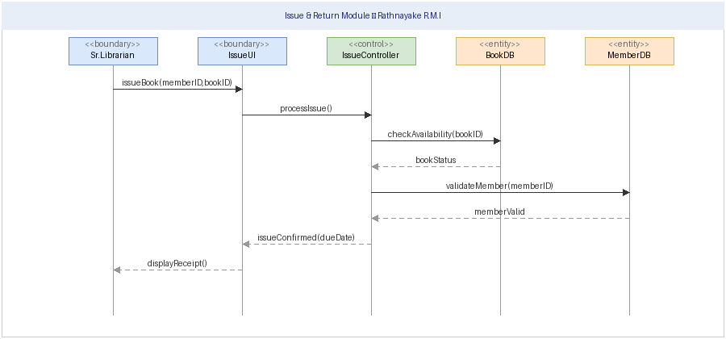
Use Case Description:
The Senior Librarian processes book issue and return transactions. The librarian submits a request through IssueUI, and the IssueController verifies book availability via BookDB and validates the member via MemberDB. If both validations pass, the transaction is recorded and a receipt is issued. Otherwise, an error message is displayed.

4. Pathirana A.P.C.E

Student ID: IT21077524
Stakeholder Role: Undergraduate Student
Module: Search & Availability Module

Sequence Diagram:
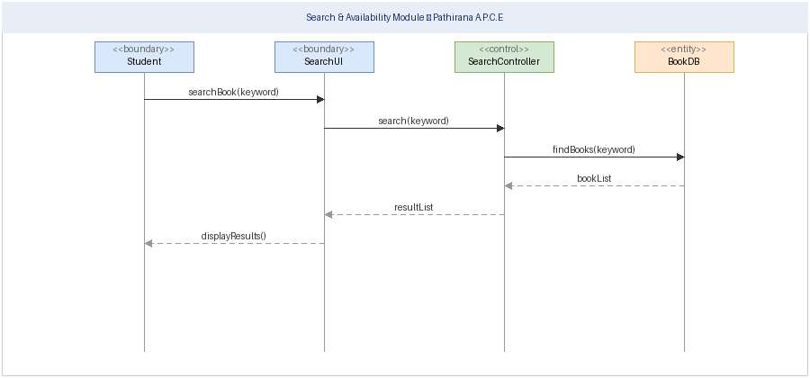
Use Case Description:
The Undergraduate Student searches for books using the Search & Availability Module. The student enters a keyword into SearchUI, which passes the query to SearchController. The controller queries BookDB and returns matching results. If books are found they are displayed; otherwise a no-results message is shown. Multiple searches can be performed in a loop.

5. Dolawatta T.Y.R

Student ID: IT21101274
Stakeholder Role: Student Services Officer
Module: Fine Management Module

Sequence Diagram:
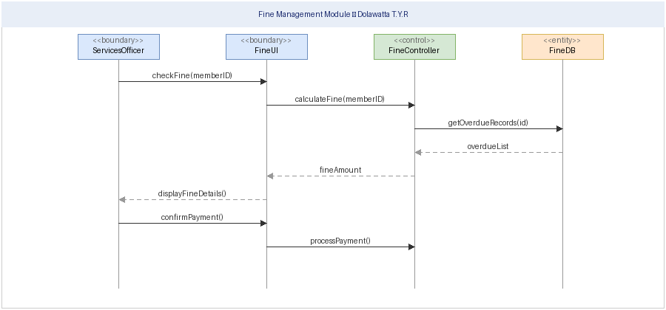
Use Case Description:
The Student Services Officer checks and processes fines via the Fine Management Module. The officer requests a fine check by member ID through FineUI. The FineController retrieves overdue records from FineDB, calculates the fine, and displays the details. If the officer confirms payment, the fine record is updated to cleared. If no fines are outstanding, a clear status is shown.

6. Vimukthi W.M.B.V

Student ID: IT21158872
Stakeholder Role: Senior Lecturer
Module: User Management Module

Sequence Diagram:
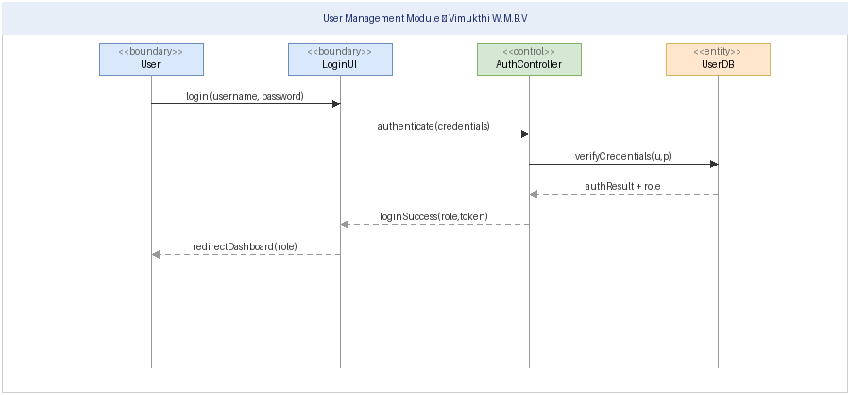
Use Case Description:
Users (library staff and students) log into the system through the User Management Module. The user submits credentials via LoginUI, which passes them to AuthController. The controller verifies the credentials against UserDB. On successful authentication, a session token is created and the user is redirected to the role-appropriate dashboard. On failure, an error is shown and the user may retry.

4. Conclusion

In this lab session, each group member successfully designed and drew a sequence diagram for their respective main use case scenario of the Web-Based Library Management System.
The diagrams were created using Draw.io, following the standard UML sequence diagram notation including lifelines, activation bars, synchronous messages, return messages, loop fragments, and alt (conditional) fragments.
Boundary, control, and entity classes were used to represent the architectural layers of the system, in line with the lab instructions and the sample answer provided.

