

IT3060 - Human Computer Interaction

Assignment 1

Craigslist.com

2023-WE-S1-13

DreamWeave

**Member Details**

|  |  |  |
| --- | --- | --- |
| **Reg. No** | **Name** | **Work Distribution** |
| IT21181474 | Hettiarachchi H.K.Y.K |  |
| IT21360046 | Jayasekara B.B.R.Y |  |
| IT21358616 | Munasingha M.H.C |  |
| IT21356636 | Perera P.K.L |  |
| IT21345746 | Siriwardana A.P.G.D.P |  |

1. **Project Description**

Our team chose the website called “Craigslist” the one of most well-known websites for online marketplace. The primary purpose of this website is to connect users within specific geographical areas, enabling them to post listings for items, services, housing, jobs and more. Users can explore listings, communicate with sellers through mail, and negotiate transactions directly. Its simplistic, Text-heavy interface and lack of modern designs (e.g. images etc.) can be occur as usability challenges for users.

1. **Alternatives Considered**

We considered several alternative considerations. Our team members chose [Blinkee.com](https://blinkee.com/), [Chestertourist.com](http://www.chestertourist.com/) and [nh.craigslist.org](https://nh.craigslist.org/) websites. First, we chose blinkee.com but everyone is going to do that site because every requirement that has given by our module is fulfilled in that website. After considering the given instructions in our HCI module we came up with the **Craigslist** website.

1. **User groups identified.**
2. 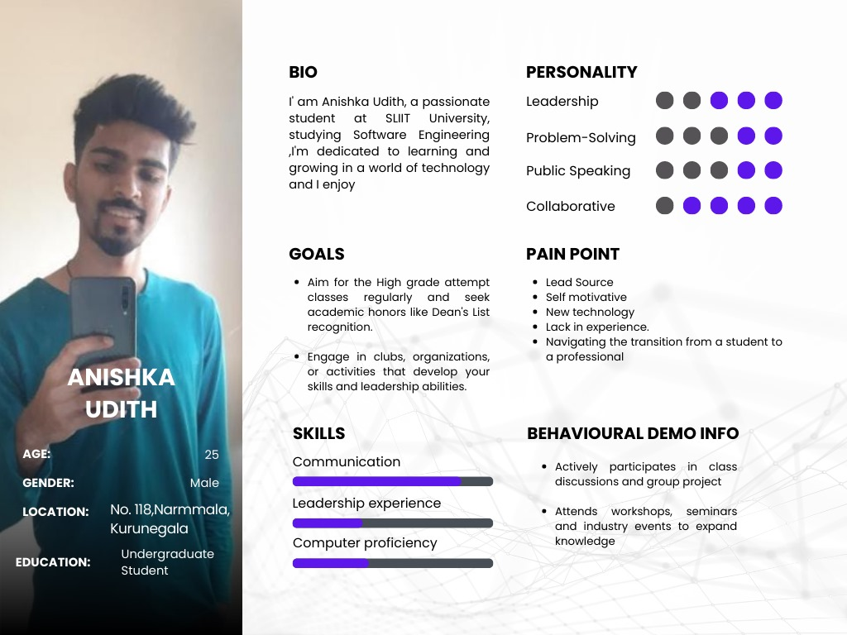**Personas**

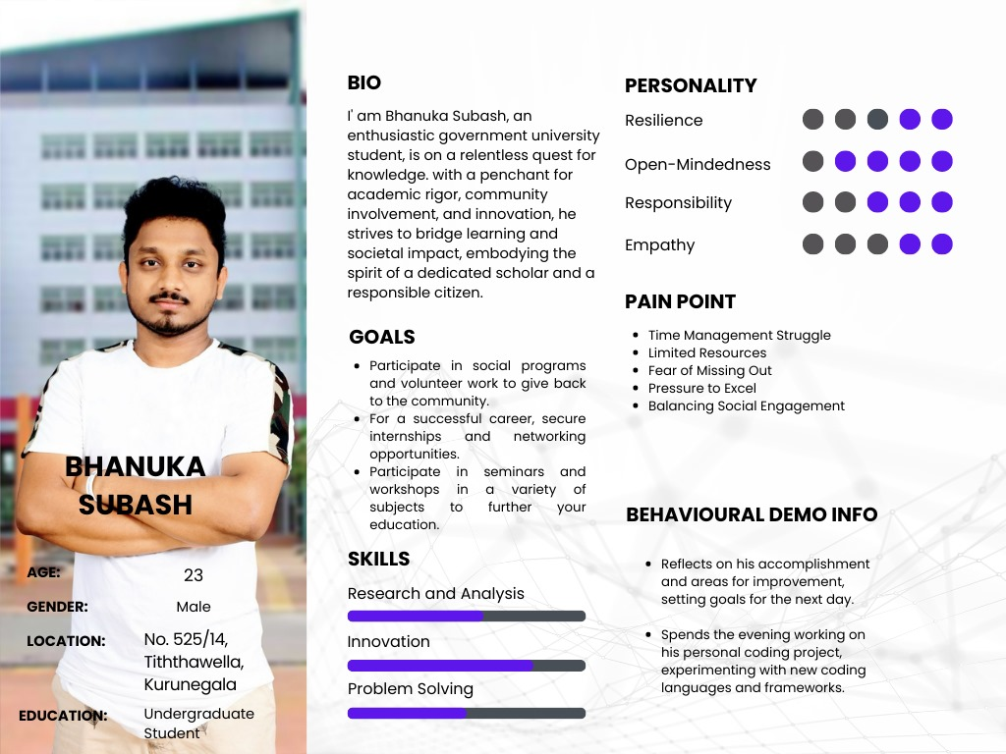

1. **Usability Issues**

## Accessibility

* Confusing texts
* Navigations are hard to understand.
* No header
* Layout problems
* Not organized interfaces in an effect way.
* No back buttons.
* Any user can change the data on the website.

## Identity

* No usage of identity of the website
* No logo added.
* Confusing pages like feedback

## Content

* No affective color usage.
* Difficult to understand instructions and some content included on the website.
* The background color is not eye catching.

1. **Scripts for contextual inquiry**
2. **Usability issues identified using contextual inquiry**
3. **Ratings**
4. **Time Schedule (Gantt Chart)**