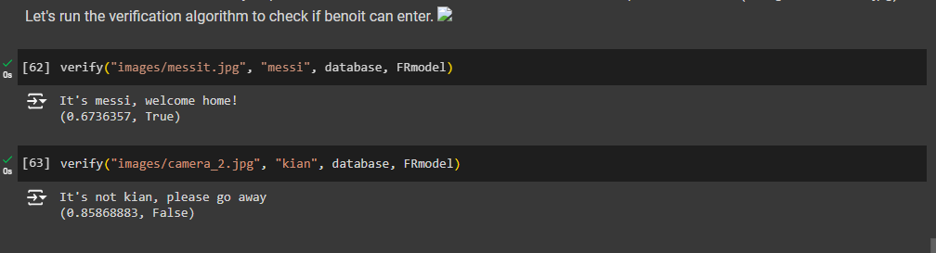face verification

screenshot of ‘output[2]’