DL_Lab04_Answers

7. The number of anchor boxes generated by YOLO model for detecting objects is represented by the 1783. These boxes cover images at different scales and aspect ratios to detect objects of varying sizes and the number of boxes is determined by the grid size and the no. of anchors used per grid cell. The maximum number is achieved with a higher grid size and more anchors, while the minimum is with a smaller grid size and fewer anchors.

8. Within a single grid cell, objects with various aspect ratios and scales can be detected thanks to anchor boxes. They make it easier for the model to predict bounding boxes of varying shapes. K-means clustering on the dataset's bounding boxes typically determines the anchor box sizes. This method selects representative anchors for each cluster of similar bounding box shapes.

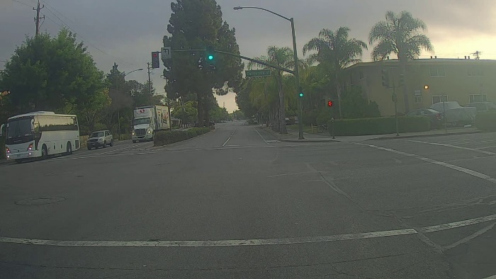10. Image 1 – 0103.jpg

correctly detected objects - Bus

incorrectly detected objects - No

undetected objects – Car, Truck

incorrect bounding boxes – No

Image 2 – 0111.jpg

correctly detected objects – Car, Fire Hydrator

incorrectly detected objects - No

undetected objects – Car, Traffic lights

incorrect bounding boxes - No

10. Change the max_boxes to 20 and all the detections of output images are incorrect