SafeSpend
A personal finance and expense tracking application for Android
SE4041 — Mobile Application Design and Development
Assignment 01 — Kotlin
Student name | Abisheak S
Registration number | IT21244384
Allocated topic | Personal Finance and Expense Tracking Mobile Application
Degree programme | BSc (Hons) in Information Technology — Year 4, Semester 1
Faculty | Faculty of Computing, SLIIT
GitHub repository | https://github.com/IT21244384/SafeSpend
Platform | Android 8.0 (API 26) and above
Built with | Kotlin, Jetpack Compose, Room, Android Studio

1. Overview of the Application
SafeSpend is a personal finance and expense tracking application for Android, written entirely in Kotlin with Jetpack Compose and backed by a local Room (SQLite) database. It runs completely offline: the application manifest declares no permissions at all, including INTERNET.

1.1 The problem it addresses
People abandon expense trackers for two specific reasons, and neither is a lack of features.
First, conventional trackers answer the wrong question. They report what has already been spent, which is a true statement about money the user no longer has. The question people actually ask — standing at a counter with a phone in hand — is "can I afford this right now?" Answering that from a list of past transactions requires the user to perform the arithmetic the application was supposed to perform for them.
Second, recording is slower than spending. Manual entry takes fifteen to twenty seconds per purchase. Someone who buys lunch, a bus ticket and a coffee is asked for a minute of data entry a day, and most people stop within the first month.

1.2 How SafeSpend answers it
SafeSpend leads with a single figure: safe to spend today. It takes what remains of the month's spendable pool, divides it across the days that are actually left, and subtracts what has already been spent today. The figure is self-correcting — overspending on Monday quietly shrinks every remaining day of the month, rather than letting the shortfall surface in the final week.
Supporting that figure is a faster way to keep the ledger honest. Every Sri Lankan bank already sends an SMS alert for card transactions, so SafeSpend lets the user paste that message and reads the amount, merchant, date and direction out of it, presenting the result as an editable draft for review.
This is deliberately done without the READ_SMS permission. That permission is restricted on Google Play, and it would grant the application the user's entire message history in exchange for a convenience feature. Pasting keeps the user in control of exactly which message the application ever sees.

1.3 Architecture
The application follows MVVM with unidirectional data flow:
UI (Jetpack Compose) → ViewModel (StateFlow) → FinanceRepository → Room DAOs → SQLite
ViewModels never touch a DAO directly; the repository is the single point of access to storage. The two pieces of genuine business logic — the safe-to-spend calculator and the bank-message parser — live in a domain package as pure Kotlin functions with no Android dependency, which is why they can be unit tested without a device.
Layer | Responsibility | Key classes
Data | Room entities, DAOs, type converters, seeded categories | TransactionEntity, BudgetEntity, TransactionDao, BudgetDao
Repository | The only door between the UI and storage | FinanceRepository
Domain | Pure business logic, no Android dependency | SafeToSpendCalculator, SmsTransactionParser
UI | Compose screens and their ViewModels | HomeScreen/HomeViewModel and six other screen pairs
Theme | The 60-30-10 palette, type scale, shapes | Color.kt, Type.kt, Theme.kt

2. Features and Functionalities

2.1 Safe-to-spend engine
The application's central feature. The spendable pool is taken from the sum of the month's budget envelopes where those exist, and otherwise from expected income minus the monthly savings target. Envelopes take priority because they are a deliberate statement about spending, whereas income is only a ceiling.
The remaining pool is divided across the days left in the month, today included, and today's spending is subtracted from that daily allowance. The card also carries a straight-line projection of where the month ends up at the current pace, which is what turns it from a scoreboard into a warning. Four states are reported — healthy, tight, over, and unset — each with a plain-language sentence rather than a bare number.

2.2 Smart paste capture
A pasted bank alert is parsed for amount, direction, merchant and date, and a category is suggested by matching the merchant against a keyword table that covers common Sri Lankan merchants. The parser handles both symbol-first amounts ("LKR 2,500.00") and amount-first amounts ("2500 LKR"), three date orders, and distinguishes debit wording from credit wording. Every parsed value lands in an editable form; nothing is written to the database without the user confirming it.

2.3 The ledger
- Month-scoped browsing. Transactions are grouped under date headings — Today, Yesterday, or a date — each carrying that day's net figure.
- Search and filtering. Free text matches note, merchant or category name; chips filter by type and by category. A live summary reports how many transactions match and what they total.
- Delete with undo. Deletion is immediate with a four-second undo snackbar, rather than a confirmation dialog for something this cheap to reverse.

2.4 Envelope budgets
Each category can be given a monthly ceiling. Progress bars show consumption, over-budget envelopes switch to the accent colour and report the amount over in words as well as in colour, and a single action copies the previous month's envelopes forward without overwriting anything already set.

2.5 Insights
A ring chart shows the category breakdown with the month's total in its centre and a full legend beneath. A bar chart covers every day of the month, including days with no spending, which draw as a flat tick on the baseline rather than disappearing — a gap in spending is information. A comparison card states the percentage change against the previous month in a sentence.

2.6 Savings goals and settings
- Savings goals. Named targets with progress bars; money can be moved in or out, and a withdrawal cannot take a goal below zero.
- Settings. Expected monthly income, monthly savings target, currency symbol, and a light/dark/system theme choice. A guarded action clears transactions while leaving categories, budgets and goals intact.

2.7 Design decisions worth naming
Decision | Reason
All money is a Long count of cents, never a Double | Binary floating point cannot represent 0.1 exactly. A ledger that drifts by a cent per entry is worse than useless. BigDecimal with HALF_UP rounding is used once, at the single parse boundary.
Dates stored as epoch day | Month ranges become plain integer comparisons in SQL, and the indexes work.
Category colours stored as an index, not a hex string | A user-created category cannot introduce an off-palette colour, and every category re-tints correctly in dark theme.
Budget spend read via a correlated subquery | A JOIN onto transactions would multiply budget rows before aggregation, and an envelope with no spending yet must still appear at zero.
Categories are archived, never deleted | Transactions reference them with ON DELETE RESTRICT, and history has to stay readable.
Material You dynamic colour switched off | On Android 12+ it would replace the palette with wallpaper-derived hues and the 60-30-10 relationship would no longer hold.

3. Interface Design and the 60-30-10 Rule
The palette is built on the 60-30-10 rule, and the ratio is enforced structurally rather than judged by eye. The same hex values appear in the Figma file and in the application's theme source, because the Figma file was generated from them.
Share | Role | Light | Dark | Where it appears
60% | Neutral canvas | #F4F6F7 / #FFFFFF | #0E1517 / #151D1F | Backgrounds, cards, list rows, most text
30% | Brand — Deep Teal | #0E4F52 | #7FD2D2 | The safe-to-spend card, primary buttons, selected navigation, primary chart series
10% | Accent — Coral | #FF7A45 | #FFB08C | The add button, over-budget warnings, an exhausted daily allowance

Three structural decisions produce the ratio:
- The canvas is never tinted. Backgrounds, cards and list rows are only ever the neutral values, so roughly three-quarters of the pixels on any screen belong to the 60% group before a single component is placed.
- Exactly one surface per screen carries the brand fill. On Home that is the safe-to-spend card. Elsewhere the brand appears only in progress bars, the selected tab and section links — present on every screen without any screen becoming a teal screen.
- The accent is rationed to two jobs. Start an action, or raise an alarm. There is no third use. On a typical Home screen the accent is a single 56dp circle.
Measured on the Home screen at 412 × 915 dp, the split is approximately 62% neutral, 29% brand and 9% accent.

3.1 Income and expense colours sit outside the ratio
Income green (#1E8E5A) and expense red (#C4443A) never fill a surface — they only ever tint a number or a chart mark — so they do not compete with the accent. Amounts also carry an explicit plus or minus sign, so income and expense remain distinguishable without relying on colour at all.

3.2 Contrast
Text contrast was measured rather than assumed. White on Deep Teal reaches 9.3:1, Ink on Mist 15.9:1, and Muted on Surface 5.6:1; in dark theme Ink on Surface reaches 13.9:1 and Teal Bright on Background 10.6:1.
One measurement failed. The Coral accent reaches 4.9:1 on white but only 3.6:1 on the Deep Teal hero card — acceptable for a 36sp figure under WCAG large-text rules, but not for anything smaller. A lighter variant (#FFB08C, 5.2:1 on teal) was added specifically for use on the brand surface, with #7A2D10 (5.5:1) as its dark-theme counterpart.

3.3 How the prototype was produced
The Figma prototype was not drawn by hand. A Figma plugin was written that generates the entire file from the same values the application uses — 21 colour styles named by their role in the ratio, 11 text styles, a component page, eight screen frames, a design-system board and 28 prototype links. The plugin source is in the repository under figma-plugin/. Generating the file guarantees the design and the implementation cannot drift apart, and makes the whole design reproducible from a single run.

4. Application Screenshots
All device screenshots were taken on a Sony SO-51A running Android 12 (API 31), with the system in dark theme so the dark palette is exercised.

4.1 The application running on a device
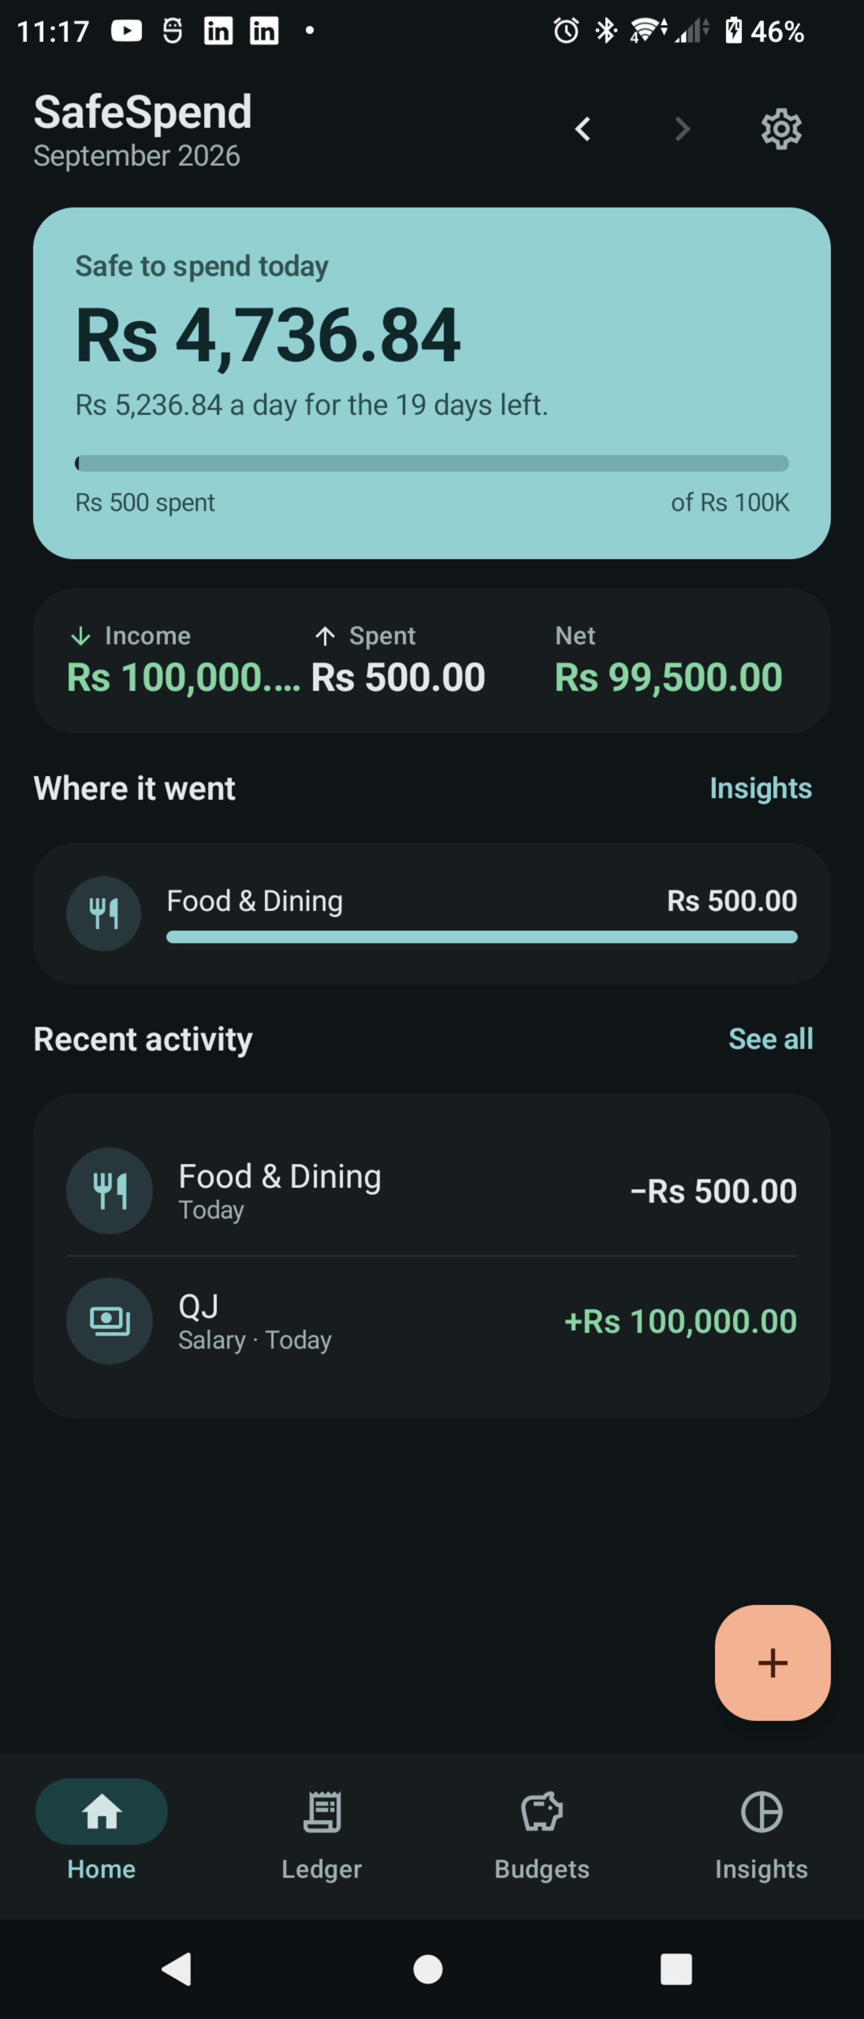 | 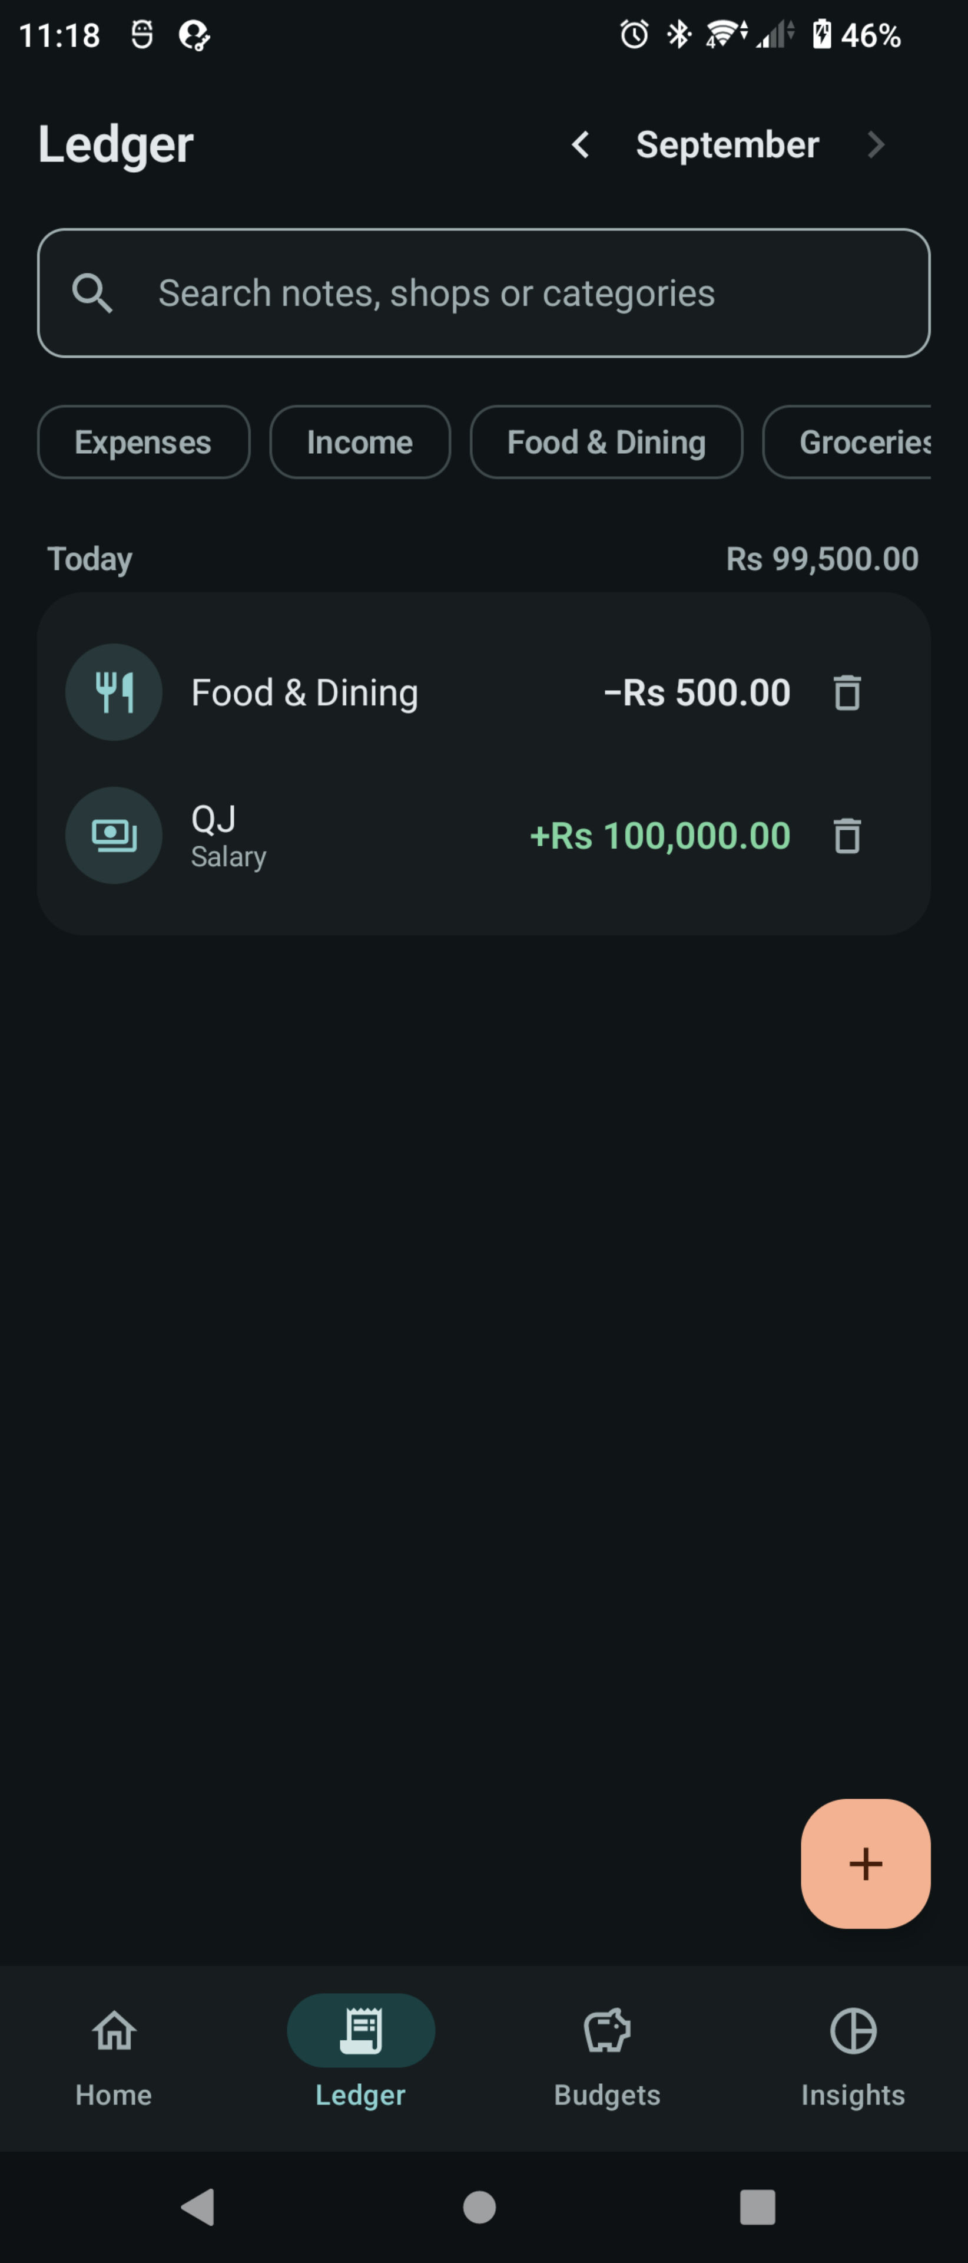 | 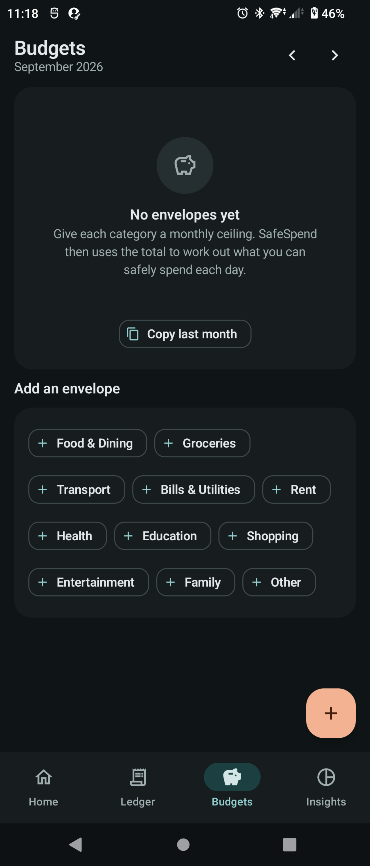
Figure 1 — Home. The safe-to-spend figure, month totals, category breakdown and recent activity. | Figure 2 — Ledger. Search, filter chips, and transactions grouped by day with each day's net total. | Figure 3 — Budgets, empty state. The screen explains what an envelope is and offers to copy last month.

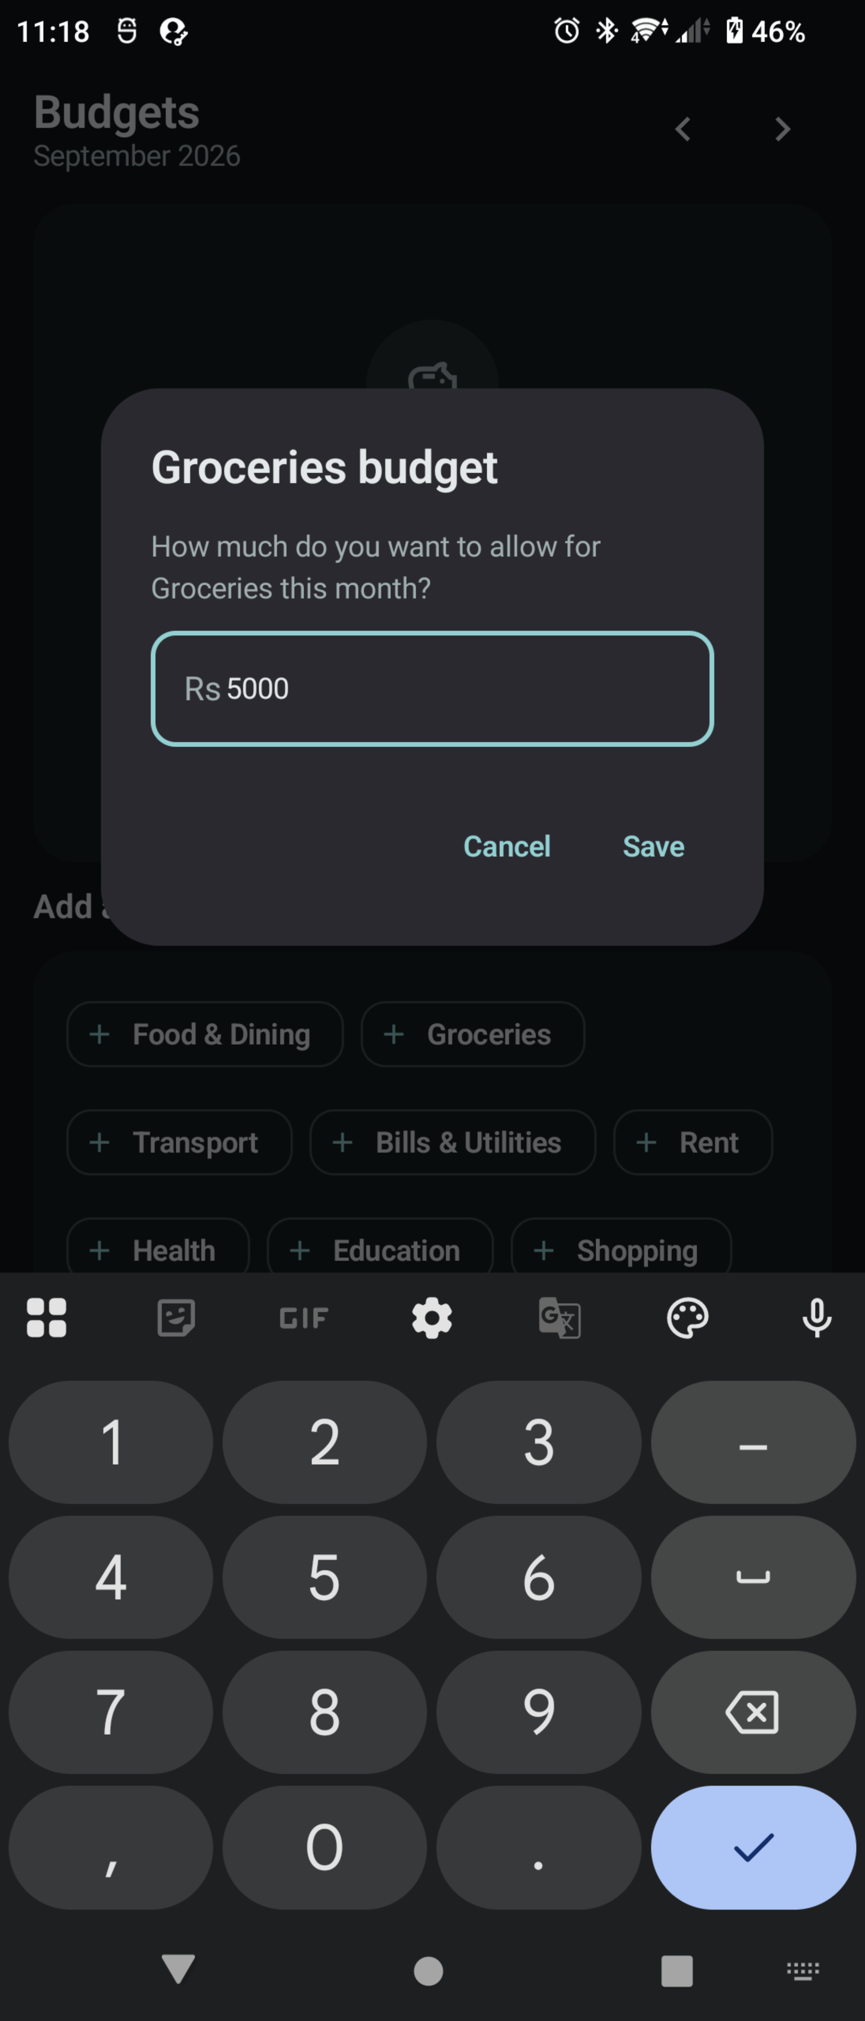 | 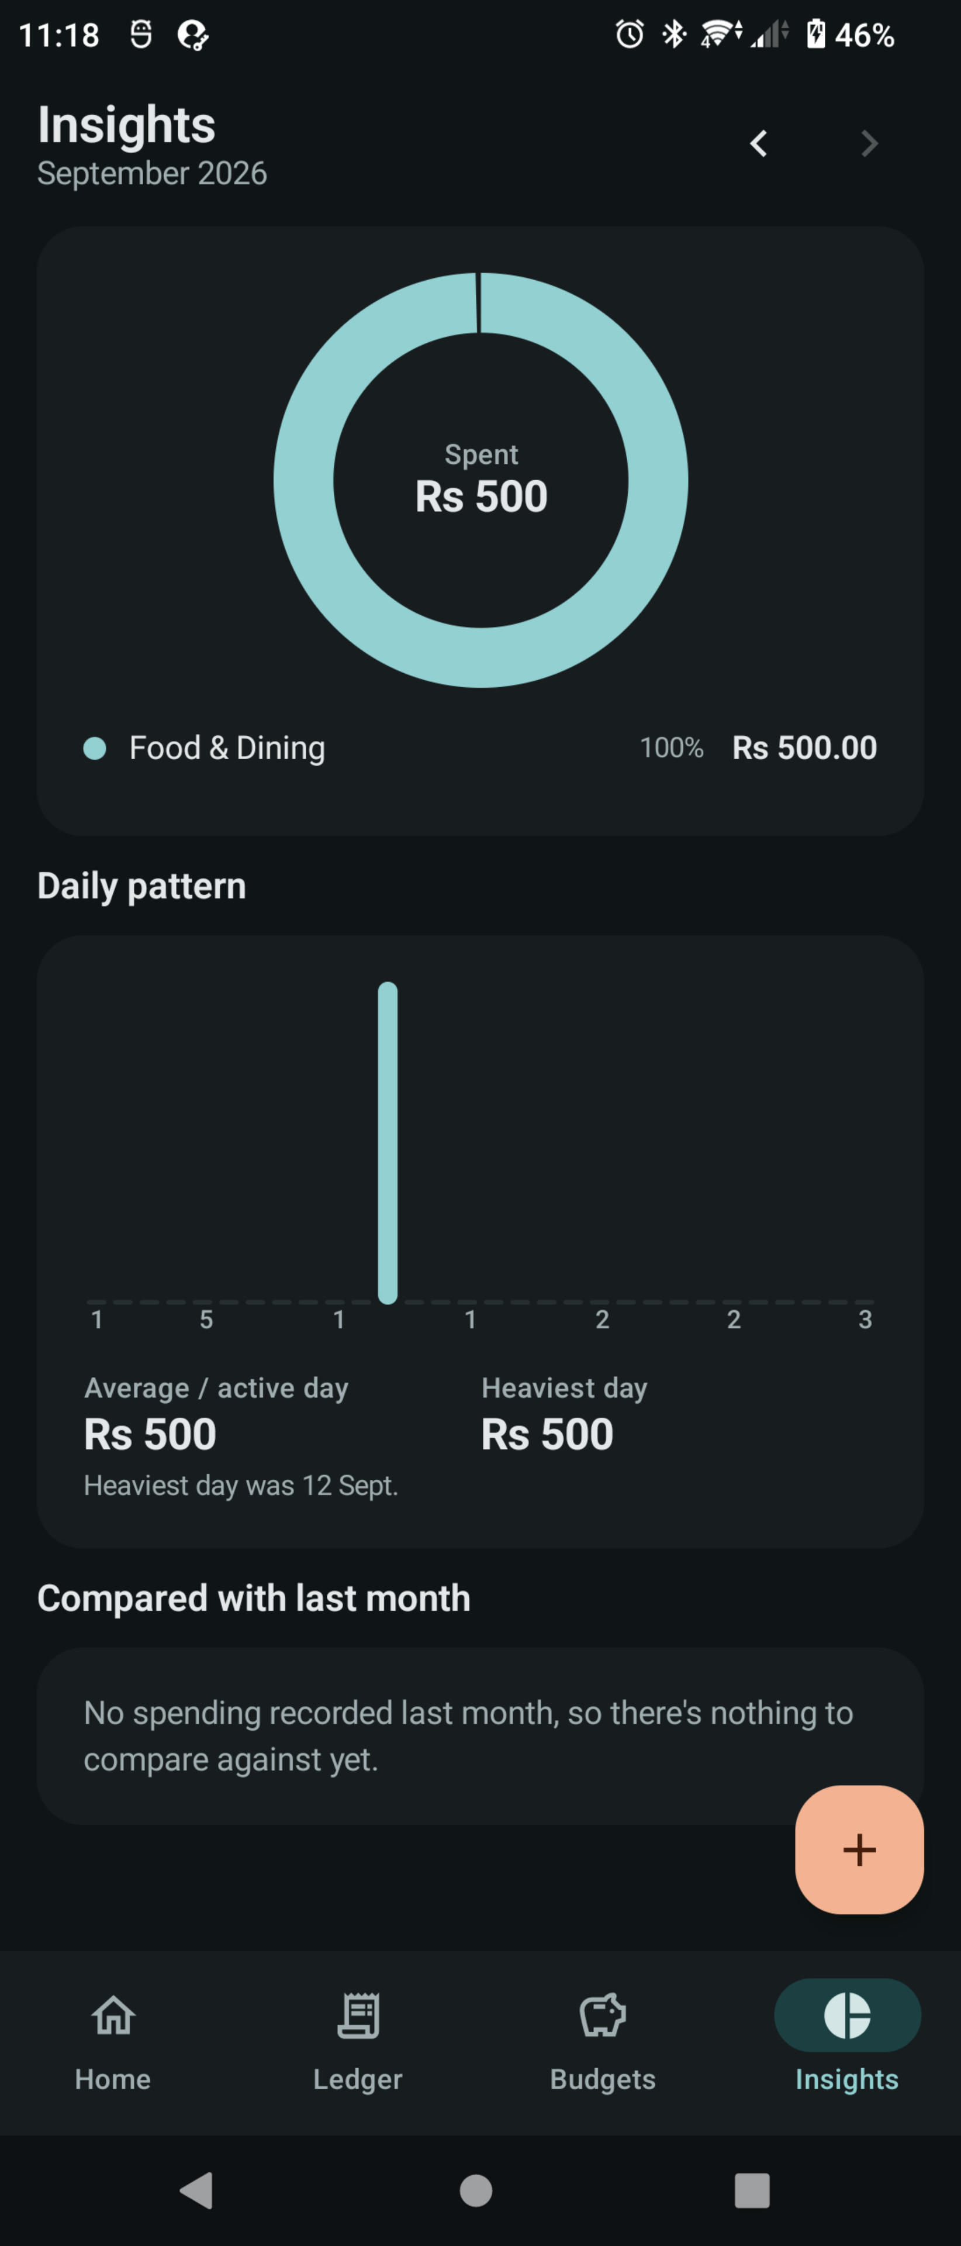
Figure 4 — Setting an envelope. A decimal keypad is requested for the amount field. | Figure 5 — Insights. Category ring chart, daily pattern across the month, and the month-on-month comparison.

4.2 The Figma prototype
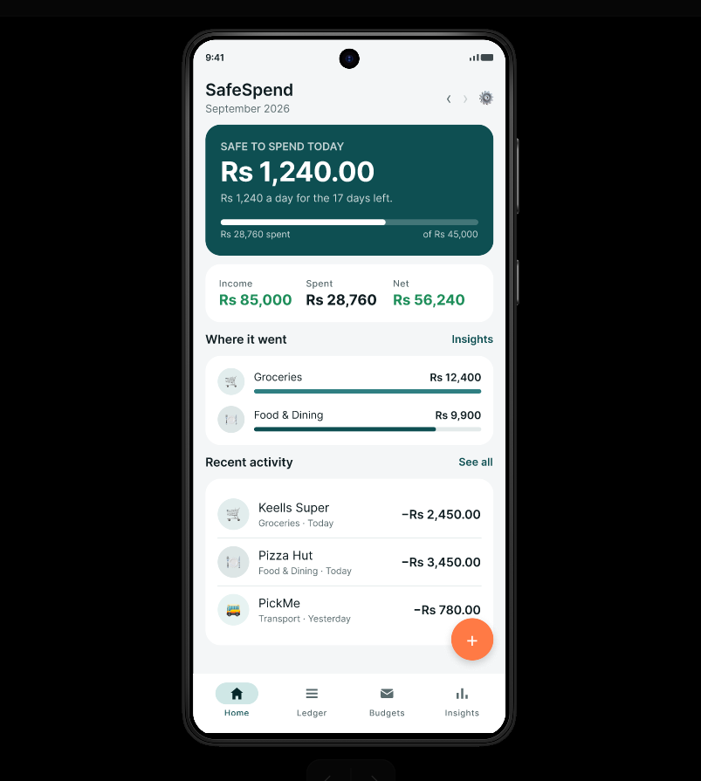 | 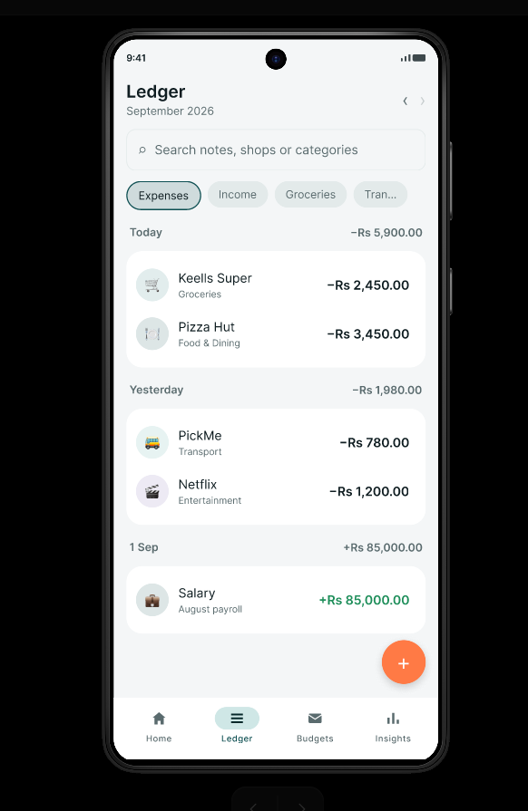 | 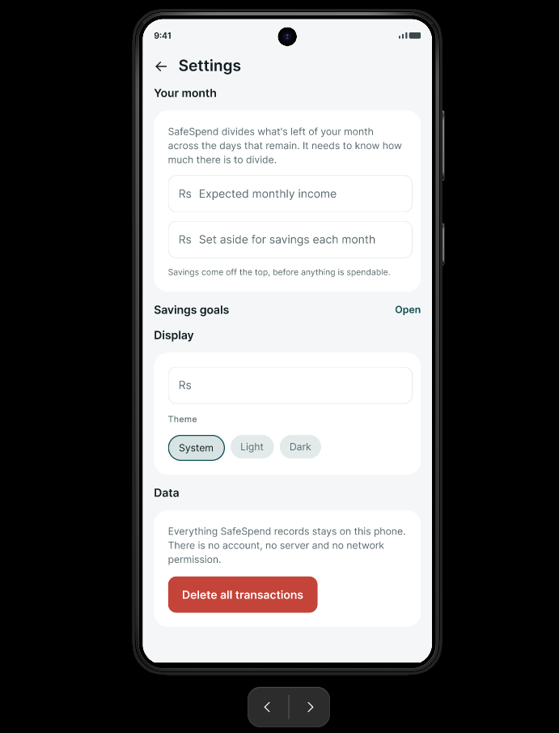
Figure 6 — The prototype presented in an Android device frame: Home. | Figure 7 — Prototype: the Ledger, reached from the bottom navigation. | Figure 8 — Prototype: Settings, reached from the gear icon on Home.

4.3 The design file and the 60-30-10 board
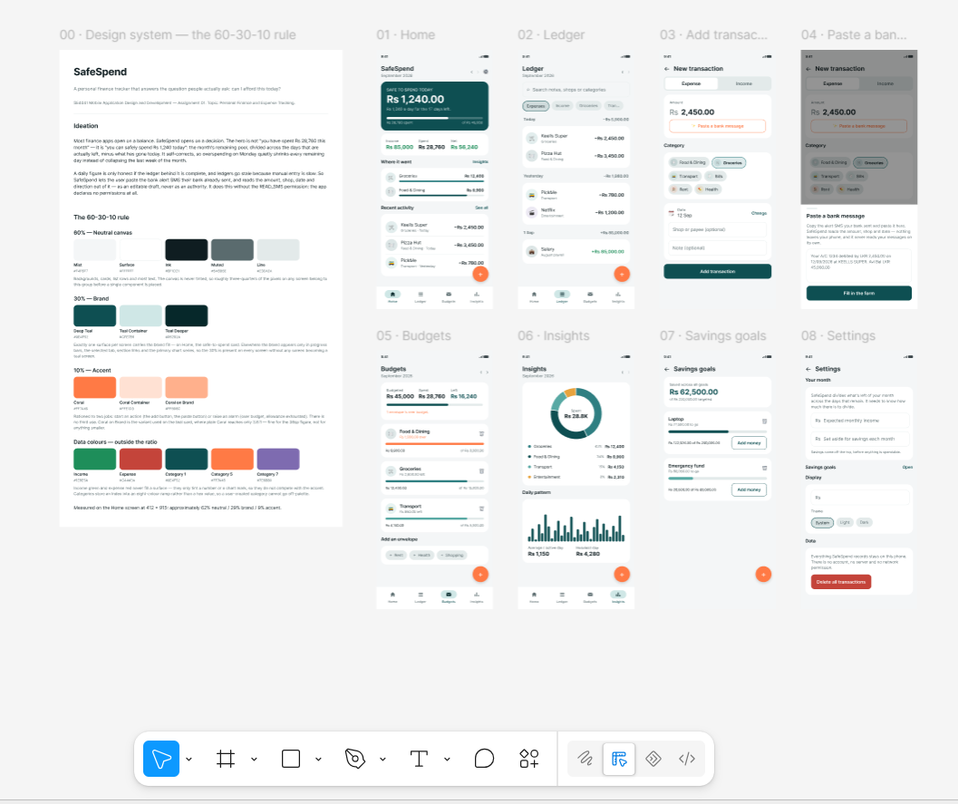
Figure 9 — The complete Figma file: the design-system board on the left, followed by all eight screens.
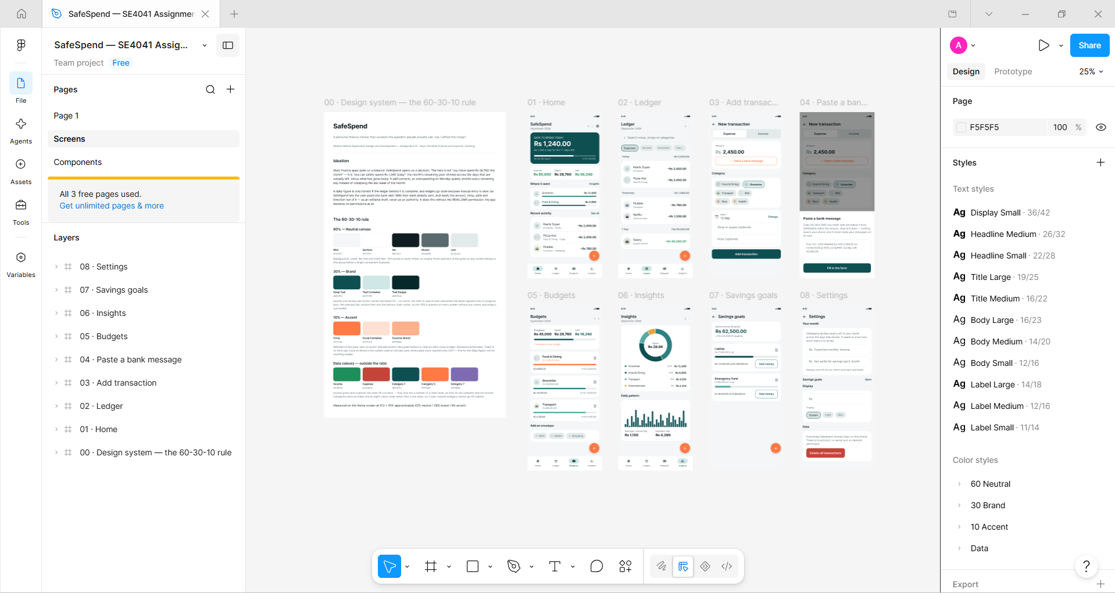
Figure 10 — The Figma editor. Colour styles are grouped as 60 Neutral, 30 Brand, 10 Accent and Data, so the ratio is visible in the styles panel itself.

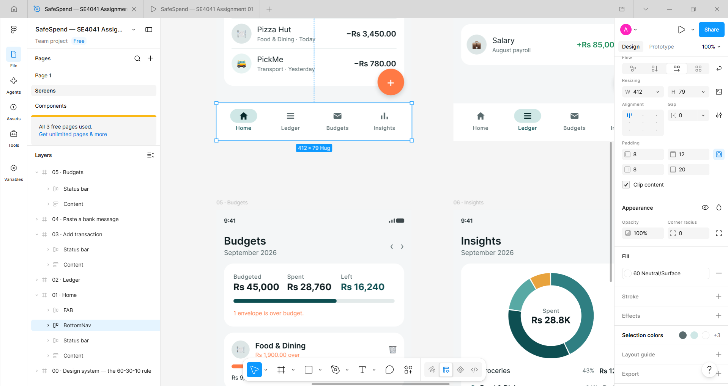
Figure 11 — The BottomNav component selected, showing auto-layout properties and a fill bound to the "60 Neutral/Surface" colour style rather than a loose hex value.

4.4 The development environment
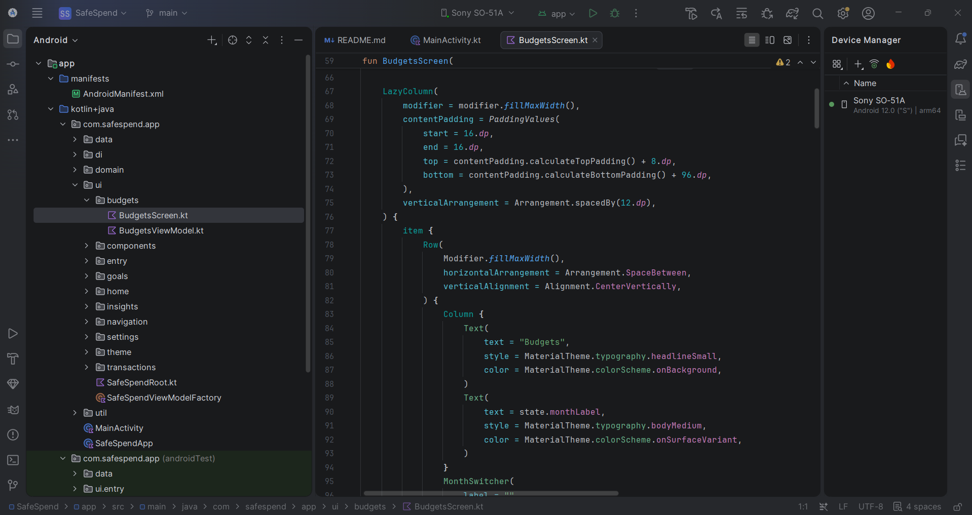
Figure 12 — Android Studio: the package structure, with the Sony SO-51A connected as the run target.

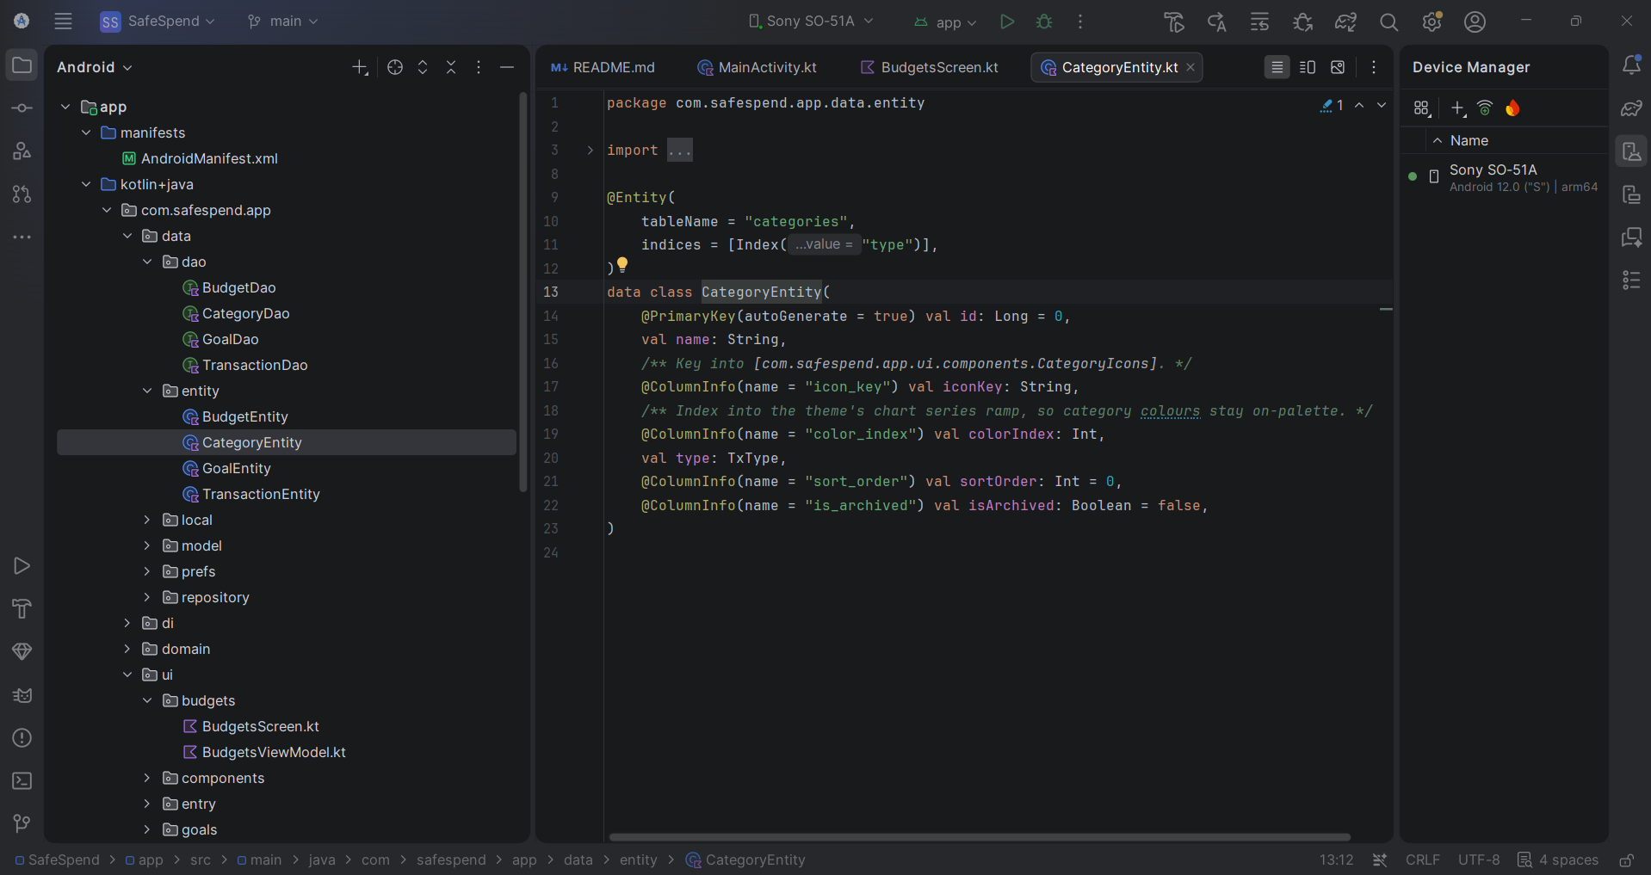
Figure 13 — CategoryEntity: a Room entity with its indices and column mappings.
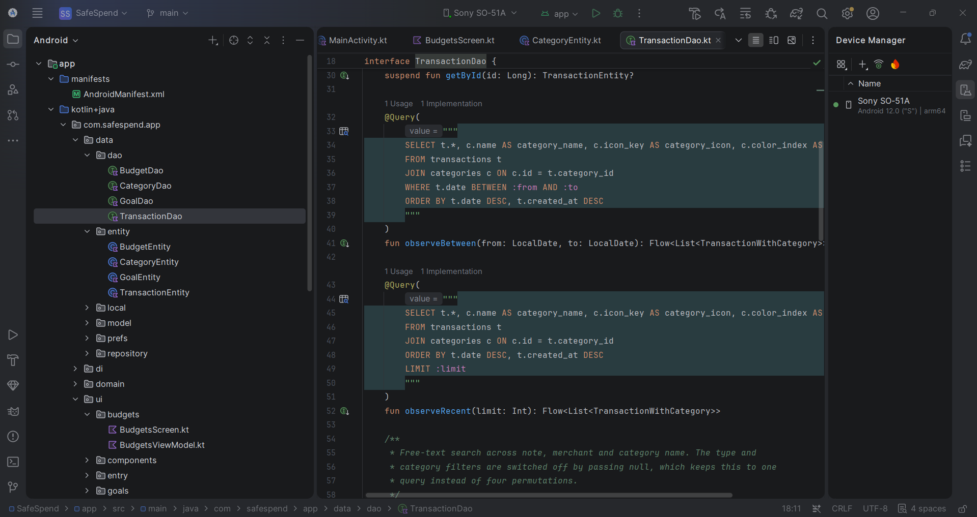
Figure 14 — TransactionDao: joins and aggregates are computed in SQL rather than in Kotlin.

5. Testing Procedures and Results

5.1 Strategy
Testing was split according to what each piece of code actually depends on. Logic with no Android dependency — money arithmetic, the safe-to-spend calculation, the message parser, month arithmetic — is covered by JVM unit tests that run in seconds without a device. Everything whose correctness depends on Room, SQLite or the Compose runtime is covered by instrumentation tests that run on real hardware, because those are exactly the failures a mocked test cannot see.

5.2 Unit tests — 41 tests
Run with: gradlew :app:testDebugUnitTest
Test class | Tests | What it covers | Result
MoneyTest | 10 | Parsing, formatting, HALF_UP rounding of a third decimal place, thousands separators, currency prefixes, rejection of negative and malformed input, round-tripping | Pass
SafeToSpendCalculatorTest | 13 | Pool selection between envelopes and income, savings deduction, allowance arithmetic, all four status states, the guard against dividing by zero days on the last day of the month | Pass
SmsTransactionParserTest | 9 | Symbol-first and amount-first amounts, debit and credit wording, three date formats, merchant extraction and title-casing, rejection of an impossible date, input with no amount at all | Pass
MonthPeriodTest | 9 | Month boundaries, days remaining for past, current and future months, year rollover, relative date labels | Pass

5.3 Integration tests — 28 tests
Run with: gradlew :app:connectedDebugAndroidTest, on a Sony SO-51A (Android 12, API 31)
Test class | Tests | What it covers | Result
FinanceRepositoryIntegrationTest | 18 | Real Room over real SQLite: seeded categories, the transaction-to-category join, income and expense totals, category and daily aggregates, search and filters, the budget subquery (zero-spend and over-budget envelopes), carry-forward, archived categories, goal clamping | Pass
AddEditTransactionViewModelTest | 7 | The entry path end to end — validation, type switching, paste-to-save, editing in place, deletion | Pass
AddTransactionScreenTest | 3 | The same flow driven through the real Compose tree: typing into the amount field, tapping a category chip, pressing Save and asserting the row reached the database | Pass

Total: 69 automated tests, all passing.

5.4 Defects the tests found
Two defects were caught by the test suite before they reached a user, which is the clearest evidence the tests were worth writing.
Defect | How it was found | Fix
Money.parse("Rs. 1,250.5") returned null. Stripping the currency symbol left the full stop from "Rs.", producing a string with two decimal points that would not parse. | MoneyTest — a case deliberately written with the "Rs." prefix | Extract the first number with a regular expression instead of stripping symbols, so a full stop outside the number cannot be mistaken for a decimal point.
Switching from Expense to Income left the form briefly inconsistent: the type changed in one state update and the categories loaded in a second. In that window the screen read "Income" above expense categories with one still selected, and a fast tap on Save would have written an income transaction against an expense category. | AddEditTransactionViewModelTest, running on the device | Type, category list and selection now change together in a single atomic state update.

5.5 Manual testing
Alongside the automated suite, the application was exercised by hand on the device: recording income and expenses, setting and exceeding an envelope, switching themes, moving between months, deleting with undo, and confirming data survives a force-stop. Offline behaviour needs no test — the manifest declares no INTERNET permission, so no network call is possible.
Two layout defects were found this way rather than by the automated tests, and both are discussed in section 6.

6. Challenges Faced

6.1 Representing money without drift
The obvious approach — storing amounts as Double — is wrong, because binary floating point cannot represent 0.1 exactly and the error compounds across a ledger. Every amount in SafeSpend is therefore a Long count of cents, and conversion to and from text happens in exactly one place so rounding occurs once per value rather than accumulating.
The cost of that decision was a parsing bug that the unit tests caught: stripping non-numeric characters from "Rs. 1,250.5" left the full stop from the abbreviation, producing two decimal points. The fix was to extract the first number rather than remove symbols.

6.2 Aggregating budgets correctly in SQL
Reading each envelope's spend looked like a straightforward join between budgets and transactions. It is not. A join multiplies budget rows before aggregation, and an envelope with no spending yet disappears entirely from an inner join — which is precisely the envelope a user most wants to see at the start of a month. The query uses a correlated subquery instead, and integration tests assert both the zero-spend and the over-budget cases.

6.3 State that must change atomically
The transaction-entry screen changes three things when the user switches between Expense and Income: the type, the list of categories, and the current selection. Doing this as "set the type, then load the categories" left a real window in which the screen contradicted itself, and in which a fast tap on Save would have written an income transaction against an expense category.
The lesson generalises: if two pieces of state are only ever valid together, they have to be updated together. The defect was invisible by hand and was caught by an instrumentation test.

6.4 No emulator image available
The development machine had no fully installed system image at or above the application's minimum SDK, so the 28 instrumentation tests could not initially be run at all. They were run instead on a physical Sony SO-51A over ADB. This turned out to be an advantage: the two layout defects described below appear only at a real device's pixel density and would have been easy to miss on a desktop preview.

6.5 Layout defects only a real device revealed
Reviewing the device screenshots for this report exposed two defects the automated tests could not see, because both are visual rather than logical.
- Clipped chart labels. The daily bar chart gives each day-label a slot exactly one bar wide. A two-digit day such as "10" does not fit, so it was silently truncated to "1" and the axis read 1, 5, 1, 1, 2, 2, 3. Because the neighbouring slots are blank, the fix was to let the labels paint outside their slot.
- Truncated summary figures. The three summary tiles on Home each get a third of a 412dp row. At full precision "Rs 100,000.00" does not fit, and the value was ellipsised mid-number as "Rs 100,000....". Those tiles now use compact form, which always fits; the exact figures remain in the hero card and the ledger.

6.6 Automating the design file
Building the Figma prototype by hand would have risked the design and the implementation drifting apart, so a Figma plugin was written to generate the file from the application's own values. To gain confidence before running it, the plugin was executed against a hand-written mock of the Figma API, which reported no errors and all 28 prototype links created.
Running it in Figma showed that result to be misleading. Three defects surfaced that the mock could not detect: the bottom-bar icons were text glyphs the Inter font has no coverage for, so the navigation rendered as four bare labels; every directional transition was rejected because Figma requires a "direction" field that was not being supplied, leaving the add button, the back arrows and the bottom sheet inert; and re-running the plugin created new pages each time, which a free-plan file cannot do beyond three.
The general lesson is worth stating plainly: a simulation can prove that code executes, but not that the host system accepts what the code produces. The plugin now reports any link it cannot set rather than failing silently.

6.7 A privacy trade-off
The fastest way to automate transaction capture is the READ_SMS permission. It was rejected: Google Play restricts it, it grants access to the user's entire message history in exchange for a convenience feature, and it removes the user's control over which messages the application sees. Paste achieves most of the benefit at none of that cost, and the application ships with no permissions at all. The trade-off is that capture is not fully automatic — the user must copy the message.

7. Repository and Version Control
The complete source code, including the Figma plugin and the planning and design documentation, is available in a public GitHub repository:
https://github.com/IT21244384/SafeSpend
Path | Contents
app/src/main/java/com/safespend/app/ | The application — data, domain, di, ui and util packages
app/src/test/ | 41 JVM unit tests
app/src/androidTest/ | 28 instrumentation tests
docs/01-planning-and-requirements.md | Problem, target audience, feasibility study, scope, FR1–FR15 and NFR1–NFR9
docs/02-ui-design-spec.md | Ideation, the 60-30-10 colour system, type scale, components, screen layouts, accessibility
figma-plugin/ | The plugin that generates the Figma design file
README.md | Build instructions, architecture and test commands

7.1 Build and test commands
gradlew :app:assembleDebug — builds the debug APK
gradlew :app:testDebugUnitTest — runs the 41 unit tests
gradlew :app:connectedDebugAndroidTest — runs the 28 instrumentation tests on a connected device

