IT21251900 – Rajapaksha R.M.S.D

Relationship Between Linear Autoencoder and Principal Component Analysis (PCA)

An autoencoder (AE) is a type of neural network designed to learn compressed representations (or encodings) of data. When the autoencoder operates without any non-linear activation functions, it is called a linear autoencoder (linear AE). Linear AEs bear a strong resemblance to Principal Component Analysis (PCA), a widely used technique for dimensionality reduction.

**Linear Autoencoders vs. PCA:**

Both linear autoencoders and PCA share the same goal: projecting high-dimensional data into a lower-dimensional space that retains the most important information or variance. PCA accomplishes this by identifying a set of orthogonal directions, known as principal components, which maximize the variance within the data.

**Key Similarities:**

1. **Dimensionality Reduction**: Both techniques reduce data dimensionality, but the process differs. PCA computes principal components by solving an eigenvalue problem, while a linear AE learns a linear transformation through backpropagation, without using activation functions.
2. **Linear Transformations**: In a linear autoencoder, both the encoder and decoder are linear mappings, much like the transformations in PCA. Without non-linearities, these layers essentially perform matrix multiplication, similar to PCA's transformation process.
3. **Data Reconstruction**: Both approaches aim to reconstruct the original data with minimal error. PCA projects the data into a lower-dimensional space and then reverses the transformation to approximate the original data. In a linear AE, the bottleneck layer compresses the data, which is then reconstructed through the decoder, following a similar process to PCA.

**Mathematical Connection:**

Under certain conditions—such as minimizing the Mean Squared Error (MSE) and using purely linear transformations—a linear autoencoder can function similarly to PCA. In fact, the encoder’s weights in a linear AE can converge to the principal components of the data, making them mathematically equivalent.

**Key Differences:**

1. **Training Method**: PCA is a deterministic algorithm that calculates the principal components directly, while a linear AE relies on iterative optimization (through backpropagation and gradient descent) to find the optimal weights.
2. **Non-Linear Capability**: PCA is strictly a linear method, whereas autoencoders can be extended to more complex scenarios by introducing non-linear activation functions, enabling them to model more intricate data patterns.

**Conclusion:**

While linear autoencoders and PCA share many similarities in terms of dimensionality reduction and data reconstruction, they differ in how they achieve these goals. PCA is a linear, non-iterative method, while autoencoders, even in their linear form, use iterative optimization. Autoencoders also have the flexibility to incorporate non-linearity, allowing them to generalize to more complex data structures.

### Reasons for Observed Improvements (Vanilla CNN over AE_FFNN)

Spatial Awareness

CNNs retain the spatial structure of images throughout the encoding and decoding process, which leads to superior reconstructions. In contrast, autoencoders using fully connected feedforward neural networks (AE_FFNNs) flatten the images, resulting in a loss of spatial relationships.

Feature Extraction

CNNs use convolutional layers as feature detectors that capture local patterns, such as edges, shapes, and textures, essential for accurate image reconstruction. Fully connected networks lack this ability, treating all input features the same without focusing on local features.

Efficient Learning

CNNs are more computationally efficient due to their smaller number of parameters and weight-sharing mechanisms. AE_FFNNs, on the other hand, require more parameters for the same amount of data, making them more complex and slower to train.

Dimensionality Reduction

CNNs excel at learning lower-dimensional representations by focusing on key features from local regions of an image. AE_FFNNs often struggle with dimensionality reduction, especially for high-dimensional data like images.

### ****Observe Performance Differences Between Image Denoising AE and Vanilla CNN AE****

compare the two autoencoders (Image Denoising AE and Vanilla CNN AE) by observing:

* Reconstruction accuracy (e.g., using MSE or other evaluation metrics).
* Visual comparison of the reconstructed images.

**Image Denoising AE (Mean squared Error)**

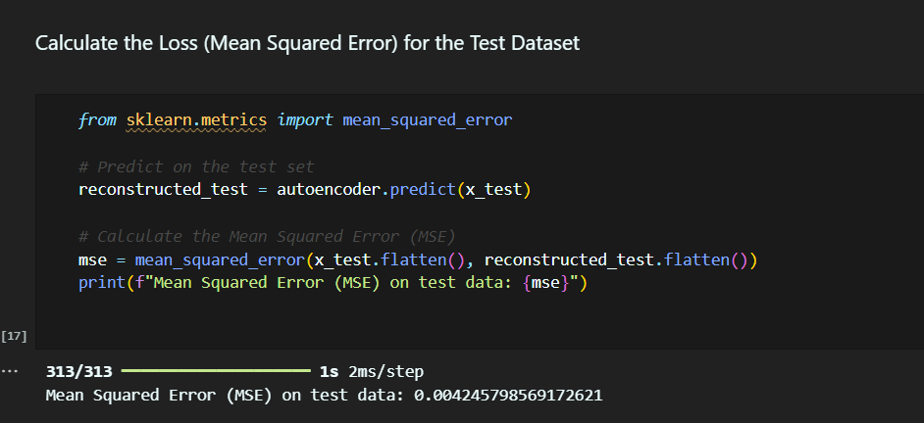

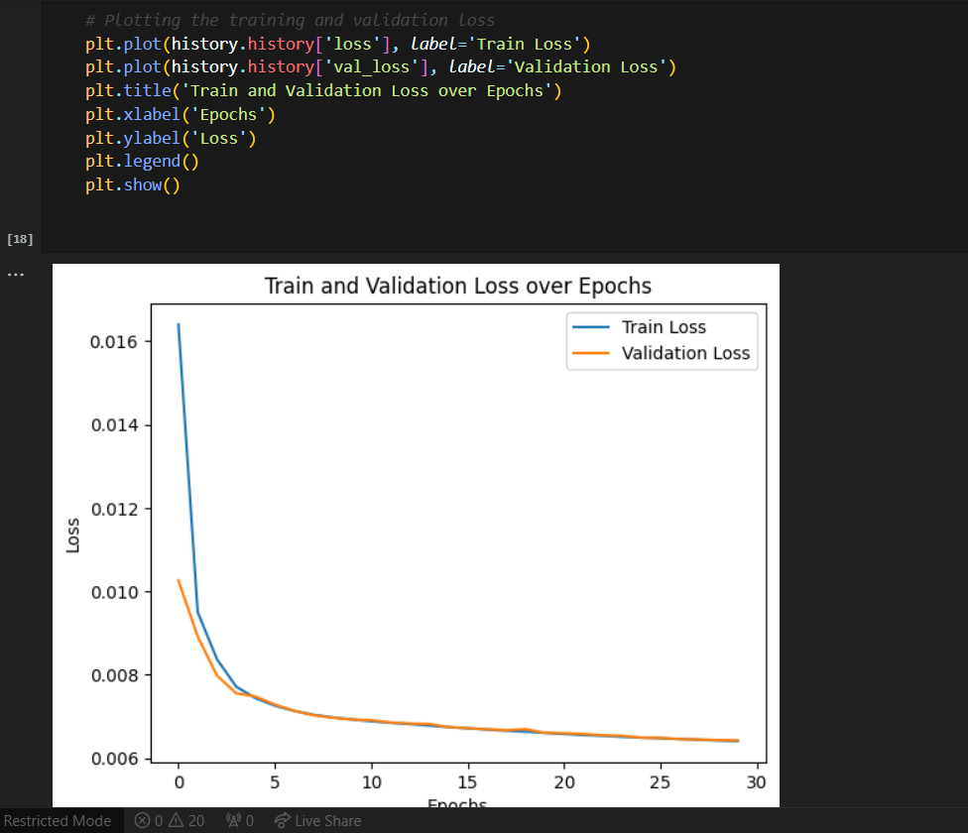

**Vanila CNN AE(Mean squared Error)**

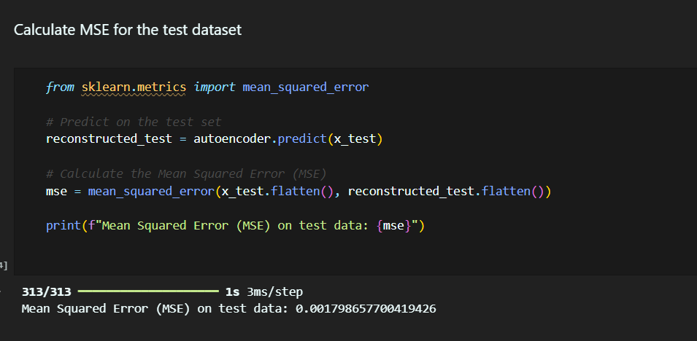

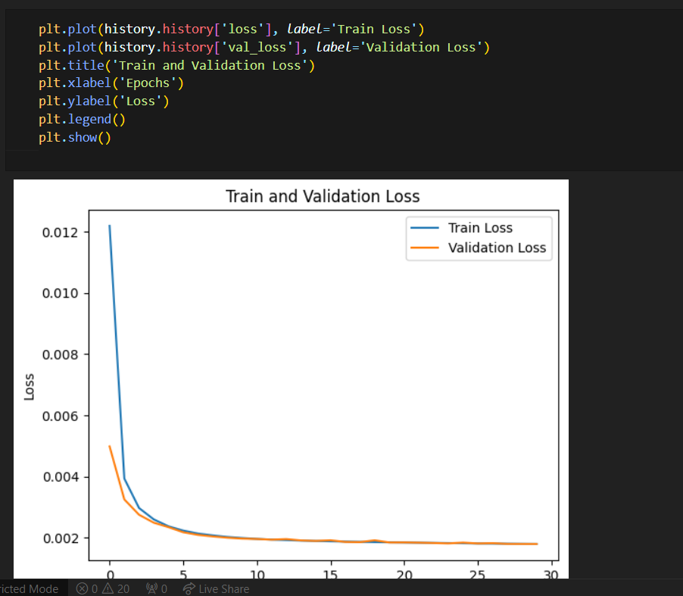

**Explain the Differences Between AE and Variational AE (VAE)**

**Autoencoder (AE)**: AEs learn to compress and reconstruct data by passing it through a bottleneck (latent space), without making assumptions about the distribution of the latent space. It is a deterministic model.

**Variational Autoencoder (VAE)**: Unlike standard AEs, VAEs assume that the latent space follows a specific probability distribution (usually Gaussian). VAEs enforce a structure on the latent space, which allows them to generate new data by sampling from this distribution. This makes VAEs suitable for generative tasks.