**PART 01**

**PART 02**

**Question 01**

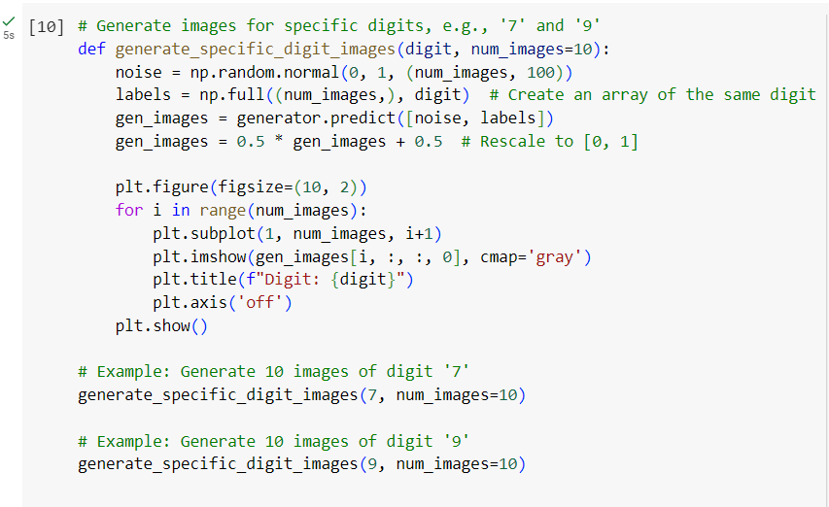

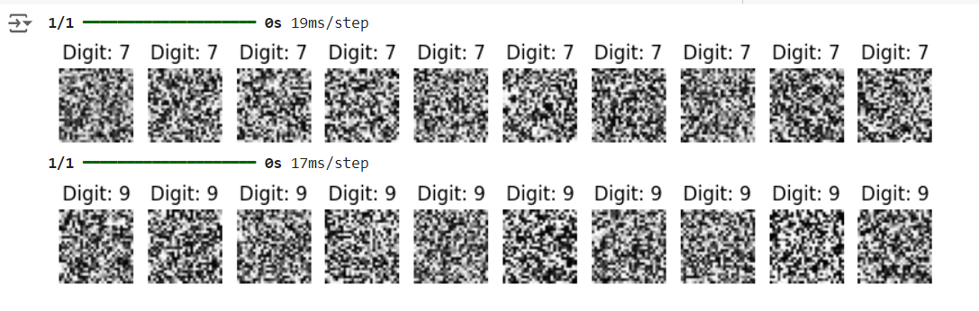

**Question 02**

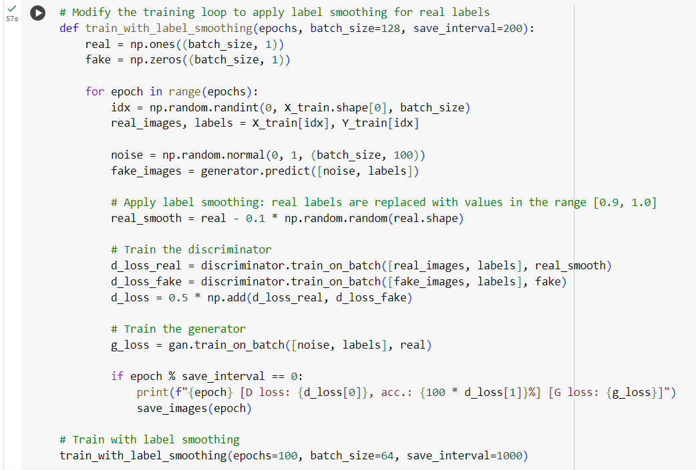

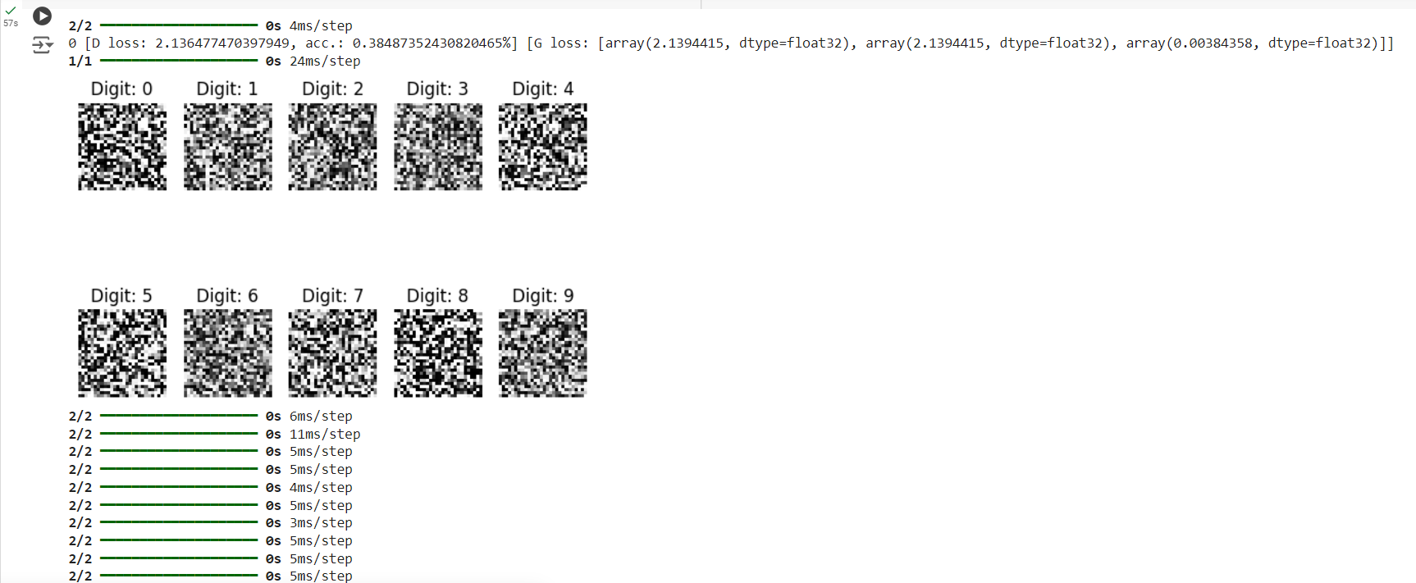

**Question 03**

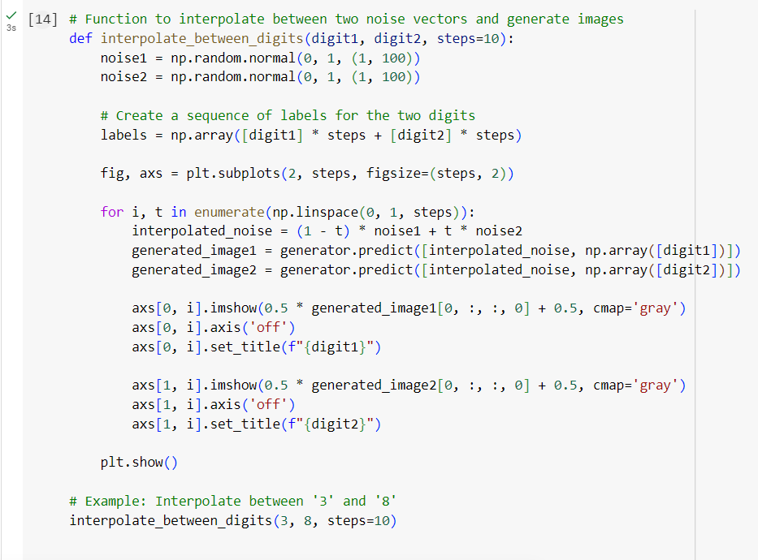

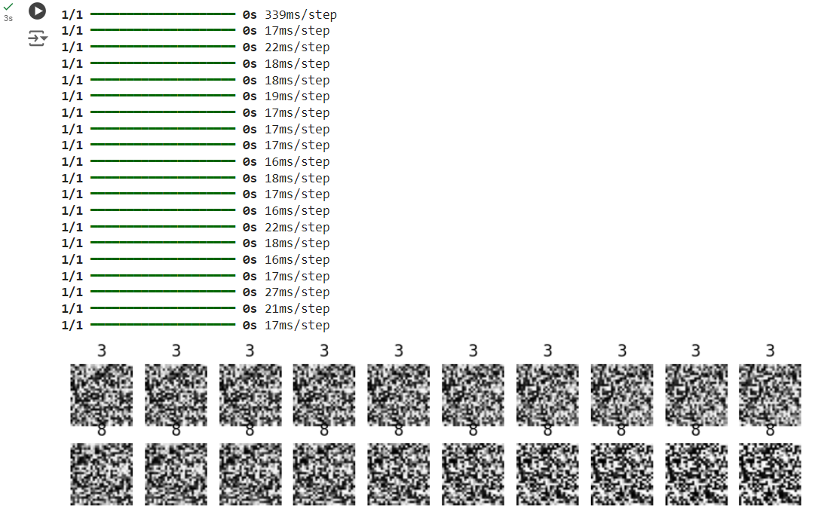

**PART 03**

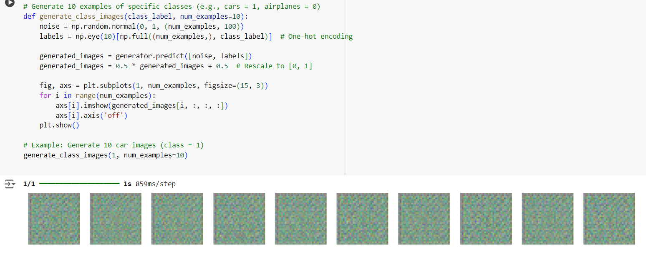**Question 1**

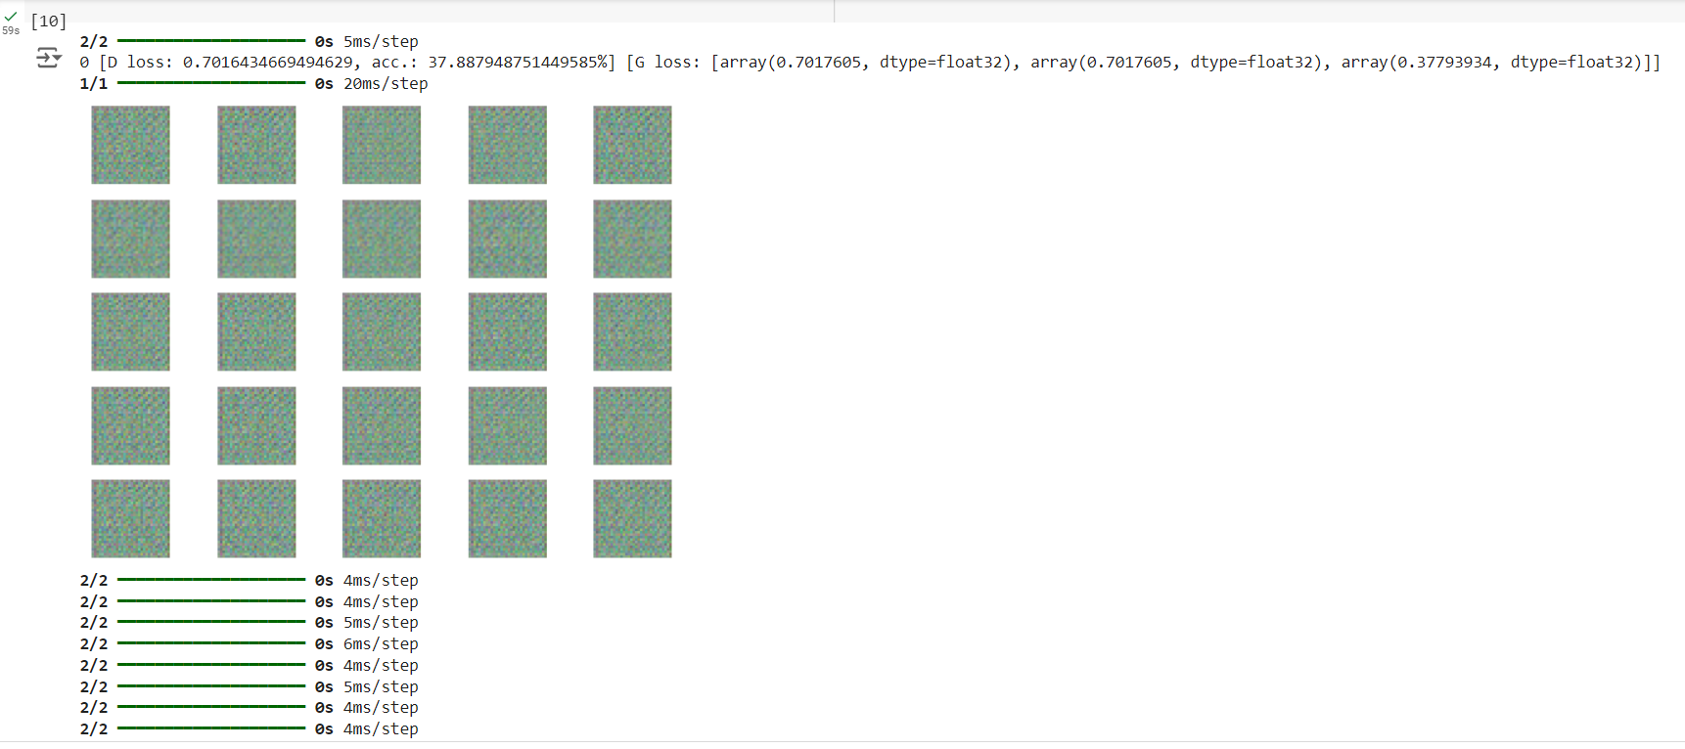**Question 2**

**Question 3**

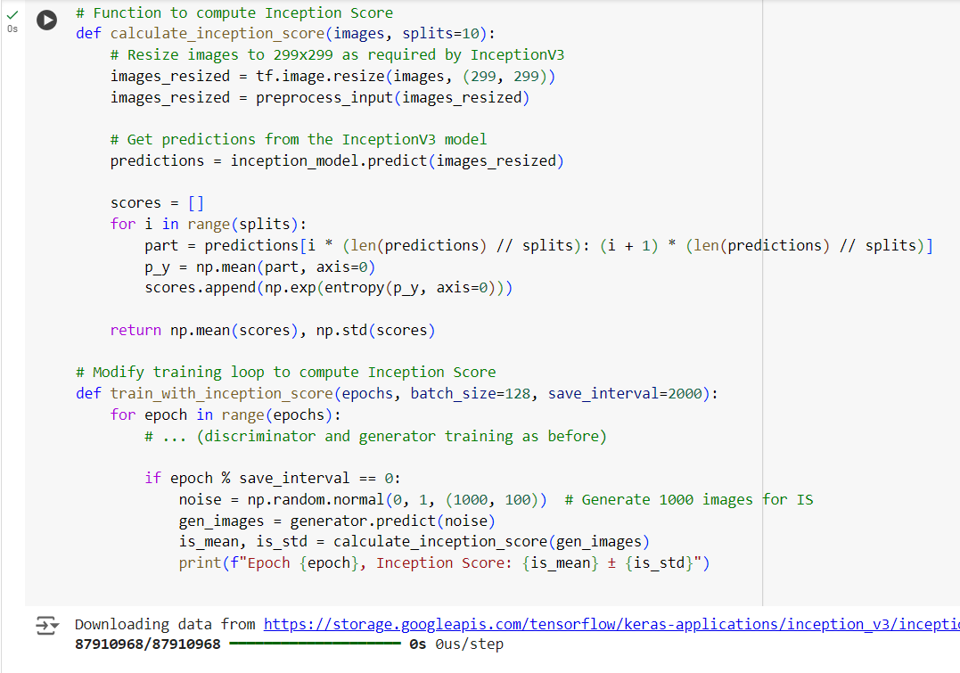

**Question 4**

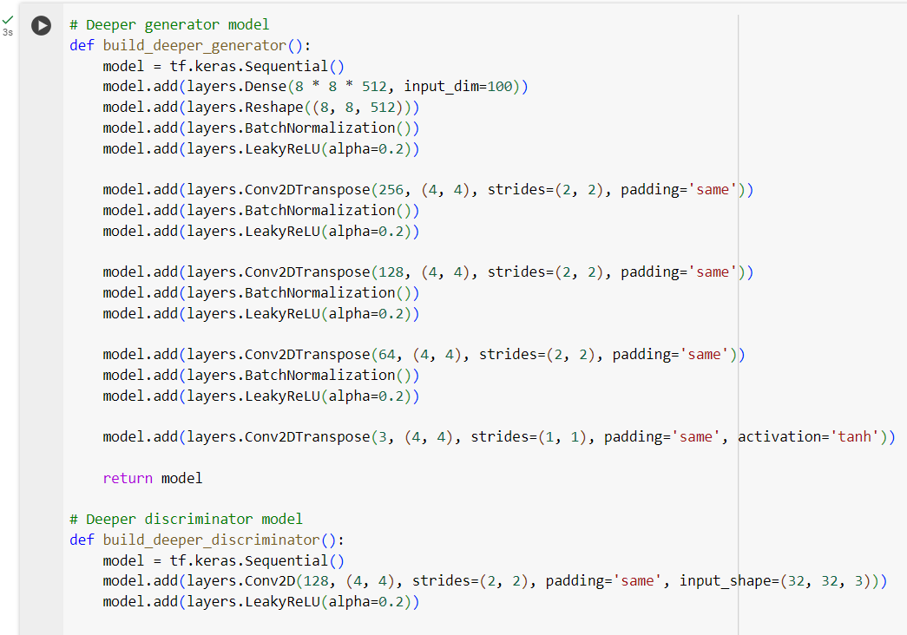**b. Impact of Parameter Changes**

Latent Space Size

Increasing the latent space size (e.g., from 100 to 200) enables the model to learn and capture more intricate patterns, which can enhance image diversity and detail. However, excessively large latent spaces may complicate training, potentially resulting in noisy or less coherent outputs.

Optimizers

The choice of optimizer, such as Adam, and its learning rate (e.g., 0.0002), greatly affects training stability. A lower learning rate tends to provide more stable and gradual progress, while a higher learning rate can accelerate convergence but may also lead to instability and erratic training.

Batch Size

Smaller batch sizes (e.g., 32) may introduce noisier gradients, causing less stable training, but can help the model learn more diverse features. In contrast, larger batch sizes (e.g., 128) offer smoother learning curves, though they risk overfitting and typically require more computational resources.

**c. Quality and Range of Generated Images**

Quality

As training progresses, the quality of generated images improves, becoming sharper and more detailed, particularly when the model is well-tuned. Initial epochs often result in blurry images, while later ones produce more realistic outputs. However, overly complex models or unstable training may lead to mode collapse, where the generator produces highly similar images.

Range

The diversity of generated images is largely influenced by the latent space and tuning of model parameters. A well-optimized model with a sufficiently large latent space generates a wide variety of images, capturing different styles and objects within the target class. Conversely, a small latent space or suboptimal tuning can limit diversity, causing the generated images to appear repetitive.