# **Lab 03 – Face Recognition**

**Image 1: sd001.jpg**  


**Image 2: sd002.jpg**



**Updated Database:**

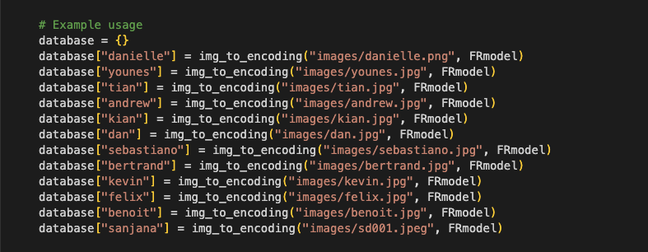

**Face Verification:**  
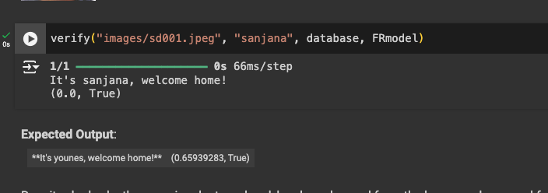

**Face Recognition:**

