**DL – Lab 3 – Jayathilaka A.G.K.D**

**Tested Images**

malinga1.jpeg

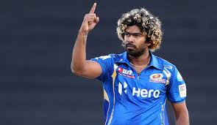

malinga2.jpeg

**Outputs**

