## IT21271182 – Rathnayake R M U V

# DL – Lab 3

### New images

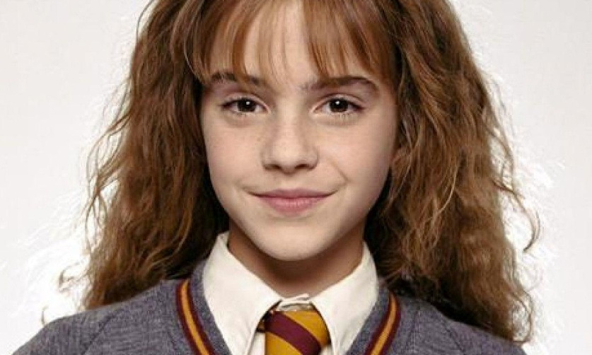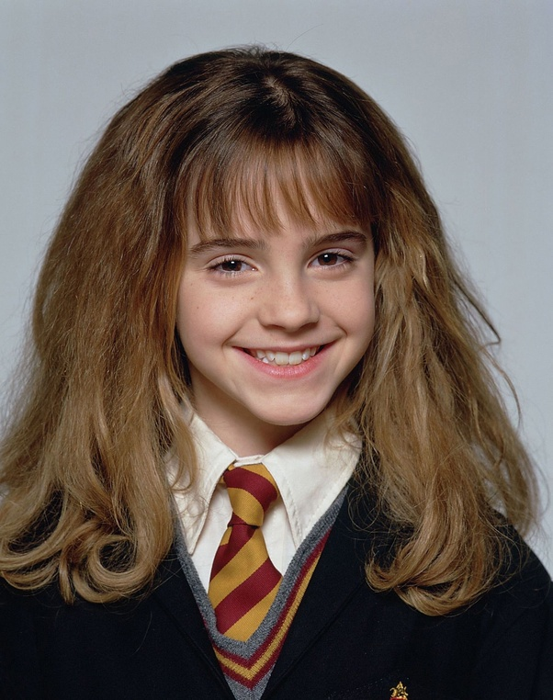Image 1 : hermione1.jpeg  
  
  
Image 2 : hermione2.jpeg

### Screenshots of outputs

