**Lab Sheet 02**

**IE2042 – Database Management Systems for Security Semester 1, 2022**

**Activity 01**

Map the following EER model into the relational model and answer the questions below

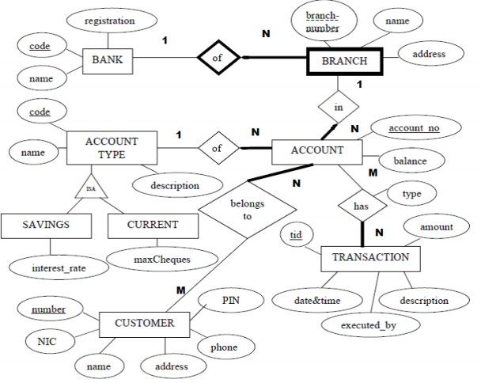

**Lab Sheet 02**

**IE2042 – Database Management Systems for Security Semester 1, 2021**

1. How many relations did you get in your relational schema after mapping?
2. What is the primary key of the Branch relation?
3. What mapping option did you use to map the entity ‘Account Type’ and its sub classes? Why did you select the option you selected?
4. How many tables refer to the AccountNo attribute in Accounts table? What are the relations that refer to AccountNo as foreign keys?