1. Convert the following EER diagram to the relational model. State any assumptions you make.

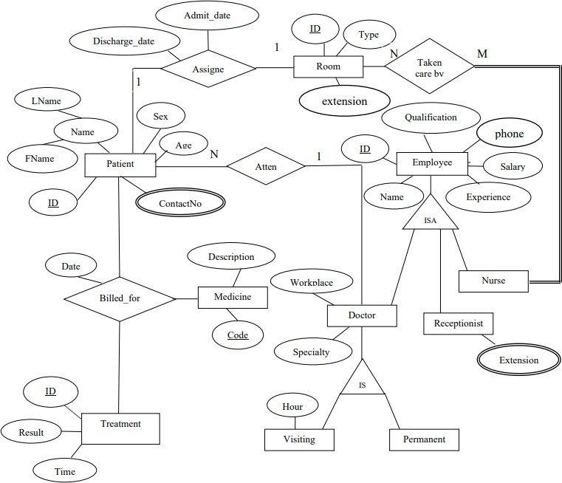

1. Convert the following EER diagram to the relational model. State any assumptions you make.

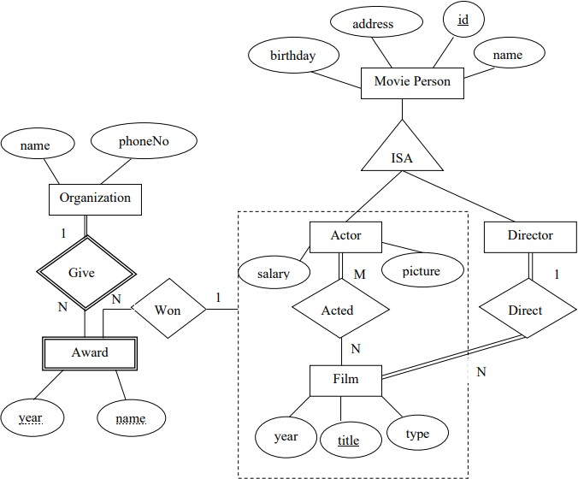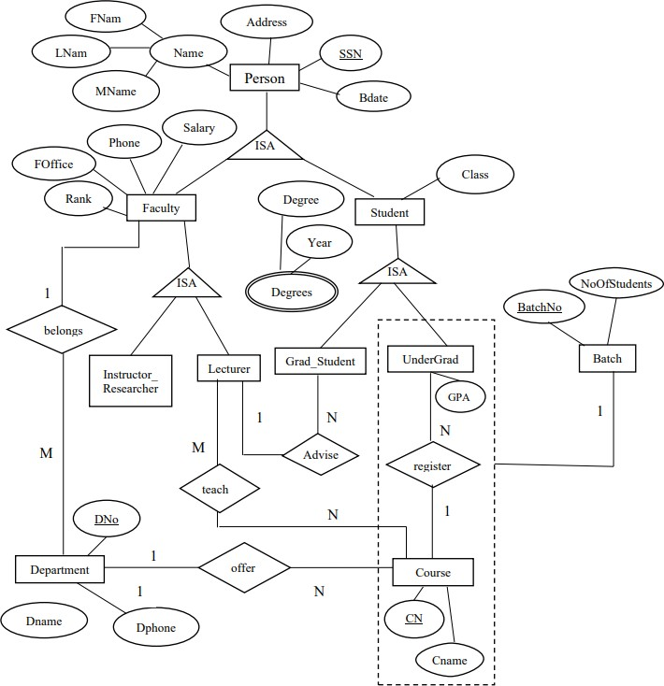

assign

1. Convert the following EER diagram to the relational model. State any assumptions you make.