IT21305900

3.1.3 Gridworld – Code Complete

3.1.3 Markov Decision Process (MDP) – Code Complete

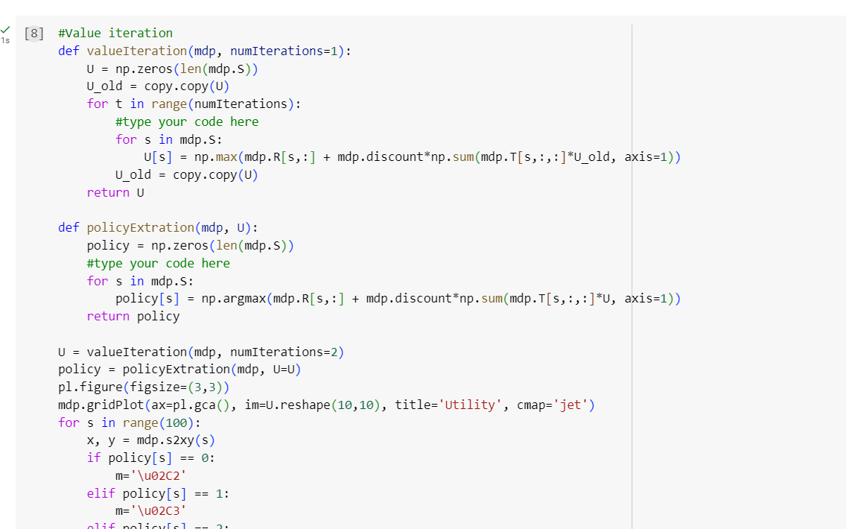

3.1.5 GridWorld notebook with size height 8 width 8

GridWorld notebook with size height 20 width 20

GridWorld notebook with with size height 50 width 50

3.1.2   
  
Model Free – Learn by trying thing and remember what have worked

Model Based - Learns a model of the environment and uses it to plan.

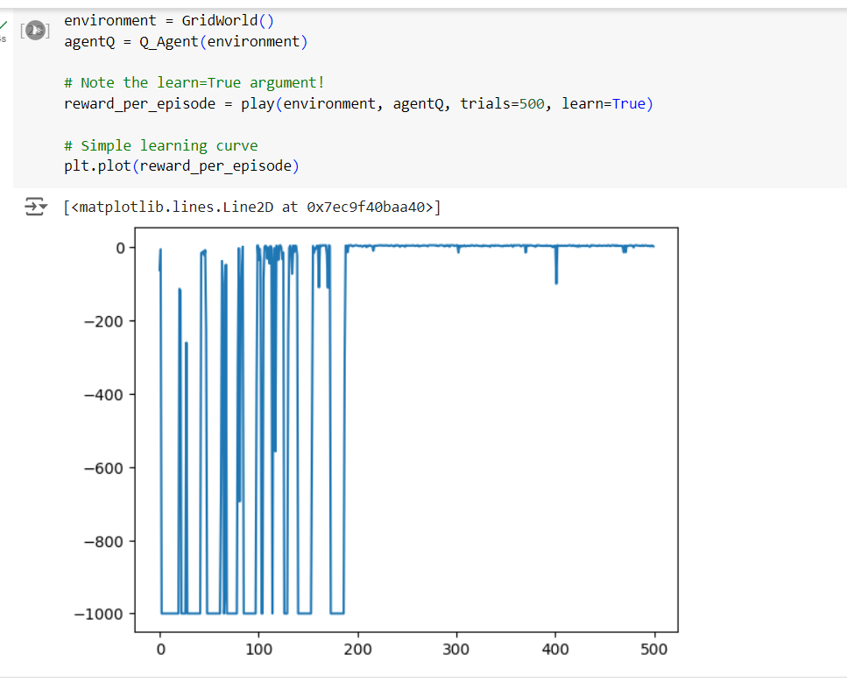

Figure Model Based Grid World

Figure Policy Evaluation Decision Process’

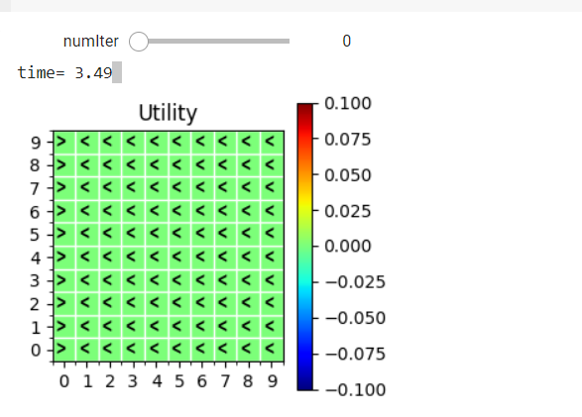 -

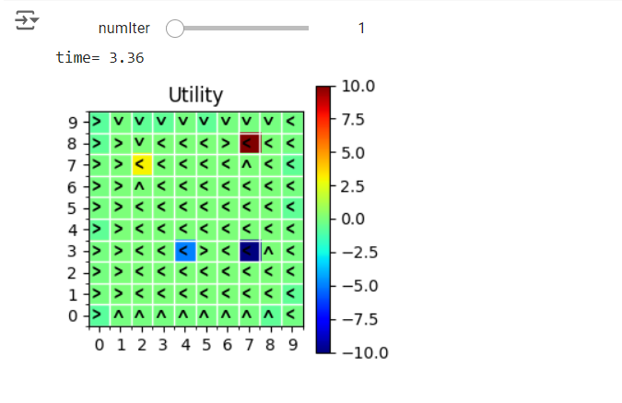

Figure Policy Iteration