

**SE4050**

**Deep Learning**

**4th Year, 1st Semester**

**<** Labsheet 04 – Answer **>**

Submitted to

Sri Lanka Institute of Information Technology

**IT21319792**

In partial fulfillment of the requirements for the

Bachelor of Science Special Honors Degree in Information Technology

<24/08/2024>

**Task 07**

**In the below given cell, shape of the boxes.eval() is (1783,4). Why are there 1783 boxes? Explain the reason for it. What is the maximum number and minimum number you can get for that?**

**Answer :** The shape (1783, 4) corresponds to 1783 bounding boxes, each defined by 4 coordinates ([x_min, y_min, x_max, y_max]). The YOLO (You Only Look Once) object detection algorithm generates a set of bounding boxes for each grid cell in the feature map based on the number of anchor boxes. Given the input dimensions [19, 19, 5, 1], the maximum possible number of boxes is 1805, calculated as 19 x 19 grid cells x 5 anchor boxes per cell. The number 1783 indicates that most of these boxes passed the filtering threshold.

**Minimum italicized text and Maximum Number of Boxes**

* Minimum Number: The minimum could be 0 if the threshold is set very high, filtering out all the boxes.
* Maximum Number: The theoretical maximum would be 1805 if all boxes pass the threshold filtering.

**Change the values like mean and stddev in lines 2 and 4 as well as threshold value in line 5 and observe the different values you get for the boxes.eval().shape.**

**Task 08**

**yolo_anchors.txt contains 10 values. They can be considered as the height and width of 5 anchor boxes. What is the advantage of using such anchor boxes? What was the method used to determine the sizes of these anchor boxes?**

**Advantages**

1. Handles Various Object Sizes and Shapes: Multiple anchor boxes with different aspect ratios help YOLO detect objects of different sizes and shapes effectively.

2. Enhances Localization Accuracy: Anchor boxes improve the precision of object location by allowing the model to adjust these predefined boxes for better bounding box predictions.

3. Reduces Computational Complexity: By predicting adjustments relative to predefined anchor boxes rather than generating bounding boxes from scratch, YOLO simplifies the learning process and speeds up training.

**Determining Anchor Box Sizes**

Anchor box sizes are typically determined using **K-means clustering** on the dimensions of ground truth bounding boxes in the training dataset. This method groups bounding boxes into clusters, with each cluster center representing an anchor box size, ensuring that the anchor boxes are representative of the dataset.

**Task 09**

**Upload a new traffic image to the images directory and edit the code as needed to detect vehicles in that image.**

**Task 10**

**Download the output images zip file from Google Drive and observe the bounding boxes in the autonomous driving dataset Select 2 images from these 21 images and, Write what you observe regarding correctly detected objects, incorrectly detected objects, undetected objects and incorrect bounding boxes**

**Answer :** Selected image ‘0110.jpg’

*Figure 1 : Image 0110.jpg*

* There are not detected car objectives

**Answer :** Selected image ‘0105.jpg’

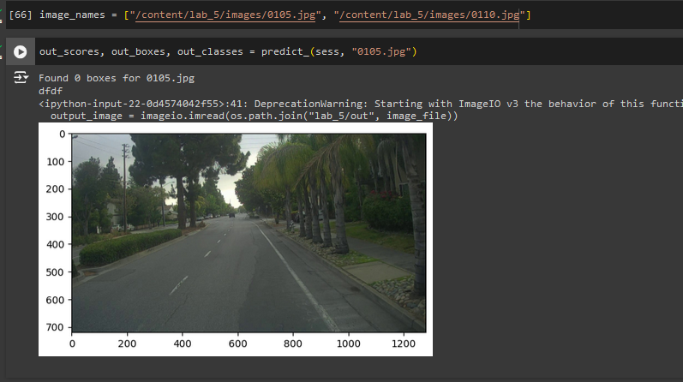

*Figure 2 : Image 0105.jpg*