**Deep Learning - Lab 4 – YOLO object detection**

**7**. In the below given cell, shape of the boxes.eval() is (1783,4). Why are there 1783 boxes? Explain the reason for it. What is the maximum number and minimum number you can get for that? Write these answers in a word file.

* The shape (1783, 4) indicates that after filtering the initial 1805 boxes by confidence score, 1783 boxes remain. This number can vary depending on the confidence scores of the generated boxes and the filtering threshold. The maximum possible number of boxes is 1805, and the minimum is 0.

8. yolo_anchors.txt contains 10 values. They can be considered as height and width of 5 anchor boxes. What is the advantage of using such anchor boxes? What was the method used to determine the sizes of these anchor boxes? Give the answers to these questions in the word file.

* Objects in images vary in size and aspect ratio. Anchor boxes help in handling this variability by providing a set of predefined bounding boxes with different shapes and sizes. This allows the model to detect objects of various dimensions more effectively.
* Each anchor box is assigned to an object if it has a high Intersection over Union with the ground truth box. This approach helps the model predict bounding boxes that closely match the actual objects.

10. Download the output images zip file from the google drive and observe the bounding boxes in the autonomous driving dataset (i.e., 21 images from 0100.jpg to 0120.jpg). Select 2 images from these 21 images and write what you observe regarding correctly detected objects, incorrectly detected objects, undetected objects and incorrect bounding boxes in the word file.

11. Adjusting parameters like max_boxes, score_threshold, and iou_threshold of the yolo_eval function can potentially address the limitations you noticed in step 10.

• Change the max_boxes [integer value] to a different value but use the original values for other 2 variables. Rerun the required cells to get the output images for the autonomous driving dataset. Observe if this results in improvement compared to step 10 for the same two images. If there are any improvements, write them in the word file. Include the new 2 output images in the word file.

When I changed max_boxes value into 14, function returns at most 14 bounding boxes, along with their corresponding scores and classes. If the model detects more objects, they will be filtered out based on their scores during the NMS process.

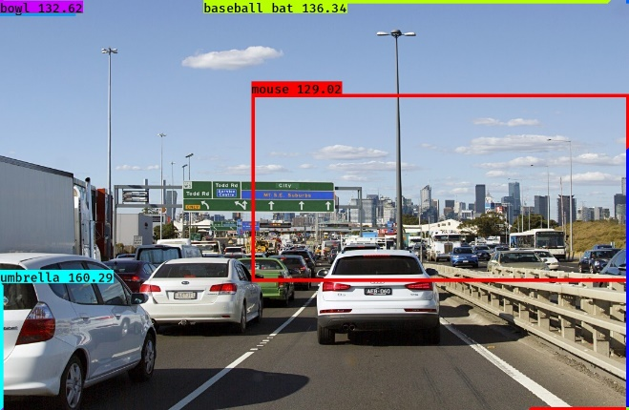

* Change the score_threshold [value between 0-1] to a different value but use the original values for other 2 variables. Rerun the required cells to get the output images for the autonomous driving dataset. Observe if this result in improvement compared to step 10 for the same two images. If there are any improvements, write them in the word file. Include the new 2 output images in the word file.

* Change the iou_threshold [value between 0-1] to a different value but use the original values for other 2 variables. Rerun the required cells to get the output images for the autonomous driving dataset. Observe if this result in improvement compared to step 10 for the same two images. If there are any improvements, write them in the word file. Include the new 2 output images in the word file.

When I changed the iou_threshold value into 0.8,

