DL lab 8 - Reinforcement Learning

Question 1

Markov_Decision_Process Notebook modifications

Gridworld Notebook modifications

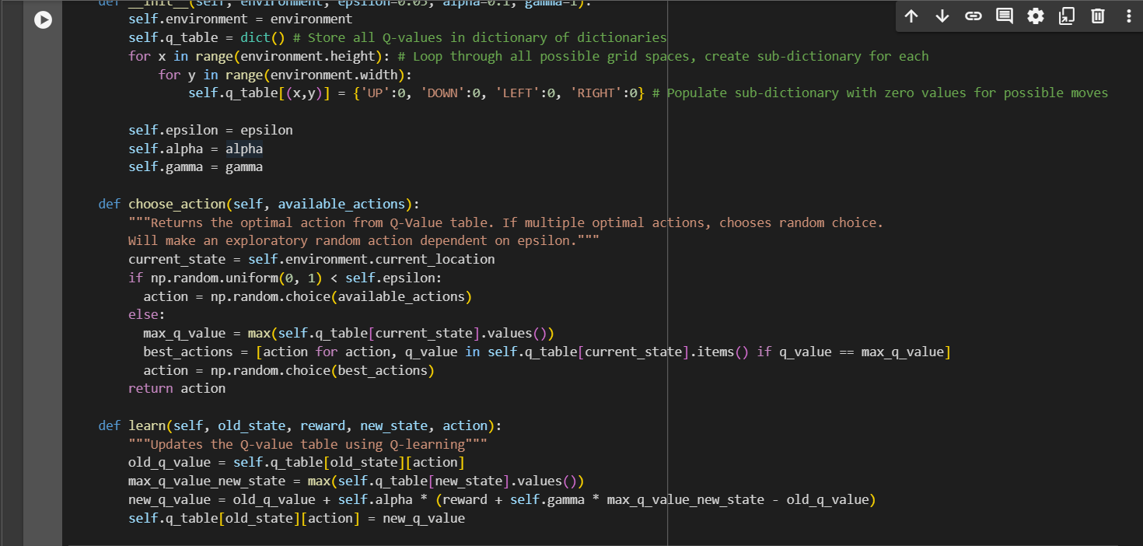

Question 2

2.Model based Algorithm

* **Use of a model**: These algorithms rely on a model of the environment (i.e., transition probabilities and reward structure).
* **How they work**: They simulate or predict the outcomes of actions using the model to compute the optimal policy or value function.
* **Example**: Value Iteration, Policy Iteration.

Model Free Algorithm

* **No model required**: These algorithms learn directly from interacting with the environment, without needing a model of the environment's dynamics.
* **How they work**: They learn the optimal policy or value function from experience, using trial and error.
* **Example**: Q-Learning, SARSA.

In essence, Model-Based algorithms rely on environmental knowledge, while Model-Free algorithms learn purely from experience.

3.

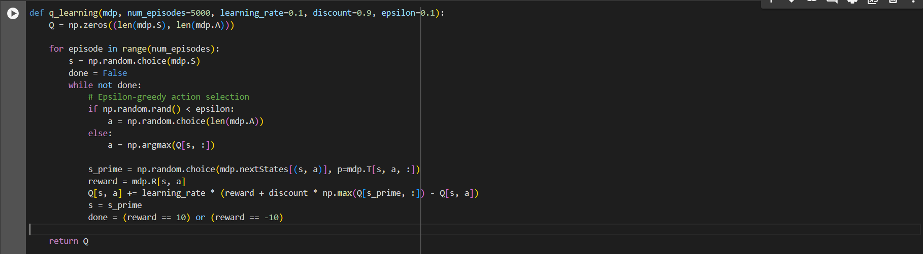

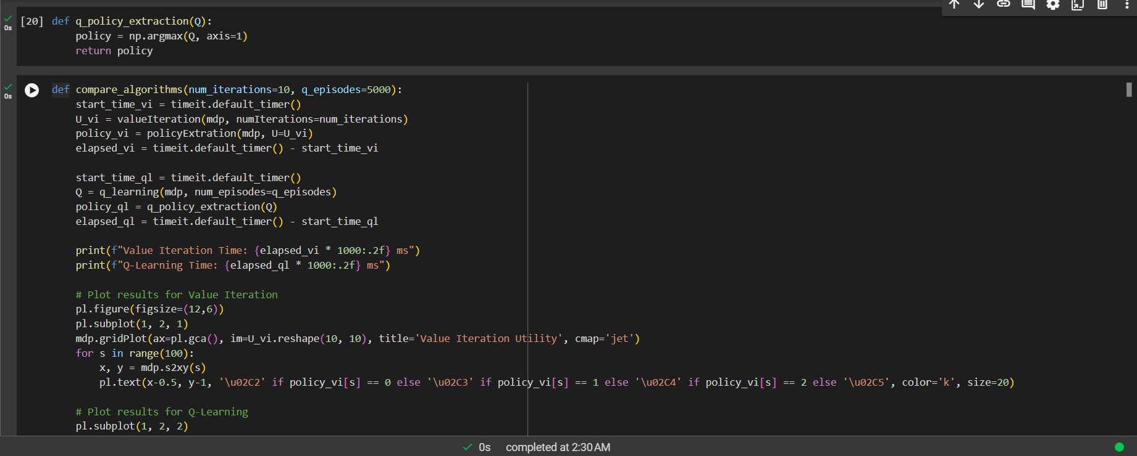

Question 3

1.

GitHub link - <https://github.com/IT21373770/DL-lab08>