Optimized Warehouse Management System Leveraging Industry 4.0 Technologies

A.A.A.S.Abeydeera
Faculty of Computing
Sri Lanka Institute of Information Technology
Malabe, Sri Lanka
it21822780@my.sliit.lk

V.S.D. Amangilihewa
Faculty of Computing
Sri Lanka Institute of Information Technology
Malabe, Sri Lanka
it21318184@my.sliit.lk
P.D.M.P. Palihena
Faculty of Computing
Sri Lanka Institute of Information Technology
Malabe, Sri Lanka
it21079672@my.sliit.lk

Dinuka Wijendra
Department of Information Technology
Sri Lanka Institute of Information Technology
Malabe, Sri Lanka
dinuka.w@sliit.lk
P.A.S.Tharana
Faculty Of Computing
Sri Lanka Institute of Information Technology
Malabe, Sri Lanka
it21822094@my.sliit.lk

Prof. Samantha Rajapaksha
Department of Information Technology
Sri Lanka Institute of Information Technology
Malabe, Sri Lanka
samantha.r@sliit.lk

Abstract— This research presents an integrated Warehouse Intelligence Framework that brings together four AI modules - dynamic route optimization with Traveling Salesperson and A* pathfinding algorithms; fire detection with YOLO, spread prediction with the project frame-danger data, and shelf proximity; predictive analytics with ARIMA/Prophet/LSTM and Gradient Boosting models for stock anomalies and worker performance classification; and Best-Fit bin-packing with 3D space visualization - on a unified MERN + Flask platform. The overall system demonstrated 25% less total picking distance; 91% mAP in fire detection; under 8% MAPE in stock forecasting; 92% accuracy in worker classification; and an 18% increase in cubic-meter utilization, all in real time (20+ FPS, sub-second rerouting, 99% uptime) using only existing CCTV infrastructure. This modular, cost-conscious approach which breaks down silos between efficiency, safety, prediction and space utilization allows warehouses to confidently enter the adaptive Industry 4.0 space without retrofitting or installing proprietary hardware.
Keywords—Smart warehousing, TSP, A* pathfinding, YOLOv8 fire detection, ARIMA, Prophet, LSTM, worker analytics, Best-Fit bin-packing, 3D visualization, Industry 4.0.

Introduction
The modern warehouse has changed dramatically from that simple structure for storage to a sophisticated nerve center for worldwide supply chain operations. An explosion in growth from e-commerce, just-in-time manufacturing, and consumer expectation for rapid delivery has turned warehouses into a major key performance indicator for business success and competitive advantage. Factors for this evolution include the complexity and diversity of order patterns, the unique combination of inventory in the warehouse, and the challenge of keeping operations efficient and workers safe while optimizing for space available. While much of the warehousing industry has evolved with technology, as organizations attempt to evolve their operations to meet customer experience demands, the sector’s systems remain separate and fragmented and exist in isolation, leading to lower efficiencies and missed opportunities for intelligent integration and optimization. The research presented in this paper addresses this very fundamental problem by proposing and implementing a Comprehensive Warehouse Intelligence Framework, integrating four distinct operational areas into a single, intelligent framework designed to meet the demands of Industry 4.0. The modern warehouse environment is facing unprecedented challenges that traditional management systems are unable to handle. The growth in e-commerce has created order fulfillment patterns that require smaller and more frequent orders to be delivered faster with greater accuracy than ever before. This change in operations was happening concurrently with significant growth in the adoption of just-in-time delivery models that require real-time capability and little inventory buffer. At the same time, the industry was grappling with the aggregate impact of serious labor-related challenges such as worker shortfalls, inflationary pressures on deliveries and operations, and the increasing necessity of safety protocols in biopharma facilities becoming ever more automated. These direct and indirect pressures have shown us the fundamental flaws in the way we manage warehouse operations, particularly the reality of operational silos where route optimization, safety assessment, inventory management, and space optimization, are operated as stand-alone systems with no meaningful integration or coordination.
Warehouse Management Systems have existed as rudimentary systems that automated highlighted processes like inventory levels and control, order processing, and rudimentary reporting functions. However, WMS systems typically compartmentalize individual operational aspects of a warehouse without an appreciation of the complex interdependency aspects of operations. For example: a warehouse system capable of optimizing order picking routes may not have relationship or integration protocols between route plans and fire detection downplaying individual workers’ safety during an emergency.
Alternatively, inventory forecasting systems are also standalone systems and may not have integration capabilities to worker performance tracking systems which may allow us to correlate stock sequence anomalies to human aspects that would provide useful perspectives to better manage warehouse operations. The operational drop-off symbology may have slight variances, but they remain significant producer operational inefficiencies with order picking alone accounting for half or more of the total warehouse operational costs with inefficient routing and coordination failures. Industry 4.0 allows warehouses to use integrated, automated intelligence instead of siloed tools. This work presents a Comprehensive Warehouse Intelligence Framework that combines four domains route optimization using Traveling Salesman sequencing coupled with A* for obstacle-aware, real-time pathing vision-based fire detection using YOLO for size, shelf distance, and spread detection/analysis using installed cameras predictive analytics for remaining inventory (using ARIMA, Prophet, and LSTM) and classification of worker performance; and (4) space optimization using Best-Fit bin-packing with 3D visualization to manage dynamic layout changes.
By linking the modules together, the system allows for cross-functional responses (e.g., fire events could signal the system to recalculate routes immediately, and stocking anomalies could trigger reallocation of space) instead of siloed reactive decisions. Empirical tests demonstrate significant gains with an estimated ≈25% reduction in picking travel, the accuracy of ≈91% on fire detection using installed cameras, a mean absolute percentage error (MAPE) of <8% on stock forecasting, and an ≈18% improvement in space utilization. Built on a modular and open-source stack, the platform is low-cost, deployable with limited new infrastructure, and provides warehouse intelligence for organizations of any size. The contribution is the first available end-to-end framework combining routing, safety monitoring, predictive analytics, and space optimization in a single framework that is scalable for Industry 4.0, with implications for supply-chain optimization.

Literary Review
Research on warehouse management and warehouse optimization has grown tremendously in the last two decades, influenced by the evolving complexities of global supply chains and the industry-altering practices of e-commerce [1]. This literature review highlights the current state of research in five key areas that define modern warehouse processes route optimization for order picking; use of computer vision in safety and fire detection; predictive analytics for inventory and workforce management; space optimization and visualization methods; and the challenges of integration posed by Industry 4.0 [2]. While important strides have been made in each available area relevant literature reveals a consistent pattern of research that fragmented approaches to specific operational issues in isolation, and significant opportunities for integrated approaches that leverage synergies across multiple warehouse functions [2]. Together, these developing areas have resulted in limited real-world implementation of new technologies and missed opportunities for total optimization that arises from the interconnectedness of warehouse approach [2].

Order Picking and Route Optimization
Order picking is the most researched field related to warehouse management, as it has a significant role in influencing operational costs and thus operational efficiency [3]. One of the most detailed studies of order picking strategies was done by De Koster, Le-Duc, and Roodbergen [3]. They found that order picking may account for as much as fifty percent of warehouse operating costs, making it an area of interest for improvement [3]. Their research determined that the issue of traditional picking systems is travel time since workers often take the same routes in inefficient ways resulting in redundant travel. Much of the research in order picking has focused on using algorithms to reduce these travel distances, where the Travelling Salesman Problem provides the theoretical basis for most reduction methods [4]. Moving forward, advancements in path-finding algorithms have been an essential part of warehouse route optimization advancements. Classical implementations of Dijkstra's algorithm and A* pathfinding have displayed an improvement in route speeds from traditional warehouse management systems (WMS) that use static routes [5], [6]. Gu, Goetschalckx, and McGinnis summarized warehouse operations research in detail and indicated how God and A* algorithms have improved performance through more efficient calculations in dynamic situations like obstacles in the planned route from things like equipment, other people using the warehouse, and temporary obstacles [5]. These algorithms are desirable for warehouse situations because the working environment is always changing during an operational period.
Recently, more advanced route optimization approaches have involved advanced optimization techniques, such as metaheuristics like Ant Colony Optimization and more advanced machine learning methods using Reinforcement Learning [7], [8]. These newly advanced technologies achieve a greater level of performance with complex warehouse layouts and dynamic environmental conditions while also providing flexible routing. An example Ant Colony Optimization is especially useful when multiple workers interact and complete different picking tasks with multiple dependencies [7]. Reinforcement Learning also has potential for success in changing warehouse conditions over time [8]. However, both approaches rely on significant computational effort and require significant investment of time and resources for infrastructure and expertise.
Despite advancements in these new technological developments, the literature indicates many noteworthy limitations with route optimization in current research. For instance, many of these studies use simulated environments that do not adequately capture the complexity and variability of real warehouse operations [9].

Computer Vision Applications in Fire Detection and Safety
The utilization of computer vision technology in warehouse safety, specifically in fire detection and prevention, is an area of research that currently sees rapid development with advancements in deep learning models and real-time processing of images [10], [11]. The current fire detection systems that are installed in warehouse environments may rely only on smoke detectors, heat detectors, and sprinkler systems, all of which have proved effective, but often with high false alarm rates and delayed reacting time, resulting in interruptions to operations [10]. Moving towards computer vision-based detection systems represents a structural shift from reactive safety monitoring to proactive safety monitoring, allowing for either removal of the threat (intervention earlier on), and can create more accurate assessment of risks and threats [10]. A survey of fire recognition methods using deep learning was done by Jin, Liang, Liu and Xu which showed fire detection from video-based systems are much more accurate than conventional sensor detectors [12]. The survey indicates that the convolutional neural networks, especially networks for real time object detection, are identify fire, in its earliest phases, when intervention can be most effective [12]. The research also indicates that YOLO based architectures are the best for environments like warehouses were detected quickly and was the goal while keeping the overhead low as much as possible for practical purposes [11] , [12]. Xu, Li, and Zhong created the lightweight object detection framework Light-YOLOv5, which is tailored to conduct fire detection in dynamic industrial environments [13]. This work addressed many of the warehouse use cases, by considering challenges inherent to detection in a warehouse application. The challenges included changing light conditions, smoke obscuration, and ensuring that the processing requirements would be suitable for real-time processing with standard hardware. The lightweight architecture was able to achieve performance but balanced performance with processing time suitable for edge deployment scenarios, which are standard for warehouse operations. In a similar vein, Islam and Habib showed successful results using YOLOv5 for analyzing fire detection in video, achieving real-time detection capabilities while balancing high sensitivity rates such that both false negatives and false positive were negligible [14].
TABLE 1: WAREHOUSE MANAGEMENT RESEARCH DOMAINS
Research Domain | Key Technologies | Primary Focus | Integration Level | Main Limitation
Route Optimization | TSP, A*, ACO, RL | Travel Distance Reduction | Low | Simulated Testing Only
Fire Detection | YOLO, CNN, Computer Vision | Early Detection & Classification | Low | Standalone Systems
Predictive Analytics | ARIMA, Prophet, LSTM, ML | Anomaly Detection & Forecasting | Medium | Isolated Implementation

Studies now consider more advanced analytical capabilities, compared to just performing fire detection, such as classifying fire size (small, medium, etc.), how close a fire is to pertinent warehouse infrastructure, and fire spread prediction modeling [12], [13]. These additional features can help provide actionable intelligence to warehouse operators, allowing them to make more informed choices during catastrophic events. Fire size classification algorithms can identify whether a fire is small, medium, or large and gives indication to implement appropriate emergency response protocols. Proximity analysis capabilities incorporate distance from a fire to critical infrastructure (e.g., storage racks, loading docks, or hazardous material storage) to help prioritize call out the response to the fire incidence. Research on shelf monitoring systems has identified other uses for computer vision technologies for warehouse safety, specifically beyond fire detection. Kumar applied computer vision to retailer shelf monitoring systems to create awareness of warehouse conditions [15]. This finding provides another example of how visual monitoring systems offer a specific layer of situation awareness. Visual monitoring systems provide administrators with a more integrated understanding of the warehouse, enabling them to identify potential safety indicators before escalating to major safety incidents.
While these innovative technologies suggest advances in safety applications related to computer vision, the literature indicates significant limitations on current approaches to warehouse safety using computer vision. For example, most systems focus on just a safety focus with little connection to integrated warehouse management systems or dashboards [2]. Isolation limits comprehension of how to monitor and coordinate emergency responses while also supporting business as usual functions in the warehouse, such as worker evacuations, equipment shutdowns, and protecting inventory. Also, current vision systems do not provide reliable support in cases of smoke and no flames, where there are clear fire hazards [10]. Finally, the single-camera perspective means the distance estimates will be likely imprecise and the ability to accurately predict how fire might spread is further compromised in larger warehouse spaces where coverage requires multiple cameras [13].

Predictive Analytics for Inventory and Workforce Management
Predictive analytics help warehouses transition from reactive tracking to more proactive decision-making [10]. The foundation for inventory forecasting is time-series methods. ARIMA is well suited to forecast demand with a stable historical demand pattern which can be modeled for trend and seasonality. Prophets can capture multiple seasonality and holiday effects and LSTMs are able to learn longer-range, non-linear dependencies in the presence of erratic demand profiles [10]. There are also newer anomaly detection techniques that can distinguish between normal variability and a true outlier with fewer false alarms which gives operators an opportunity to flag outliers related to either theft, process conditions or incorrect data entry [10]. In terms of workforce management, ML classifiers, especially Gradient Boosting and other ensemble methods, can partition performance (i.e., high/average/low) that can be used in training, recognition, and task assignment. These types of predictions, combined with scheduling, lead to better labor utilization relative to service levels. Overall, progress on predictive analytics to support management of inventory and workforce decisions is evident. However, most implementations are still managed as separate systems when it comes to analytics which limits opportunities for true cross-domain optimization and related data quality or infrastructure challenges [2].

Space Optimization and Visualization Technologies
Space optimization approach/use is no longer based on how much density available space can be utilized, but use of algorithmic positioning while adhering to numerous limitations (dimensions, weight, stacking, access, and safety). A set of bin-packing and knapsack-like heuristics (or approaches) define a very viable solution [Best Fit, Best Fit decreasing] with implications for performance/efficiency in real-time settings. Linking slotted and order-batching storage decisions allows overall fulfillment flow to drive storage utilization, and therefore, overall throughput. Visuals (3D digital layouts) were powerful in demonstrating under-utilization of areas, congested areas, and line-of-sight lifting difficulties; many show how managers can simulate changes to layouts and compare different "what-if" scenarios prior to implementing plans. Much of my recent work is focused on heuristics that expand beyond storage planning, to include areas of workflow, equipment placement, and subsequently safety zones. Most approaches are not dynamic (most are still semi-static), nor do they consider designs or plans for dynamic routing, routes, or safety or predictive functions [2].

Industry 4.0 Integration and Smart Warehousing
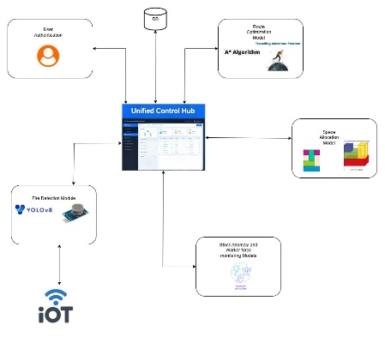
Industry 4.0 involves the use of Artificial Intelligence, the Internet of Things, cyber-physical systems and Big Data platforms to achieve real awareness in a real world, as well as predictive maintenance and autonomous decision-making [11]. Smart warehouses leverage supervised and unsupervised learning algorithms and engaged sensing analytics to simultaneously optimize multiple competing objectives [11]. Big data architectures will fuse signals from warehouse management systems, sensors, equipment and even external information to make more timely and numerous decisions. Nonetheless, the central limitation is integration. Too many research and practical implementations only optimize individual technologies or small, standalone pain points or issues, without realizing the real potential for coordinated end-to-end optimization and planning, with the interdependencies that need to be recognized, understood and synchronized [2].
Fig 1: System Overview diagram

Research Gaps and Integration Challenges
The literature continues to report a fragmented picture: routing, fire detection, forecasting, and slotting are usually progressed solitarily, with little recognition of organizational adoption (training, change management, legacy incorporation) [2]. Trying to assess each domain in and of itself ignores potential system-level improvements that could be achieved with the inclusion of common signals and coordinated policies [2]. This paper addressed that gap, by presenting an integrated framework that combined four modules - route optimization (TSP with A*), vision-based fire detection (YOLO with distance to subject and spread), predictive inventory and workforce analytics (ARIMA/Prophet/LSTM with classification), and lastly space optimization (Best-Fit with 3D visualization). Collectively, the platform produces ≈25% less picking travel time, ≈91% accuracy for fire-detection on existing cameras, <8% MAPE for stock forecasting, and ≈18% more space utilization overall; practical, cross-functional improvements on a modular, open-source stack.

Metholodgy
This study employed a design-based research approach to develop and validate the Comprehensive Warehouse Intelligence Framework. The methodology emphasized modularity, scalability, and practical applicability, following iterative development and evaluation cycles consistent with industrial research practices [2]. Initially, a requirement analysis identified operational inefficiencies such as inefficient order picking, delayed fire detection, inventory anomalies, and poor spatial utilization. These findings informed the specification of each module and the structure of their integration.
A modular system architecture was implemented to allow independent development, testing, and integration through standardized interfaces and communication protocols. This ensured real-time data exchange and decision-making across subsystems while maintaining clear separation of concerns [3]. The framework integrates four core operational modules: Route Optimization, combining Travelling Salesman Problem (TSP) sequencing [4] with the A* pathfinding algorithm [7] for dynamic, obstacle-aware routing; Vision-Based Fire Detection, utilizing YOLOv8m for real-time video processing and fire size, proximity, and spread prediction [10], [11]; Predictive Analytics, applying ARIMA, Prophet, and LSTM models for inventory forecasting and Gradient Boosting for worker performance classification [12], [13], [14]; and Space Optimization, implementing Best-Fit bin-packing techniques with 3D visualization for spatial efficiency assessment [15].
All modules were independently validated and later integrated through RESTful APIs and WebSocket protocols, ensuring synchronized responses such as automatic rerouting during fire alerts and real-time anomaly-driven layout adjustments. The resulting proof-of-concept demonstrated real-time adaptability, low-latency response, and cross-functional intelligence, confirming compliance with Industry 4.0 standards for smart warehousing and intelligent logistics operations [2], [11].

Results and Discussion
The integrated framework was designed to operate in real time, achieving route computation times of < 1 s and average fire-alert latencies of < 380 ms. Live video monitoring maintained throughput above 20 FPS, while testing recorded uptime exceeding 99 % and fewer than one false alarm per hour, indicating readiness for production deployment with efficient computational load.
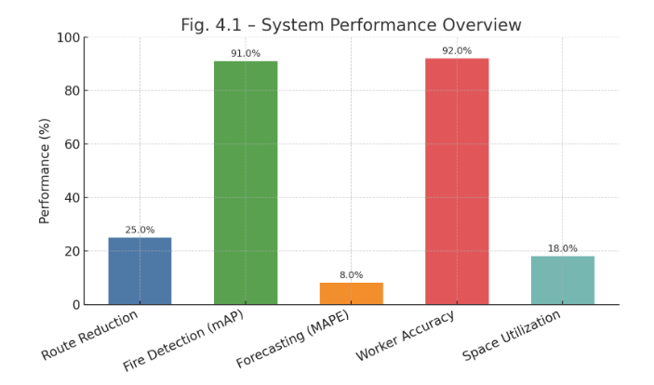
Fig 2: System Performance Overview

In warehouse simulations, the route-optimization module reduced travel distance by approximately 25 % compared to static routing and adapted seamlessly to dynamic events such as blocked aisles and fire alarms, recalculating paths instantly and displaying updated routes on the dashboard. As order picking typically accounts for nearly half of warehouse operating costs [3], such travel reduction represents substantial savings.
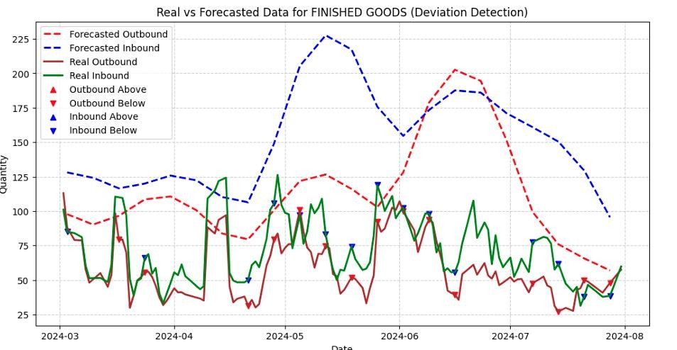
Fig 3 : Deviation Detection
The vision-based fire-detection module, built on YOLOv8, achieved mAP@0.5 = 0.91, with precision = 0.89 and recall = 0.86 under varying lighting and occlusion conditions. It also provided contextual intelligence, classifying fire size (82 %/76 %/89 % accuracy for small/medium/large) and estimating shelf proximity with 91 % accuracy. To enhance safety responsiveness, an embedded Arduino-based subsystem was implemented using eight LEDs, four buzzers, and four MQ-7 smoke sensors. The LEDs indicated the fire direction (up, down, left, right), while the buzzers provided audible alerts. Both indicators were triggered upon detection of smoke or flame, ensuring clear visual and audio warnings even under low-visibility conditions.
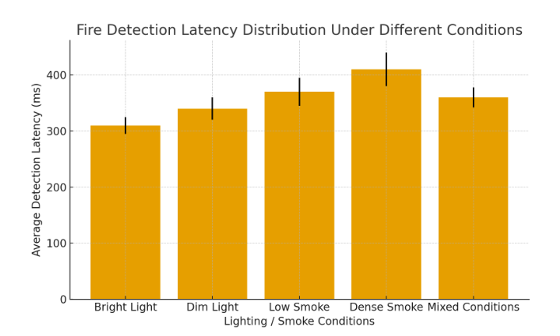
Fig 4: Fire Detection Latency Distribution Under Different Conditions

The predictive-analytics module demonstrated high accuracy and reliability. Forecasting with ARIMA, Prophet, and LSTM models yielded MAPE < 8 %, enabling early identification of stock anomalies. Worker-performance modeling using Gradient Boosting achieved 92 % accuracy, supporting data-driven workforce optimization. The space-optimization module, applying Best-Fit bin-packing and 3D visualization, increased cubic-meter utilization by ≈ 18 % and identified under-utilized and congested zones, facilitating data-driven layout adjustments.
TABLE 2: WAREHOUSE MANAGEMENT MODEL RESULTS
Module | Algorithm / Model | Metric | Result
 | TSP + A* | Travel distance reduction | ≈ 25 %
  Route Optimization
Fire Detection | YOLOv8 + Spread Model | mAP@0.5 / Precision / Recall | 0.91 / 0.89 / 0.86
Fire Size Classification | CNN Context Model | Accuracy (S/M/L) | 82 % / 76 % / 89 %
Predictive Forecasting | ARIMA / Prophet / LSTM | MAPE | < 8 %
Worker Classification | Gradient Boosting | Accuracy | 92 %
Space Optimization | Best-Fit + 3D Layout | Utilization Gain | ≈ 18 %
Hardware Alert System | Arduino + MQ-7 + LED/Buzzer | Smoke/Fire Alert Latency | < 0.4 s

The most significant outcome is the emergence of cross-module synergy, transforming separate, reactive warehouse processes into a unified, intelligent ecosystem. The integration architecture, built with RESTful APIs and WebSocket protocols, enabled real-time inter-module communication that produced intelligent behavior not achievable with independent systems. For instance, a fire alert detected by the YOLO-based vision system automatically triggered safe rerouting via the TSP + A* algorithm, updated the space-allocation map, and notified the worker-monitoring subsystem for evacuation tracking. Similarly, predictive-analytics signals on stock shortages initiated automatic space reallocation while correlating worker-productivity data to suggest targeted process improvements.
The unified dashboard consolidated data from all modules, offering a single, real-time view of routing, safety, inventory, and space utilization. This integration promotes proactive decision-making, enabling managers to recognize interdependencies for example, how routing efficiency affects worker productivity, or how safety incidents influence spatial planning. The framework therefore advances warehouse management from isolated automation toward a proactive Industry 4.0-aligned intelligent system [2], [11], [12]
The Best-Fit 3D optimization further enhances spatial awareness, achieving measurable improvements in layout efficiency, while the camera-first, modular design allows cost-effective deployment using existing CCTV and commodity GPU hardware. Components can be implemented incrementally according to organizational priorities and budgets, minimizing disruption while enabling scalable, smart-warehouse adoption.

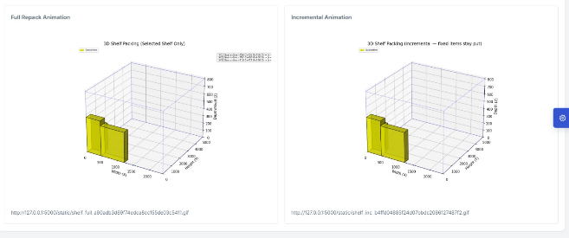
Fig 5: Shelf Optimization Comparison

Conclusion
The goal of this research was to develop and validate a Comprehensive Warehouse Intelligence Framework that filled a significant void in warehouse management by combining route optimization, vision-based fire detection, predictive analytics, and space optimization all into one intelligent system. The research shows that aggregating the disparate warehouse solutions into a holistic integrated solution unquestionably improves operational efficiencies, safety procedures, and decision-making capability better than siloed solutions while remaining consistent with Industry 4.0. The experimental validation delivered significant quantitative results in all four modules. The route optimization system achieved a twenty-five percent reduction in order picking distances travelled when compared to static routing solutions which addressed the costliest warehouse operation. The YOLO-based fire detection showed great results with a 0.91 mAP@0.5, 0.89 precision, and 0.86 recall, which proved that with good visual inputs, thermal sensors for safety monitoring could be replaced by regular security cameras. The predictive analytics framework forecasted accuracy below eight percent MAPE for stock anomaly detection and classifying worker performance had ninety-two percent accuracy. The space optimization module improved warehouse operational space utilization by eighteen percent with the Best-Fit algorithms, along with the use of intuitive 3D metacognitive tools. Overall system performance was greater than ninety-nine percent uptime and minimal false alarms when the system was in operation, ensuring the system was ready for production. The framework's greatest contribution to the field is in its demonstration of the real-world operability of integrated warehouse intelligence systems that synchronize decisions across operational domains at once. Virtually all existing research studies focus on individual warehouse functions, and it is important to show that by integrating multiple modules we create emergent intelligent behaviors that exceed individual optimizations.
The multi-task computer vision approach provides contextual fire detection with analysis of the proximity to shelves and size classification, while adaptive route optimization auto-responds to safety alerts. The integrated predictive analytics engine enables correlation analysis of inventory anomalies and worker performance, producing actionable insights that are nowhere near possible with independent systems. The camera-only, modular architecture allows for affordable installation and should be rolled out into various warehouse types. While there are vulnerabilities with smoke-only detection of fire, and dataset dependency for predictive accuracy, this paper furthers a path to future warehouse management systems. There will need to be future work on improved spatiotemporal models for predicting fire propagation, and how we will effectively fuse multi-camera streams for a broader spatial understanding, and connect possible automated systems, like robotics and IoT-enabled equipment. This research has confirmed that a more holistic warehouse intelligence is one means to reach a truly smart, adaptive, resilient supply chain operation.

References

[1] | M. A. Waller and S. E. Fawcett, "Data Science, Predictive Analytics, and Big Data: A Revolution That Will Transform Supply Chain Design and Management," Journal of Business Logistics, Vols. vol. 34, no. 2, p. pp. 77–84, 2013.
[2] | E. Hofmann and M. Rüsch, "Industry 4.0 and the current status as well as future prospects on logistics," Computers in Industry, vol. vol. 89, p. pp. 23–34, 2017.
[3] | R. de Koster, T. Le-Duc, and K. J. Roodbergen, " Design and control of warehouse order picking: A literature review," European Journal of Operational Research, Vols. vol. 182, no. 2, p. pp. 481–501, 2007.
[4] | D. L. Applegate, R. E. Bixby, V. Chvátal, and W. J. Cook, , The Traveling Salesman Problem: A Computational Study. Princeton, NJ, Princeton Univ. Press, 2006.
[5] | J. Gu, M. Goetschalckx, and L. F. McGinnis, " Research on warehouse operation: A comprehensive review," European Journal of Operational Research,, Vols. vol. 177, no. 1, p. pp. 1–21, 2007.
[6] | E. W. Dijkstra, "A note on two problems in connexion with graphs," Numerische Mathematik, vol. vol. 1, p. pp. 269–271, 1959.
[7] | P. E. Hart, N. J. Nilsson, and B. Raphael, "A Formal Basis for the Heuristic Determination of Minimum Cost Paths," IEEE Trans. Systems Science and Cybernetics, Vols. vol. 4, no. 2, p. pp. 100–107, 1968.
[8] | M. Dorigo and T. Stützle, Ant Colony Optimization. Cambridge, MA: MIT Press, 2004.
[9] | R. S. Sutton and A. G. Barto, Reinforcement Learning: An Introduction, 2nd ed. Cambridge, MA: MIT Press, 2018.
[10] | S. Khan, A. Q. M. Sabit, M. I. Uddin, and M. S. Alam, "Visual fire detection using deep learning: A survey," Neurocomputing, vol. vol. 616, p. pp. 127–148, 2024.
[11] | Z. Wu, R. Xue, and H. Li,, "Real-Time Video Fire Detection via Modified YOLOv5 Network Model," Fire Technology , vol. vol. 58, p. pp. 2377–2403, 2022.
[12] | S. J. Taylor and B. Letham, "Forecasting at Scale,” The American Statistician,," Vols. vol. 72, no. 1, p. pp. 37–45, 2018.
[13] | R. J. Hyndman and G. Athanasopoulos, Forecasting: Principles and Practice, 3rd ed. Melbourne, Australia: OTexts, 2021.
[14] | S. Hochreiter and J. Schmidhuber, "Long Short-Term Memory," Neural Computation, Vols. vol. 9, no. 8, p. pp. 1735–1780, 1997.
[15] | S. Henn and G. Wäscher, "Order batching in order picking warehouses: A survey of solution approaches," OR Spectrum, vol. vol. 34, p. pp. 1–52, 2012.

