IT22053282 – Deep Learning Labsheet 3

* Face Verification Output

* Face Recognition Output

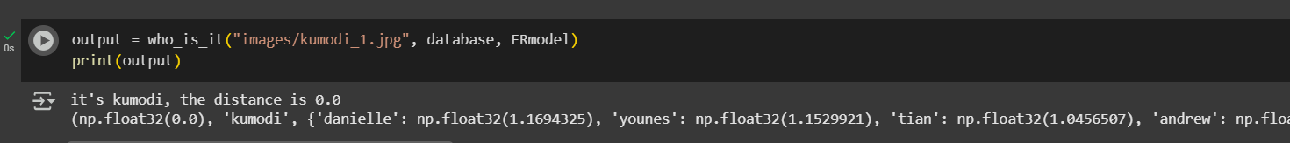

* Face Recognition Output 2

