

Information Systems and Data Modeling – IT1090

**Assignment**

|  |  |
| --- | --- |
| Title: Online Voting System for Award Nominations | |
| Batch Number: Y1.S2.WD.CSNE.02.1 | Group Number: MLB_WD_CSNE_02.01_01 |
| Declaration:  We hold a copy of this assignment that we can produce if the original is lost or damaged.  We hereby certify that no part of this assignment has been copied from any other group’s work or from any other source. No part of this assignment has been written / produced for our group by another person except where such collaboration has been authorized by the subject lecturer/tutor concerned.  Group Members:  A purple text on a black background  Description automatically generated with low confidence  A picture containing handwriting, darkness, font, night  Description automatically generatedIT22571298 Silva P. K. A …………………………  signature  IT22258762 Weerasekara P. A. S. S …………………………  signature  IT22047656 Chandrasiri E. M. S. M …………………………  signature  IT22617514 Lakshitha R. A. T. R … ……………………...  signature  IT22315700 Ravindran S …………………………  signature  **Submitted on: <20/05/2023>** | |

Table of Contents

1. Hypothetical Scenario

2.0 Requirements Analysis

2.1 Introduction

o Purpose of the system

2.2 Main Requirements of The System

• Functional requirement

• Nonfunctional requirement

3.0 Performance requirement

4.0 Security requirement

5.0 Data Requirements of The System

6.0 Currant system

7.0 Entity Relationship (ER) Diagram

8.0 Relational Schema

9.0 SQL Queries To Create The Database

10.0 Contribution of Project

**1.0 Hypothetical scenario**

In the hypothetical scenario of the "Online Voting System for Award Nominations," let's imagine an annual film awards ceremony where professionals from the film industry and movie enthusiasts come together to celebrate outstanding achievements in various categories. The online voting system facilitates the nomination and selection process, ensuring fairness and transparency. The system includes the following entities: Administrator, User, Vote, Nomination, Nominee, Award category, and Winner. The Administrator manages the platform and has the authority to oversee user accounts. Users participate in the nomination and voting process. They can make nominations in different award categories and cast votes for their preferred nominees. Nominations are associated with users and nominees. Each nomination is uniquely identified. Nominees are individuals who are nominated in specific award categories. They belong to the single award category. Votes are cast by users for the nominated individuals. Each vote is linked to a specific user and nominee. At the end of the voting period, winners are determined based on the vote counts received by each nominee. A nominee can potentially win in multiple categories. Award categories represent the different categories for which nominations and votes are collected. The system ensures fairness and transparency by recording the relationships between administrators, users, nominations, nominees, votes, award categories, and winners.

Overall, the hypothetical scenario showcases an online voting system that allows users to make nominations and cast votes, leading to the recognition of winners in various award categories at awards ceremony.

**2.0 Requirements Analysis**

**2.1) Introduction**

**Purpose of the system**

The goal of the "Online Voting System for Award Nominations" scenario is to give industry professionals and movie fans a fair and transparent platform to engage in the nomination and voting process for an annual film awards ceremony. The approach attempts to make it easier to choose exceptional accomplishments across many award categories and to ultimately identify the winners. The system provides fairness and openness in the selection process by including elements like user participation, original nominations, nominee categorization, voting, and documentation of relationships. The main goal is to enhance the awards event by streamlining nominations, voting, and winner selection using an online platform.

**2.1) Functional requirements**

1. Administrator:

* Can manage the platform and its functionalities.
* Authority to oversee user accounts and perform administrative tasks.
* Ability to add, modify, or remove award categories.
* Can monitor and maintain the integrity and security of the system.
* Ability to generate reports and gather statistical data related to nominations and voting.

1. User:

* Can create an account and log in to the system.
* Ability to view and browse the available award categories.
* Must be able to make nominations in different award categories.
* Have chance to cast votes for preferred nominees.
* Ability to view the nominees and their information.
* Can track the status of their nominations and votes.
* Able to modify or withdraw their nominations or votes within a specific timeframe.
* Ability to receive notifications and updates related to the nomination and voting process.

1. Vote:

* Can record votes cast by users.
* Must link each vote to a specific user and nominee.
* Ability to ensure that a user can only cast one vote per nominee per award category.
* Must be able to store and secure voting data.

1. Nomination:

* Ability to create unique nominations associated with users and nominees.
* Can link each nomination to a specific award category.
* Must store and manage nomination information.
* Ability to track the status of nominations.

1. Nominee:

* can represent individuals who are nominated in specific award categories.
* Must be belong to a single award category.
* Ability to store and display nominee information.
* Ability to track the number of nominations received by each nominee.

1. Award Category:

* Ability to define different categories for which nominations and votes are collected.
* Must add, modify, or remove award categories.
* Must assign nominees to their respective award categories.
* Ability to track the nominees and votes within each award category.

1. Winner:

* Can determine winners based on the vote counts received by each nominee.
* Ability to calculate the highest vote count within each award category.
* Must handle scenarios where a nominee can potentially win in multiple categories.
* Ability to announce and display the winners in each award category.
* Top of Form

**2.2. Nonfunctional requirements**

1. Performance:

* The system should be able to handle many simultaneous user interactions during peak periods, ensuring smooth performance and responsiveness.
* Response times for actions such as nomination submissions, vote casting, and result display should be within acceptable limits to provide a satisfactory user experience.
* The system should have efficient database management to handle the storage and retrieval of large amounts of data associated with nominations, votes, and users.

1. Usability:

* The user interface should be intuitive, user-friendly, and accessible to a wide range of users, including those with disabilities.
* Clear instructions and guidance should be provided throughout the nomination and voting process to ensure that users can easily understand and navigate the system.
* The system should be compatible with various devices and browsers to accommodate users accessing it from different platforms.

1. Security:

* User accounts and personal information should be securely stored and protected against unauthorized access or misuse.
* Measures such as user authentication, password encryption, and secure data transmission (e.g., HTTPS) should be implemented to ensure the confidentiality and integrity of user data.
* The system should have mechanisms to prevent fraudulent activities such as duplicate nominations, unauthorized vote casting, or tampering with nomination or voting records.

1. Reliability:

* The system should be highly reliable and available, minimizing downtime and ensuring that users can access it when needed.
* Backup and recovery mechanisms should be in place to safeguard data and allow for system restoration in case of failures or disasters.
* Proper error handling and logging mechanisms should be implemented to capture and address any system errors or exceptions.

1. Scalability:

* The system should have the ability to scale and accommodate increasing user demands and data volumes over time.
* It should be designed to handle additional award categories, nominees, and user accounts without significant performance degradation.
* Scalability measures should also consider potential future enhancements or expansions of the system's features and functionalities.

1. Maintainability:

* The system should be designed and implemented in a modular and maintainable manner, allowing for easy updates, bug fixes, and future enhancements.
* Clear documentation should be provided to support system maintenance and troubleshooting tasks.
* The system should adhere to coding standards and best practices to facilitate code readability and maintainability.

These nonfunctional requirements ensure that the online voting system meets certain quality standards and provides a reliable, secure, and user-friendly platform for the nomination and voting process.

**Top of Form**

**3.0 Performance Requirements**

1. Response Time:

* The system should respond to user interactions, such as nomination submissions and vote casting, within an acceptable timeframe, typically within a few seconds.
* The time taken to load pages and display information should be minimal to ensure a smooth user experience.
* The system should prioritize reducing latency and optimizing server-side processing to minimize user waiting times.

1. Throughput:

* The system should be capable of handling a large number of simultaneous user interactions, such as nominations and votes, particularly during peak periods (e.g., when nominations or voting is about to close or during the awards ceremony).
* The throughput requirement should specify the number of concurrent users the system can support without significant degradation in response time or performance.

1. Scalability:

* The system should be designed to scale horizontally or vertically to handle increased user demands and data volumes over time.
* The scalability requirement should define the expected growth rate and the system's ability to accommodate additional users, nominees, and award categories without impacting performance negatively.
* The system should support load balancing and distributed processing to distribute the workload across multiple servers or resources effectively.

1. Database Performance:

* The database used by the system should be optimized to handle a large amount of data associated with nominations, votes, users, and nominees.
* Database queries and operations should be efficient and have minimal impact on overall system performance.
* Indexing, caching, and database tuning techniques should be employed to enhance database performance and reduce response times.

1. Network and Bandwidth:

* The system should be designed to optimize network communication between users and the system servers.
* Network latency should be minimized to ensure quick data transmission and response times.
* The system should be able to handle fluctuations in network bandwidth and accommodate users with varying internet connection speeds.

1. Stress Testing:

* The system should undergo stress testing to determine its performance and stability under extreme load conditions.
* Stress tests should simulate scenarios with a significantly high number of concurrent users and transactions to assess the system's ability to handle such loads.
* Stress testing should identify potential bottlenecks, performance limitations, and areas of improvement in the system's architecture and infrastructure.

These performance requirements aim to ensure that the "Online Voting System for Award Nominations" can handle a large number of users, process nominations and votes efficiently, and deliver a responsive and satisfactory user experience throughout the nomination and voting process.

**4.0 Security Requirements**

Security requirements for the "Online Voting System for Award Nominations" scenario are crucial to protect user data, prevent unauthorized access, and maintain the integrity of the system. Here are some security requirements that may apply:

1. User Authentication:

* The system should implement secure user authentication mechanisms, such as username/password combinations or multi-factor authentication, to verify the identity of users.
* Passwords should be securely stored using strong encryption algorithms to prevent unauthorized access.

1. Authorization and Access Control:

* The system should enforce appropriate authorization levels to control access to different system functionalities and data.
* Administrators should have elevated privileges and access rights compared to regular users.
* Access controls should be in place to restrict users from modifying or accessing sensitive information, such as vote counts or nomination records.

1. Data Protection:

* User data, including personal information and voting preferences, should be securely stored and protected against unauthorized access or tampering.
* Data transmission between the system and users should be encrypted using secure protocols, such as HTTPS, to ensure data privacy during communication.
* Adequate measures should be implemented to prevent data breaches, such as SQL injection attacks or cross-site scripting (XSS) attacks.

1. Secure Coding Practices:

* The system should adhere to secure coding practices to minimize vulnerabilities and potential security risks.
* Input validation and sanitization should be implemented to prevent malicious input from compromising the system's integrity or exposing sensitive information.
* Regular code reviews and security audits should be conducted to identify and address any security vulnerabilities.

1. Auditing and Logging:

* The system should maintain comprehensive audit logs that record user activities, system events, and administrative actions.
* Logs should capture details such as user login/logout, nomination and vote submissions, and any critical system changes.
* Logging should be tamper-proof and securely stored to facilitate system monitoring, incident investigation, and compliance with data protection regulations.

1. Protection against Fraudulent Activities:

* The system should have mechanisms in place to detect and prevent fraudulent activities, such as duplicate nominations, unauthorized vote casting, or tampering with nomination or voting records.
* Measures such as vote validation, verification of user identities, and automated checks for suspicious patterns should be implemented to ensure the integrity of the voting process.

1. Disaster Recovery and Backup:

* Regular data backups should be performed to ensure the availability and integrity of the system's data.
* Disaster recovery plans should be in place to handle system failures, including provisions for data restoration and minimizing downtime.

1. Compliance with Privacy Regulations:

* The system should comply with relevant privacy regulations, such as General Data Protection Regulation (GDPR) or applicable local data protection laws.
* User consent and data handling policies should be clearly communicated, and users should have control over their personal information.

Top of Form

**5.0 Data requirement of the system**

Administrator

Name

User name

Password

Phone_Number

AdminID

Email

User

UserID

Password

Username

E-mail

Phone_Number

Age

Name

Vote

Vote_Date

voteID

UserID

NomineeID

Nomination

UserID

NominationID

NomineeID

Nominee

NomineeName

NomineeID

CategoryID

Award category

Category_Name

CategoryID

Winner

NomineeID

WinnerID

CategoryID

**6.0 Current system**

**Overview**

* "Online Voting System for Award Nominations" enables professionals and movie enthusiasts to nominate and vote for winners in different award categories.
* The system ensures fairness and transparency in the nomination and selection process.
* Entities involved: Administrator, Users, Votes, Nominations, Nominees, Award Categories, and Winners.
* Administrator manages the platform, oversees user accounts, and maintains system integrity.
* Users create accounts, make nominations, and cast votes.
* Nominations are associated with users and nominees, each uniquely identified.
* Nominees are individuals nominated in specific award categories.
* Votes are linked to users and nominees, and winners are determined based on vote counts.
* Nominees can win in multiple categories.
* Award categories represent the different categories for nominations and votes.
* Nonfunctional requirements include performance, usability, security, reliability, scalability, and maintainability.
* System prioritizes security, user-friendly experience, and accurate result determination.

Top of Form

Bottom of Form

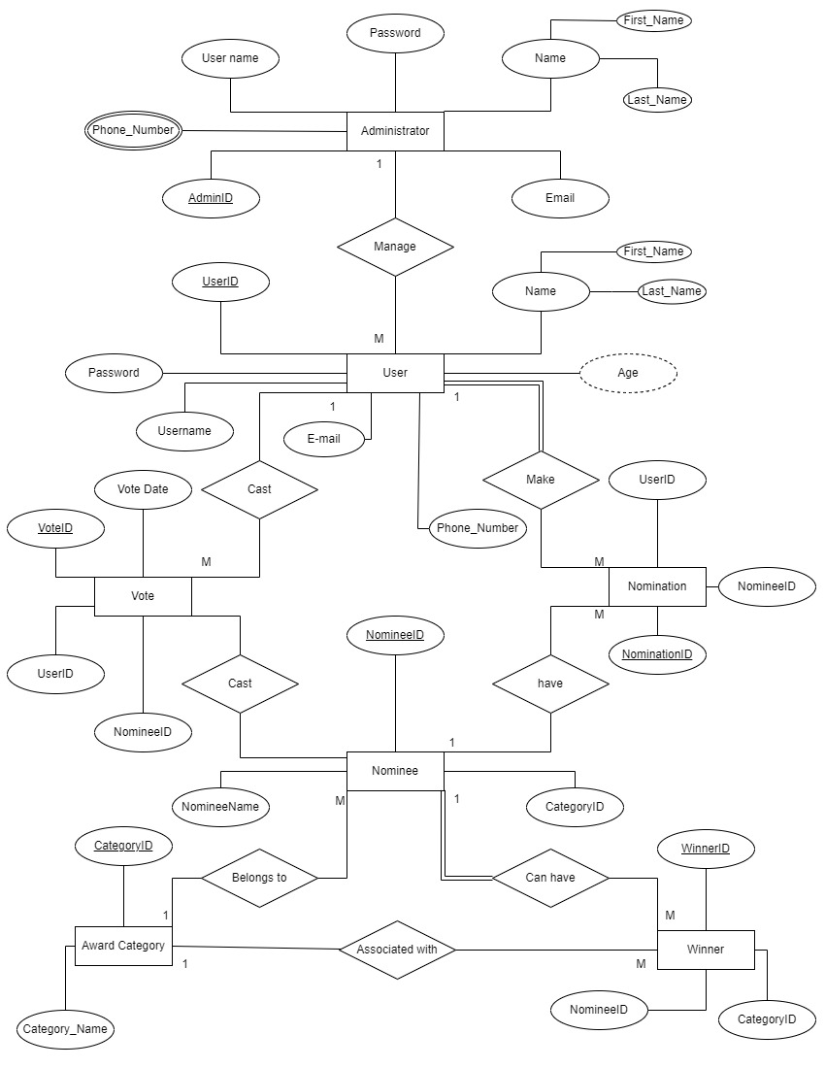ER Diagram

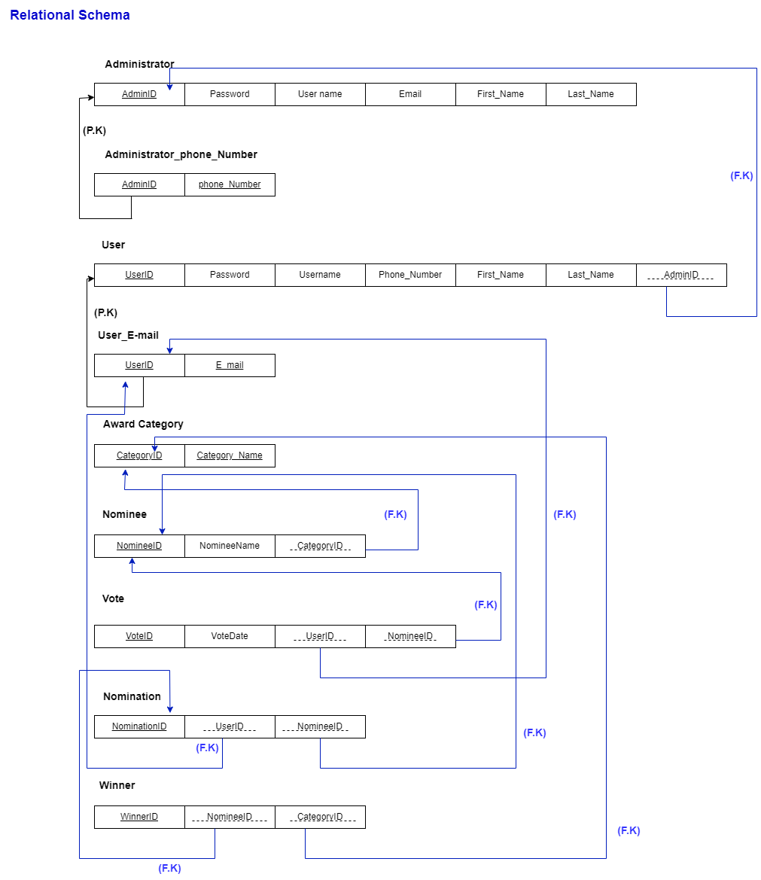

--09. SQL queries to create the DATABASE—

CREATE DATABASE voting_system;

-- Administrator Table

CREATE TABLE Administrator (

AdminID VARCHAR(20),

Password INTEGER,

UserName CHAR(20),

Email VARCHAR(30),

First_Name CHAR(20),

Last_Name CHAR(20),

CONSTRAINT Administrator_pk PRIMARY KEY (AdminID)

);

-- INSERTING VALUES INTO Administrator TABLE

INSERT INTO Administrator

VALUES('A001',17895,'James Mary','jamary01@gmail.com','James','Mary');

INSERT INTO Administrator

VALUES('A002',45678,'Robert Patricia','robpatrica75@gmil.com','Robert','Patricia');

INSERT INTO Administrator

VALUES('A003',45689,'Michael Linda','micheallind7@gmail.com','Michael','Linda');

INSERT INTO Administrator

VALUES('A004',47896,'David Elizabeth','davidzabeth789@gmail.com','David','Elizabeth');

INSERT INTO Administrator

VALUES('A005',73050,'William Barbara','williambara@gmail.com','William','Barbara');

INSERT INTO Administrator

VALUES('A006',76340,'Richard Susan','richardsusan780@gmail.com','Richard','Susan');

-- Administrator_phone_Number Table

CREATE TABLE Administrator_phone_Number (

AdminID VARCHAR(20),

phone_Number INTEGER,

CONSTRAINT Administrator_phone_Number_fk FOREIGN KEY (AdminID) REFERENCES Administrator (AdminID)

);

--INSERTING VALUES INTO Administrator_phone_Number TABLE

INSERT INTO Administrator_phone_Number

VALUES('A001',0754879456);

INSERT INTO Administrator_phone_Number

VALUES('A002',0715483500),('A002',0714596780);

INSERT INTO Administrator_phone_Number

VALUES('A003',0754578348),('A003',0777823489),('A003',0701276489);

INSERT INTO Administrator_phone_Number

VALUES('A004',0771287963);

INSERT INTO Administrator_phone_Number

VALUES('A005',0778945777);

INSERT INTO Administrator_phone_Number

VALUES('A006',0707896421),('A006',0771285794);

-- User Table

CREATE TABLE User__ (

User_ID VARCHAR(20),

Password VARCHAR(10),

Username CHAR(20),

Phone_Number INTEGER,

First_Name CHAR(20),

Email VARCHAR(50),

Last_Name CHAR(20),

Age INTEGER,

AdminID VARCHAR(20),

CONSTRAINT User_pk PRIMARY KEY (User_ID),

CONSTRAINT Administrator__fk FOREIGN KEY (AdminID) REFERENCES Administrator (AdminID)

);

-- Vote Table

CREATE TABLE Vote (

vote_ID INT,

vote_date INT,

User_ID VARCHAR(20),

Nominee_ID INT,

CONSTRAINT Vote_pk PRIMARY KEY (vote_ID),

CONSTRAINT Vote_User_fk FOREIGN KEY (User_ID) REFERENCES User__ (User_ID),

CONSTRAINT Vote_Nominee_fk FOREIGN KEY (Nominee_ID) REFERENCES Nominee (Nominee_ID)

);

-- Winner Table

CREATE TABLE Winner (

winner_ID INT,

Nominee_ID INT,

Category_ID INT,

CONSTRAINT Winner_pk PRIMARY KEY (winner_ID),

CONSTRAINT Winner_Nominee_fk FOREIGN KEY (Nominee_ID) REFERENCES Nominee (Nominee_ID),

CONSTRAINT Winner_Category_fk FOREIGN KEY (Category_ID) REFERENCES Award_Category (Category_ID)

);

-- Nominee Table

CREATE TABLE Nominee (

Nominee_ID INT,

NomineeName VARCHAR(50),

CategoryID INT,

CONSTRAINT Nominee_pk PRIMARY KEY (Nominee_ID),

CONSTRAINT Nominee_Category_fk FOREIGN KEY (CategoryID) REFERENCES Award_Category (Category_ID)

);

-- Nomination Table

CREATE TABLE Nomination (

NominationID INT,

User_ID VARCHAR(20),

NomineeID INT,

CONSTRAINT Nomination_pk PRIMARY KEY (NominationID),

CONSTRAINT Nomination_User_fk FOREIGN KEY (User_ID) REFERENCES User__ (User_ID),

CONSTRAINT Nomination_Nominee_fk FOREIGN KEY (NomineeID) REFERENCES Nominee (Nominee_ID)

);

-- Award_Category Table

CREATE TABLE Award_Category (

Category_ID INT,

Category_Name VARCHAR(50),

CONSTRAINT Award_Category_pk PRIMARY KEY (Category_ID)

);

**10.0 Contribution of Project**

**IT22571298 Silva P. K. A**

In this group project, it was my responsibility to specify the demands of the subject. Include both functional and nonfunctional needs in the project. I am involved with many parts of this report but mostly I focus on the table-creating part of the queries.

I was also tasked with figuring out any unique security needs and performance standards for this project. I utilize the internet to do research and obtain information for this. I gained knowledge on how to identify a system's particular performance traits and security needs.

**IT22258762 Weerasekara P. A. S. S**

Entity Relationship (ER) diagram creation was my contribution to this collaborative project. In order to develop the ER diagram for the group project, I followed Chandrasiri E. M. S. M.I help with the quires to create the table and enter data.

Once more, I started by paying close attention to the lecture slides and video for this purpose. I then discovered how to create an ER diagram by following the detailed instructions.

**IT22047656 Chandrasiri E. M. S. M**

This is the part of the group project where I had to briefly explain the hypothetical scenario. For this reason, I started by carefully reviewing the lecture video and lecture slides. And I search Google Then I learned how to construct an ER diagram by following the step-by-step instructions. I have done a part of ER Diagram too with help of Weerasekara P. A. S. S

**IT22617514 Lakshitha R. A. T. R**

I have done a part of Performance Requirements and Security Requirement populate each table with some sample data (minimum 5 records per table) .

I got opened by thoroughly going over the lecture slides and video.After conducting a Google search, I discovered how to create the functional and non-functional requirements for the system. referring to the detailed instructions.

**IT22315700 Ravindran S**

The schema was the component I worked on. It made learning much easier for me. Since understanding the ER diagram is necessary for designing a schema, I had to acquire that expertise by learning about it. Additionally, it was feasible to deduce how to construct a schema from an ER diagram and how to divide several spheres inside the schema. I have done data entry too the tables.