

**Software Requirement**

**Specifications**

For

**Automatic Door opening**

**System**

**Version 1.0 approved**

**Prepared by**-

Navneet Singh-IIT2019056

Gautam Kumar-IIT2019087

Ritik Kumar-IIT2019088

Subham Kumar-IIT2019093

***Indian Institute of Information Technology,***

***Allahabad***

**Date Jan 27, 2021**

1. **Introduction**

It is basically a system which is controlling the entry gate of the building. It will allow only verified users to enter the building in their given time slots and days and will notify them if their time slot expires and they are still occupying the building while keeping a flag of their presence in the building. It will also register new users after taking manager’s permission.

* 1. **Purpose**

Generally, manually checking the id and identifying if it is a genuine user or not for each individual entering the gate by the security guard is inefficient and has security issues. Also many people occupy the building even after their time slot has expired. So in order to resolve these issues we have made this application.

**From Company’s point of view-**

* Security guards do not have to regularly keep checking for unauthorized person in the building
* Manual checking of id could lead to mistakes
* Many a times people do not visit the office in their allotted time which makes management difficult
* Many times companies change the time slots of the individuals. In that case manually mailing a large number of individuals is exhaustive and could lead to mistakes
* Presence of students/members of the college at different times is very difficult to obtain
* Data about how many hours the individual was present inside the building, how many hours employee did his duty is very difficult to gather

**From Worker’s/Student’s point of view-**

* When there are limited rooms and each individual is assigned a particular time slot to access the room by their turn. Then there are chances that some persons are still occupying the room after their time slot has expired.
* It could also happen that they had been allotted different time slots on different days. So, it is hard for them to remember time slots and hence they become more vulnerable to making mistakes.

So, this project is an attempt to overcome these drawbacks in any office/college/IIIT Allahabad.

* 1. **Product Scope**

This software is working as a security guard which will be always ready to recognize any unauthorised presence in the CC-3 building/ any working place.

It will allow authority and security to work more efficiently and become more secure.Also the people inside the building will get the resources at the allotted time which will ensure that the resources are utilised by all people easily Automatic door opening system will consist of some features which are described below-

*In Scope:*

➤It will open the door when someone will login with correct credentials.

➤It will allow you to register yourself using your college id after manager permission so that you can open the door via login

➤It will refresh the database after a particular amount of time to keep the database updated.

➤It will verify id’s of workers by application

➤Only allowing user to enter in its assigned time slot

➤In case any person is staying in building after his/her time slot has expired then it will inform the person and security guard

*Out of Scope:*

➤You cannot send a message with this application.

➤You can’t text anyone with it only system generated emails will be send with it automatically to the particular person

➤Location of the person present in the building cannot be obtained

**1.3 Definitions, Acronyms, and Abbreviations**

*Acronyms and Abbreviations*:

SRS- Software requirement specification

*Definition:*

Automatic door opening system- A system which is controlling the entry gate of the building. It will allow only verified users to enter the building in their given time slots and days

**1.4 References**

IEEE SRS Format

**2. Overall description**

**2.1 Product Perspective**

Automatic door opening system will automatically open the door for only authorised persons who are registered in the database. And once you get into the building and if you forgot to come out of the building in the given time then it will notify you . This will ensure that everyone is able to utilise the resources by their respective time slots.

**2.2 Product functions**

|  |  |  |
| --- | --- | --- |
| **REQUIREMENT ID** | **USE CASES** | **DESCRIPTION OF USE CASES** |
| **STUDENT** | | |
| **1** | **Student Login** | **Allows student to Login** |
| **2** | **Student Registration** | **Allows student to Register** |
| **3** | **Student Exit** | **Allows student to exit** |
| **4** | **Student change password** | **Student can change the password** |
| **MANAGER** | | |
| **5** | **Manager Login** | **Allows manager to Login by password only** |
| **6** | **Permission to register** | **Manager will give new user permission to do registration by ensuring that the employee is a member of company** |
| **7** | **Update details** | **In case someone joins or leaves school or the timing changes then details could be modified by the manager.** |
| **8** | **Track Users and their details** | **He can see the entering and exit timings made by the user and their details** |
| **SYSTEM** | | |
| **9** | **Verify and**  **Permission to enter** | **Will verify person when he enters credentials and will give permission to person to enter the building** |
| **10** | **Verify and**  **Permission to Register** | **Will verify person when he enters credentials and will give permission to person to enter the building** |
| **11** | **Check continuously** | **Keeps checking for users whose time limit exceeded** |
| **12** | **Mail** | **When a person’s time limit exceeds then it will notify** |
| **13** | **Tracking** | **Stores the record of time in which student was present in building** |
| **14** | **Help** | **Stores the info of how to do the particular task by the user/manager** |

**2.3 Principal actors**

The two principal actors are STUDENT AND MANAGER.

**2.4 GENERAL CONSTRAINTS**

➤Every user should have a mailing app installed in their phones

➤Working of app requires internet connection

**2.5 ASSUMPTIONS AND DEPENDENCIES**

➤Every user has a mailing app installed

➤Manager must actively update the details.

➤The app has a good internet connection.

**APPENDIX A: USE CASE DIAGRAM**

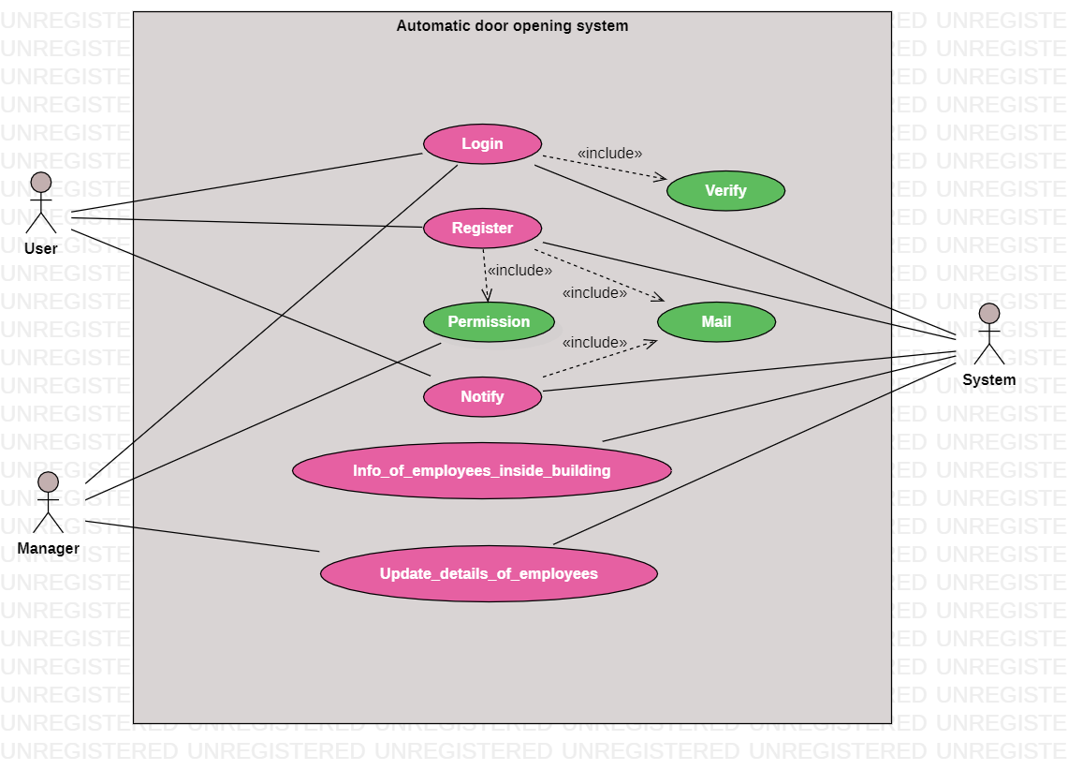

**3. Specific requirements:**

**3.1 Functional requirements:**

We describe the functional requirements by giving various use cases.

**Use Case 1**

**Name**-Student Login

**Summary**- Allows Student to login

**Actors**- Student, System

**Pre-conditions:**

* Only for registered IDs
* Login time resides in allotted slot

**Extension:**

* Id or password is wrong then it will show error dialog box
* Login time does not reside in allotted slot then it will show no permission granted dialog box

**Post-condition:**

NIL

**Use Case 2**

**Name**-Student registration

**Summary**-Allows student to Register

**Actors**-Student, Manager, System

**Pre-conditions:**

Firstly, Manager needs to give the permission

**Extension:**

* An email will be send after registration

**Post-conditions:**

NIL

**Use Case 3**

**Name**-Student exit

**Summary**-Allows student to exit

**Actors**-Student,System

**Pre-conditions:**

Student must have logged into the system

**Extension:**

* If the user hasn’t logged in then user can’t exit

**Post-conditions:**

NIL

**Use Case 4**

**Name**-Student change password

**Summary**-Student can change his/her password

**Actors**-Student,Manager

**Pre-conditions:**

Only registered students can change their passwords

**Extension:**

NULL

**Post-conditions:**

NULL

**Use Case 5**

**Name**-Manager login

**Summary**-allows manager to login

**Actors**-Manager, System

**Pre-conditions:**

* Only for registered IDs
* Login time resides in allotted slot

**Extension:**

* Id or password is wrong then it will show an error dialog box.
* Login time does not reside in allotted slot then it will show no permission granted dialog box

**Post-condition:**

NIL

**Use Case 6**

**Name**-Permission for registration

**Summary**- For any new student registration the permission of Manager is required

**Actors**-Manager, System, Student

**Pre-conditions:**

* Only for members

**Extension:**

NULL

**Post-conditions:**

NULL

**Use Case 7**

**Name**-Update Details

**Summary**- As many new student joins or leaves the schools or the timing changes then updating details is required

**Actors**-Manager, System

**Pre-conditions:**

* School had witnessed changes in their database

**Extension:**

NULL

**Post-conditions:**

NULL

**Use Case 8**

**Name**-Track users and update details

**Summary**- Tracks the details updated by the user

**Actors**-Manager,System

**Pre-conditions:**

* User must have updated something

**Extension:**

NULL

**Post-conditions:**

NULL

**Use Case 9**

**Name**-Verify and permission to enter

**Summary**-Verifies a user by their login credentials and the allotted time slot and gives permission to enter

**Actors**-Student,Manager,System

**Pre-conditions:**

* Student must have registered in the system
* Student tries to enter in their allotted times

**Extension:**

* If the allotted time does not match with current time or user has entered wrong or unauthentic information, then show not allowed dialog box else shows please enter dialog box

**Post-conditions:**

NULL

**Use Case 10**

**Name**-Verify and permission to register

**Summary**-Verifies a user by their login credentials and the allotted time slot and gives permission to register

**Actors**-Student,Manager,System

**Pre-conditions:**

* Entered credentials should be correct

**Extension:**

* If the user has entered wrong or unauthentic information, then show error message

**Post-conditions:**

NULL

**Use Case 11**

**Name**-Check continuously

**Summary**-System will check continuously for time limits

**Actors**-System

**Pre-conditions:**

User must have logged into the system then only system will continuously check time slots

**Extension:**

* If time limit expires then user will be notified

**Post-conditions:**

NULL

**Use Case 12**

**Name**-Mail

**Summary**- When a person’s time limit exceeds then it will notify via mail

**Actors**-System, Student

**Pre-conditions:**

* Student is present in the building even after his allotted time expires

**Extension:**

* Sends an email to leave the building

**Post-conditions:**

NULL

**Use Case 13**

**Name**-Tracking

**Summary**-Keeps a track of time when the user is present in the building.

**Actors**-SYSTEM

**Pre-conditions:**

NULL

**Extension:**

NULL

**Post-conditions:**

NULL

**3.2 Non functional requirements**

**3.2.1 User Friendly**

* There will be very less time between navigation
* It is a simple software and it is easy to use.

**3.2.2 Performance Requirement**

System should have performed in most operating systems without any hassle. Background running will be faster which will ensure notification is done on time.

**3.2.3 Safety Requirement**

There should be focus to keep safe essential and private details i.e email id, password etc. Of users’ like the whole database should be stored in encrypted format so that no one can access it .Also the password would not be known or accessible to anyone except the user.

**3.2.4 Security Requirement**

The handling of user id and password will be done with the help of Firebase which has no security issues.System should have been pre installed antivirus, security functions which can prevent your system from malicious activities and keep it safe from malwares and unknown attacks.

**3.2.5 Data Integrity**

System should be accessed only by university mail id and pre-registered mail id to detect the users’ identity and time should be calculated from Indian Standard Time Zone which needs to be entered in the database.

**3.2.6 Manageability requirement**

System has to notify about regular updates and any maintenance if required in software. Unknown user entry is strictly prohibited until being registered with valid email id into the system.

**3.3. Hardware Requirements**

It should run on an android device requiring a minimum 2GB ram for smooth functionality of the app.

**3.4. Software Requirements**

Minimum SDK version: Android 4.0.3(Ice Cream Sandwich)

**3.5. Design Constraints**

* Data will not get corrupted in case of system failure.
* The password should not be accessible to anyone except the user.