**Class, Sequence, State and E R Diagrams**

*FOR THE DEGREE OF*

**Bachelor of Technology**

*IN*

**Information Technology**



*BY*

**Navneet Singh (IIT2019056)**

**Gautam Kumar (IIT2019087)**

**Ritik kumar (IIT2019088)**

**Subham Kumar (IIT2019093)**

**Class Diagram**

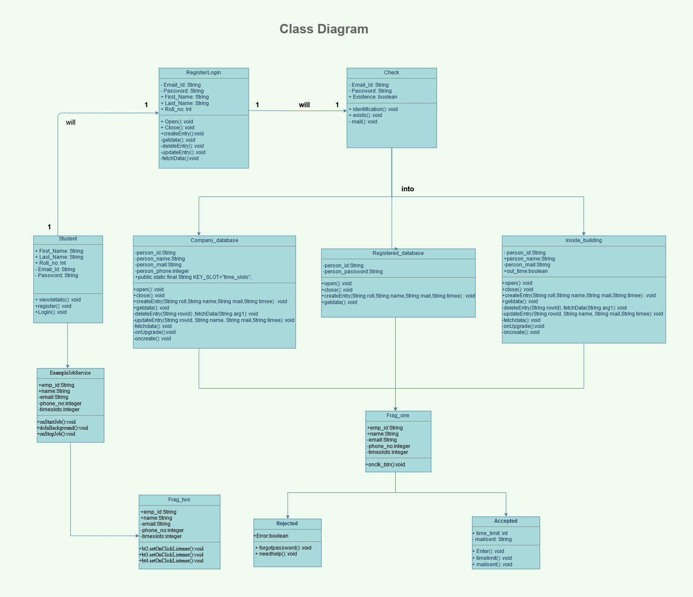

**SEQUENCE DIAGRAM**

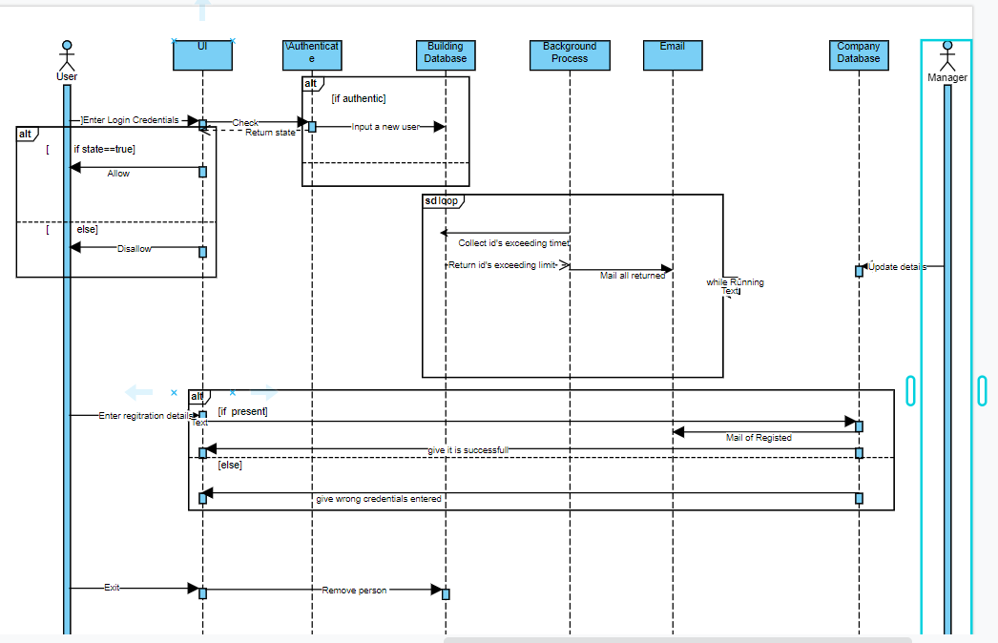

**STATE DIAGRAM:-**

