***TESTING***

WE HAVE TOTAL OF 16 MAIN TEST CASES AND 34 SUB TEST CASES

|  |  |
| --- | --- |
| Test ID | Test description |
| T1 | student Register |
| T-2 | Student login |
| T-3 | Student exit |
| T-4 | Users change password |
| T-5 | manager login |
| T-6 | Updating details of users |
| T-7 | Removing users |
| T-8 | Verify details and give permission to enter |
| T-9 | registration permission is required |
| T-10 | Mail for timeout |
| T-11 | Mail registration notification |
| T-12 | Flagging entry/exit time |
| T-13 | Manager sees the entry/exit time |
| T-14 | Manager sees the details of user |
| T-15 | Manager inserts details of person |
|  |  |

|  |  |  |  |
| --- | --- | --- | --- |
| TEST ID | How to do | Sub Test case ID | Sub Test case description |
| T-1 | Go to user/member section→Enter college Id & password→Click on register | T1.ST1 | Not a member of company |
| T1.ST2 | User enter correct credential |
| T1.ST3 | Already registered |
| T-2 | Go to user/member section→Enter registered college Id & password→Click on login | T2.ST1 | Not a member of company |
| T2.ST2 | User enter correct credential which is registered |
| T2.ST3 | User enter wrong credential |
| T2.ST4 | Not registered |
| T2.ST5 | Not in allocated time slot |
| T-3 | Go to user/member section→Enter registered college Id & password→Click on Exit | T3.ST1 | User enter correct credential |
| T3.ST2 | User enter wrong credential |
| T-4 | Go user/member section→ Manager will enter password→ User will enter new password→ Click on change password | T4.ST1 | Manager enter wrong password |
| T4.ST2 | Manager enter correct password |
| T-5 | Go to manager section→ Enter password | T5.ST1 | Manager enter wrong password |
| T5.ST2 | Manager enter correct password |
| T-6 | Go to manager section→Enter password→ Enter details in change record of users section->Click Submit | T6.ST1 | Manager enter wrong password |
| T6.ST2 | Manager enter correct password |
| T-7 | Go to manager section→Enter password→ Enter details in change record of users section→ Click on remove/submit accordingly | T7.ST1 | Manager enter wrong password |
| T7.ST2 | Manager enter correct password |
| T-8 | System’s work | T8.ST1 | Already registered |
| T8.ST2 | Not a member of company |
| T8.ST3 | User enter correct credential |
| T8.ST4 | User enter wrong credential |
| T8.ST5 | Not Registered |
| T8.ST6 | Not in allocated time slot |
| T-9 | System’s work |  |  |
| T-10 | System work | T10.ST1 | Time limit |
| T10.ST2 | Time limit not exceed |
| T-11 | System generated mail | T11.ST1 | Genuine user |
| T11.ST2 | Not genuine user |
| T-12 | Time at which student leaves/arrives system work |  |  |
| T-13 | Go to manager2 section→ Enter ID of particular student→Click on user flag | T13.ST1 | Manager enter wrong password |
| T13.ST2 | Manager enter correct password |
| T-14 | Go to manager2 section→ Enter ID of particular student→Click on user details | T14.ST1 | Manager enter wrong password |
| T14.ST2 | Manager enter correct password |
| T-15 | Go to manager1 section→Enter password→ Enter details in change record of users section  ->Click submit | T15.ST1 | Manager enter wrong password |
| T15.ST2 | Manager enter correct password |
|  |  |  |  |
|  |  |  |  |

TEST CASE-1

USER REGISTER

In this page, the user can register himself into the database by entering his college id and password and then clicking on register button

How to do-

Go to the user section then enter your college id and password and then click on the Register button.

Sub Test Cases-

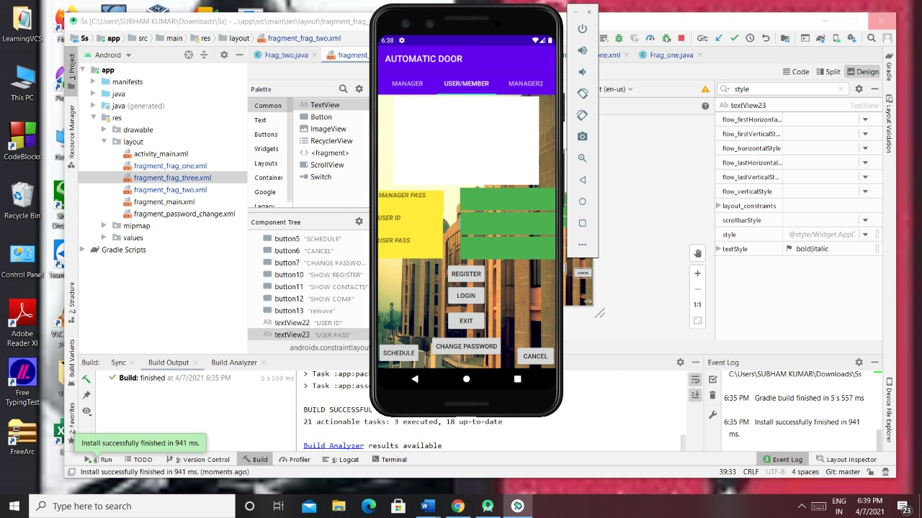

1)If the user is not a member of the company then he will not be allowed to register

2)If user is member of company and has entered correct credentials then a confirmation mail will be sent and will be registered

3)If the user is already registered then he will informed on the screen

TEST CASE-2

USER LOGIN

After the user gets registered successfully into the database then, the user can login by entering his ID and password and then clicking login button

How to do-

Go to the user section then enter your college id and password and then click on the login button.



Sub Test Cases-

1)If the user is not a member of the company/not registered then he will not be allowed to login

2)If the users enter wrong credentials then he’ll not be able to login

3)If the users enter correct credentials then he can login

4)If the user tries to login outside the time slot then he can’t login

TEST CASE-3

STUDENT EXIT

In this page,the user can exit by entering his correct id and password and then clicking on exit button

How to do-

Go to the user section then enter your college id and password and then click on the login button.

Sub Test Cases-



1)If the user enters correct credentials then he can exit

2)If the user enters wrong credentials then he can’t exit

TEST CASE-4

USER CHANGE PASSWORD

In this page, the user can change his/her password with the help of manager.First the manager will enter his correct password and then the user will enter his Id and new password and then click on change password button



How to do-

Go to the manager,then the manager will go to the user section and he will enter his correct password and then the user will enter his correct credentials and then he’ll click on the change password button.

Sub Test Cases-

1)If the manager enters the wrong password,then the user can’t change his password.

2)If the manager enters the correct password,then the user can change his password.

TEST CASE-5

MANAGER LOGIN

In this page,the manager can login by entering his correct password

How to do-

Go to Manager2 section then enter manager’s correct login password

Sub Test Cases-

1)If the manager enters wrong password then he can’t login

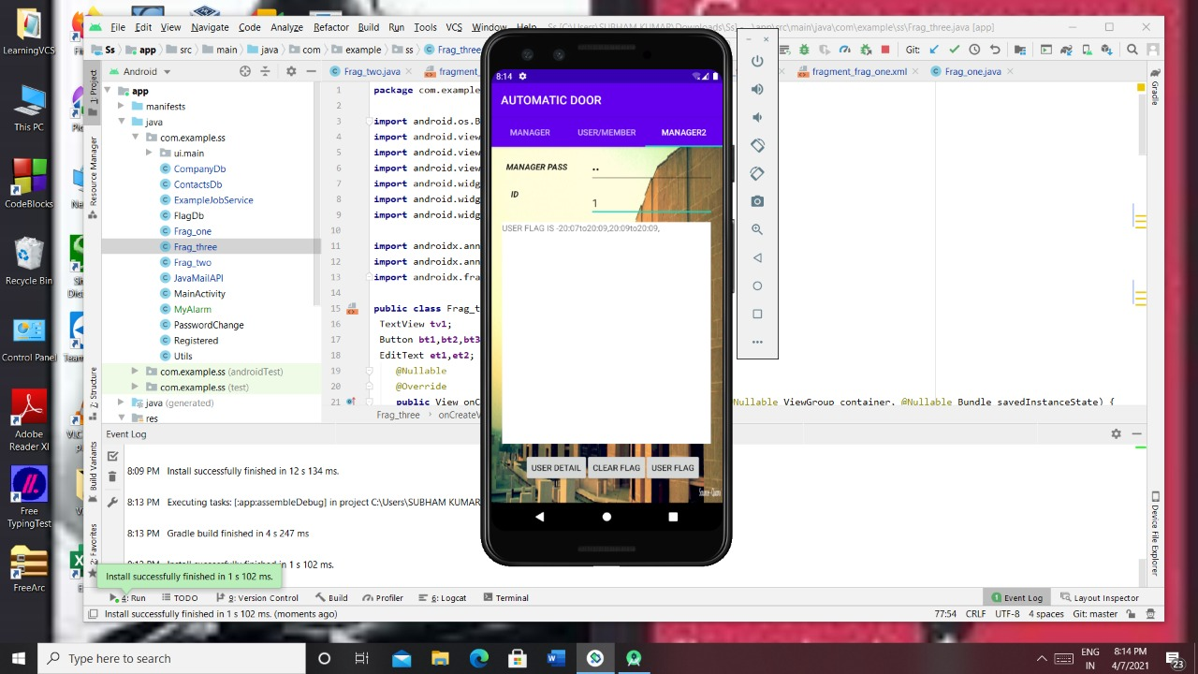

2)If the manager enters correct password then he can login

TEST CASE-6

UPDATING DETAILS OF USERS

In this page, the manager will enter his password and then he’ll enter the details of that student (like user’s roll no,name,email id etc) whose details needs to be updated and then he’ll click on add button

How to do-

Go to manager section then enter manager’s

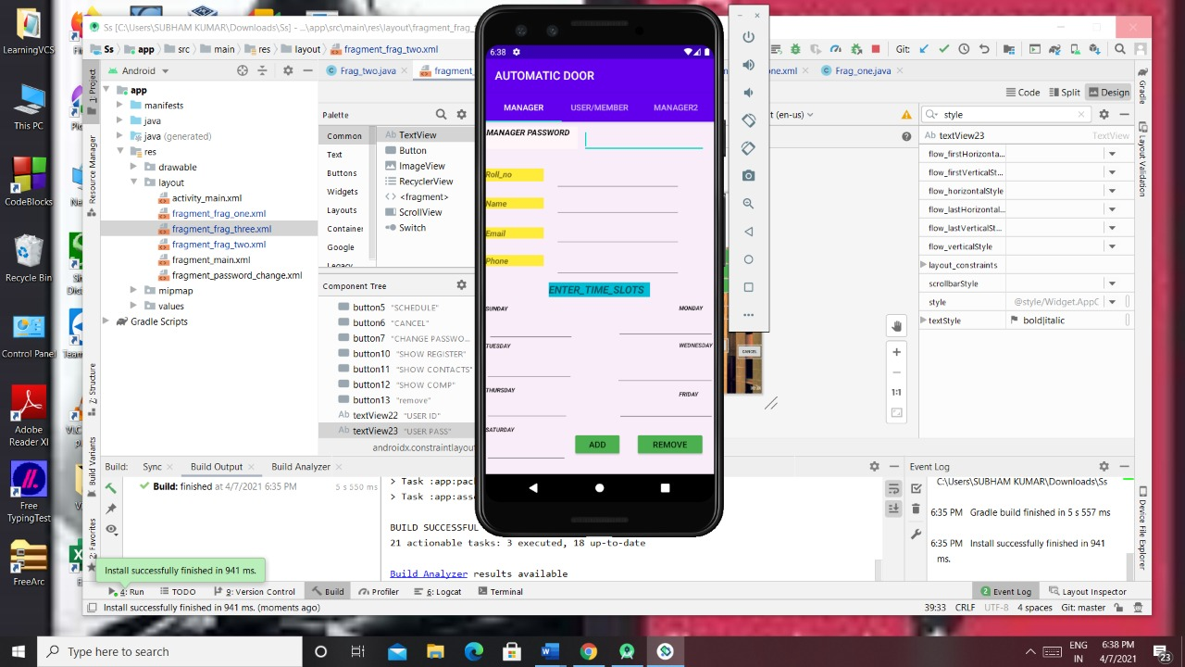

correct password then enter the user’s details which are required to be updated

Sub Test Cases-

1)If the manager enters correct password then he can update the details of the user

2)If the manager enters wrong password then he can’t update the details of the user

TEST CASE-7

REMOVING USERS

In this page, the manager will enter his/her password then he’ll enter the enter the details of that user whom he want to remove and then he’ll click on remove button

How to do-

Go to Manager section and then enter manager’s correct password then enter the



details of those users whom you want to remove

Sub Test Cases-

1)If the manager enters correct password then he can remove the user

2)If the manager enters wrong password then he can’t remove the user

TEST CASE-10

MAIL FOR TIMEOUT

Here, a system generated mail will be sent automatically when the time allotted to the student will expire and it’ll tell the student to come out of the building

How to do-

Mail will be sent by system automatically when the time limit expires

Sub Test Cases-

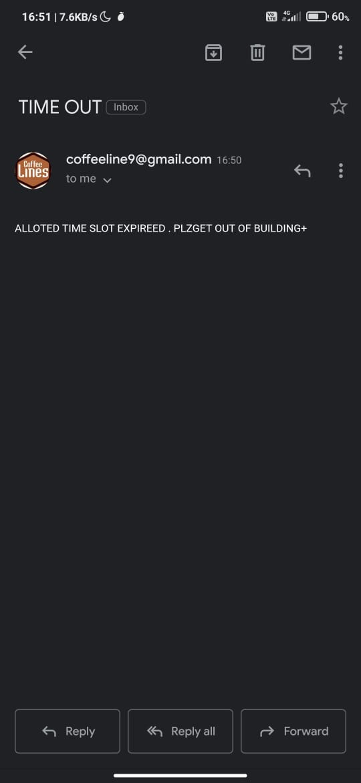

1)If the time limit expires then mail will be sent automatically to the user on his registered email id

2)1)If the time limit is not expired then mail will not be sent automatically to the user on his registered email id

TEST CASE-11

MAIL REGISTRATION NOTIFICATION

Here, a system generated mail will be sent to the user who will register themselves into the system and that mail will say that “you are registered”

How to do-

Mail will be sent by system automatically when the user registers

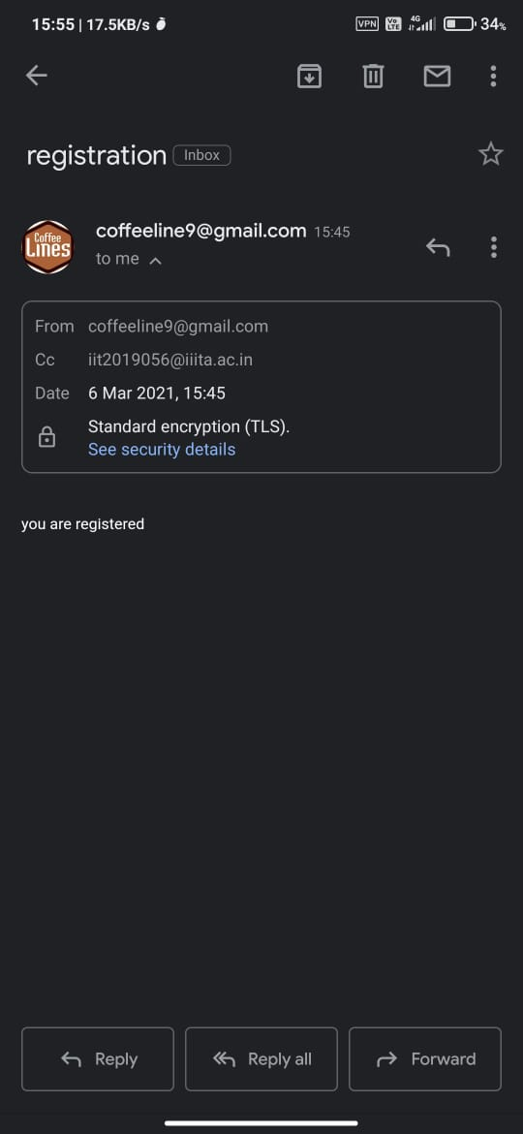

himself successfully

Sub Test Cases-

1)If the user has registered himself successfully on the database then a successful registration email will be sent on his registered email ID

2)If the user hasn’t registered himself successfully on the database then no mail will be sent to him

TEST CASE-13

MANAGER SEES THE ENTRY/EXIT TIME

In this page, the manager will enter his/her password and then he’ll enter the ID of that student whose entry/exit details he wants to see and then he’ll click on user detail button

How to do-

Go to Manager2 section then enter Manager’s

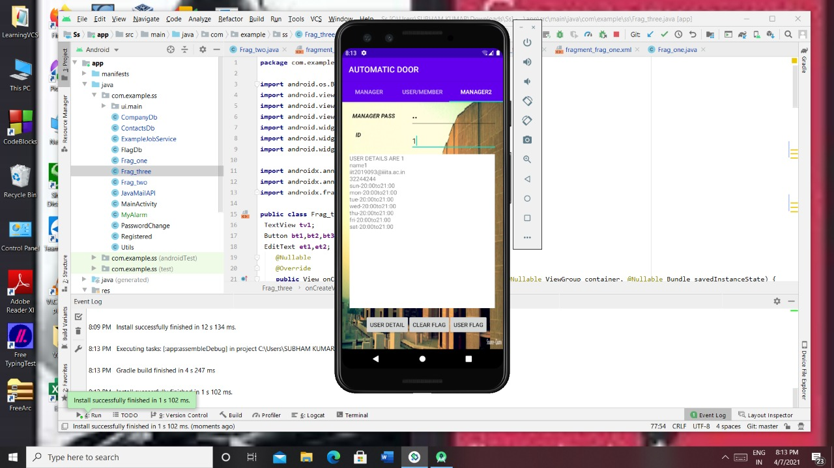

correct password then enter the user’s ID whose entry/exit time you want to see

Sub Test Cases-

1)If the manager enters correct password then he can update the details of the user

2)If the manager enters wrong password then he can’t update the details of the user

TEST CASE-14

MANAGER SEES THE DETAILS OF USER

In this page, the manager will enter his/her password and then he’ll enter the ID of that student whose details he wants to see and then click on the user detail button



How to do-

Go to Manager2 section then enter correct password then enter the user’s ID whose details you want to see

Sub Test Cases-

1)If the manager enters correct password then he can see the details of the users

2)If the manager enters wrong password then he can’t see the details of the users

TEST CASE-15

MANAGER INSERTS DETAILS OF PERSON

In this page the manager will enter his password and then he’ll enter the details of the person (like user’s name,roll no,id etc.) which he wants to enter 

and then he’ll click on add to enter the details in the database

How to do-

Go Manager’s section then enter manager’s correct password then enter the details of the user which you want to insert into the database

Sub Test Cases-

1)If the manager enters correct password then he can insert details of a particular user

2)If the manager enters wrong password then he can’t insert details of a particular user

**INTEGRATION TESTING**

TEST CASE 1

Description:

We expect that as soon as the user enters his correct email address and password he can register himself into the system

In this case if the manager has registered the user in the database then only the user can register into the system by entering his registered ID and password and after registering successfully a mail will be sent on the user’s registered email which says ‘you are registered’.

Since these related modules are working fine together, this test case is passed.

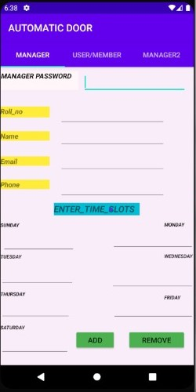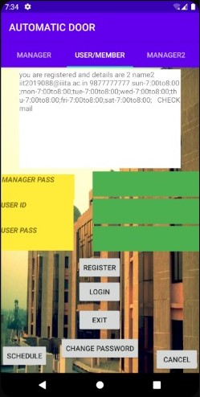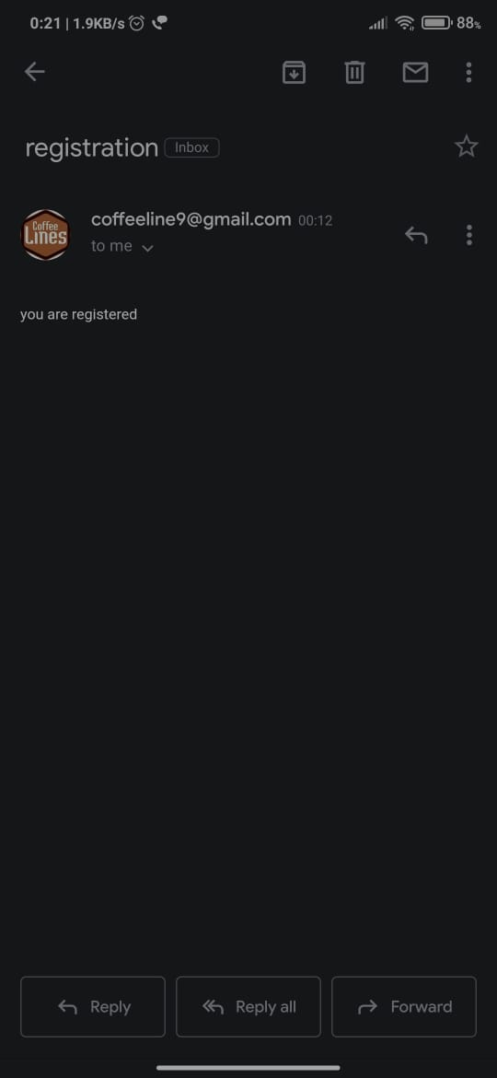

TEST CASE 2

Description:

We expect that as soon as the user enters his registered email address and password he can login into the system

In this case also if the user is registered into the database then only the user can login & the user can login only when he’s trying to login at a proper time slot which will be entered by the manager depending upon the requirements of the users.

Since these related modules are working fine together, this test case is passed.

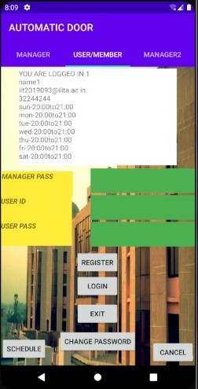

TEST CASE 3

Description:

We expect the manager to enter his correct password which will allow the users to change their passwords

In this case if the user is registered into the system then only he can change his password. First, the manager will enter his correct password which will allow the users to enter their details so that they can change their password(assuming that they’re registered into the system)

Since these related modules are working fine together, this test case is passed.

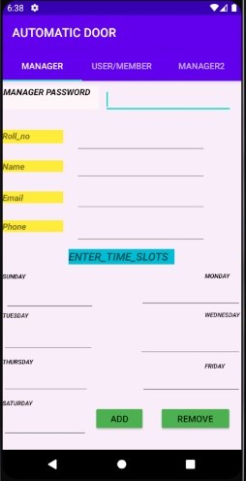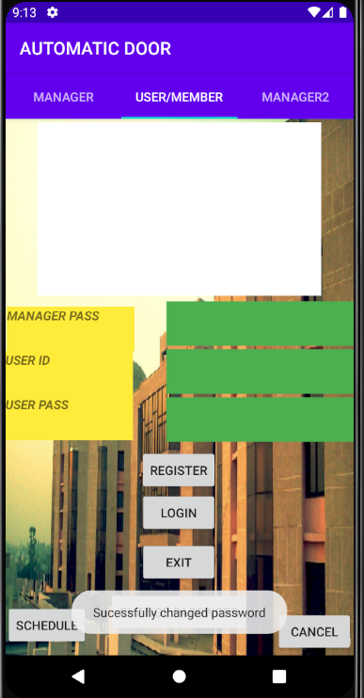



TEST CASE 4

Description:

We expect the manager to enter his correct password otherwise he can’t change/see anything.Then the manager will enter ID of that user whose entry/exit time he wants to see

In this case the manager will enter his correct password to login to the system and then the manager will enter the user’s ID whose entry/exit time is required and that ID should be present in the Registered database then only his entry/exit time will be shown otherwise it’ll show a blank screen only

Since these related modules are working fine together, this test case is passed.

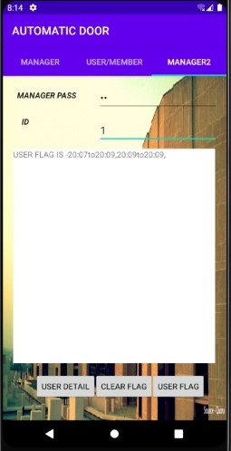

TEST CASE 5

Description:

We expect the manager to enter his correct password otherwise he can’t change/see anything.Then the manager will enter ID of that user whose details he wants to see

In this case the manager will enter his correct password to login to the system and then the manager will enter the user’s ID whose details are required and that ID should be present in the database then only the details of that user will be shown otherwise it’ll show a blank screen only

Since these related modules are working fine together, this test case is passed.

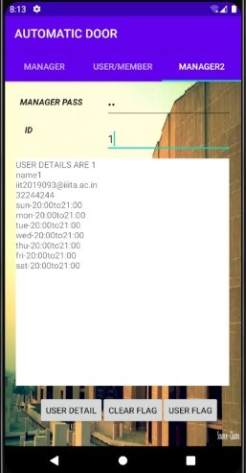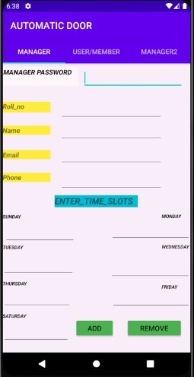

TEST CASE 6

Description:

We expect the manager to enter his correct password and then enter the id of the user whose flag he wants to remove as this will ensure the data is not overloaded.For clearing a user flag it should be registered first . Hence if user is registered then we can expect that his flag can be cleared

In this case the manager will enter his correct password to login to the system and then the manager will enter the roll number of that user whose flag he wants to erase and since the user was registered his flag got cleared.

Since these related modules are working fine together, this test case is passed.

