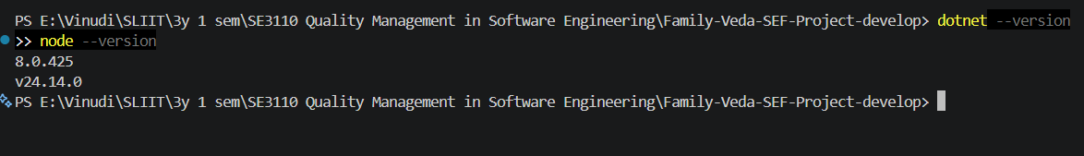
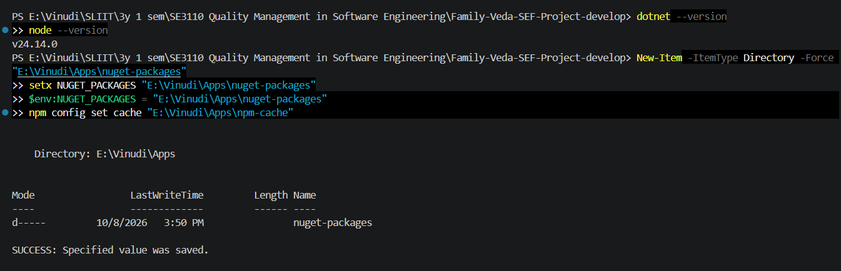
Backend
dotnet test backend/tests/UnitTests/FamilyVeda.UnitTests.csproj --filter "FullyQualifiedName~ConsentStateMachineTests"
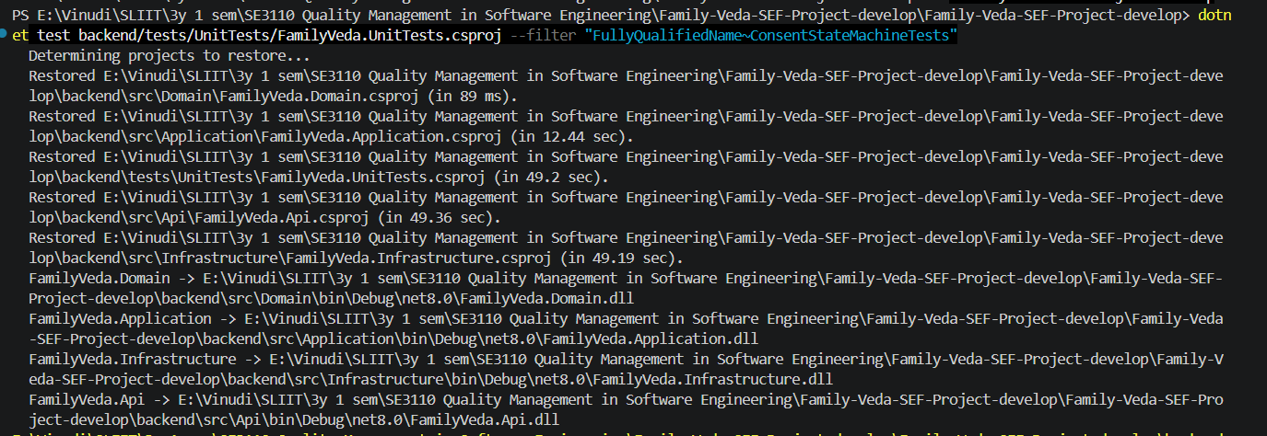
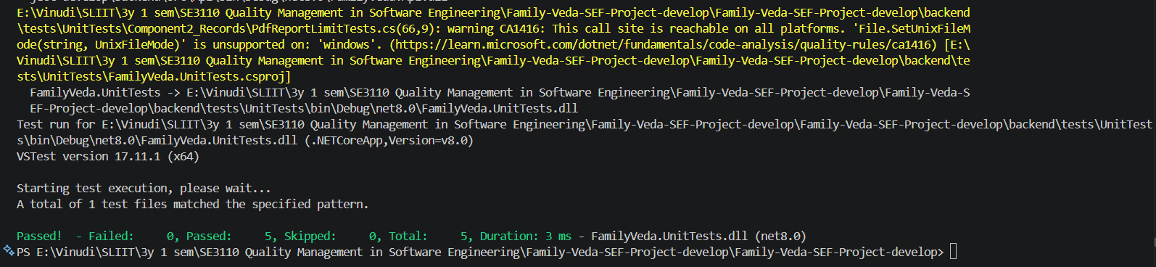
web test
cd web
npm install

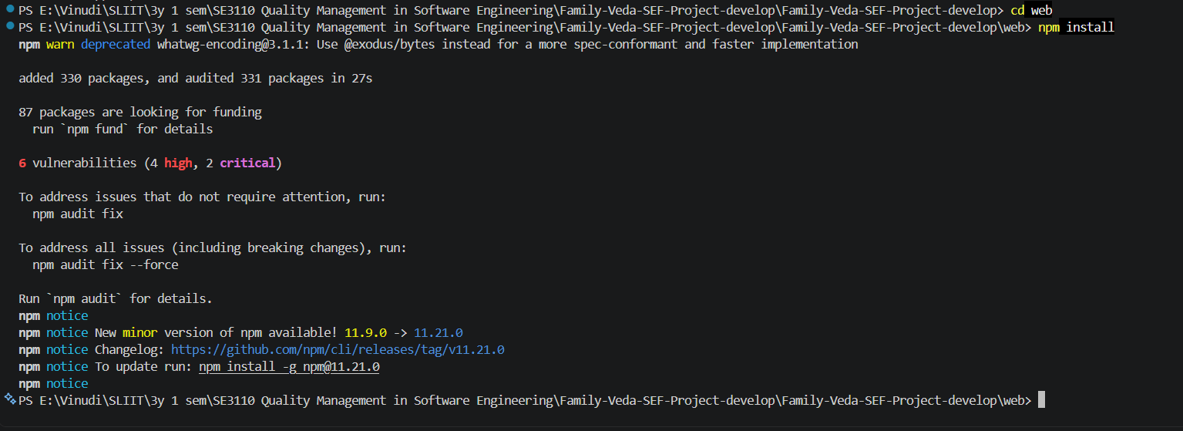
npx vitest run src/routes/AppRouter.test.tsx
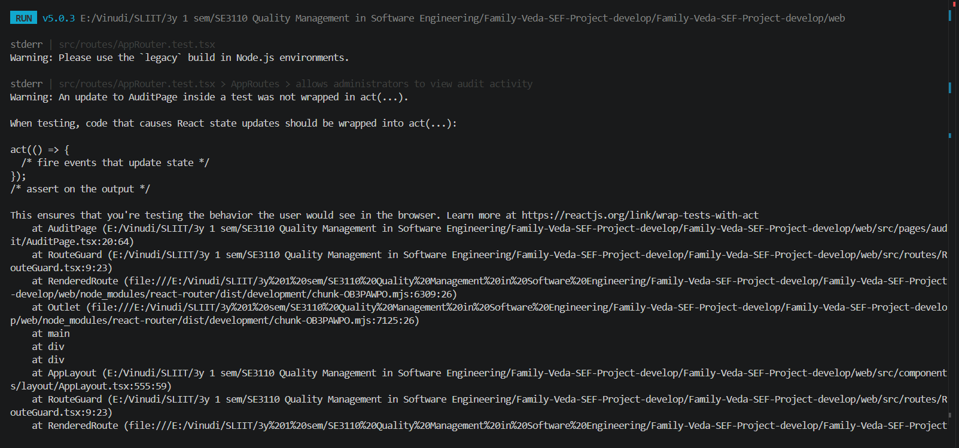
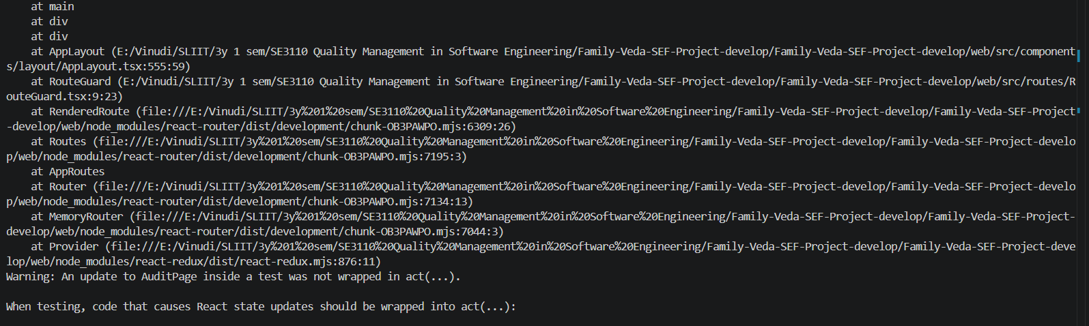
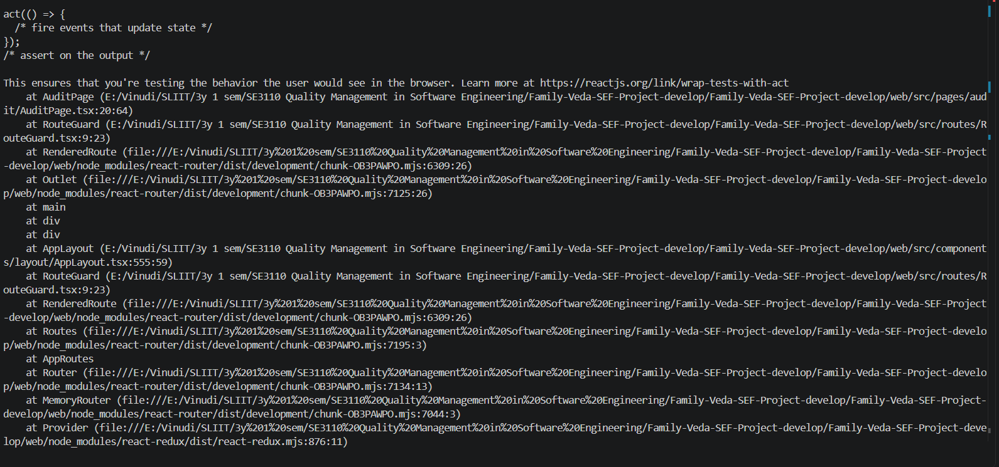
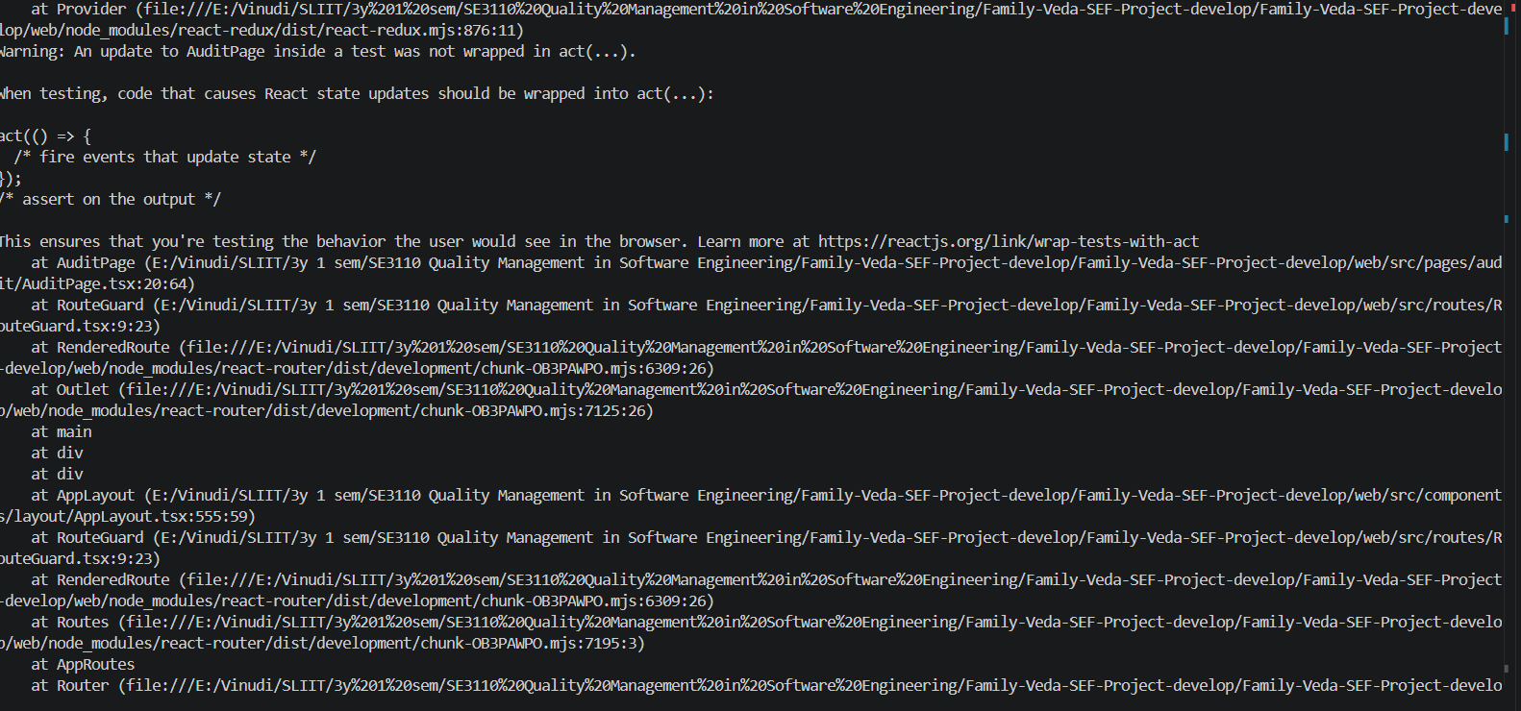
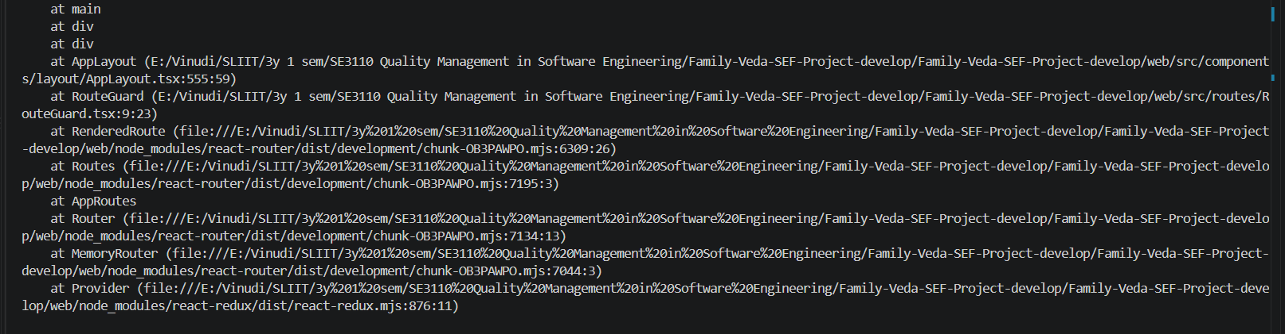
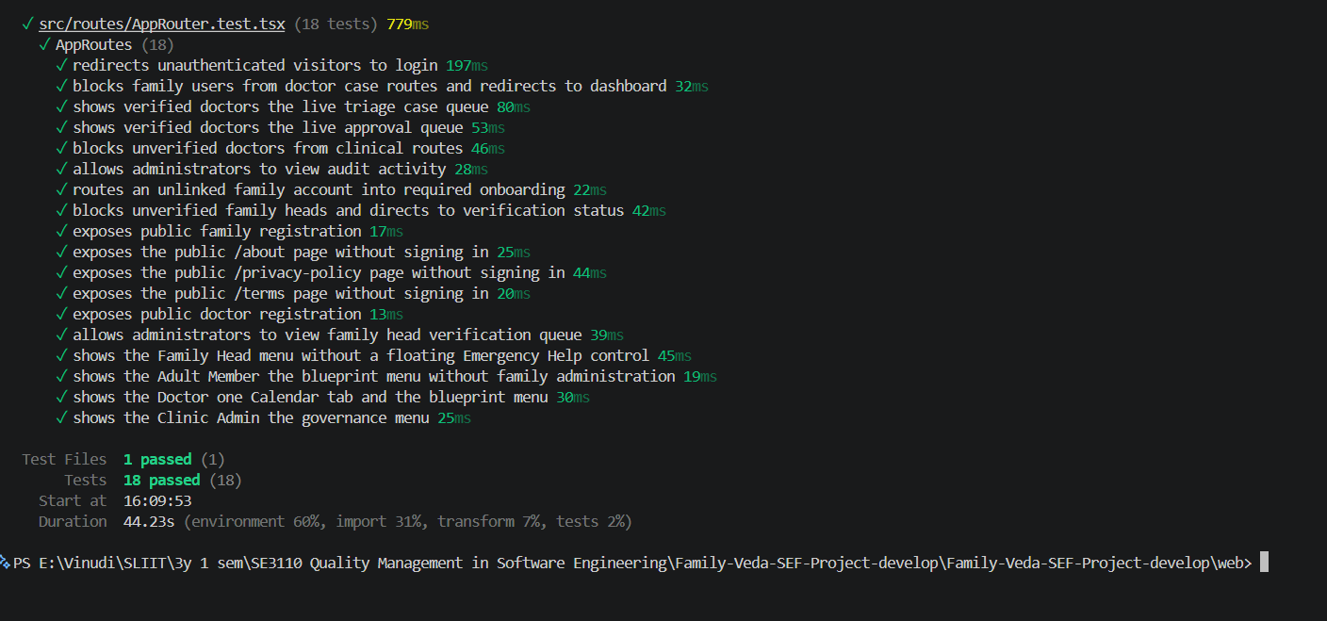
cd ..
2. Open the test file in VS Code:
backend\tests\UnitTests\Component1_Family\ConsentStateMachineTests.cs
3. Paste the new tests. Scroll to the very bottom of the file. The last line is a single }, which closes the class. Click at the end of the line just above it, press Enter, and paste this:
csharp

[Theory]
[InlineData(ConsentStatus.NotSet, ConsentStatus.Revoked)]
[InlineData(ConsentStatus.NotSet, ConsentStatus.PendingReaffirmation)]
[InlineData(ConsentStatus.Granted, ConsentStatus.Granted)]
[InlineData(ConsentStatus.Granted, ConsentStatus.NotSet)]
[InlineData(ConsentStatus.Revoked, ConsentStatus.PendingReaffirmation)]
[InlineData(ConsentStatus.PendingReaffirmation, ConsentStatus.NotSet)]
public void CanTransition_WhenMoveIsNotAllowed_ReturnsFalse(ConsentStatus from, ConsentStatus to)
{
Assert.False(ConsentStateMachine.CanTransition(from, to));
}

[Theory]
[InlineData(ConsentStatus.NotSet, ConsentStatus.Granted)]
[InlineData(ConsentStatus.Granted, ConsentStatus.Revoked)]
[InlineData(ConsentStatus.Revoked, ConsentStatus.Granted)]
[InlineData(ConsentStatus.PendingReaffirmation, ConsentStatus.Revoked)]
public void CanTransition_WhenMoveIsAllowed_ReturnsTrue(ConsentStatus from, ConsentStatus to)
{
Assert.True(ConsentStateMachine.CanTransition(from, to));
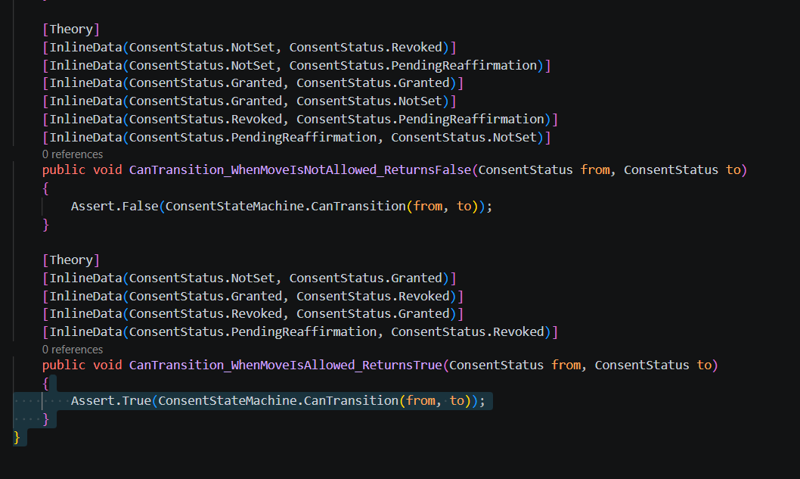

4. dotnet test backend/tests/UnitTests/FamilyVeda.UnitTests.csproj --filter "FullyQualifiedName~ConsentStateMachineTests"

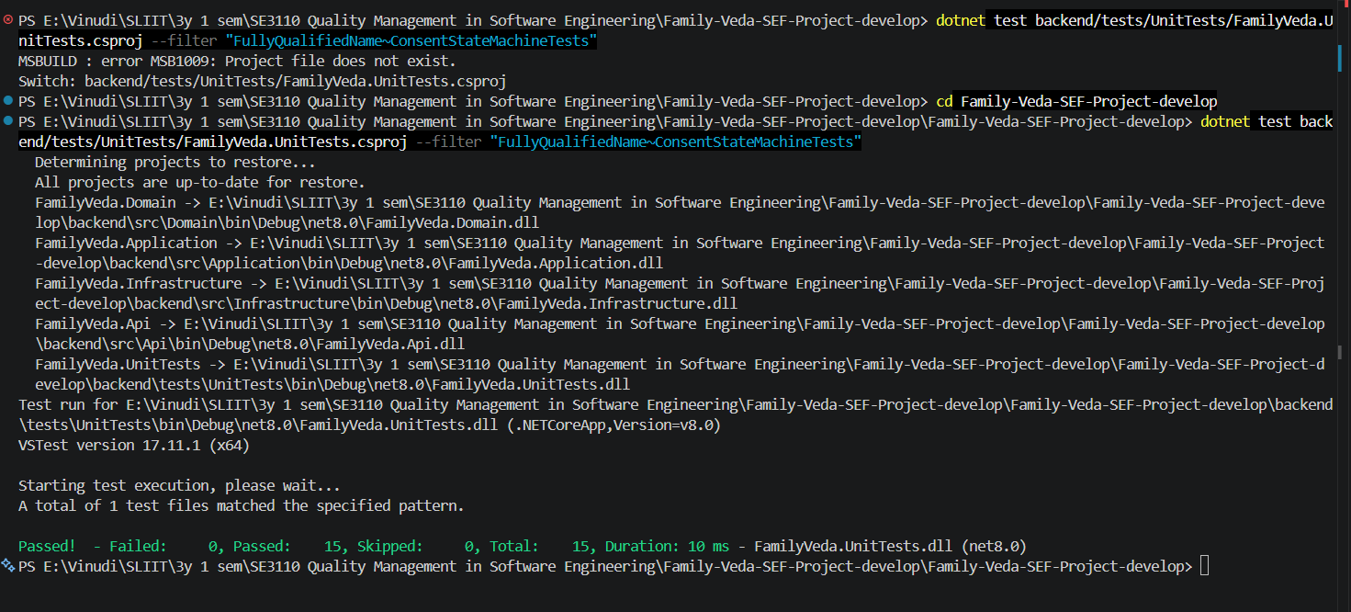
defect detected
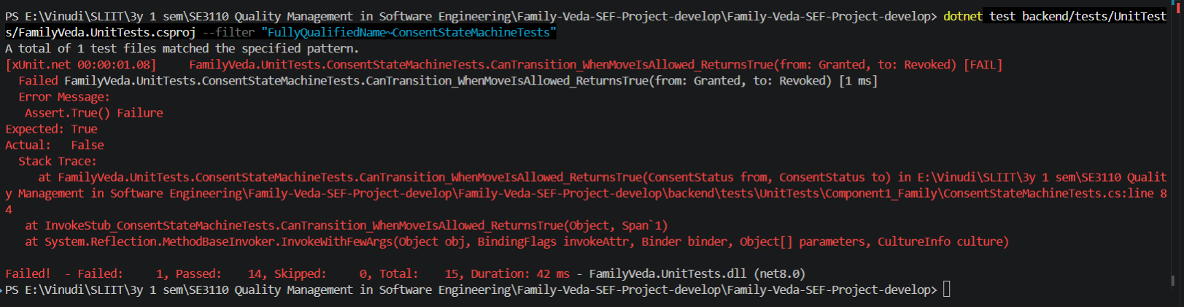
After correction
