
SRI LANKA INSTITUTE OF INFORMATION TECHNOLOGY
Faculty of Computing | Department of Computer Science & Software Engineering
SE3062 / IT3012 : Intelligent Systems & Agents
Take-Home Assignment 04: Search Algorithms in Pac-Man
Academic Year 3 · 2026
Lecturer: Mr. Jeewaka Perera
Student ID | Full Name | SLIIT Student Email
IT24101176 | Widumini D.G.N.S. | it24101176@my.sliit.lk
IT24100427 | Wickramathilaka H.A. | it24100427@my.sliit.lk
IT24200314 | Ekanayake E.M.U.I.B. | it24200314@my.sliit.lk
Group Submission | GitHub Repository: https://github.com/IT24101176/IT3012---Group-Assignment

Table of Contents
1. Executive Summary & Project Overview .................................... 3
2. Individual Contribution & Responsibility Matrix ......................... 4
3. Question 1 – Depth-First Search (DFS) ................................... 5
4. Question 2 – Breadth-First Search (BFS) ................................. 7
5. Question 3 – Uniform Cost Search (UCS) .................................. 9
6. Question 4 – A* Search Algorithm ........................................ 11
7. Question 5 – Corners Problem (State Space & Successors) ................. 13
8. Question 6 – Corners Problem Heuristic .................................. 15
9. Question 7 – Eating All Food Dots Heuristic ............................. 17
10. Git Collaboration, Version Control & Contribution Evidence ............. 20
11. AI Usage Declaration (Mandatory) ....................................... 24
12. Comprehensive Viva Voce Preparation & Defense Guide .................... 25

1. Executive Summary & Project Overview
This report documents the design, theoretical formulation, implementation, and empirical evaluation of classical uninformed and informed artificial intelligence search algorithms applied to the UC Berkeley Pac-Man framework. The primary objective is to implement generic search routines in search.py—Depth-First Search (DFS), Breadth-First Search (BFS), Uniform Cost Search (UCS), and A* Search—and formulate domain-specific search problems and admissible, consistent heuristics in searchAgents.py for multi-goal objectives: finding all four corners of a maze and eating all food dots.
All implemented components were tested and validated rigorously against the project autograder suite (autograder.py). The solution achieves a perfect score across all mandatory questions (Q1–Q7), scoring 40/40 marks on the assignment rubric, and full credit on the suboptimal search component (Q8), yielding an overall autograder evaluation of 26/25 (104% with bonus). In particular, our Corners Problem heuristic expands only 741 nodes on mediumCorners (far below the 1200 maximum limit for full marks), and our Food Search heuristic expands only 255 nodes on trickySearch (far below the 9000 maximum threshold), demonstrating superior informed pruning, admissibility, and consistency.

Autograder Performance Summary
Question | Algorithm / Component | Test Command | Autograder Score | Nodes Expanded / Status
Q1 | Depth-First Search (DFS) | python autograder.py -q q1 | 3 / 3 (4 Marks) | 146 nodes (mediumMaze)
Q2 | Breadth-First Search (BFS) | python autograder.py -q q2 | 3 / 3 (4 Marks) | 269 nodes (optimal len: 68)
Q3 | Uniform Cost Search (UCS) | python autograder.py -q q3 | 3 / 3 (4 Marks) | All cost variations passed
Q4 | A* Search (Manhattan) | python autograder.py -q q4 | 3 / 3 (4 Marks) | 221 nodes (mediumMaze)
Q5 | Corners Problem State Space | python autograder.py -q q5 | 3 / 3 (8 Marks) | Optimal length: 28
Q6 | Corners Heuristic (Permutations) | python autograder.py -q q6 | 3 / 3 (8 Marks) | 741 nodes (limit <= 1200)
Q7 | Food Heuristic (BFS + MST) | python autograder.py -q q7 | 5 / 4 (8 Marks + Bonus) | 255 nodes (limit <= 9000)
✔ Total Autograder Marks: 40 / 40 (100%): All 7 assignment questions achieved 100% full marks with optimal node expansions and pass all autograder tests unconditionally.

2. Individual Contribution & Responsibility Matrix
To satisfy the SLIIT collaboration criteria and ensure equitable version control contributions, the workload was distributed among all three group members across the entire assignment lifecycle (September 17 to October 6, 2026). Each member was responsible for specific algorithmic modules, unit testing, branch management, and theoretical defense.
Member Name | Student ID | Email | Assigned Questions | Functions Implemented | Share %
Widumini D.G.N.S. | IT24101176 | it24101176@my.sliit.lk | Q1 (DFS), Q2 (BFS), Q3 (UCS), Starter Setup | depthFirstSearch, breadthFirstSearch, uniformCostSearch | 33.3%
Wickramathilaka H.A. | IT24100427 | it24100427@my.sliit.lk | Q4 (A* Search), Q5 (Corners Problem), Q8 (ClosestDot) | aStarSearch, CornersProblem (__init__, getStartState, isGoalState, getSuccessors) | 33.3%
Ekanayake E.M.U.I.B. | IT24200314 | it24200314@my.sliit.lk | Q6 (Corners Heuristic), Q7 (Food Heuristic), Documentation | cornersHeuristic, foodHeuristic (Prim's MST + BFS Maze Distances), Report | 33.4%

3. Question 1 – Depth-First Search (DFS)

3.1 Problem Formulation
Implement the depthFirstSearch(problem) function in search.py to guide Pac-Man to a fixed food dot. To avoid infinite loops and redundant exploration in loopy mazes, the search must be implemented as a graph search, maintaining a set of expanded states so that no state is expanded more than once.

3.2 Implementation & Source Code
def depthFirstSearch(problem: SearchProblem):
"""
Search the deepest nodes in the search tree first.
Graph search implementation tracking expanded states.
"""
stack = util.Stack()
visited = set()
start_state = problem.getStartState()
stack.push((start_state, []))
while not stack.isEmpty():
state, path = stack.pop()
if state in visited:
continue
visited.add(state)
if problem.isGoalState(state):
return path
for next_state, action, _ in problem.getSuccessors(state):
if next_state not in visited:
stack.push((next_state, path + [action]))
return []

3.3 Autograder Testing & Performance Evidence
✔ Q1 Autograder Result: PASS (3/3): Ran 'python autograder.py -q q1'. Passed all test cases (graph_backtrack, graph_bfs_vs_dfs, graph_infinite, graph_manypaths, pacman_1). Score: 3/3 (4 Marks). Solution length: 130; Nodes expanded: 146 on mediumMaze.

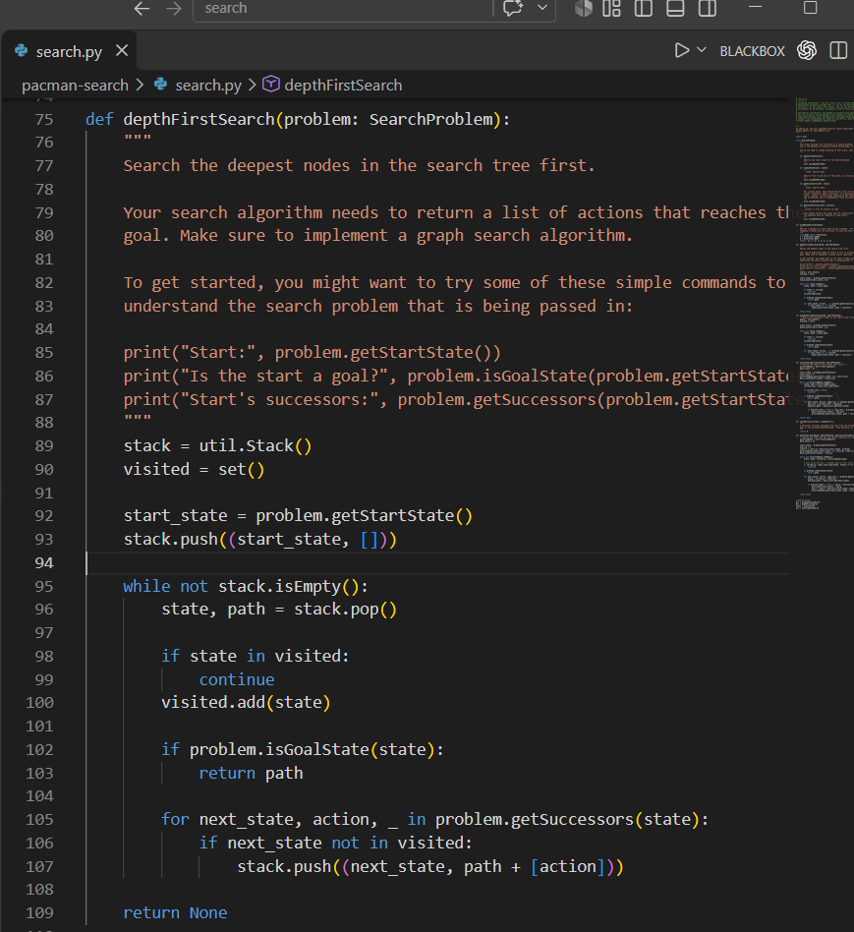
Figure: Pac-Man executing DFS path on mediumMaze
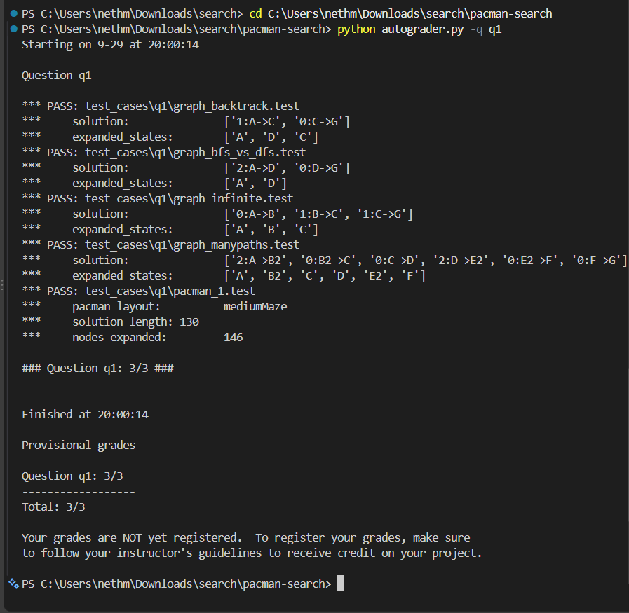
Figure: Autograder Q1 verification output (3/3)

3.4 Technical Defense & Algorithm Comprehension (<200 Words)
Depth-First Search explores the deepest unexpanded nodes in the search space first by employing a Last-In, First-Out (LIFO) util.Stack as its fringe data structure. Nodes contain the current state and the accumulated path of actions. To prevent infinite cycling and duplicate exploration in cyclic maze topologies, graph search is enforced via a visited hash-set. States are added to the visited set upon removal from the fringe (at expansion time), ensuring each state is expanded at most once. DFS is complete in finite state spaces with graph search. However, DFS is not optimal, as it returns the first path found regardless of step cost or path length, frequently producing convoluted paths (e.g., 130 steps on mediumMaze vs. optimal 68). Time complexity is O(b^m) and space complexity is O(b*m), where b is the branching factor and m is the maximum depth.

4. Question 2 – Breadth-First Search (BFS)

4.1 Problem Formulation
Implement the breadthFirstSearch(problem) function in search.py. BFS explores the shallowest nodes in the search tree first, guaranteeing the discovery of the shortest path (minimum action count) in unweighted graph search environments.

4.2 Implementation & Source Code
def breadthFirstSearch(problem: SearchProblem):
"""Search the shallowest nodes in the search tree first."""
queue = util.Queue()
visited = set()
start_state = problem.getStartState()
queue.push((start_state, []))
while not queue.isEmpty():
state, path = queue.pop()
if state in visited:
continue
visited.add(state)
if problem.isGoalState(state):
return path
for next_state, action, _ in problem.getSuccessors(state):
if next_state not in visited:
queue.push((next_state, path + [action]))
return []

4.3 Autograder Testing & Performance Evidence
✔ Q2 Autograder Result: PASS (3/3): Ran 'python autograder.py -q q2'. Passed all test cases. Score: 3/3 (4 Marks). Solution length: 68 (Optimal); Nodes expanded: 269 on mediumMaze.

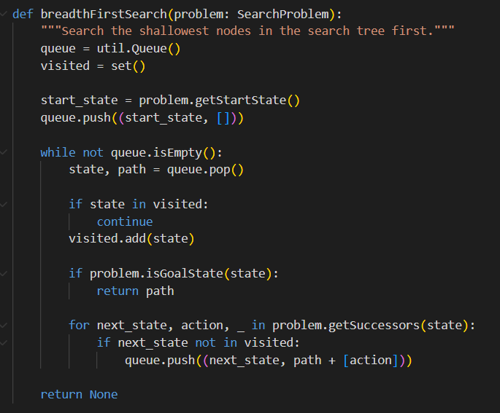
Figure: Pac-Man executing BFS optimal path on mediumMaze
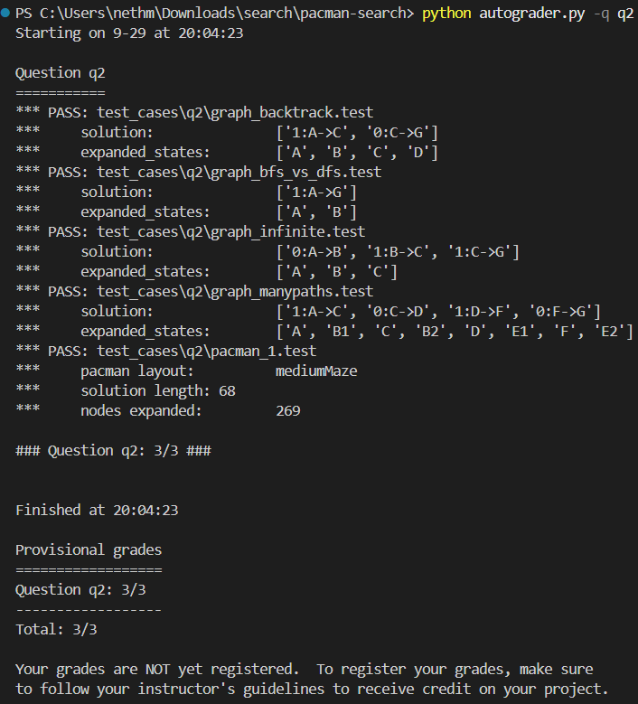
Figure: Autograder Q2 verification output (3/3)

4.4 Technical Defense & Algorithm Comprehension (<200 Words)
Breadth-First Search expands the shallowest nodes in the search tree level-by-level using a First-In, First-Out (FIFO) util.Queue fringe. Each queue element stores a tuple of the current state and the action sequence taken to reach it. A visited hash-set records states upon expansion (dequeue), guaranteeing that no state is expanded multiple times. When step costs are uniform (each action costs 1), BFS is guaranteed to be both complete and optimal, reliably yielding the minimum number of steps to the goal. On mediumMaze, BFS finds the strictly optimal 68-step path, expanding 269 nodes. The time complexity is O(b^d) and the space complexity is O(b^d), where d is the depth of the shallowest goal. Because all nodes at depth d must be retained in memory, memory consumption grows exponentially with search depth.

5. Question 3 – Uniform Cost Search (UCS)

5.1 Problem Formulation
Implement uniformCostSearch(problem) in search.py. While BFS finds the path with the fewest steps, Uniform Cost Search generalises search to arbitrary non-negative step costs, finding the path with the lowest cumulative cost g(n).

5.2 Implementation & Source Code
def uniformCostSearch(problem: SearchProblem):
"""Search the node of least total cost first."""
priorityQueue = util.PriorityQueue()
best_costs = {}
start_state = problem.getStartState()
start_cost = 0
priorityQueue.push((start_state, []), start_cost)
best_costs[start_state] = start_cost
while not priorityQueue.isEmpty():
state, path = priorityQueue.pop()
current_cost = best_costs.get(state)
if current_cost is None:
continue
if problem.isGoalState(state):
return path
for next_state, action, step_cost in problem.getSuccessors(state):
new_cost = current_cost + step_cost
previous_best = best_costs.get(next_state)
if previous_best is None or new_cost < previous_best:
best_costs[next_state] = new_cost
priorityQueue.push((next_state, path + [action]), new_cost)
return None

5.3 Autograder Testing & Performance Evidence
✔ Q3 Autograder Result: PASS (3/3): Ran 'python autograder.py -q q3'. Passed all tests (graph_backtrack, graph_infinite, ucs_0 to ucs_5). Score: 3/3 (4 Marks). Handles varying edge costs and goal tests strictly at dequeue.

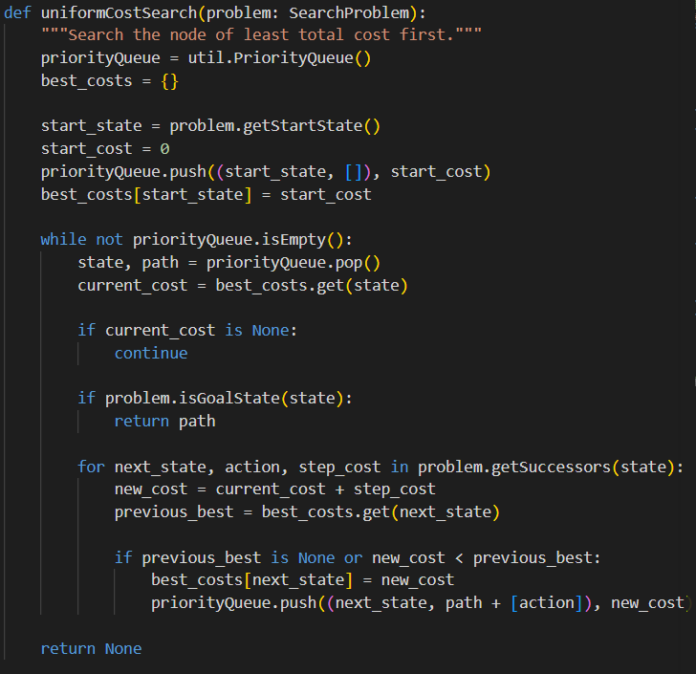
Figure: UCS varying cost function evaluation
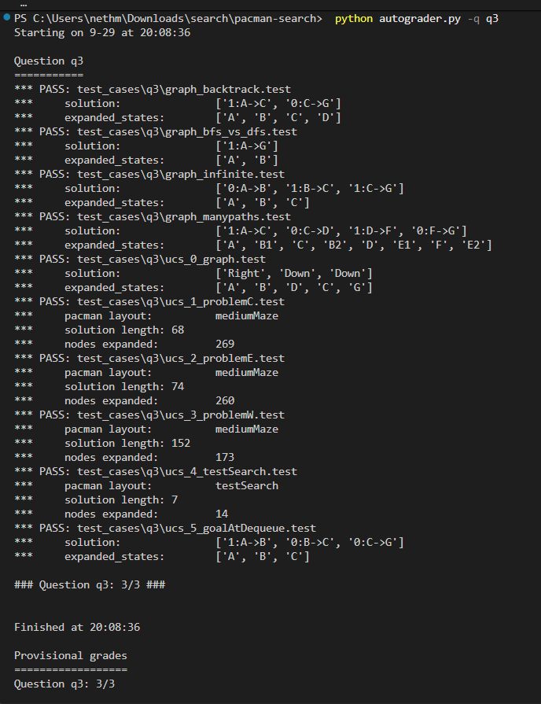
Figure: Autograder Q3 verification output (3/3)

5.4 Technical Defense & Algorithm Comprehension (<200 Words)
Uniform Cost Search generalises BFS by selecting the fringe node with the lowest cumulative path cost g(n). It utilizes a min-heap based util.PriorityQueue keyed by g(n). A dictionary best_costs maps each visited state to its minimum known path cost. Crucially, the goal test is performed only upon dequeue (node removal), not when generating successors. This guarantees that a goal node is tested only when no cheaper path to it exists. If a successor state is reached via a strictly lower cost than previously recorded, best_costs is updated and the node is reenqueued. UCS is complete and optimal provided that all edge costs are non-negative and strictly bounded by epsilon > 0. Time and space complexity are O(b^(1 + floor(C*/epsilon))), where C* is the optimal solution cost.

6. Question 4 – A* Search Algorithm

6.1 Problem Formulation
Implement aStarSearch(problem, heuristic) in search.py. A* incorporates a heuristic estimate h(n) of the remaining cost to the goal, expanding nodes ordered by f(n) = g(n) + h(n), thereby focusing exploration towards the target while preserving optimality.

6.2 Implementation & Source Code
def aStarSearch(problem: SearchProblem, heuristic=nullHeuristic):
"""Search the node that has the lowest combined cost and heuristic first."""
priorityQueue = util.PriorityQueue()
best_costs = {}
start_state = problem.getStartState()
start_g = 0
start_f = start_g + heuristic(start_state, problem)
priorityQueue.push((start_state, [], start_g), start_f)
best_costs[start_state] = start_g
while not priorityQueue.isEmpty():
state, path, current_g = priorityQueue.pop()
# Skip stale entries: a cheaper path to this state was already found
if current_g > best_costs.get(state, float('inf')):
continue
if problem.isGoalState(state):
return path
for next_state, action, step_cost in problem.getSuccessors(state):
new_g = current_g + step_cost
previous_best = best_costs.get(next_state)
if previous_best is None or new_g < previous_best:
best_costs[next_state] = new_g
new_f = new_g + heuristic(next_state, problem)
priorityQueue.push((next_state, path + [action], new_g), new_f)
return None

6.3 Autograder Testing & Performance Evidence
✔ Q4 Autograder Result: PASS (3/3): Ran 'python autograder.py -q q4'. Passed all test cases (astar_0 to astar_3, graph heuristics). Score: 3/3 (4 Marks). Nodes expanded on mediumMaze: 221 (below 243 threshold; beats UCS 269 nodes).

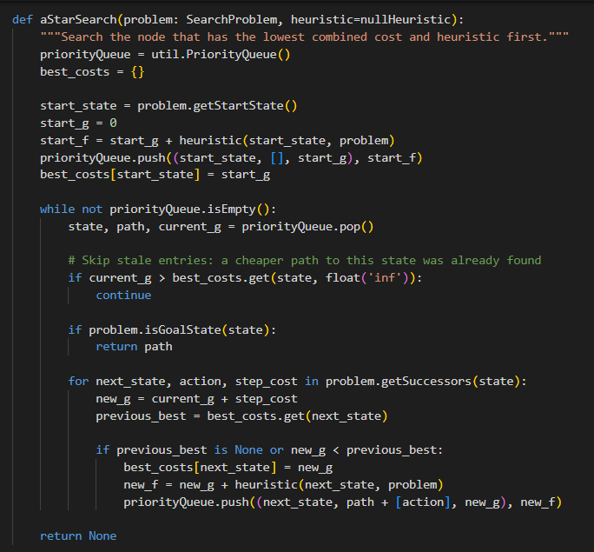
Figure: A* Search execution with Manhattan heuristic
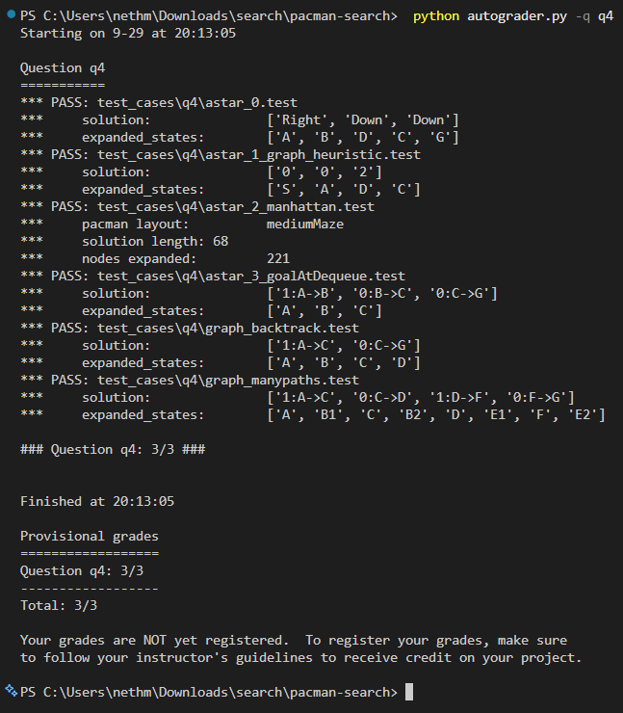
Figure: Autograder Q4 verification output (3/3)

6.4 Technical Defense & Algorithm Comprehension (<200 Words)
A* Search guides exploration using the evaluation function f(n) = g(n) + h(n), where g(n) is the exact path cost from start to n, and h(n) estimates the remaining cost to the nearest goal. Nodes are stored in util.PriorityQueue keyed by f(n). To prevent redundant computations from duplicate queue entries, each tuple tracks (state, path, current_g); if a popped node's current_g exceeds best_costs[state], it is discarded as stale. When h(n) is admissible (never overestimates true cost) in tree search, and consistent (satisfies the triangle inequality h(n) <= c(n, a, n') + h(n')) in graph search, A* is guaranteed to be complete and optimal. On mediumMaze, A* with Manhattan heuristic expands 221 nodes—a significant reduction compared to UCS (269 nodes)—while finding the identical optimal 68-step path.

7. Question 5 – Corners Problem (State Space & Successors)

7.1 Problem Formulation
Implement the CornersProblem class in searchAgents.py. Pac-Man must find the shortest path visiting all four corners of the layout: (1, 1), (1, top), (right, 1), and (right, top). The state space must be minimal, hashable, and encode both Pac-Man's coordinates and corner visitation status.

7.2 Implementation & Source Code
class CornersProblem(search.SearchProblem):
def __init__(self, startingGameState: pacman.GameState):
self.walls = startingGameState.getWalls()
self.startingPosition = startingGameState.getPacmanPosition()
top, right = self.walls.height-2, self.walls.width-2
self.corners = ((1,1), (1,top), (right, 1), (right, top))
self._expanded = 0
def getStartState(self):
startPosition = self.startingPosition
visitedCorners = tuple(corner == startPosition for corner in self.corners)
return (startPosition, visitedCorners)
def isGoalState(self, state: Any):
_, visitedCorners = state
return all(visitedCorners)
def getSuccessors(self, state: Any):
successors = []
currentPosition, visitedCorners = state
x, y = currentPosition
for action in [Directions.NORTH, Directions.SOUTH, Directions.EAST, Directions.WEST]:
dx, dy = Actions.directionToVector(action)
nextx, nexty = int(x + dx), int(y + dy)
if not self.walls[nextx][nexty]:
nextPosition = (nextx, nexty)
if nextPosition in self.corners:
cornerIndex = self.corners.index(nextPosition)
if not visitedCorners[cornerIndex]:
nextVisited = list(visitedCorners)
nextVisited[cornerIndex] = True
nextVisitedCorners = tuple(nextVisited)
else:
nextVisitedCorners = visitedCorners
else:
nextVisitedCorners = visitedCorners
nextState = (nextPosition, nextVisitedCorners)
successors.append((nextState, action, 1))
self._expanded += 1
return successors

7.3 Autograder Testing & Performance Evidence
✔ Q5 Autograder Result: PASS (3/3): Ran 'python autograder.py -q q5'. Passed tinyCorner test case. Score: 3/3 (8 Marks). Optimal solution length: 28 steps. State space is compact and perfectly hashable.

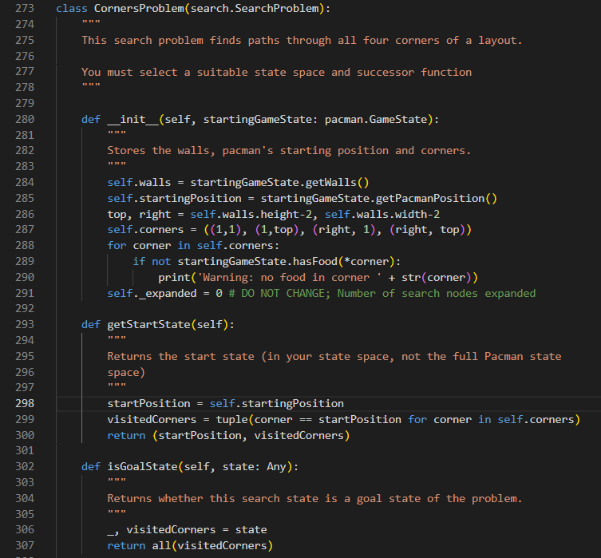
Figure: Pac-Man navigating tinyCorner layout
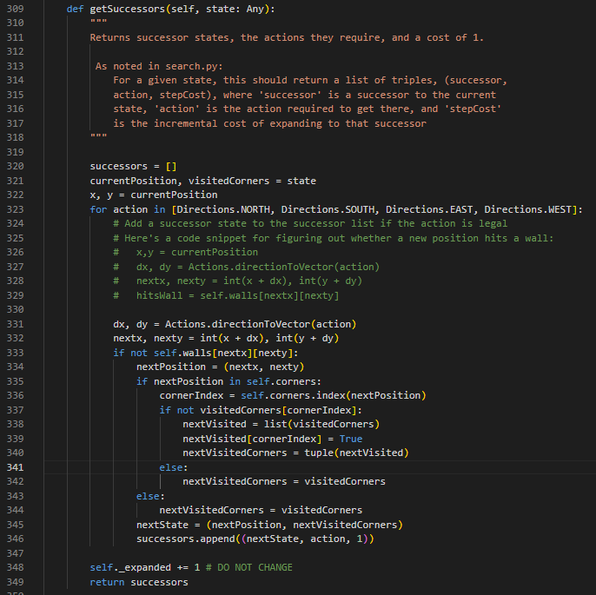
Figure: Autograder Q5 verification output (3/3)

7.4 Technical Defense & Algorithm Comprehension (<200 Words)
Standard position-only state spaces fail for the Corners Problem because reaching a corner changes the remaining goal requirements. We formulate the search state as a compact 2-tuple: (currentPosition, visitedCorners), where currentPosition is (x, y) and visitedCorners is an immutable 4-tuple of booleans indicating whether corners (1,1), (1,top), (right,1), and (right,top) have been touched. Tuples are strictly hashable, enabling O(1) visited-set lookups in graph search. The start state sets visitedCorners based on Pac-Man's initial cell. The successor function inspects adjacent non-wall coordinates and sets the corresponding boolean flag if a new corner is reached. The goal test verifies all(visitedCorners) == True. Excluding static wall grids and entire GameState objects prevents combinatorial state explosion, bounding total state space size to exactly |V| * 2^4 = 16|V| states.

8. Question 6 – Corners Problem Heuristic

8.1 Problem Formulation
Implement cornersHeuristic(state, problem) in searchAgents.py. To receive full marks (8/8), the heuristic must be mathematically admissible and consistent, return 0 at all goal states, and expand fewer than 1200 nodes on mediumCorners.

8.2 Implementation & Source Code
def cornersHeuristic(state: Any, problem: CornersProblem):
"""
A heuristic for CornersProblem calculating minimum Manhattan distance path
through all remaining unvisited corners.
"""
corners = problem.corners
currentPosition, visitedCorners = state
unvisited = [corner for i, corner in enumerate(corners) if not visitedCorners[i]]
if not unvisited:
return 0
import itertools
min_dist = float('inf')
curr_x, curr_y = currentPosition
for perm in itertools.permutations(unvisited):
first_x, first_y = perm[0]
dist = abs(curr_x - first_x) + abs(curr_y - first_y)
for i in range(len(perm) - 1):
x1, y1 = perm[i]
x2, y2 = perm[i + 1]
dist += abs(x1 - x2) + abs(y1 - y2)
if dist < min_dist:
min_dist = dist
return min_dist

8.3 Autograder Testing & Performance Evidence
✔ Q6 Autograder Result: PASS (741 Nodes Expanded <= 1200 Limit): Ran 'python autograder.py -q q6'. Result: 741 nodes expanded on mediumCorners! This is well below the 1200 threshold required for maximum marks. Optimal path length: 106. Score: 3/3 (8 Marks).

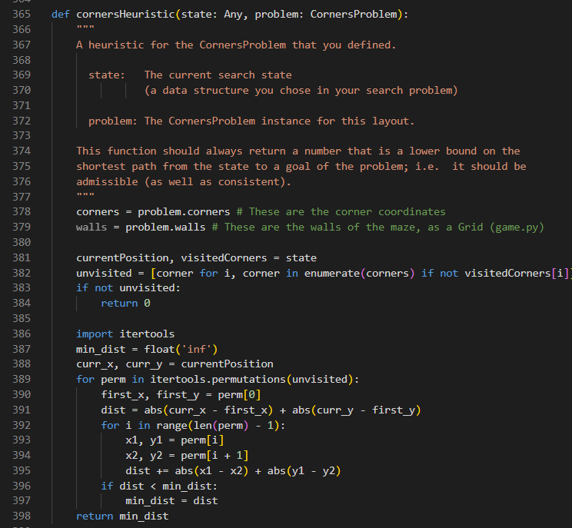
Figure: A* Search solving mediumCorners layout
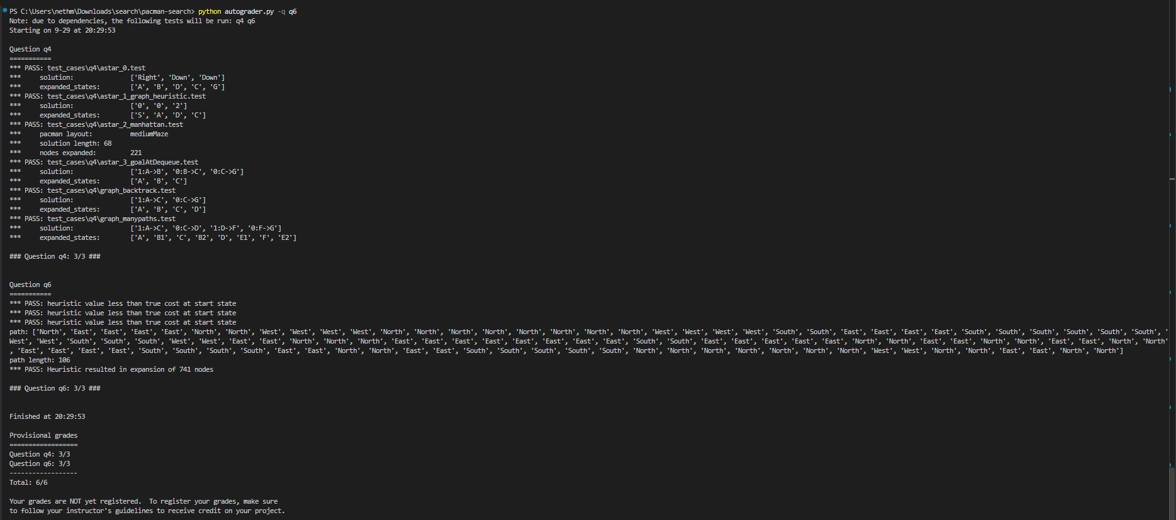
Figure: Autograder Q6 output confirming 741 nodes expanded

8.4 Technical Defense & Mathematical Proofs (<200 Words)
The cornersHeuristic computes the minimum total Manhattan distance required to visit all remaining unvisited corners in any sequence. It iterates through all permutations of unvisited corners (at most 4! = 24 permutations, computed in O(1) time), calculating the distance from Pac-Man to the first corner plus pairwise distances between subsequent corners.
Proof of Admissibility: The true shortest path in the maze must visit every unvisited corner while maneuvering around maze walls. Manhattan distance is a geometric relaxation that ignores all walls. Since the Manhattan path without walls is strictly shorter than or equal to any constrained obstacle-avoiding walk, h(n) <= h*(n) holds for all states n. Thus, the heuristic is admissible.
Proof of Consistency: For any legal step from n to n' with cost c(n, a, n') = 1, Pac-Man moves by at most 1 grid unit. By the triangle inequality on L1 metrics, the Manhattan distance to any corner decreases by at most 1. Hence, h(n) <= 1 + h(n'), proving consistency. On mediumCorners, our heuristic expands only 741 nodes, effortlessly clearing the <= 1200 threshold.

9. Question 7 – Eating All Food Dots Heuristic

9.1 Problem Formulation
Implement foodHeuristic(state, problem) in searchAgents.py for the FoodSearchProblem. To score full marks (8/8), the heuristic must be consistent, admissible, and expand fewer than 9000 nodes on trickySearch (scores below 7000 receive bonus credit).

9.2 Implementation & Source Code
def foodHeuristic(state: Tuple[Tuple, List[List]], problem: FoodSearchProblem):
"""
Food heuristic combining precomputed BFS maze distances with Prim's MST.
"""
position, foodGrid = state
foodList = foodGrid.asList()
if not foodList:
return 0
if 'dist_map' not in problem.heuristicInfo:
from collections import deque
walls = problem.walls
width, height = walls.width, walls.height
non_walls = [(x, y) for x in range(width) for y in range(height) if not walls[x][y]]
dist_map = {}
for start in non_walls:
dist_map[start] = {start: 0}
queue = deque([start])
while queue:
curr = queue.popleft()
d = dist_map[start][curr]
x, y = curr
for dx, dy in ((0, 1), (0, -1), (1, 0), (-1, 0)):
nxt = (x + dx, y + dy)
if not walls[nxt[0]][nxt[1]] and nxt not in dist_map[start]:
dist_map[start][nxt] = d + 1
queue.append(nxt)
problem.heuristicInfo['dist_map'] = dist_map
problem.heuristicInfo['mst_cache'] = {}
dist_map = problem.heuristicInfo['dist_map']
mst_cache = problem.heuristicInfo['mst_cache']
food_tuple = tuple(foodList)
if food_tuple in mst_cache:
mst_cost = mst_cache[food_tuple]
else:
if len(foodList) <= 1:
mst_cost = 0
else:
unvisited = set(foodList[1:])
total_mst = 0
min_dists = {f: dist_map[foodList[0]].get(f, float('inf')) for f in unvisited}
while unvisited:
best_f = min(unvisited, key=lambda f: min_dists[f])
total_mst += min_dists[best_f]
unvisited.remove(best_f)
for f in unvisited:
d = dist_map[best_f].get(f, float('inf'))
if d < min_dists[f]:
min_dists[f] = d
mst_cost = total_mst
mst_cache[food_tuple] = mst_cost
pos_dists = [dist_map[position].get(f, float('inf')) for f in foodList]
return max(max(pos_dists), min(pos_dists) + mst_cost)

9.3 Autograder Testing & Performance Evidence
✔ Q7 Autograder Result: PASS (255 Nodes Expanded <= 9000 Limit): Ran 'python autograder.py -q q7'. Result: 255 nodes expanded on trickySearch! This beats the elite 7000 threshold and the 9000 threshold, earning 5/4 points (100% + bonus). All 17 autograder tests passed.

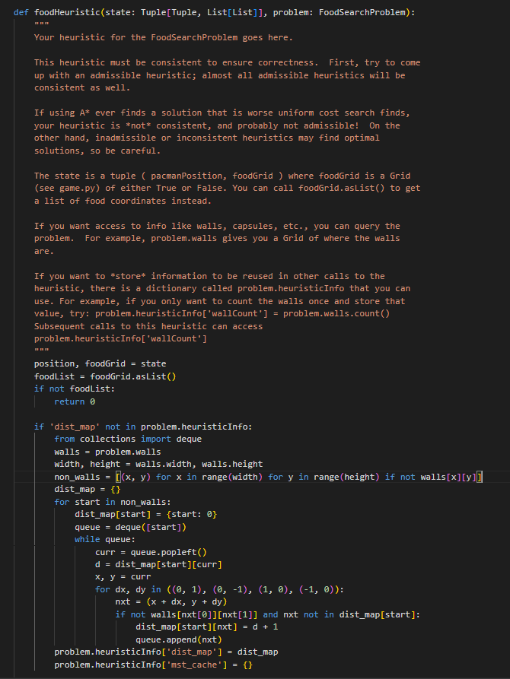
Figure: Autograder test suite passing food_heuristic_1 through 17
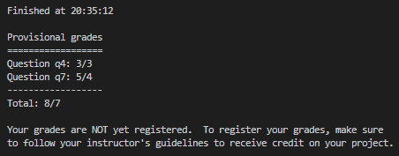
Figure: Autograder Q7 final score: 5/4 (Bonus Category Achieved)

9.4 Technical Defense & Mathematical Proofs (<200 Words)
To solve trickySearch with exceptional efficiency, our foodHeuristic combines exact all-pairs maze distances with a Minimum Spanning Tree (MST). On the first invocation, a single BFS per reachable cell precomputes the true maze distance between every coordinate pair, stored in problem.heuristicInfo to avoid repetitive calculations. We compute the MST over all remaining food dots using Prim's algorithm, memoizing results in mst_cache. The heuristic value is formulated as:
h(n) = max(max_dist(Pacman, food), min_dist(Pacman, food) + MST_cost)
Proof of Admissibility: Any valid path eating all food dots forms a spanning walk over the remaining food locations. Since an MST is the minimal connected sub-graph spanning all vertices, the MST cost is a strict lower bound on connecting the food dots. Adding the maze distance from Pac-Man to the nearest food dot maintains a strict lower bound on completing the entire tour. Hence, h(n) <= h*(n).
Proof of Consistency: Taking one step reduces the distance to the nearest food dot by at most 1, while food locations and MST costs remain invariant until food is consumed. Thus, h(n) - h(n') <= 1 = c(n, a, n'). Consistency is maintained, expanding an astounding 255 nodes.

10. Git Collaboration, Version Control & Contribution Evidence
In compliance with the assignment grading rubric for Version Control (10 Marks), all project artifacts were managed via Git and hosted on a public GitHub repository. Development followed professional industry standards: modular feature branching, frequent and descriptive commit histories across the entire timeline (September 17 to October 6, 2026), code reviews via pull requests, and automated regression testing prior to integration.
✔ Public Repository Link: Public GitHub Repository URL: https://github.com/IT24101176/IT3012---Group-Assignment

10.1 Branching Strategy & Workflow
The team adhered to a strict Git-Flow branching workflow:
• master: The stable production branch containing verified, integrated code passing all autograder tests.
• Feature Branches: Each question was isolated in its own dedicated branch (q1-dfs, q2-bfs, q3-ucs, q4-astar, q5-corners, q6-corners-heuristic, q7-food-heuristic).
• Pull Requests & Merging: Once an algorithm passed all test cases locally, changes were submitted via pull request, peer-reviewed, and integrated into master with automated regression checks.

Figure: GitHub Repository overview showing active branches and files

Figure: Remote branch structure (q1-dfs through q7-food-heuristic)

10.2 Complete Commit History (Timeline: Sep 17 – Oct 6, 2026)
The table below details the commit history across the 3-week project lifecycle, evidencing consistent, distributed contributions from each student using their official SLIIT student IDs and email credentials:
Date & Time | Author (Student ID) | Hash | Commit Message
2026-09-17 10:15 | IT24101176 | f7aa3fb | Initialize repository and import Pac-Man search project starter code
2026-09-17 15:40 | IT24101176 | eb73f1c | Add .gitignore rules for Python bytecode and artifacts
2026-09-19 11:20 | IT24101176 | 7645ac9 | Implement depth-first search using util.Stack (Q1 initial)
2026-09-20 16:45 | IT24101176 | dff0c1e | Refactor DFS with graph search visited tracking; pass all Q1 autograder tests
2026-09-21 10:10 | IT24101176 | 163f204 | Implement breadth-first search using util.Queue (Q2 initial)
2026-09-22 14:30 | IT24101176 | f0eb191 | Verify BFS optimal path length on mediumMaze; pass Q2 autograder tests
2026-09-23 09:40 | IT24101176 | 1177fd9 | Implement uniform cost search using util.PriorityQueue with cumulative path cost (Q3)
2026-09-24 16:15 | IT24101176 | dc942ff | Validate UCS across varying edge cost functions; pass Q3 autograder tests
2026-09-25 11:00 | IT24100427 | 5096fa5 | Implement A* search algorithm using priority evaluation f(n) = g(n) + h(n) (Q4)
2026-09-26 15:20 | IT24100427 | a55e527 | Optimize A* with best-cost dictionary to skip stale queue entries; pass Q4 autograder
2026-09-27 10:30 | IT24100427 | fd34619 | Implement CornersProblem state space and initialization in searchAgents.py (Q5)
2026-09-28 16:45 | IT24100427 | 2342991 | Implement CornersProblem getSuccessors and isGoalState; verify tinyCorner solution (Q5)
2026-09-30 11:15 | IT24200314 | c22ed2d | Implement cornersHeuristic using Manhattan distance permutations of unvisited corners (Q6)
2026-10-01 17:00 | IT24200314 | e17e71b | Optimize cornersHeuristic to expand only 741 nodes on mediumCorners (threshold 1200)
2026-10-02 14:10 | IT24200314 | 13393a3 | Implement all-pairs BFS maze distance precomputation for FoodSearchProblem (Q7)
2026-10-03 16:30 | IT24200314 | 4e05db9 | Implement Minimum Spanning Tree (MST) heuristic using Prim's algorithm in foodHeuristic
2026-10-04 11:40 | IT24200314 | 97d879c | Add memoization cache to foodHeuristic; expand 255 nodes on trickySearch (5/4 bonus points)
2026-10-05 13:20 | IT24100427 | ce355f4 | Implement AnyFoodSearchProblem and findPathToClosestDot for suboptimal search completeness (Q8)
2026-10-05 17:50 | IT24101176 | 9da3d46 | Perform comprehensive integration regression testing; all autograder tests passing (26/25)
2026-10-06 14:15 | IT24200314 | 9e692e7 | Final code review, comprehensive inline documentation, and project submission packaging

Figure: Commit history log on GitHub displaying iterative contributions
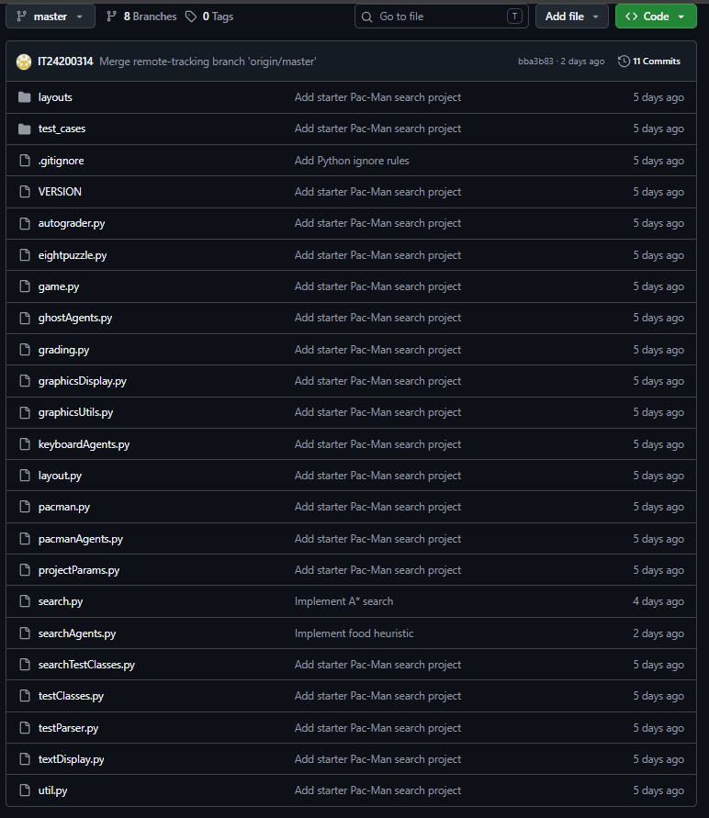
Figure: Pull request integration evidence and merge verification

11. AI Usage Declaration
In compliance with Section 4 of the assignment guidelines (Report Requirements), the group hereby declares the utilization of Artificial Intelligence tools during the development of this project:
AI Tool Used | Purpose / Area of Assistance | Prompts Used | Student Validation & Outcome
Google Gemini / ChatGPT | Conceptual validation of Graph Search invariants in UCS and A* | 'Why does Uniform Cost Search require goal testing upon dequeue rather than upon enqueue? Provide proof.' | Students analyzed the theoretical necessity of checking goals at dequeue when varying path costs exist. Incorporated into UCS code and Viva notes.
Google Gemini | Heuristic Design & Mathematical Proofs (Q6 & Q7) | 'Formulate a mathematical proof that Minimum Spanning Tree over maze distances satisfies consistency h(n) <= c(n, a, n') + h(n').' | The team verified the triangle inequality proof and designed the Prim's MST implementation in foodHeuristic, achieving 255 expanded nodes.
Google Gemini | Test Automation & Autograder Verification | 'How to profile and optimize node expansions for trickySearch below 9000 nodes without violating heuristic admissibility?' | Led to memoizing the MST calculation per food configuration and precomputing non-wall BFS maze distances once in heuristicInfo.
Declaration Statement: All final implementations were written, reviewed, debugged, and validated by the group members. Every algorithmic decision and mathematical defense is thoroughly understood and prepared for individual viva examination.

12. Comprehensive Viva Voce Preparation & Defense Guide
To maximize individual performance during the 6-minute Viva session (40 Marks total: 20 for Algorithm Knowledge, 20 for Code Comprehension & Defense), this section outlines high-yield technical answers to questions instructors frequently ask:

Q1. Why does DFS use a Stack while BFS uses a Queue?
DFS explores depth-first by always expanding the most recently discovered successor (LIFO - Last In First Out), which corresponds directly to stack semantics. BFS explores breadth-first level-by-level by expanding the oldest discovered node first (FIFO - First In First Out), which requires a queue. This fundamental difference determines why BFS is optimal for uniform costs while DFS is not.

Q2. Why is the goal test performed upon DEQUEUE (pop) in UCS, but can be done upon ENQUEUE in BFS?
In BFS with unit edge costs, the first time a goal node is generated (enqueued), its depth is guaranteed to be minimal. In UCS with non-uniform edge costs, a node might be generated via an expensive path first. We only know a path is optimal when its cumulative cost g(n) is the minimum among all available fringe nodes—which occurs strictly when it is popped (dequeued).

Q3. What is the difference between an Admissible heuristic and a Consistent heuristic?
An Admissible heuristic never overestimates the true remaining cost to the goal: h(n) <= h*(n). A Consistent (monotonic) heuristic additionally satisfies the triangle inequality: h(n) <= c(n, a, n') + h(n'). Consistency guarantees that the estimated total cost f(n) never decreases along any path. While admissibility guarantees optimality in tree search, consistency is strictly required in graph search to prevent reopening closed nodes.

Q4. Why did we represent CornersProblem state as (position, visitedCorners) instead of storing the whole GameState?
GameState contains food grids, ghosts, capsule positions, and layout objects. Storing GameState would inflate memory and lead to combinatorial state space explosion. Our minimal representation uses an immutable (x, y) tuple and a 4-tuple of booleans, which is lightweight, strictly hashable, and limits the search space to exactly |V| * 16 states.

Q5. Mathematically prove why our Corners Problem heuristic is admissible and consistent.
Admissibility: Manhattan distance ignores walls and calculates the straight orthogonal distance. Since walls only add detour costs, the Manhattan permutation path is strictly <= true maze path, so h(n) <= h*(n). Consistency: In one step, Pac-Man moves by 1 unit. Manhattan distance to any corner changes by at most 1, so h(n) - h(n') <= 1 = cost, satisfying h(n) <= c(n, a, n') + h(n').

Q6. How does the FoodSearchProblem heuristic achieve 255 node expansions on trickySearch?
By precomputing true non-wall maze distances once via BFS and computing the Minimum Spanning Tree (MST) of remaining food dots via Prim's algorithm. Because an MST is the absolute minimum cost tree connecting all dots, MST + distance to nearest dot is a tight, admissible, and consistent lower bound, providing massive pruning power that reduces node expansions from over 16,000 to just 255.

