BSc (Hons) in Information Technology Specialized in AI

IT3012 : Intelligent Agents
Year 3 · Semester 1 · 2026 Semester 2
Faculty of Computing

Practical 02



Objective & Lecture Mapping: In Lecture 03, we learned that a mathematically perfect "Table-Driven Agent" is impossible to build due to combinatorial explosion. Instead, we must write Agent Programs. Today, you will implement a Simple Reflex Agent using Condition-Action rules, observe its fatal flaws in a partially observable environment, and then upgrade it to a Model-Based Agent that maintains an internal memory state.

Part 1: Practical Implementation — Coding the Architectures

Step 1.1: Setting the Trap (Partial Observability)

To see why Simple Reflex agents fail, we must handicap your agent's sensors. We are moving from a Fully Observable world to a Partially Observable one.

- Open your visual_grid_game.py from Lab 01.
- Locate the get_percept(self) method.
- Modify it so it no longer returns the exact global coordinates ( agent_pos ). Instead, it should only return local booleans, e.g., {'wall_ahead': True/False, 'food_here': True/False} based on checking the adjacent cell in its current facing direction.

Step 1.2: The Simple Reflex Agent (Implementation & Failure)
- Create a new class called SimpleReflexAgent .
- Implement a sense_and_act(self, percept) method that uses strictly IF-THEN logic (Condition-Action rules). Do not use an init method to store history.

Example Logic: IF food_here THEN suck; IF wall_ahead THEN turn_left; ELSE move_forward
3. Run the simulation. Observe: Watch the agent get trapped in a corner or a U-shaped wall, infinitely repeating a cycle (e.g., turn left, step forward, hit wall, turn left...).
Step 1.3: The Model-Based Agent (Memory & State)
- Create a new class called ModelBasedAgent .
- Implement an init (self) method to initialize an internal memory state (e.g.,
self.visited_cells = set() or a relative movement tracker).
- In sense_and_act(self, percept) , first update the state (Transition & Sensor Model) by recording the current percept and the last action taken.
- Update your IF-THEN rules to query the memory.
Example Logic: IF wall_ahead AND left_is_visited THEN turn_right
- Run the simulation. Observe: The agent should now remember where it has been, realize it is in a loop, and choose an alternate path to escape.

Part 2: Theoretical Evaluation & Lecture Mapping

Based on your practical observations above, answer the following questions to map your code directly to the architectural theories covered in Lecture 02.
- (Remember) According to Lecture 02, why is it impossible to program a mathematically perfect "Table-Driven Agent" for complex environments like Chess? What happens as the agent's lifetime increases?

A mathematically perfect Table-Driven Agent is impossible for complex environments
such as chess because it must store the correct action for every possible percept 
sequence. As the agent’s lifetime increases, its percept history becomes longer and the

- (Understand) Look at the code you wrote for your SimpleReflexAgent . Identify and explain the specific lines of code that represent the "Condition-Action Rules" discussed in the lecture.

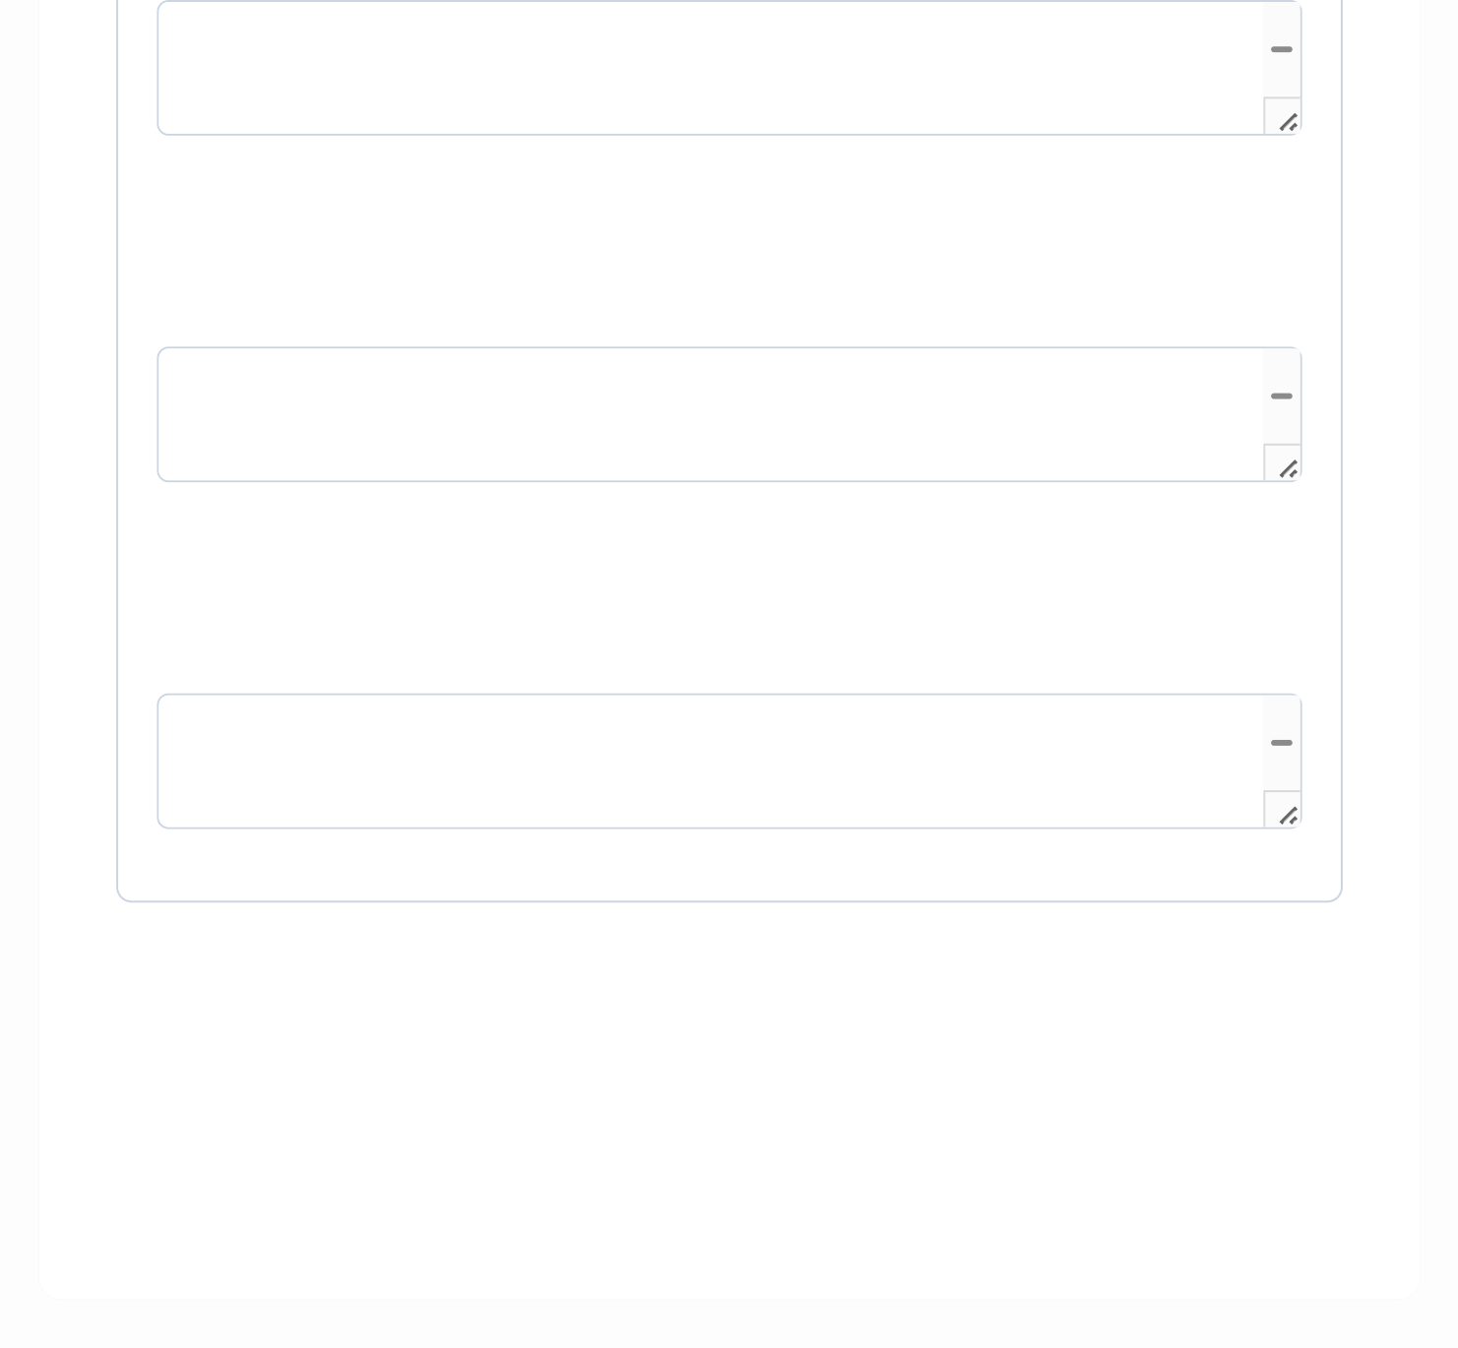
In my SimpleReflexAgent, the lines if percept["food_here"]: return "suck", if percept["wall_ahead"]: return "turn_left", and return "move_forward" represent the  Condition-Action Rules. The first rule checks whether food is in the current cell and


(Analyze) Your SimpleReflexAgent likely got stuck in an infinite loop during Step
1.2. Based on the lecture, analyze exactly why this happened. How did the combination of "Partial Observability" and a lack of "Percept History" cause this failure?
The SimpleReflexAgent became trapped because the environment was partially

observable and the agent had no percept history. It could sense only whether 
wall_ahead and food_here were true or false, but it could not observe its exact

(Evaluate) In Step 1.3, you added an internal state to your ModelBasedAgent . Evaluate how your specific code handles the "Transition Model" (how the world evolves) and the "Sensor Model" (how the agent's actions affect the world).
In my ModelBasedAgent, the Transition Model updates the internal relative position

and direction according to the previous action: move_forward updates the estimated 
position, while turn_left and turn_right update the direction. The Sensor Model uses

Finalize and Lock Lab 02 Documentation

Incomplete: 0/11 questions answered. Please provide detailed responses for all questions.


FACULTY OF COMPUTING

