COD Delivery Return Risk Study
IT3091 Machine Learning | Final Group Report | 2026-DS-11K
Sri Lanka Institute of Information Technology | Year 3 Semester 1 2026
Industry Explorer Track | MODALII LENSHUB (PVT) LTD | 11 October 2026

Executive summary
We investigated whether historical order information could help MODALII LENSHUB prioritise confirmation of orders at risk of being returned. The supplied data contains 4,316 records and 592 returns (13.72%). The final target is reported to have been constructed by matching delivery and return reports on Waybill Number, replacing the initial collection-based proposal.
Seven model strategies were compared using five-fold cross-validation within the training data. Random forest with SMOTENC achieved the highest mean validation average precision, 0.208. Its threshold of 0.5164 was selected using training out-of-fold F1 before evaluating the 864-order holdout.
On the holdout, average precision was 0.245, ROC-AUC 0.585, precision 22.48%, recall 24.37% and F1 0.234. The model flagged 129 orders: 29 were returns and 100 were successful deliveries. It missed 90 returns. These results support, at most, a monitored confirmation pilot; they do not justify automatic rejection or a claim of realised savings.
We excluded identifiers and unvalidated address-derived text from the submission data. All 206 zero-COD records were retained and flagged because their operational meaning remains unknown. Original source exports were unavailable for independent target verification. Stakeholder feedback and the demo link must be inserted before submission; each member completes their own personal learning report.

Group responsibilities
Student ID | Member | Assigned responsibility
IT24101529 | Ranasinghe R.M.N.K | Problem framing and stakeholder liaison
IT24102718 | Gangadhara J.S | EDA and data quality reasoning
IT24102236 | Piyarathne A.K.G.C.K | Preprocessing and feature engineering
IT24102475 | Siriwardana K.A.B | Model comparison and evaluation

1 Business problem and decision lens
MODALII LENSHUB is the named client in the initial submission. The identified problem is revenue leakage and wasted fulfilment effort associated with failed or returned deliveries. Our primary lens is order-level return-risk prediction. No secondary lens is added because a disconnected segmentation analysis would not strengthen this decision.
Framing element | Definition
Stakeholder decision | Which orders should receive additional confirmation or manual review before dispatch?
Unit of analysis | One supplied order record identified by a delivery waybill in the source records.
Prediction target | Is_Returned = 1 for matched return records; 0 for successful/non-returned deliveries, as explained by the dataset-preparing member.
ML task and output | Supervised binary classification; a ranking score and review flag for each order.
Intervention | Confirmation call, order verification or optional prepayment discussion; no automatic cancellation.
Success criteria | Identify returns within a manageable review workload, then measure prevented return costs and review effort in a prospective pilot.
Decision constraints | No verified costs, timestamps, customer histories or original outcome exports are available. Zero-COD meaning is unknown.

2 Workflow and scope approval
Lecturer approval of the Industry Explorer scope was confirmed by the group on 11 October 2026. The approval record should be retained by the group. Approval does not independently establish data provenance or guarantee bonus marks.
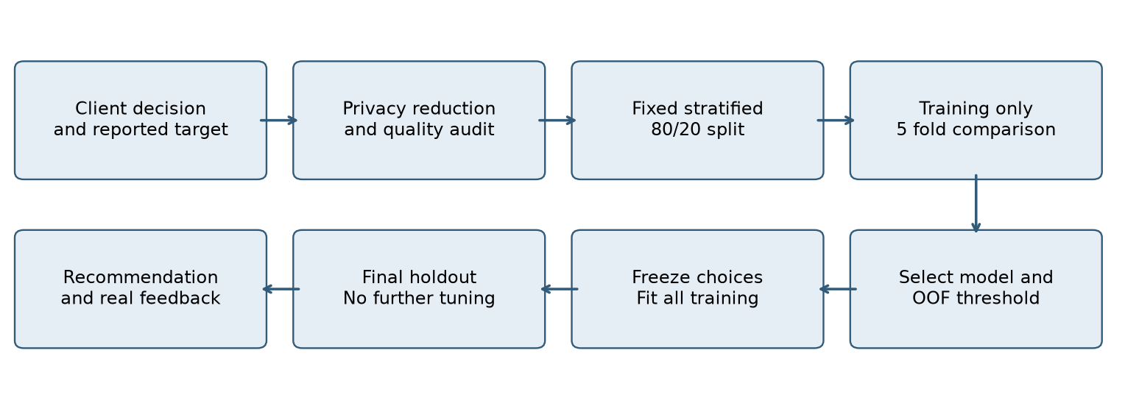
Model family selection uses mean training-fold average precision. Threshold selection uses training out-of-fold predictions. Both decisions are frozen before holdout evaluation. Holdout diagnostics inform the limitations and recommendation, not further tuning.

3 Dataset provenance and target construction
The initial submission describes 4,316 client order records. The member who prepared the final dataset explains that DeliveryOrdersReport.csv and ReturnOrdersReport.csv were matched using Waybill Number. Return matches were labelled Is_Returned = 1; successful/non-returned delivery orders were labelled 0. This final operational definition replaces the provisional collection-based definition in the initial submission.
This is a reported construction, not an independently reproduced merge. The original exports and merge script are absent. In particular, a missing match in a return file may mean successful delivery or an incomplete/pending outcome; completeness, duplicate matching and final delivery status should be checked against the source records. COD value is not the outcome label and COD = 0 does not imply return.
The submission CSV preserves all 4,316 rows, replaces waybill identifiers with sequential Order_Record_ID values, and removes Extracted_City, Phone_Prefix and COD_Deviation. In the prior city field, 352 records contained digits and 118 had text longer than 40 characters, suggesting possible address fragments. Excluding the entire unvalidated field avoids distributing that text. The released dataset contains no direct customer names, contact numbers or addresses; it should still be treated as client business data, with sharing permission retained.

Data dictionary
Field | Type and meaning | Treatment
Order_Record_ID | Integer sequential record number | Audit only; never a predictor
Delivery Charge | Numeric delivery fee in LKR | 375 or 425; used to check route and ratio
Weight | Numeric recorded shipment weight | Constant; excluded
COD | Numeric recorded COD amount in LKR | Retained; zero meaning unconfirmed
Delivery_Charge_Ratio | Numeric charge divided by COD | Recomputed; zero sentinel when COD = 0
Is_Outstation | Binary flag derived from route fee | 0 lower charge; 1 higher charge; retained
COD_Is_Zero | Binary indicator derived during execution | 1 if COD = 0; retained
Is_Returned | Binary target from reported delivery and return report match | 1 return match; 0 successful/non-returned

Route geography and fee availability before dispatch should be confirmed with the client. Higher charge is a supplied proxy, not an independently verified geographic label. COD_Is_Zero is created by the code and is therefore documented even though it is not a stored CSV column.

4 Data understanding and quality
The target contains 3,724 non-returned/successful labels and 592 returned labels. A majority-only predictor can exceed 86% accuracy while detecting no returns, so accuracy is secondary to returned-class and ranking metrics.
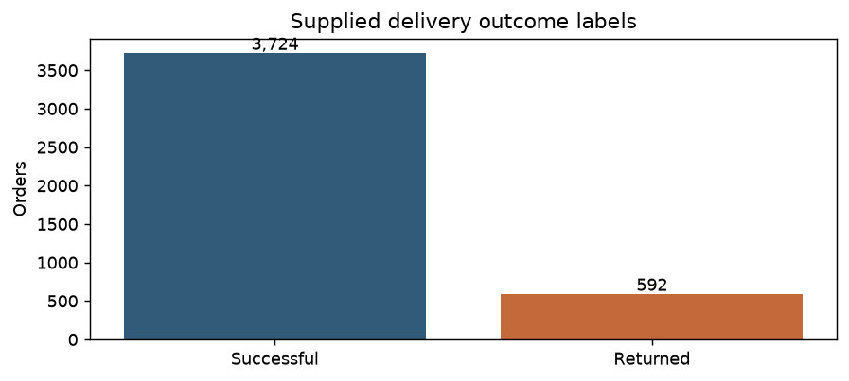
No missing cells or duplicated sequential IDs were found. Weight has one unique value. Delivery Charge maps exactly to the supplied route flag. There are 4,153 repeated nonidentifier rows after privacy reduction; these are repeated feature/outcome profiles, not proven duplicate orders. Removing them would alter the population, so every order is retained. Repeated profiles show how little information the available predictors distinguish.
There are 206 zero-COD records: 205 successful/non-returned and one returned. They are not automatically removed or relabelled. Their business meaning is unknown; the zero flag records the special case without assuming that these are prepaid orders or replacements. COD ranges from 0 to LKR 19,980. No defensible domain threshold identifies erroneous high amounts, so amounts are retained rather than trimmed to improve scores.
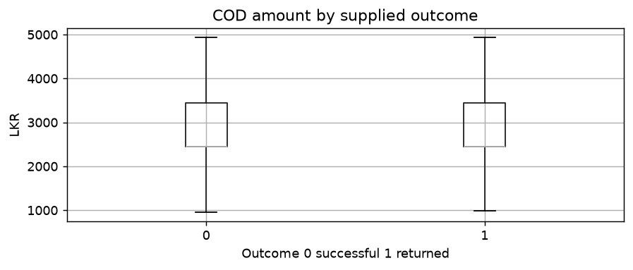
Figure notes: the amount plot omits fliers for readability only; the records remain in training. Route return-rate figures are included in the results folder. These descriptive relationships do not establish causes of return.

5 Preprocessing and imbalance decisions
The split uses stratification and random_state = 20261011: 3,452 training records with 473 returns, and 864 holdout records with 119 returns. Five shuffled stratified folds are formed inside training. The dataset was explored during the earlier draft, so this is retrospective validation on a previously examined dataset, not an independent prospective test.
Decision | Implementation and reason
Privacy and identifiers | Remove waybill, unvalidated city/address text and phone prefix. Use a sequential record ID only to audit split membership.
Redundancy | Remove constant Weight and full-dataset COD_Deviation. Do not model Delivery Charge separately from its route flag. Ratio and zero flag are useful nonlinear transformations but add no new source information.
Missingness and scaling | No missing values are currently present. Fit median imputation and standard scaling for numeric features only within each training fold; transform validation/holdout using fitted parameters.
Categories | One-hot encode binary route/zero flags. No city vocabulary or high-cardinality grouping is learned.
Class weights | Logistic regression, tree, forest and histogram boosting use balanced weights. XGBoost positive weight is calculated from the current training fold only.
SMOTENC | Resample primitive COD and categorical route within each training fold. Reconstruct ratio and zero indicator afterwards, then fit preprocessing and a random forest. Holdout and validation records are never resampled.

Reconstructing derived features after resampling prevents inconsistent synthetic ratios or fractional route flags. With one resampled numeric dimension, there is no relative scale imbalance between numerical features. SMOTENC still creates hypothetical amounts rather than new observed orders, and may amplify noise. Resampling and class weights are evaluated alternatives, not assumed improvements.

Leakage and availability checks
Is_Returned is excluded from predictors. Identifiers, source matching fields and post-delivery collection information are not used. Source fees and COD are assumed available at the pre-dispatch decision; the client must verify that assumption. Test records never enter fitted transformations, resampling, class weights, model selection or threshold selection. Customer overlap and chronological leakage cannot be audited without customer groups or dates.

6 Model strategy and training comparison
The baseline predicts the majority class. Six alternatives cover an interpretable linear model, a bounded tree, bagged trees, two boosting methods, and synthetic resampling with a forest. Hyperparameters are fixed, modest choices rather than an extensive search: tree depth 5 with leaf size 20; forests 200 trees, depth 8 and leaf size 10; histogram boosting 150 iterations and 15 leaves; XGBoost 200 trees, depth 3 and learning rate 0.05. Logistic regression uses a maximum of 2,000 iterations. The source lists all remaining settings.
Average precision (AP) is the primary model-selection metric because it evaluates ranking quality for the minority class across thresholds. AP is the recall-increment-weighted precision summary from average_precision_score, not trapezoidal PR-AUC. ROC-AUC is supplementary. Returned-class F1 summarises precision/recall at an operating threshold but does not express financial cost.
Model | Mean AP | SD AP | Mean AUC | F1 at 0.5
Random forest with SMOTENC | 0.208 | 0.027 | 0.585 | 0.255
Random forest | 0.202 | 0.029 | 0.576 | 0.252
Hist gradient boosting | 0.202 | 0.029 | 0.579 | 0.254
XGBoost | 0.199 | 0.030 | 0.574 | 0.253
Decision tree | 0.190 | 0.029 | 0.566 | 0.250
Logistic regression | 0.185 | 0.041 | 0.579 | 0.243
Dummy baseline | 0.137 | 0.001 | 0.500 | 0.000

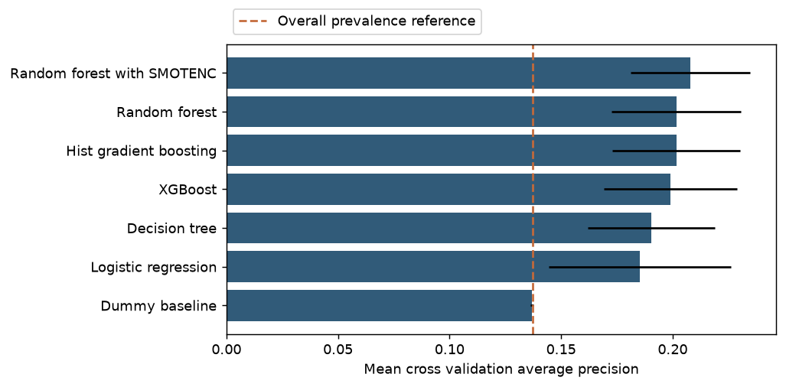
Random forest with SMOTENC is selected by the highest mean fold AP, 0.208. Its margin over the class-weighted forest is small relative to variation between folds. The comparison does not establish statistically significant superiority. Fold standard deviation describes five folds, not a confidence interval. Training out-of-fold AP is separately recorded because pooling scores differs from averaging fold AP.

7 Frozen threshold and holdout evaluation
The selected threshold is 0.5164, chosen to maximise returned-class F1 on training out-of-fold scores. Ties use the highest threshold. This is a reproducible provisional operating point, not a stakeholder-approved cost optimum. F1 at the selected threshold is optimistic if estimated on the same out-of-fold scores used to choose it; the holdout is used for the final assessment. Weighted and resampled scores are not calibrated probabilities.
Model | Precision | Recall | F1 | AP | AUC
Dummy baseline | 0.000 | 0.000 | 0.000 | 0.138 | 0.500
Logistic regression | 0.147 | 0.992 | 0.257 | 0.269 | 0.619
Decision tree | 0.144 | 0.916 | 0.249 | 0.267 | 0.603
Random forest | 0.153 | 0.672 | 0.250 | 0.242 | 0.592
Hist gradient boosting | 0.161 | 0.613 | 0.255 | 0.266 | 0.587
XGBoost | 0.152 | 0.664 | 0.248 | 0.264 | 0.590
Random forest with SMOTENC | 0.225 | 0.244 | 0.234 | 0.245 | 0.585

All alternatives are shown for transparency. The model remains the training-selected one even if another alternative has a stronger holdout metric. The CSV also includes every model at threshold 0.5. Model or threshold changes after this comparison would require fresh validation.
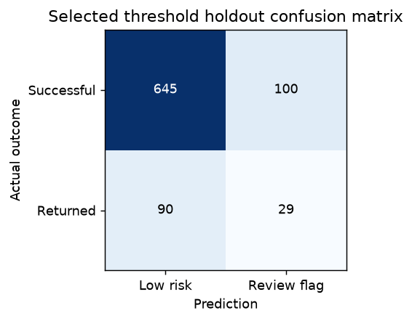
Of 864 holdout orders, 129 (14.93%) would be flagged. This captures 29 of 119 returns (24.37%) but also flags 100 successful orders; 77.52% of flags are false positives. The selected accuracy is 78.01%; the majority baseline achieves 86.23% with zero return recall. The missed 90 returns limit any operational claim.

8 Uncertainty sensitivity and review workload
Selected model metric | Estimate | 95% bootstrap interval
Average Precision | 0.245 | 0.192 to 0.315
ROC AUC | 0.585 | 0.534 to 0.643
Precision Returned | 0.225 | 0.165 to 0.295
Recall Returned | 0.244 | 0.168 to 0.328
F1 Returned | 0.234 | 0.167 to 0.302

Intervals use 1,000 stratified bootstrap resamples of the fixed holdout predictions, preserving the observed class counts. They describe sampling uncertainty conditional on the fitted model and split. They do not include uncertainty from target errors, repeated customer records, model selection, future drift or intervention effectiveness.
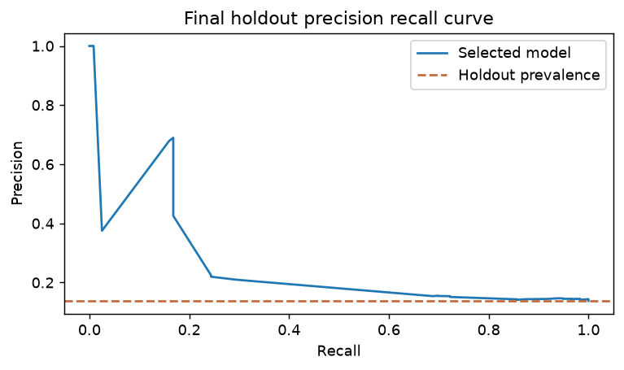
A training-only sensitivity analysis excludes zero-COD orders while keeping the selected family fixed. It uses 3,282 records and 472 returns. Mean fold AP is 0.210 versus 0.208 in the main analysis. The cohorts differ, so this is a diagnostic rather than proof that zero-COD orders should be excluded. Their unknown business meaning remains a data requirement.
Review budget | Orders | Returns caught | Precision | Recall
5.00% | 44 | 20 | 45.45% | 16.81%
10.00% | 87 | 24 | 27.59% | 20.17%
20.00% | 173 | 35 | 20.23% | 29.41%
30.00% | 260 | 46 | 17.69% | 38.66%

The capacity table ranks fixed holdout scores at illustrative budgets. It does not select a new threshold or prove prevented returns. Tied scores are resolved by a deterministic ordering; deployment would need a fair tie policy and a client-approved workload. Intervention effectiveness and review cost were not measured.

9 Recommendation and responsible use
Do not use the current model to automatically reject, cancel or demand payment from an order. A small monitored pilot could compare score-prioritised confirmation with the current process, subject to target verification, permission and stakeholder feedback. Record reviewed orders, confirmation outcomes, delivery outcomes and review effort. A control or randomised comparison is needed to attribute fewer returns to the intervention.
A useful pilot decision equation is: prevented return losses minus review cost and any lost margin caused by unnecessary interventions. The current records contain no verified return-loss amounts, review costs or causal intervention effects; therefore no numerical savings are claimed. Review capacity should be agreed with the client rather than selected retrospectively from favourable holdout results.
Improve data capture with final delivery status and return reasons, order and dispatch dates, confirmation outcomes, delivery attempts, product/order composition and responsibly handled customer return history. Retain only predictors available at the intended decision time. Validate chronologically and group repeat customers when reliable identifiers can be protected and used for splitting.

Limitations
The supplied labels depend on the completeness of return matching and cannot be independently reconstructed. Zero-COD orders may fall outside a strictly COD-only population. Privacy reduction leaves a small set of mostly derived predictors with many repeated profiles. Five-fold results show limited discrimination and small differences between methods. Random splits cannot assess time drift or customer overlap. Synthetic samples are hypothetical; risk scores are uncalibrated. No fairness, customer acceptance or financial-impact study has been completed.

10 Industry evidence and stakeholder feedback
Evidence item | Current status
Real client and problem | MODALII LENSHUB named in the initial submission; retain the engagement evidence.
Scope approval | Lecturer approval confirmed by the group; retain the approval record.
Client dataset and permissions | Source described by the group; original exports and permission record should be retained privately.
Data handling | Privacy-reduced dataset and documented features; source records remain confidential.
Recommendation feedback | Pending actual stakeholder response. No response or endorsement has been invented.

Stakeholder reviewer and role: [INSERT REAL DETAILS]
Date and evidence reference: [INSERT REAL DETAILS]
Feedback on usefulness and workload: [INSERT ACTUAL FEEDBACK]
Changes made to recommendation after feedback: [INSERT ACTUAL CHANGES OR STATE NONE]

11 Reproducibility and submission contents
The group notebook and matching Python module implement the complete workflow. Four role notebooks provide runnable evidence for the assigned responsibilities. Their presence does not independently certify a member's personal contribution. Each member reviews the work and writes their own one-A4-page personal learning journey.
Folder | Evidence
01 Final report | Editable report and PDF; report content must be updated with feedback and video URL.
02 Colab notebooks | Complete group notebook and four role notebooks with executed outputs.
03 Python code | Shared workflow, five entry scripts, pinned ML and notebook requirements.
06 Dataset and dictionary | Privacy-reduced dataset and dictionary including generated features.
07 Evidence logs | Framing canvas, decision/EDA/preprocessing logs, provenance and feedback form.
08 Model results | CV, frozen selection, split membership, holdout metrics/scores, sensitivity, confidence intervals and figures.
10 Demo materials | Three-minute recording script, recording checklist and URL field.

Python version: 3.12.14. Fixed random seed: 20261011. Package versions are pinned in requirements.txt and requirements-notebooks.txt. Locally, install the notebook requirements and run 03_PYTHON_CODE/00_FINAL_GROUP_COMPLETE_PROJECT.py. In Colab, run the notebook from top to bottom and upload the completed package ZIP or supplied dataset when prompted. Results are regenerated under 08_MODEL_RESULTS.
Submission dataset SHA-256 fingerprint: 78283eea4de4e4c4732de84a0cbd4c0d2da3c7f903687796abe18a6f1b96a96b

12 AI assistance declaration
OpenAI Codex assisted with auditing the supplied files, rewriting the Python workflow and notebooks, training and validation execution, producing figures and evidence logs, drafting this report, and preparing the demo script. Earlier draft material was supplied by the group. AI did not supply original client records, lecturer approval, stakeholder feedback, personal experiences or measured business benefits. The group remains responsible for verifying the data, reviewing the generated analysis, understanding the methods and declaring assistance under module rules.

13 Demonstration and references
Three-minute YouTube demo URL: [INSERT FINAL YOUTUBE LINK]
Assignment sources: IT3091 Assignment Descriptor V1, pages 1-2; 2026-DS-11K Initial Submission Report, pages 1-4. Both are retained in 09_REFERENCE_DOCUMENTS. Final dataset construction and lecturer approval were confirmed by the group on 11 October 2026.
Technical references: scikit-learn documentation, Common pitfalls and recommended practices (https://scikit-learn.org/stable/common_pitfalls.html); imbalanced-learn documentation, SMOTENC (https://imbalanced-learn.org/stable/references/generated/imblearn.over_sampling.SMOTENC.html). Accessed 11 October 2026. Exact implementation settings are recorded in the supplied source and pinned dependencies.

