

SE3082 – Parallel Computing

Lab 05
IT24101655 – Rankalana K.B.G.P

Exercise 4

Code
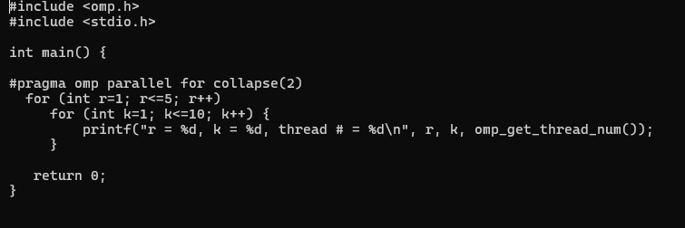

Output

01.
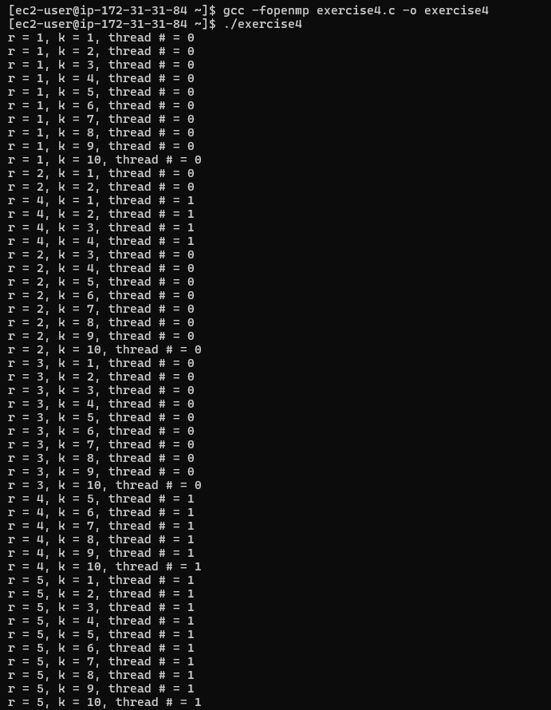
With #pragma omp parallel for, OpenMP parallelizes the outer loop. In this program, the five iterations of r are distributed among the available threads. The inner k loop is executed sequentially by the thread assigned to each r iteration. In my execution with two threads, Thread 0 handled r = 1, 2, 3, while Thread 1 handled r = 4, 5. The output order can vary because the threads execute concurrently.
02.
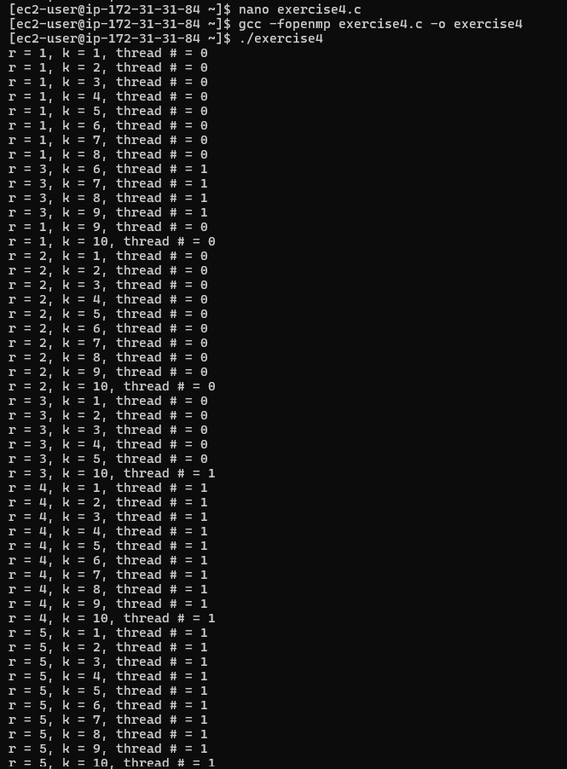
When #pragma omp parallel for collapse(2) is used, OpenMP combines the two nested loops into one iteration space. Since the outer loop has 5 iterations and the inner loop has 10 iterations, there are 50 combined iterations. These iterations are then distributed among the available threads. This provides finer-grained work distribution than parallelizing only the outer loop and can improve load balancing when the outer loop has only a small number of iterations.

