

SE3082 – Parallel Computing

Lab 05
IT24101655 – Rankalana K.B.G.P

Exercise 7
Code
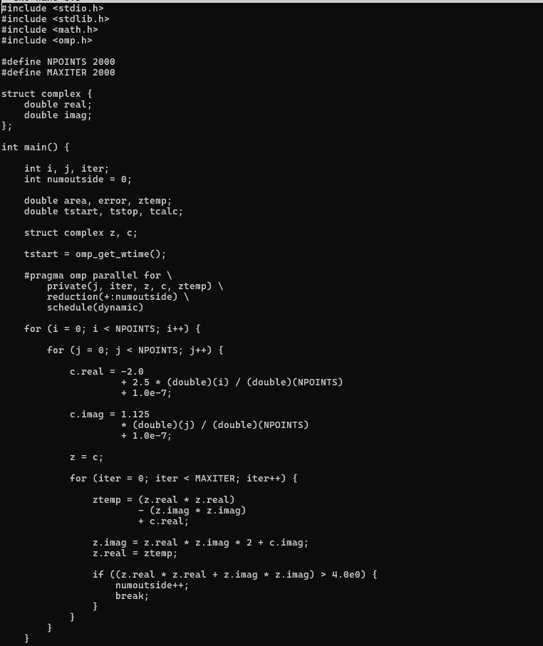

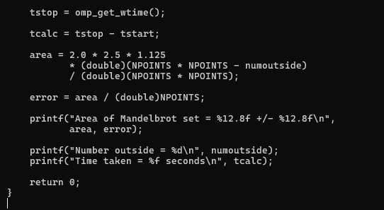
Output
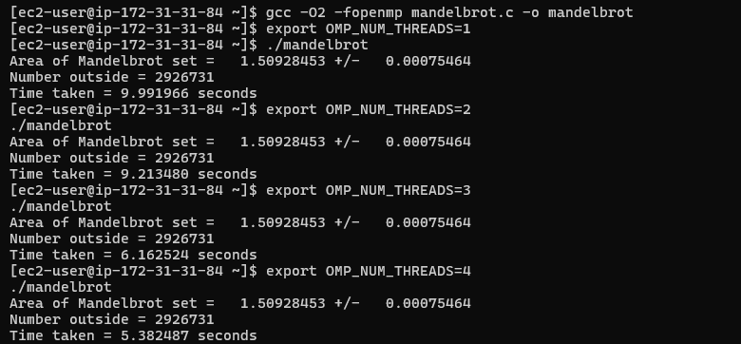
Thread | Area | Number Outside | Time | Speedup
1 | 1.50928453 | 2,926,731 | 9.991966 s | 1.00x
2 | 1.50928453 | 2,926,731 | 9.213480 s | 1.08x
3 | 1.50928453 | 2,926,731 | 6.162524 s | 1.62x
4 | 1.50928453 | 2,926,731 | 5.382487 s | 1.86x

Extra Exercise
Scheduling | Threads | Area | Time
static | 4 | 1.50928453 | 5.382487 s
dynamic | 4 | 1.50928453 | 5.079417 s
