

SE3082 – Parallel Computing

Lab 05
IT24101655 – Rankalana K.B.G.P

Exercise 3 — omp master
Code
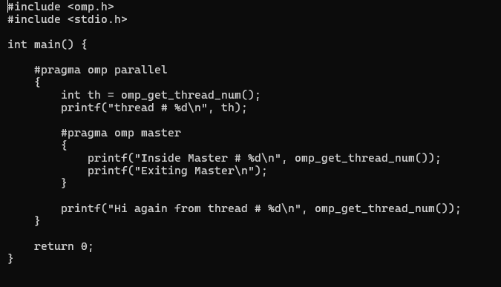

Output
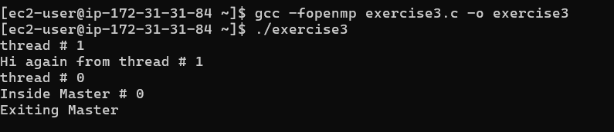

#pragma omp master specifies that the associated block is executed only by the master thread, which is Thread 0. Other threads skip this block and continue with the following statements. In this program, only Thread 0 prints "Inside Master" and "Exiting Master". Unlike single, the master construct does not have an implicit barrier, so the other threads do not wait for the master thread to complete the block.

