

SE3082 – Parallel Computing

Lab 05
IT24101655 – Rankalana K.B.G.P

Exercise 5 — Fibonacci using OpenMP Tasks
Code
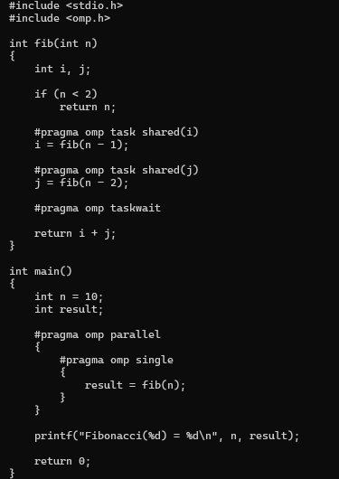

Output

The serial Fibonacci program was parallelized using OpenMP task parallelism. The calculations of fib(n-1) and fib(n-2) are created as separate tasks because they can be calculated independently. #pragma omp taskwait ensures that both tasks finish before their results are added. The initial Fibonacci call is placed inside a single region so that only one thread starts generating the recursive tasks, while the available OpenMP threads can execute those tasks concurrently.

