

SE3082 – Parallel Computing

Lab 05
IT24101655 – Rankalana K.B.G.P

Exercise 1:
code
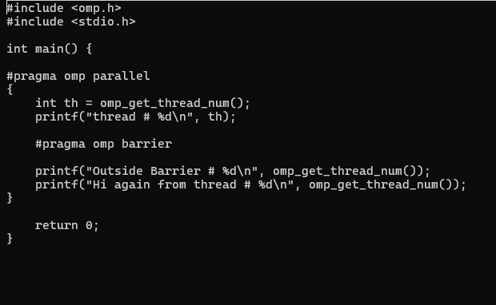

Output
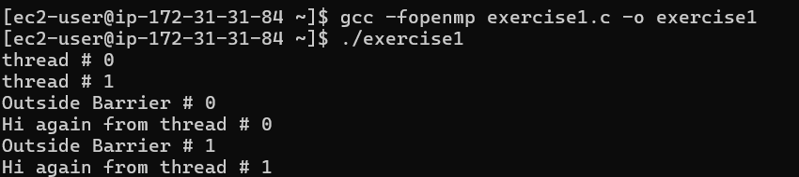
#pragma omp barrier synchronizes all threads at a specific point in the parallel region. Each thread must wait at the barrier until all other threads have reached it. In this program, every thread first prints its thread number and then waits at the barrier. After all threads reach the barrier, they continue executing the statements after it. The execution order of the threads is not guaranteed.

