

SE3082 – Parallel Computing

Lab 05
IT24101655 – Rankalana K.B.G.P

Exercise 2 — omp single
Code
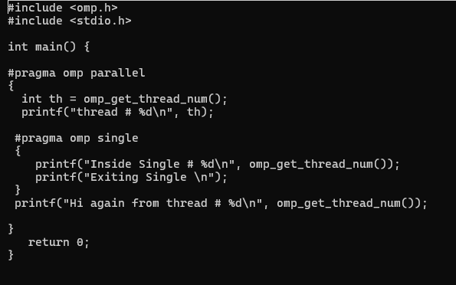

Output
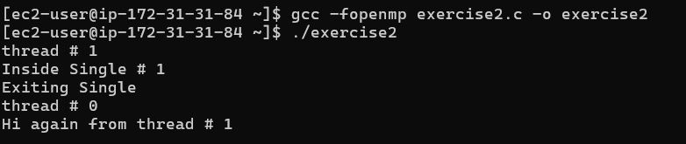

#pragma omp single specifies that the associated block of code should be executed by only one thread in the parallel region. The thread that executes the block is not predetermined. In this execution, Thread 1 executed the single block, while Thread 0 skipped it. After the single section, both threads continued executing the remaining parallel code. By default, there is an implicit barrier at the end of the single construct.

