

SE3082 – Parallel Computing

Lab 05
IT24101655 – Rankalana K.B.G.P

Exercise 6 — Array Multiplication with Strip Mining
Code
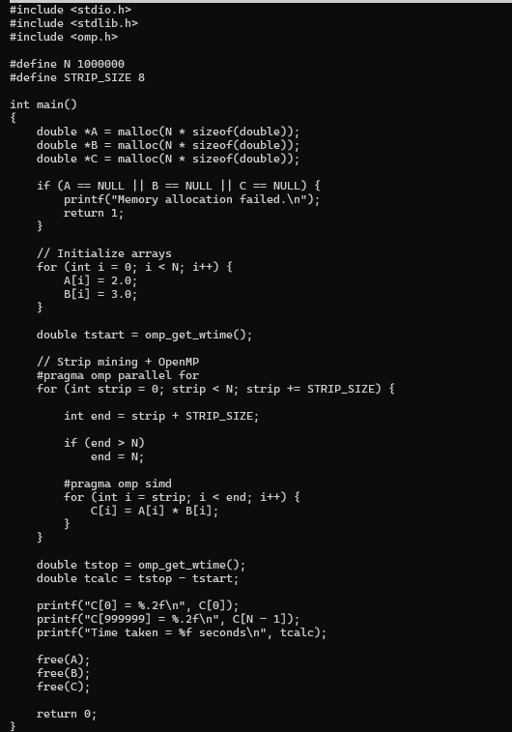

Output
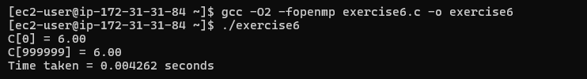

The element-wise multiplication was parallelized using OpenMP and strip mining. The array of 1,000,000 elements was divided into fixed-size strips of 8 elements. #pragma omp parallel for distributes these strips among the available threads, while #pragma omp simd allows the elements within each strip to be vectorized. Each element is calculated independently using C[i] = A[i] * B[i]. A strip size of 8 was selected to provide a small fixed-size block suitable for SIMD processing. The program produced the correct result of 6.00 and took approximately 0.004262 seconds on this execution.

