Parallel computing
Lab 07
IT24101662

Exercise 1
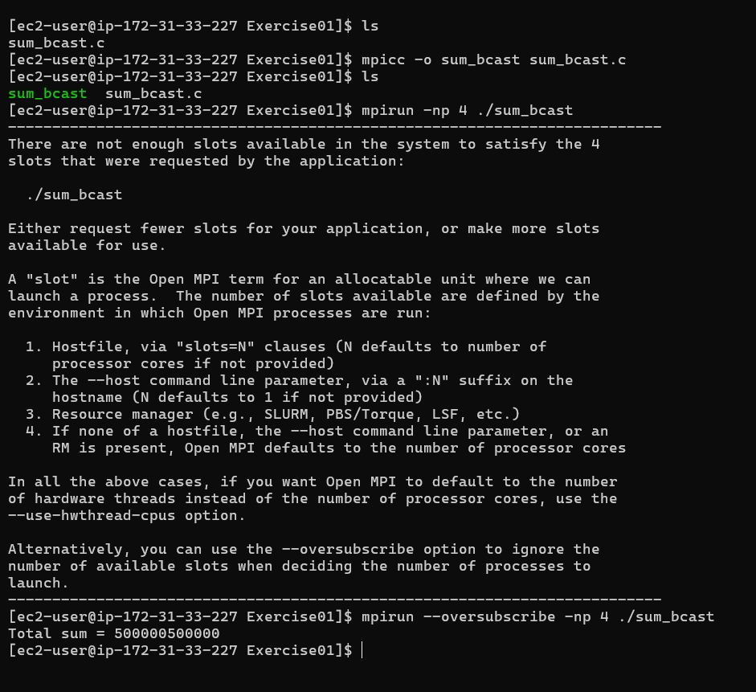
Exercise 2
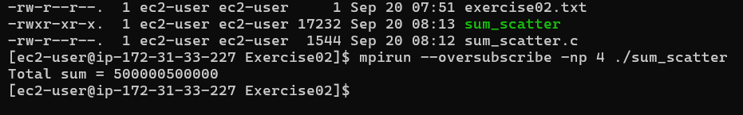
Exercise 3
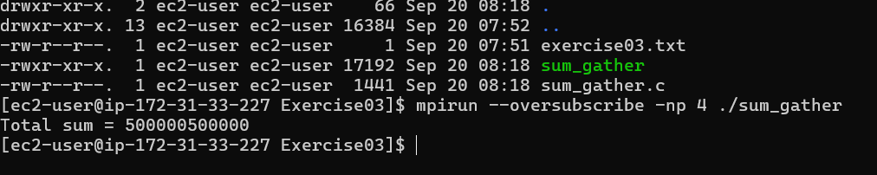
Exercise 4
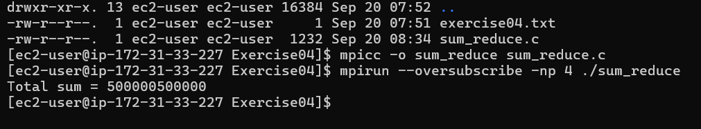
Exercise 5
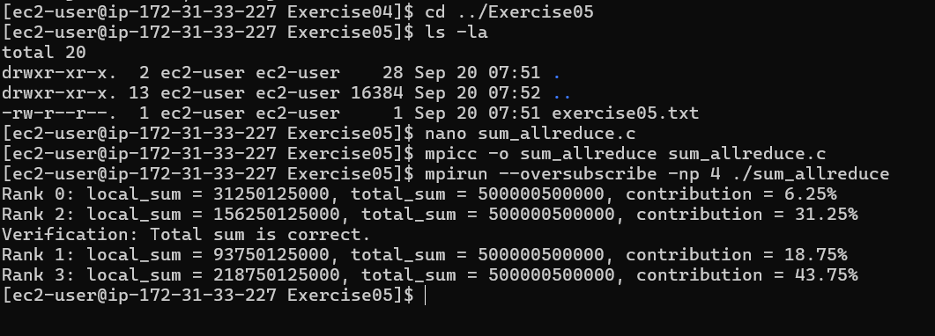
Exercise 6
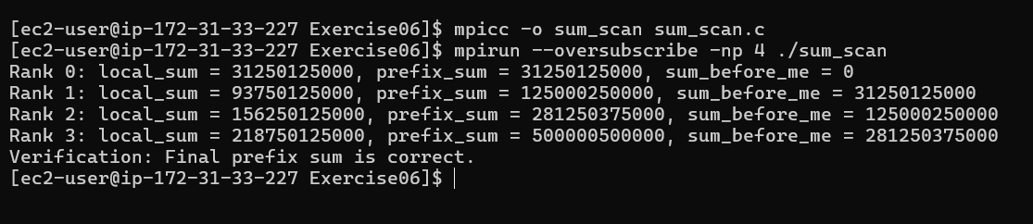

Exercise 7
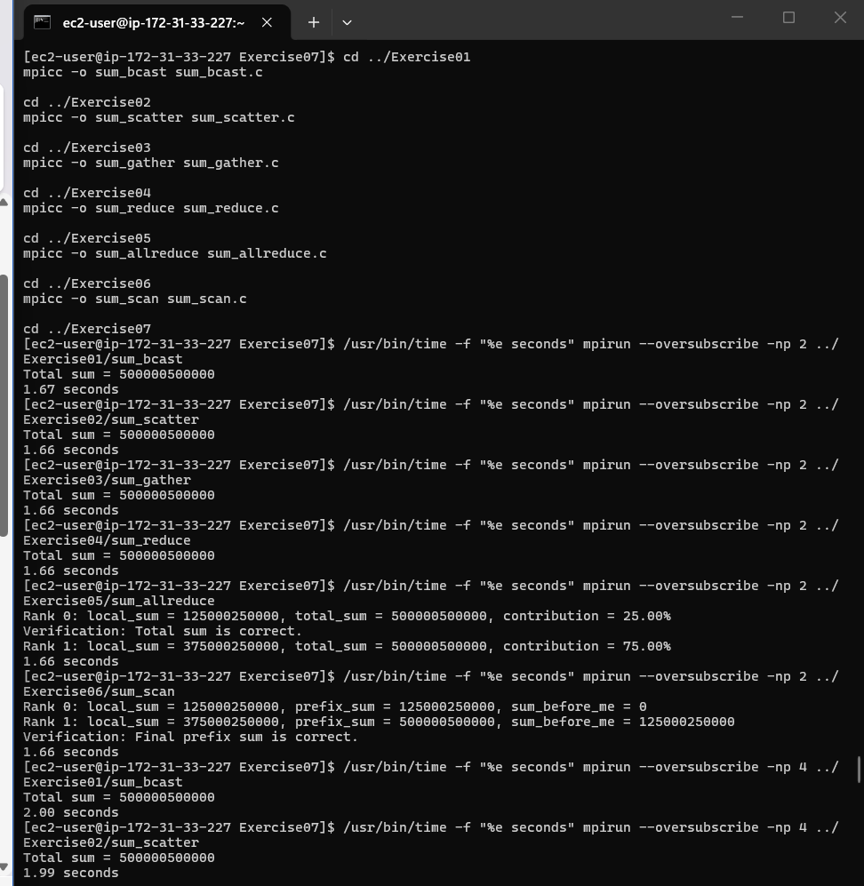
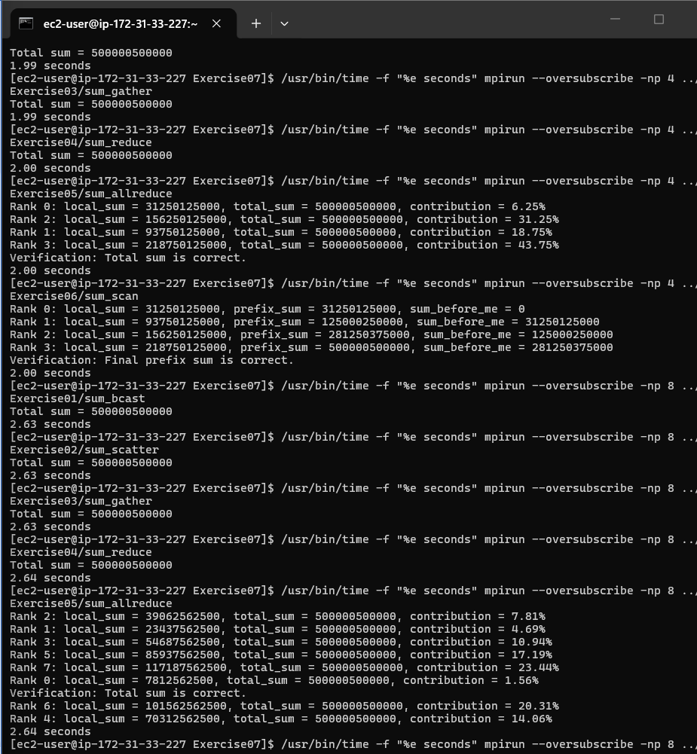
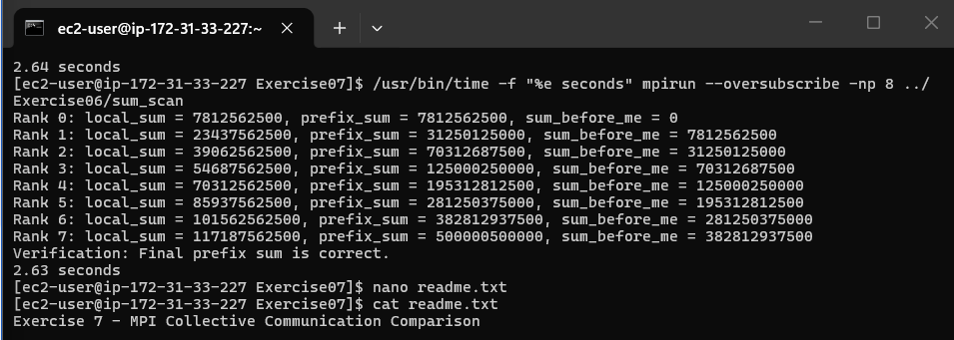
1. Collective communication comparison
Exercise | Collective communication | Array allocation | Manual root summation? | Final result
1 | MPI_Bcast + MPI_Send/Recv | Full array on every process | Yes | Root only
2 | MPI_Scatter + MPI_Send/Recv | Chunk on every process | Yes | Root only
3 | MPI_Scatter + MPI_Gather | Chunk on every process | Yes | Root only
4 | MPI_Scatter + MPI_Reduce | Chunk on every process | No | Root only
5 | MPI_Scatter + MPI_Allreduce | Chunk on every process | No | Every process
6 | MPI_Scatter + MPI_Scan | Chunk on every process | No | Prefix result on every process

2. Performance results
Exercise | Approach | 2 Processes | 4 Processes | 8 Processes
1 | Bcast + Send/Recv | 1.67 s | 2.00 s | 2.63 s
2 | Scatter + Send/Recv | 1.66 s | 1.99 s | 2.63 s
3 | Scatter + Gather | 1.66 s | 1.99 s | 2.63 s
4 | Scatter + Reduce | 1.66 s | 2.00 s | 2.64 s
5 | Scatter + Allreduce | 1.66 s | 2.00 s | 2.64 s
6 | Scatter + Scan | 1.66 s | 2.00 s | 2.63 s

3. Performance Observation
The 2 process runs were faster than the 4 process and 8process runs. This is because the EC2 instance has limited CPU resources, and using more processes with oversubscribe causes extra CPU and communication overhead.
4. When would you choose MPI_Scan over MPI_Allreduce?
MPI_Allreduce is used when all processes need the same final result.
MPI_Scan is used when each process needs a cumulative or prefix result.
For example, MPI_Scan can be used to find the sum of all previous processes, which can be useful for calculating data offsets.

