Parallel computing - SE3082
Lab 05
IT24101662

Exercise 1 — Barrier
The #pragma omp barrier directive forces all threads to wait until every thread has reached the barrier. In the output, the thread # messages are printed before the barrier, while the Hi again messages occur only after all threads have reached the barrier. Therefore, the barrier ensures synchronization between the threads.
With 4 threads, threads 0, 1, 2, and 3 were created, and all of them passed the barrier before continuing.
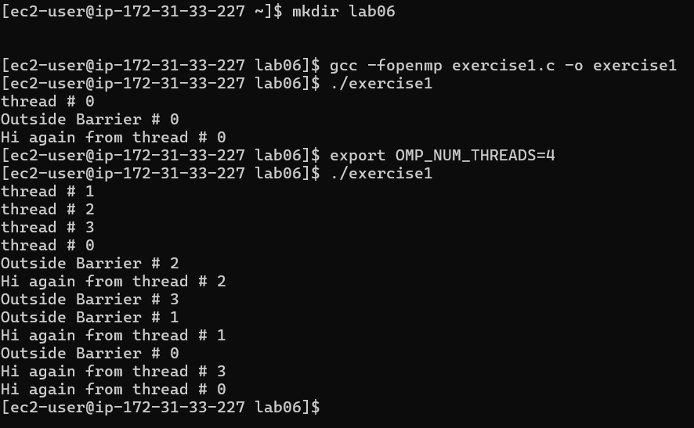

Exercise 2 — Single
The #pragma omp single directive allows a block of code to be executed by only one thread, even though multiple threads are available in the parallel region. The selected thread executes the single block while the other threads continue with their own work.
This is useful when a particular operation should only be performed once instead of once by every thread.
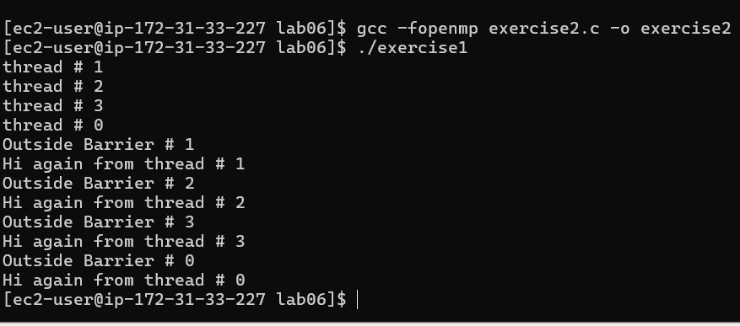
Exercise 3 — Master
The #pragma omp master directive allows only the master thread, thread 0, to execute the associated block. In the output, only thread 0 prints:
Inside Master # 0
Exiting Master
The other threads do not execute the master block. Unlike single, the master directive does not have an implicit barrier at the end, so the other threads do not have to wait for thread 0 to finish the master block.
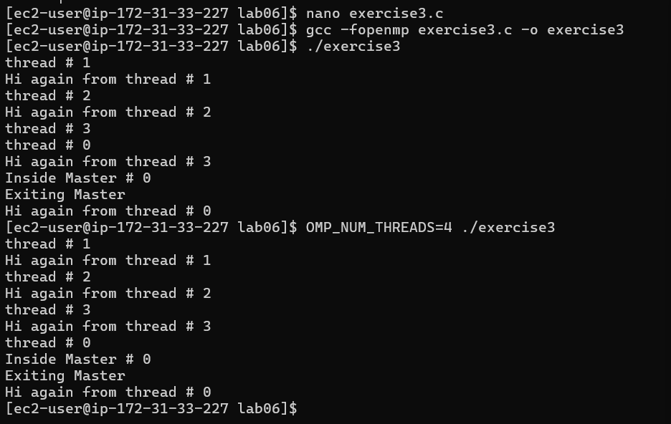

Exercise 4 — Nested Loops
parallel for distributes only the outer loop, while collapse(2) combines both loops and distributes all 50 iterations across the threads. Therefore, collapse(2) provides finer-grained work distribution and can improve load balancing.
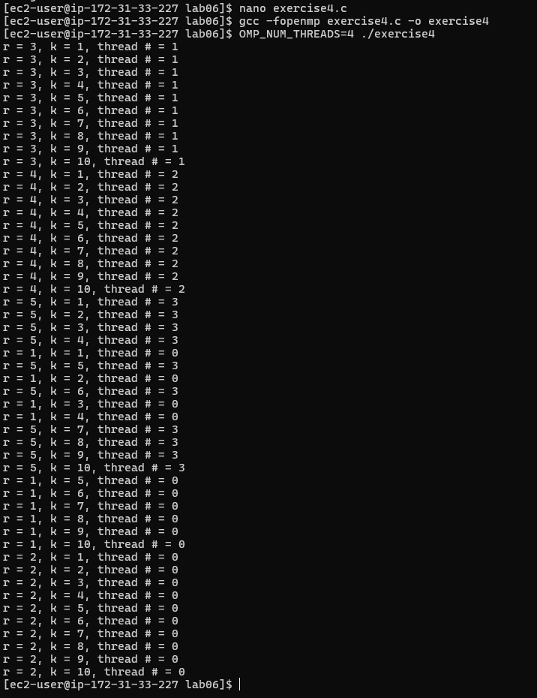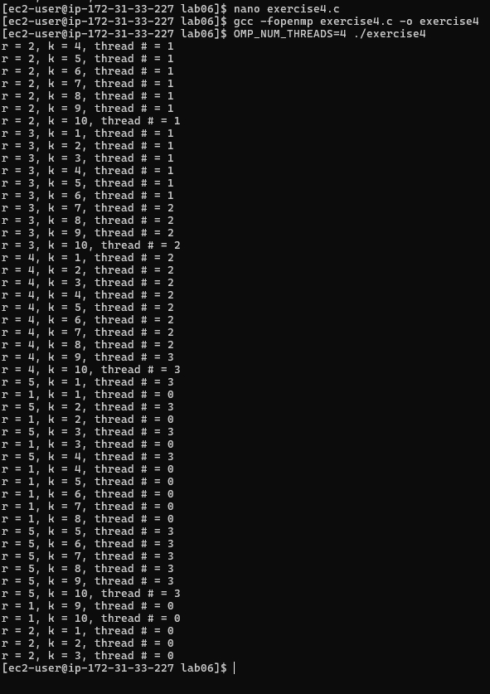

Exercise 6 — Strip Mining
Threads | Time (seconds) | C[0] | C[500000] | C[999999]
1 | 0.008109 | 0 | 1,000,000 | 1,999,998
2 | 0.008313 | 0 | 1,000,000 | 1,999,998
4 | 0.008345 | 0 | 1,000,000 | 1,999,998

The results were correct for all tested thread counts. Increasing the number of threads did not provide a speedup because the EC2 instance has only one CPU core. The small increase in execution time with more threads is caused by OpenMP thread-management overhead.

Exercise 7 — Mandelbrot Set

Threads | Points Inside | Estimated Area | Time (seconds)
1 | 167740 | 1.5096600000 | 2.985790
1 | 167740 | 1.5096600000 | 2.996066
1 | 167740 | 1.5096600000 | 2.978945
3 | 167740 | 1.5096600000 | 2.982431
4 | 167740 | 1.5096600000 | 2.978698

The Mandelbrot program produced the same result for all tested thread counts, with 167740 points inside the set and an estimated area of 1.5096600000. The execution time remained around 3 seconds, showing almost no speedup when increasing the number of threads. This is because the EC2 instance has only one CPU core, so multiple OpenMP threads cannot execute in parallel on separate cores.

