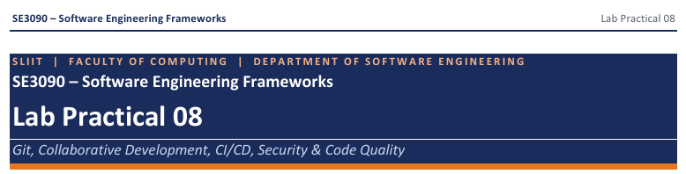
IT24101893 – Ranasinghe.N.A
• Your GitHub repository link : https://github.com/IT24101893/campuseats-task-tracker.git

Task 1: Github Repository setup
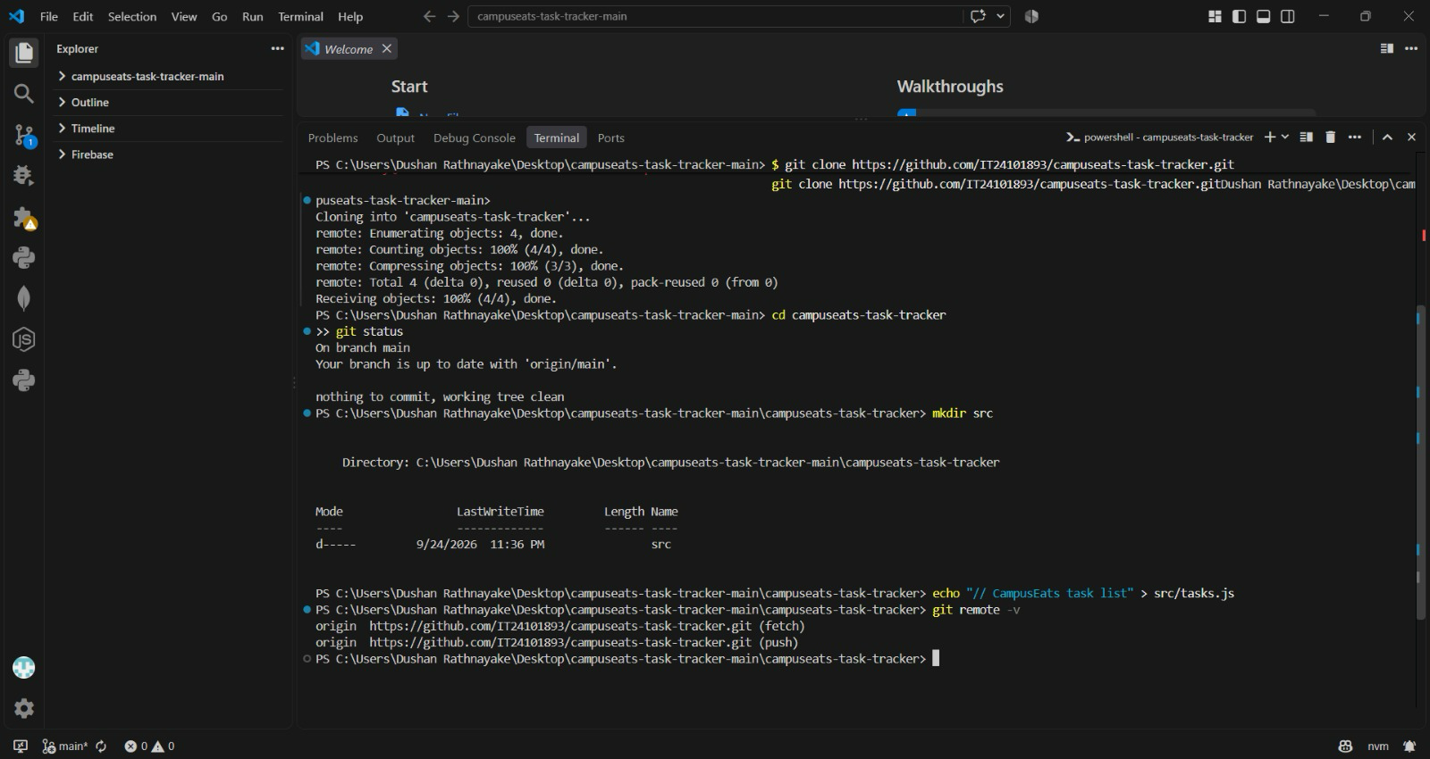
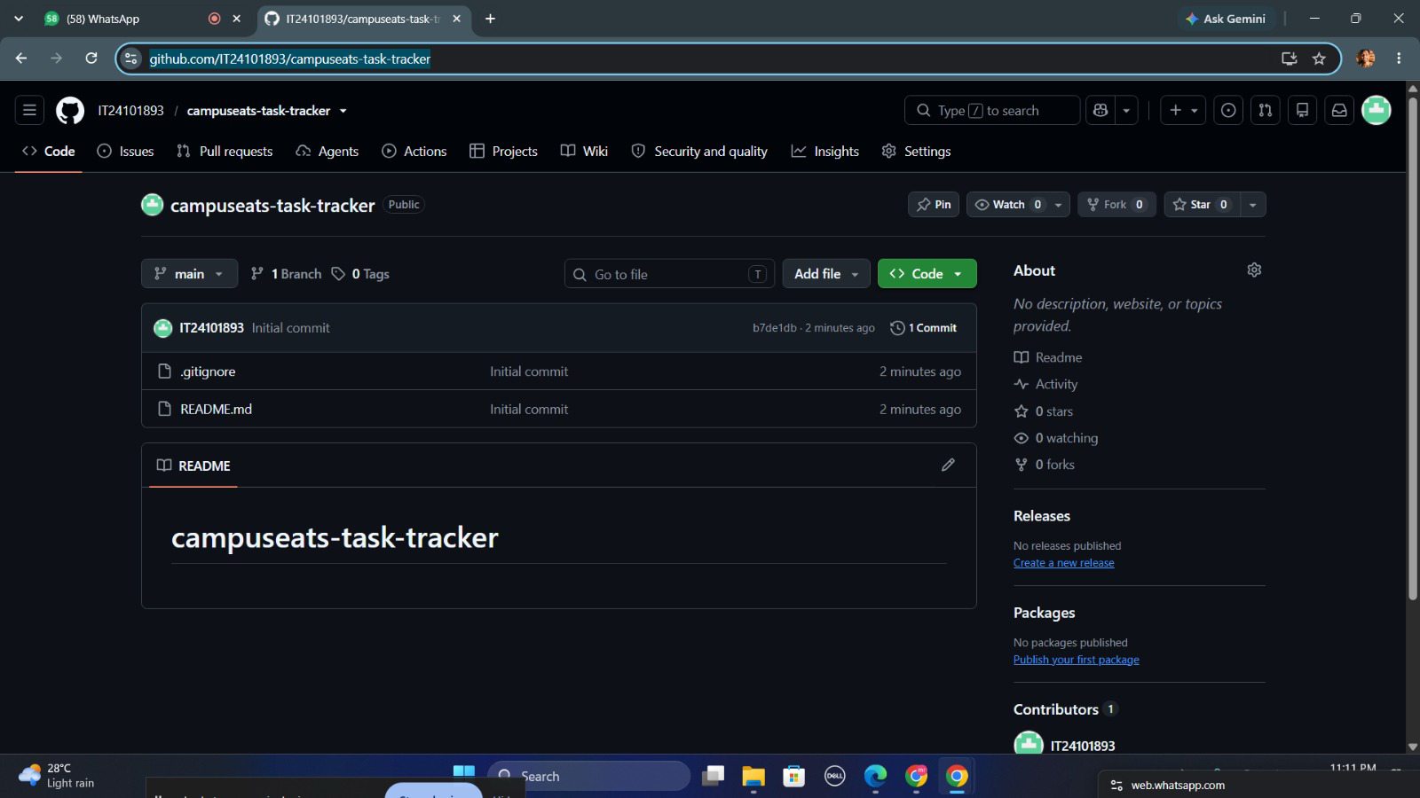

Task 2: Branching and commit workflow

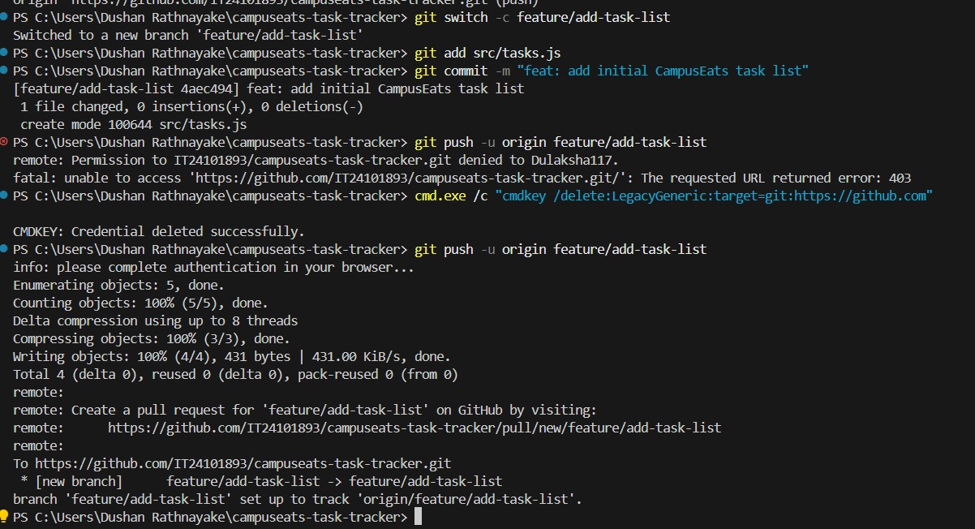

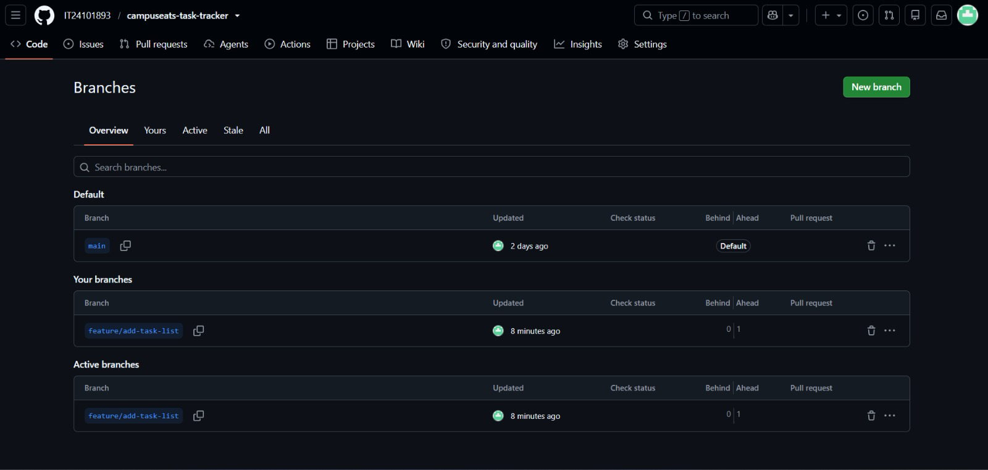

Task 3: pull request and code review
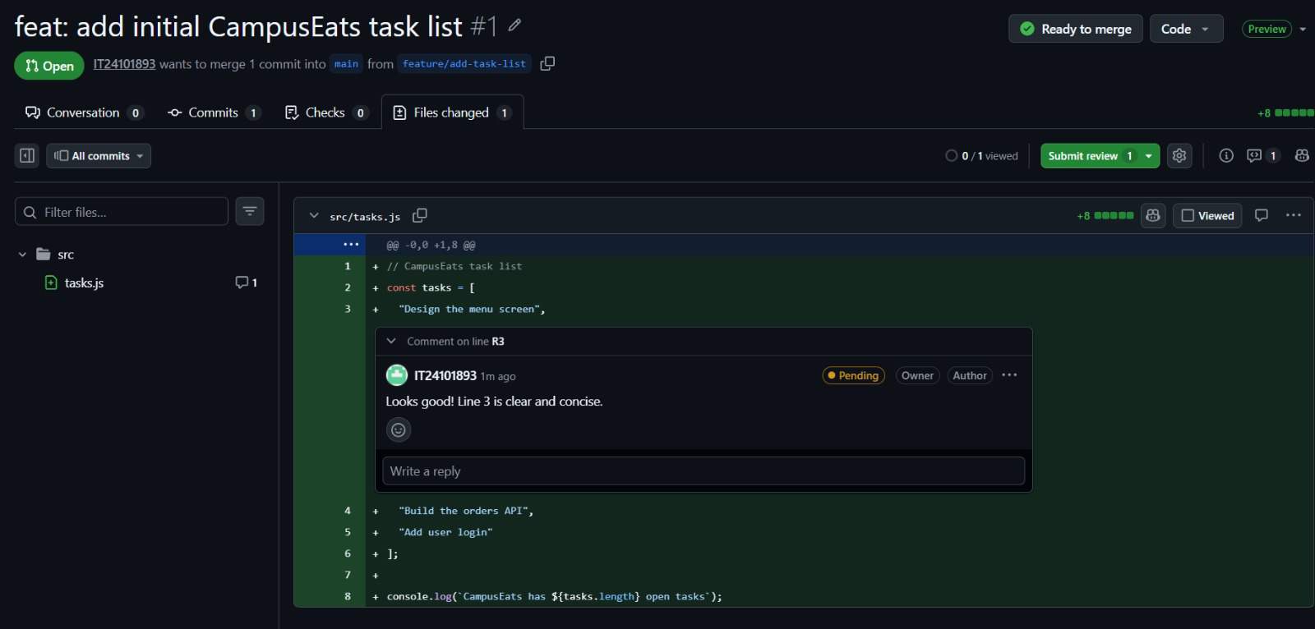
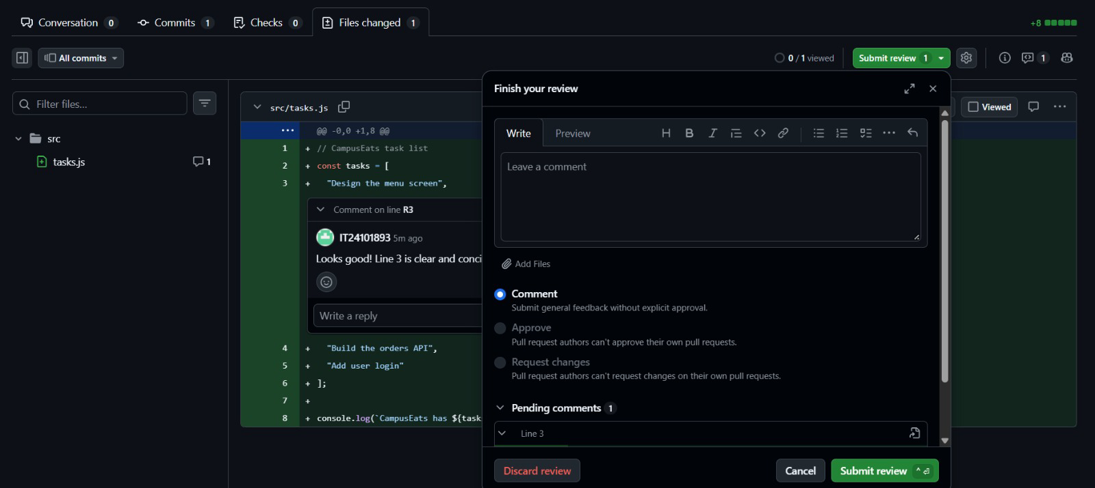
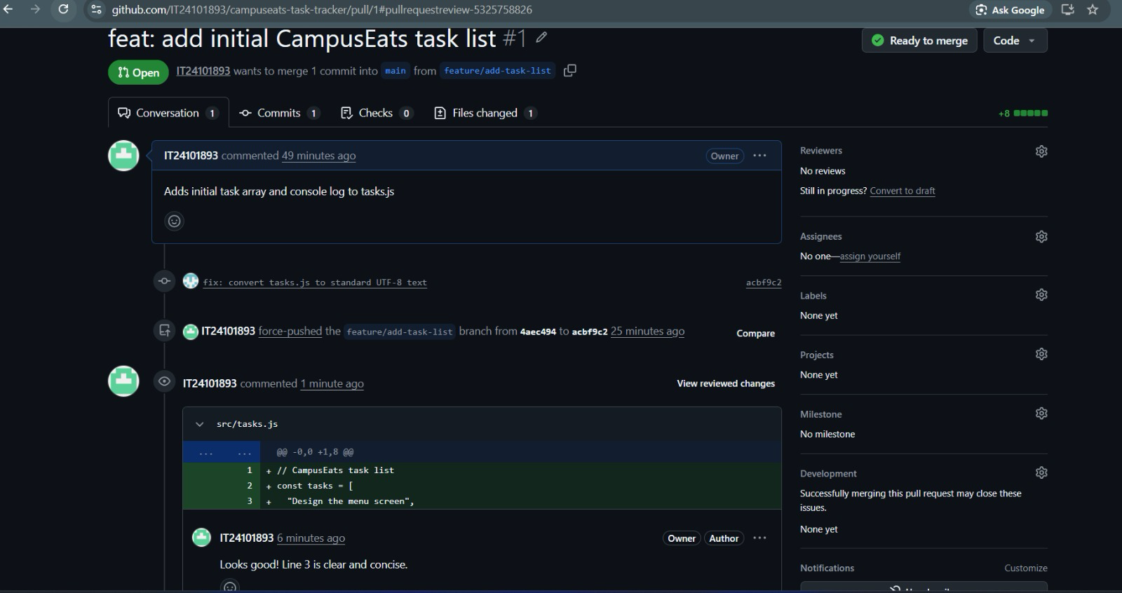

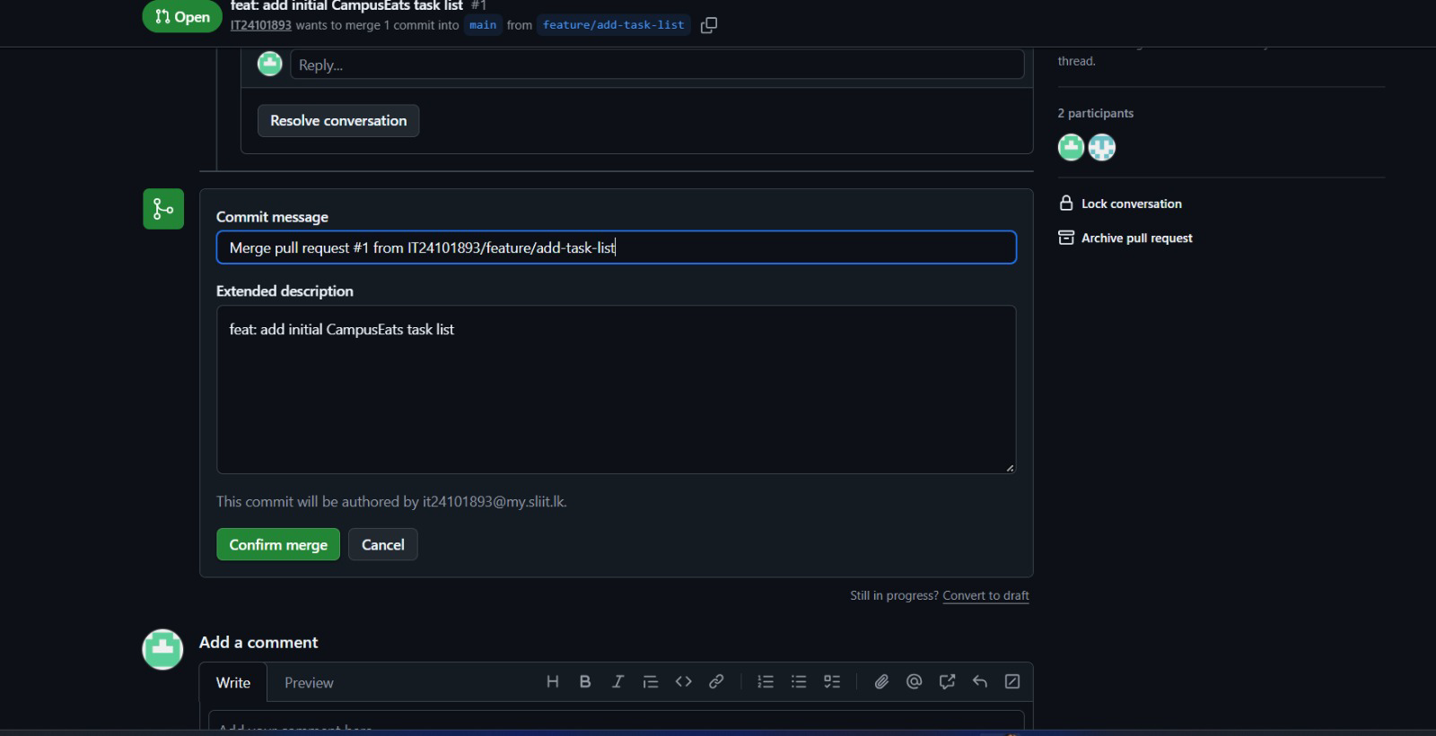
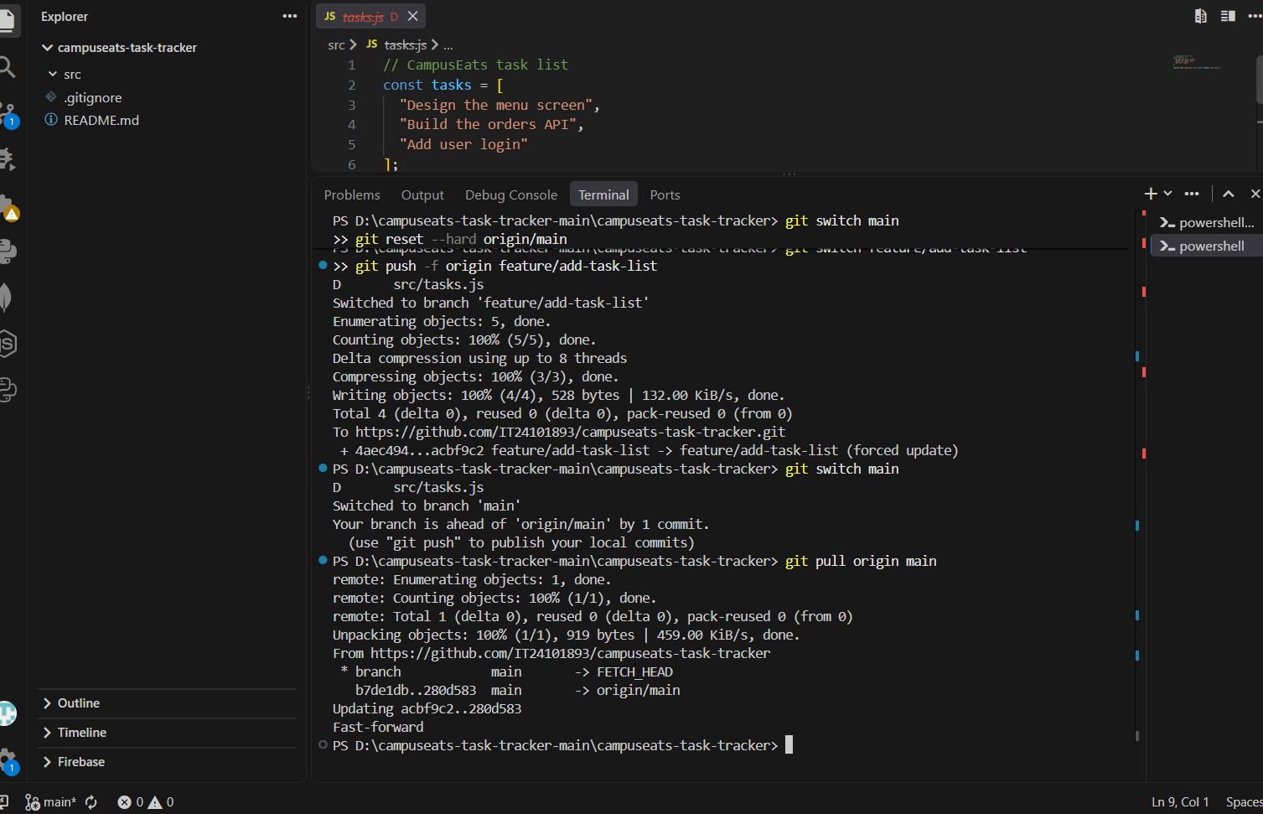

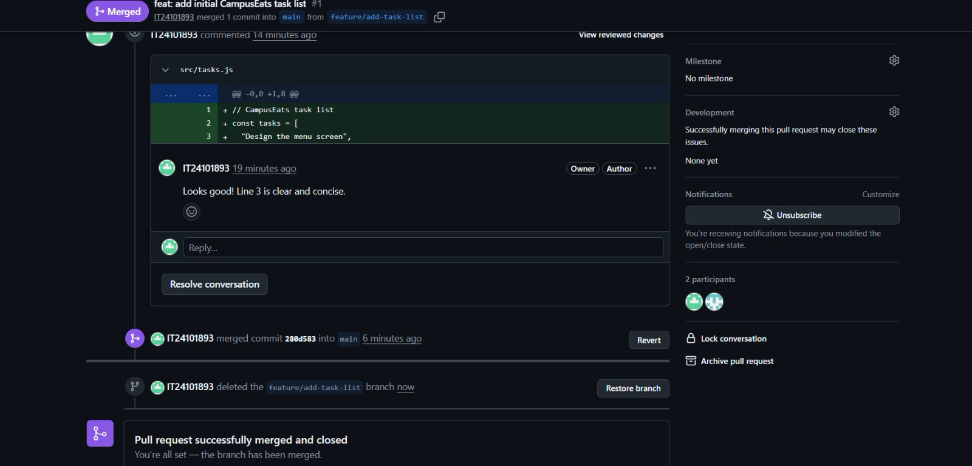

Task 4: GitHub issues and collaborative workflow
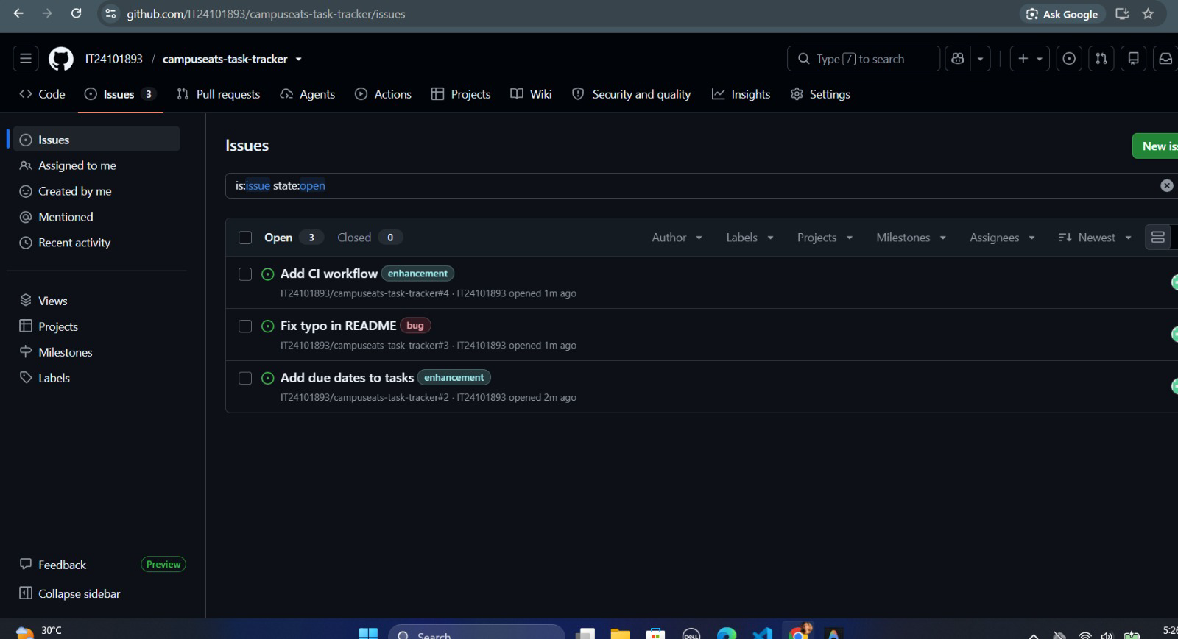
GitHub Issues can be linked to development work using issue references such as Closes #1. When the related commit or pull request is merged, GitHub automatically closes the referenced issue.

Task 5: CI/CD pipeline using Github actions
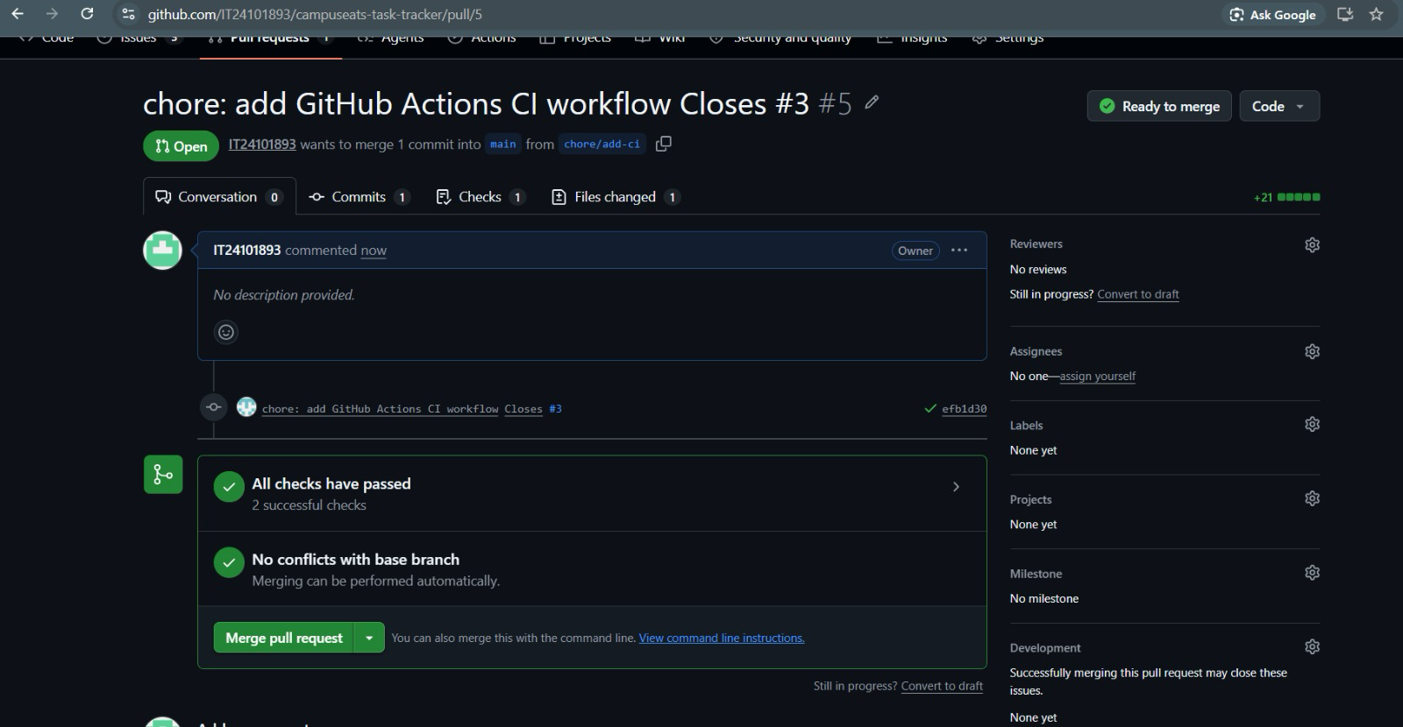
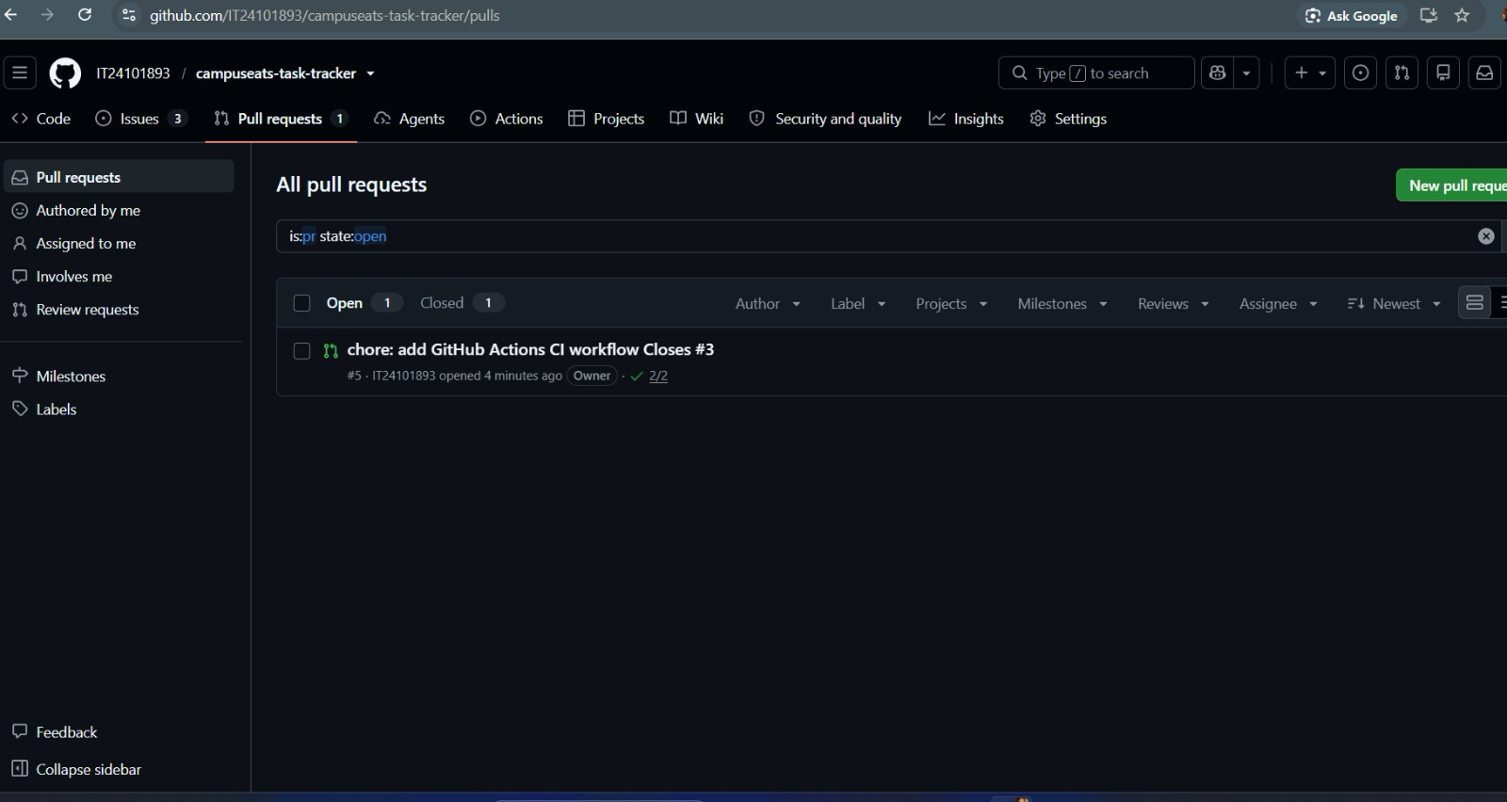

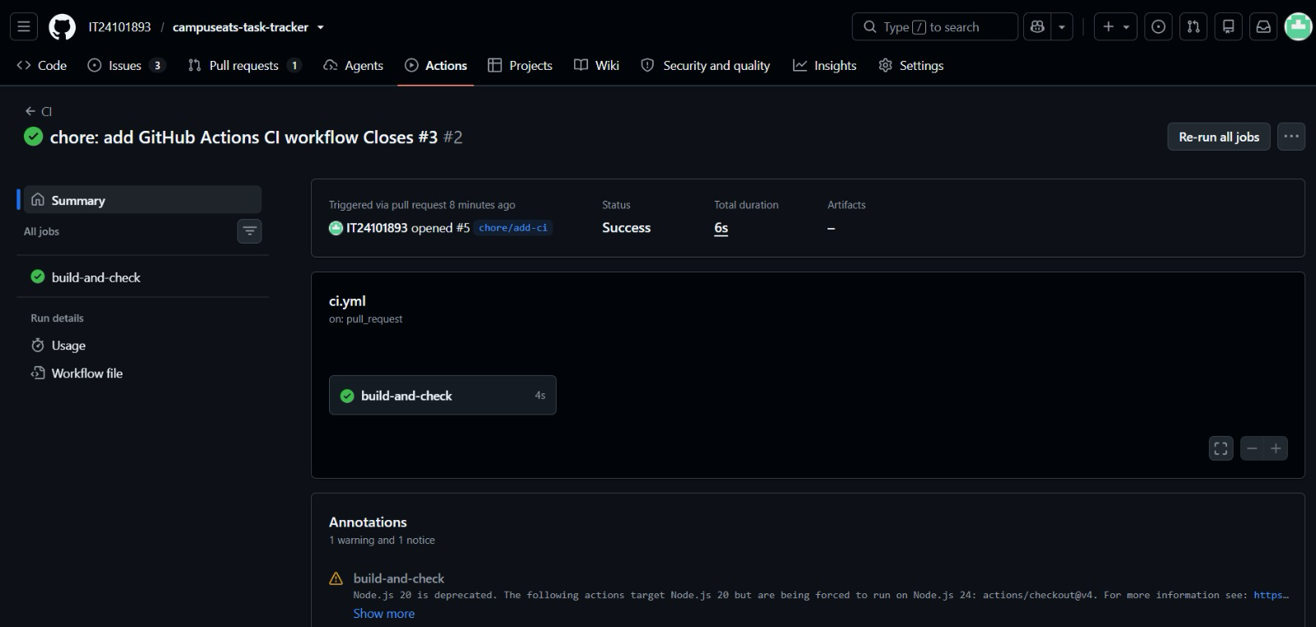
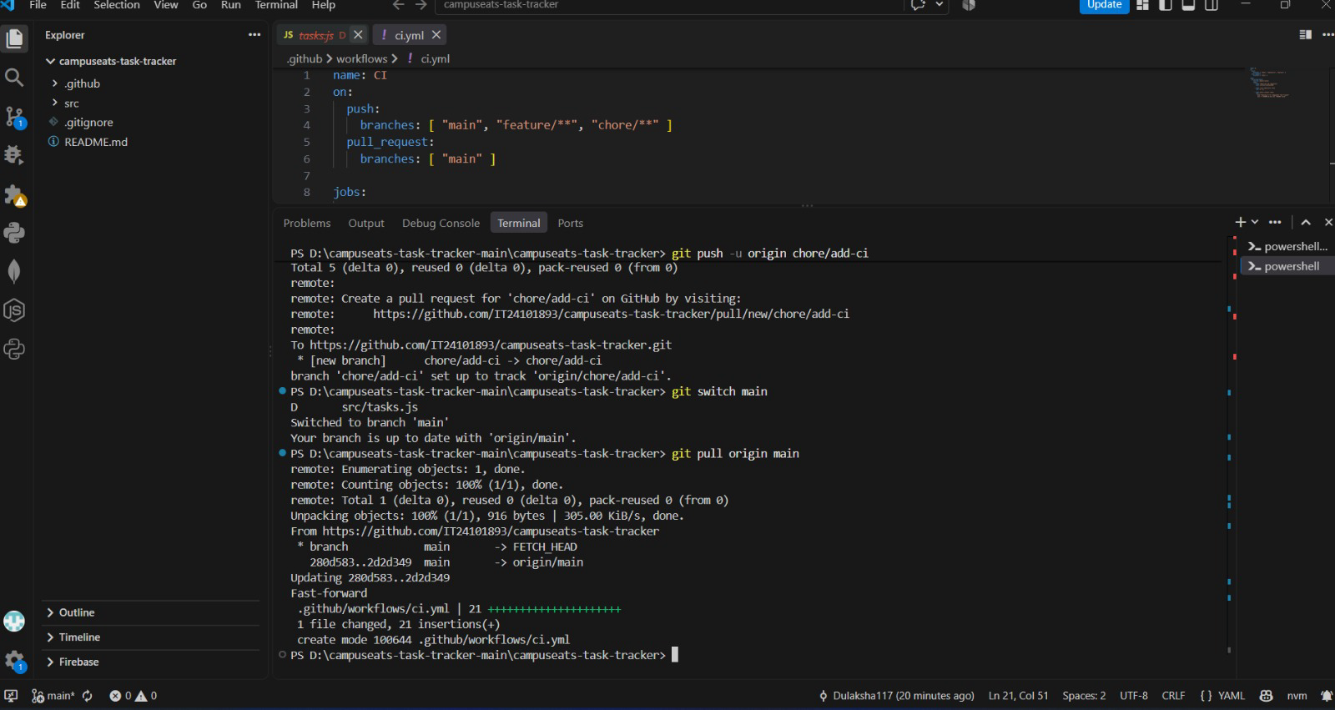
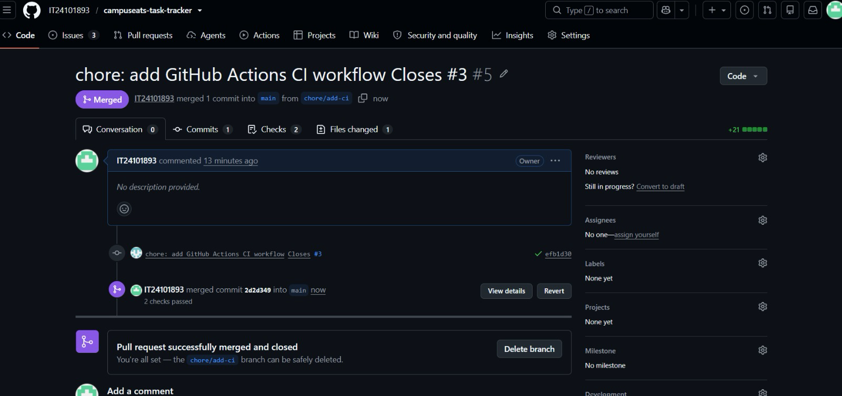
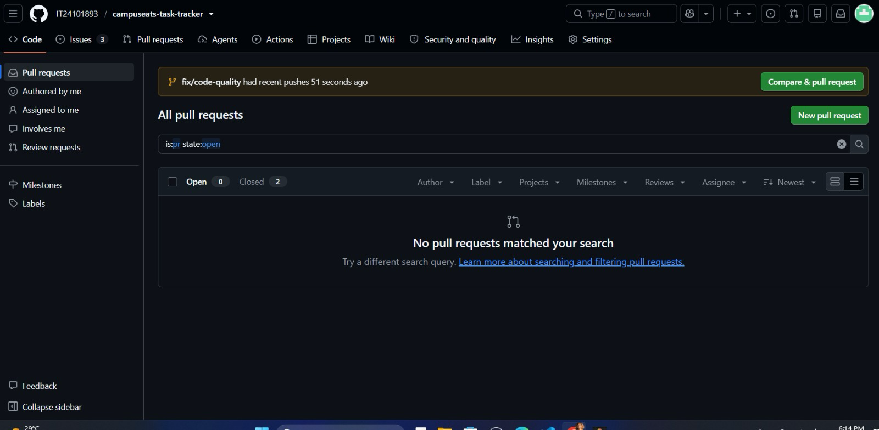
This task helped me understand the importance of writing clean, readable, and secure code. I learned that meaningful variable and function names, constants, input validation, and strict comparisons can make code easier to maintain and less error-prone. I also learned that sensitive information such as API keys should never be hard-coded or committed to a Git repository. Using tools such as Dependabot can help identify dependency-related security issues and improve the overall security of a project.
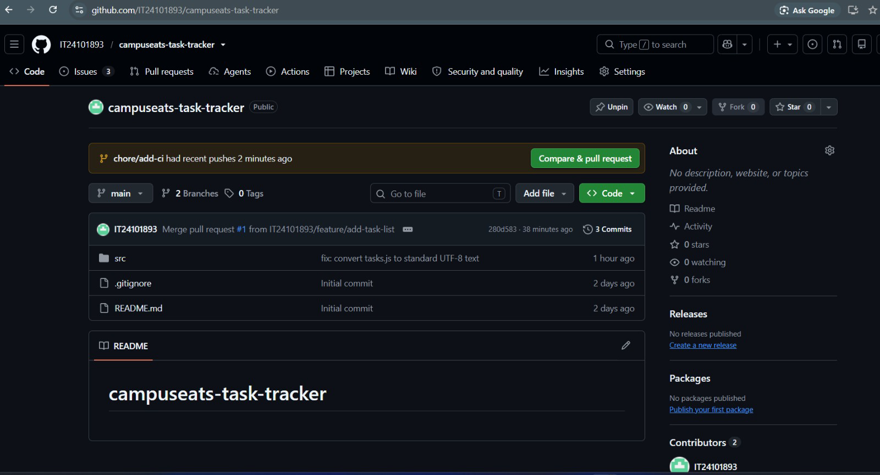

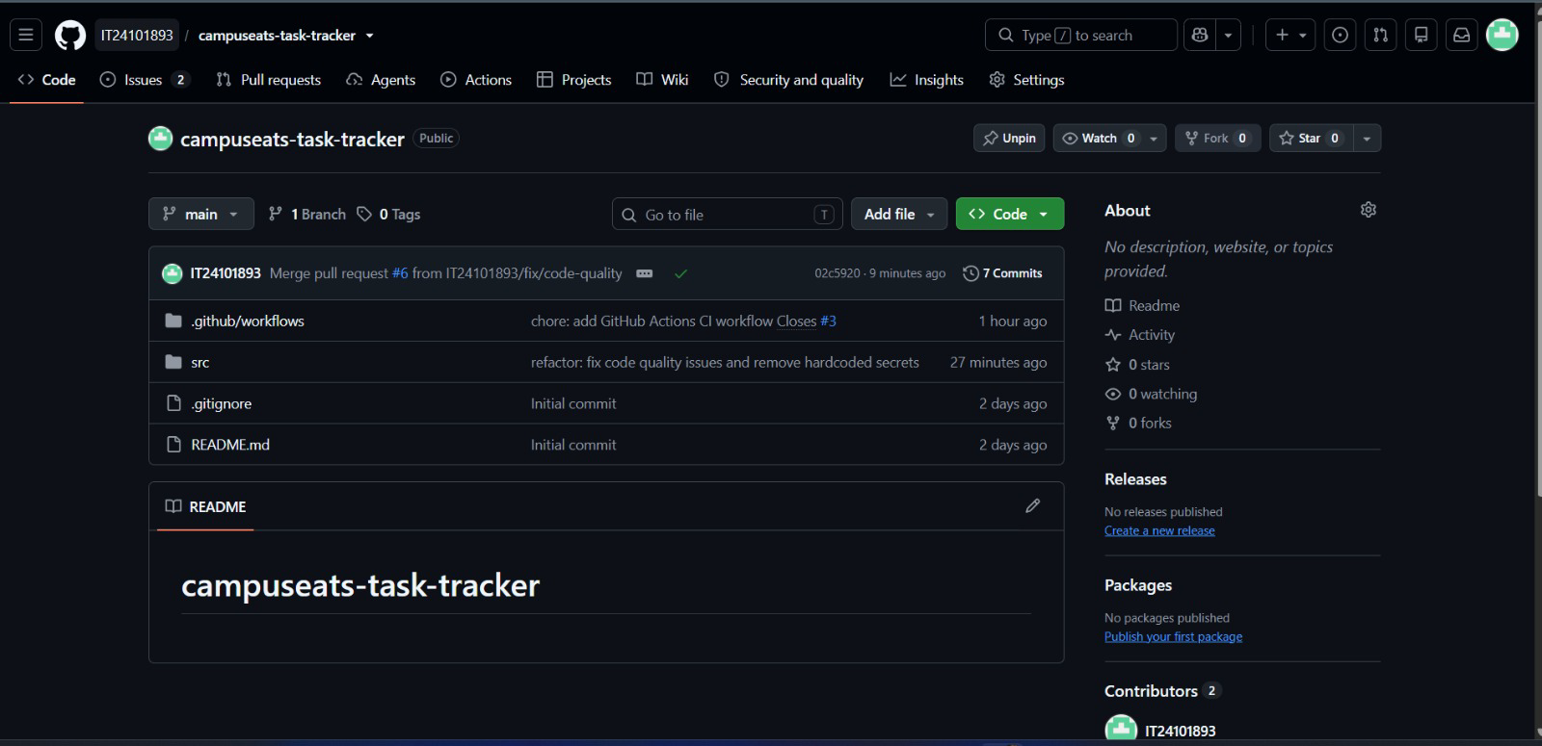

1. Unclear variable/function names - calc, a, b, t, and x do not clearly explain what they represent.
2.Magic number - 0.1 is used directly instead of a named constant such as VIP_DISCOUNT.
3. Hardcoded API key/secret - the API key is written directly in the source code, which is a security risk.
4. Uses var - var is less safe/clear than const or let for modern JavaScript.
5. Loose equality (==) - == can perform type conversion; strict equality === is clearer and safer.

Q1. Which command creates a new branch AND switches to it in one step?
(c) git switch -c new
Q2. A pull request is used to:
(b) delete a branch
Q3. The main purpose of CI/CD is to:
(d) automatically build, test, and deploy changes
Q4. GitHub Actions workflow files are stored in:
(b) .github/workflows/ as .yml files
Q5. Which is a secure development practice?
(c) store secrets in environment variables and never commit them
Q6. Write the two Git commands to stage all changes and commit them with the message fix: correct total.
git add .
git commit -m "fix: correct total"
Q7. Name any three stages of a typical CI/CD pipeline, in order.
Commit - Build - Test
Q8. A teammate pushes a commit that contains a live API key in appsettings.json. What is the risk, and what three actions should they take?
Treat the key as compromised. Then remove it from the repository code. Then regenerate the key. after store the new key securely using environment variables or a secrets store.

