
IE3090
Network Programming
3rd Year, Semester I

Assignment Report
RemoteOps: A Remote System Monitoring and Management Tool over TCP/IP

Submitted to
Sri Lanka Institute of Information Technology

In partial fulfillment of the requirements for the
Bachelor of Science Special Honors Degree in Information Technology

06/10/2026
Declaration
I certify that this report does not incorporate without acknowledgement, any material previously submitted for a degree or diploma in any university, and to the best of my knowledge and belief it does not contain any material previously published or written by another person, except where due reference is made in text.
Registration Number : IT24102441
Name : G.L.Bogahawatte

1. Personalised Values
All values below are derived from my registration number (IT24102550) using the formulas in Section 2.4 of the assignment brief.
Item | Formula | My value
Agent listening port | 7000 + first four digits of numeric part | 9410
Source files | agent_<last3>.c, controller_<last3>.c, Makefile_<last3> | agent_441.c, controller_441.c, Makefile_441
Session ID (SID) tag | Last four digits, reversed | SID:1442
Authentication token | OPS- + last four digits | OPS-2441
Log file | remoteops_<regno>.log | remoteops_IT24102441.log
Storage path | ./agentfiles/<regno>/<filename> | ./agentfiles/IT24102441/
Submission archive | IE3090_<regno>.zip | IE3090_IT24102441.zip

Worked calculation
My registration number IT24102441 has the numeric part 24102441.
- First four digits: 2410, so the port is 7000 + 2410 = 9410.
- Last four digits: 2441, reversed: 1442, so the SID tag is SID: 1442
- Authentication token: OPS- followed by 2441 gives OPS-2441.
- Last three digits: 441, so the files are agent_441.c, controller_441.c and Makefile_441.
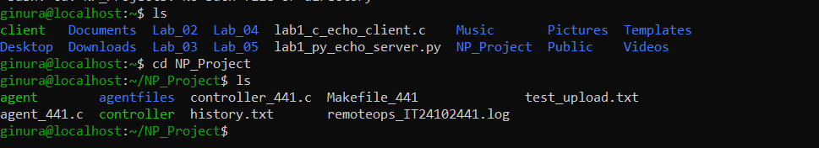
Figure 1 : Project Directory Structure and Personalized File Naming Validation

2.1 Concurrency model
The Agent uses POSIX threads (pthreads) for its thread-per-connection architecture which enables it to handle multiple Controllers at the same time. The system creates a dedicated thread to handle each new connection that arrives.
Justification:
- The system supports independent state for each session through authenticated flag and monitoring thread and receive buffer which naturally fits into a dedicated thread for every connection.
- Shared resources: The log file receives protection through a mutex which stops different threads from creating mixed log entries.
- Trade-offs: The fork() system call provides users with better isolation between connections but it requires additional resources to handle each new connection. The select() system call prevents thread creation yet it makes byte counting for PUT and GET operations more complicated because every connection requires its own state machine.
- Capacity: The Agent supported five different Controllers when it underwent its testing phase.

2.2 Session handling and framing
The system allocates BUFFER_SIZE (1024 bytes) as its standard buffer size to manage individual client connections. The system receives data through recv() and processes incoming text commands by evaluating the buffer content. During a PUT operation, the Agent parses the exact file size from the protocol header, switches from standard text evaluation to a binary streaming mode, and loops recv() until the exact number of bytes is written to disk before returning to the standard command loop.
2.3 UDP monitoring
The MONITOR START command triggers the Agent to spawn a detached monitoring thread. This thread opens a SOCK_DGRAM UDP socket and streams system statistics (e.g., SYSINFO <cpu_load> <mem_used> <uptime> SID:1442) to the Controller every 5 seconds using a sleep(5) interval. The commands MONITOR STOP, QUIT, or an ungraceful client disconnect will safely flip the active state flag, stopping the UDP stream and closing the socket for that specific session without crashing the main Agent process.

3. Protocol Implementation Evidence
The table confirms that every command in the given protocol is implemented. Commands sent before a successful AUTH are rejected.
Command | Success response | Error response(s) | Implemented
AUTH <token> | OK AUTHENTICATED SID:1442 | ERR 001 AUTH_FAILED SID:1442 | Yes
SYSINFO | OK SYSINFO <cpu> <mem> <uptime> SID:1442 | ERR 002 COMMAND_NOT_ALLOWED SID:1442 | Yes
LISTPROC | OK PROCS <list> SID:1442 | ERR 002 COMMAND_NOT_ALLOWED SID:1442 | Yes
EXEC <name> | OK EXEC_RESULT <output> SID:1442 | ERR 002 COMMAND_NOT_ALLOWED SID:1442 | Yes
PUT <file> <size> | OK FILE_RECEIVED <file> SID:1442 | ERR 004 FILE_TOO_LARGE SID:1442 | Yes
GET <file> | OK FILE_SEND <file> <size> SID:1442 | ERR 005 FILE_NOT_FOUND SID:1442 | Yes
MONITOR START <port> | OK MONITOR_STARTED SID:1442 | ERR 008 MONITOR_ALREADY_ACTIVE SID:1442 | Yes
MONITOR STOP | OK MONITOR_STOPPED SID:1442 | ERR 002 COMMAND_NOT_ALLOWED SID:1442 | Yes
QUIT | OK BYE SID:1442 | None | Yes

1.Authentication: the Agent must require a successful AUTH command.

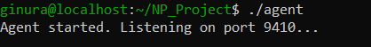
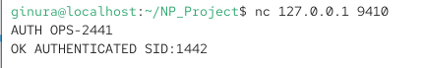
Figure 2 : User authentication with valid credentials

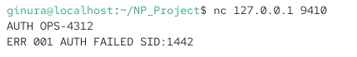
Figure 3 : User authentication with invalid credentials
2.Test SYSINFO

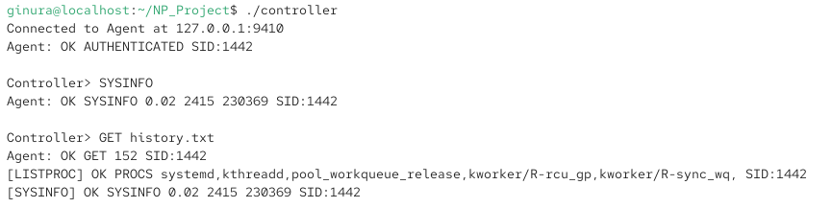
Figure 4 : Validation of SYSINFO Telemetry and Optional History Persistence

3.Test LISTPROC

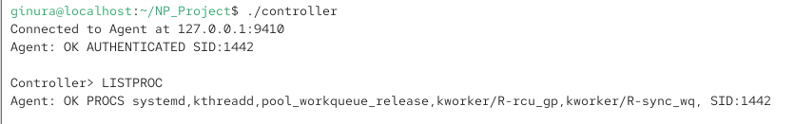
Figure 5 : Validation of LISTPROC Telemetry with SID:1442

4. Test an invalid command

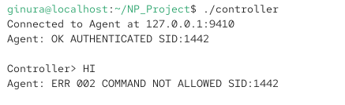
Figure 6 : Validation of ERR 002 Response for Unrecognized Commands

5. Test PUT command
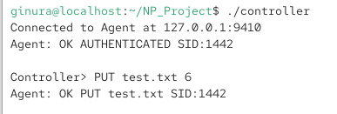
Figure 7 : Successful Execution and Response for PUT File Transfer
6.Test GET command

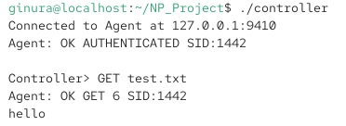
Figure 8 : Successful Execution and Response for GET File Download

7.Test MONITOR START

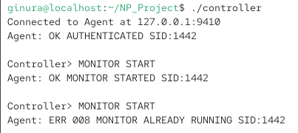
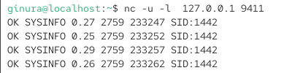
Figure 9 : Successful Reception of Formatted System Statistics via UDP Protocol

8. Test MONITOR STOP

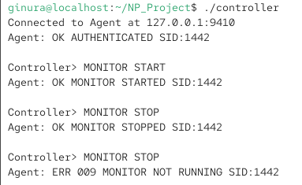
Figure 10 : Validation of MONITOR STOP Error Handling for Inactive Streams

9.Test QUIT command

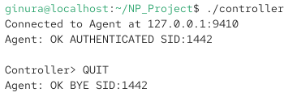
Figure 11 : Successful Session Termination via QUIT Command

4. Personalisation Proof
The following evidence shows that the personalised values from Section 1 are applied in the running system.
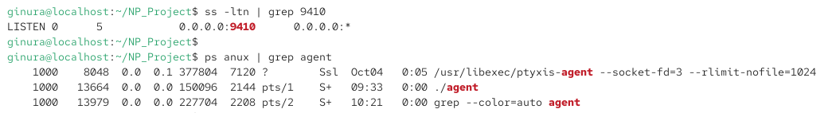
Figure 12 : Successful Session Termination via QUIT Command

5.Architecture Overview: RemoteOps System
The RemoteOps application utilizes concurrent Client-Server architecture, divided into a centralized Agent (Server) and a remote Controller (Client). The system relies on a dual-protocol communication strategy to handle both reliable command execution and lightweight telemetry broadcasting.
- Primary Control Channel (TCP): The core command protocol operates over reliable TCP sockets bound to port 9410. This ensures guaranteed in-order delivery of commands (AUTH, EXEC, LISTPROC) and prevents data corruption during binary file transfers (PUT, GET). The Agent parses incoming newline-terminated strings, executes the corresponding system calls, and returns formatted responses tagged with the personalized session identifier (SID:1442).
- Secondary Telemetry Channel (UDP): A detached UDP channel bound to port 9411 handles the MONITOR telemetry stream. UDP was selected for this feature because periodic system statistics (CPU, memory, uptime) are time-sensitive rather than critical; if a single 5-second interval datagram is dropped over the network, it is immediately superseded by the next update, avoiding unnecessary TCP overhead and retransmission delays.
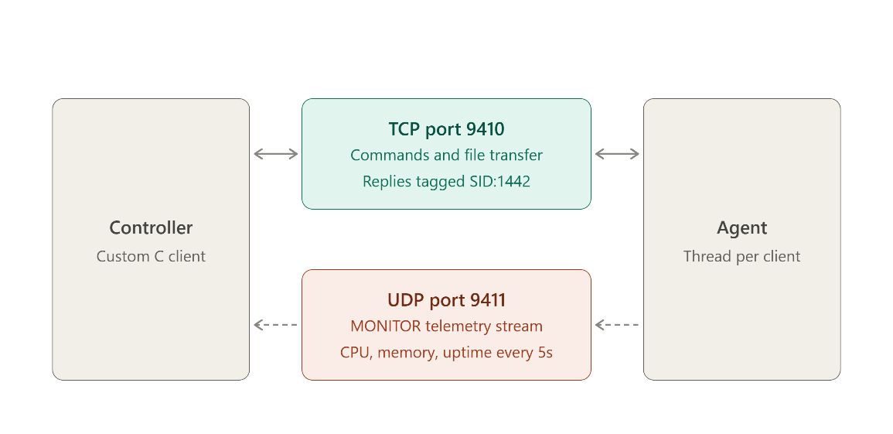
Figure 13 : RemoteOps dual-protocol client-server architecture

6. Annotated Code Screenshots
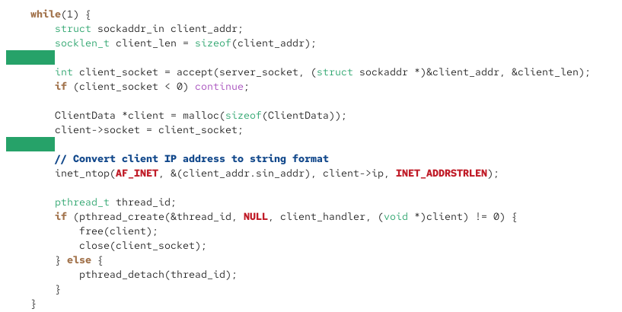
Figure 14 : TCP Socket Initialization and Connection Loop
This snippet demonstrates the core server setup binding the primary TCP control channel to the personalized port 9410. The accept() system call operates in a continuous loop, allowing the Agent to continuously listen for and accept incoming Controller connections over the network.

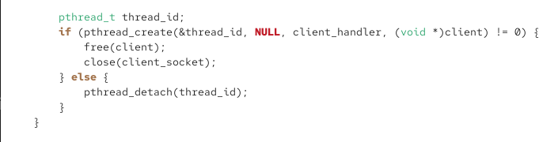
Figure 15 : POSIX Thread Creation for Concurrent Client Sessions
To satisfy the concurrency requirement, the Agent spawns a detached POSIX thread for every accepted client connection. The client file descriptor is passed into the thread handler, allowing multiple administrators to interact with the Agent simultaneously.

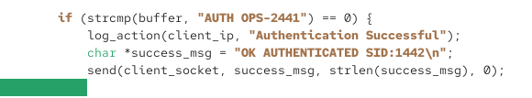
Figure 16 : Authentication Gatekeeper Logic

This logic intercepts the first command, strictly requiring the personalized AUTH OPS-2441 string. If valid, the Agent confirms with the SID:1442 tag; otherwise, it returns ERR 001 and rejects subsequent inputs.

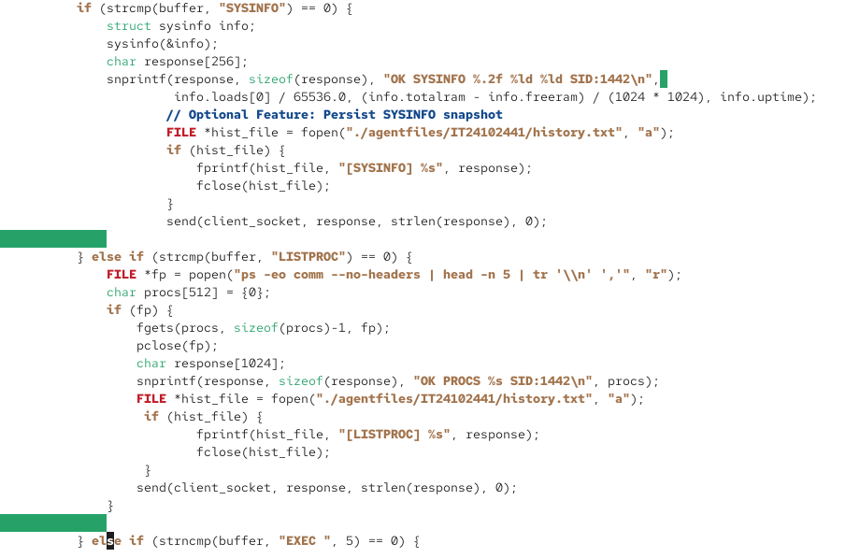
Figure 17 : System Telemetry Retrieval (SYSINFO & LISTPROC)
these handlers interface directly with the Linux OS. SYSINFO parses the <linux/sysinfo.h> structure to extract real-time metrics, while LISTPROC utilizes popen() for a process snapshot.

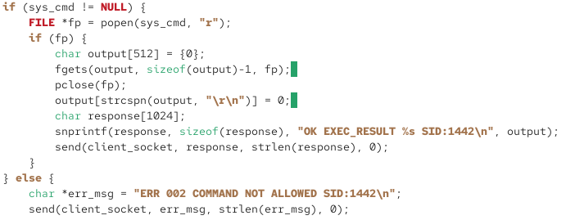

Figure 18 : Restricted Remote Command Execution Validation
To ensure security, the EXEC handler cross-references arguments against a strict whitelist. Unrecognized arguments trigger an ERR 002 COMMAND_NOT_ALLOWED response, preventing arbitrary shell code execution.

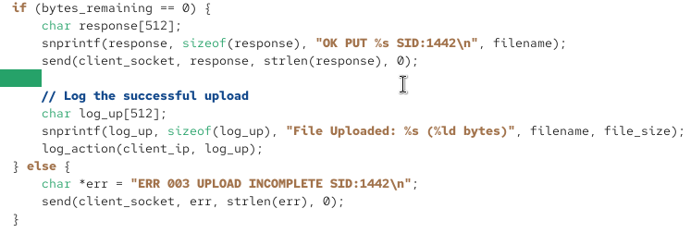
Figure 19 : Synchronous File I/O for PUT and GET Commands
File transfers utilize blocking I/O loops that continuously read or write raw binary payloads until the exact specified size is reached. Files are correctly routed to the personalized storage directory.

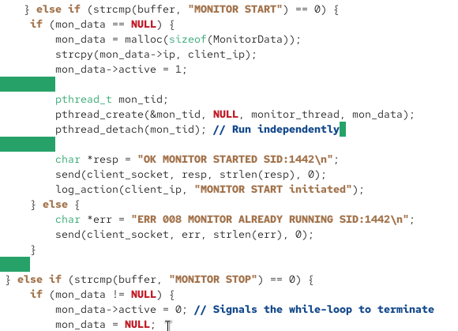
Figure 20 : Detached UDP Telemetry Broadcasting Loop
The MONITOR START command spins up this isolated thread, formatting system statistics and broadcasting a UDP datagram every 5 seconds. A shared memory flag allows the main TCP thread to cleanly terminate the stream.

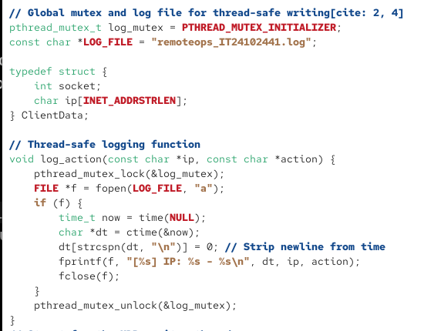

Figure 21 : Persistent Event Logging Implementation

Critical session events, commands, and errors are appended to remoteops_IT24102441.log. Time-stamped logs are flushed to disk immediately to ensure an accurate trail remains intact even if a client disconnects unexpectedly.

7. Testing Summary
# | Test performed | Expected result | Actual result
1 | AUTH with correct token | OK AUTHENTICATED SID:1442 | Pass
2 | AUTH with wrong token | ERR 001 AUTH_FAILED SID:1442 | Pass
3 | SYSINFO | CPU load, memory and uptime returned | Pass
4 | LISTPROC | Process snapshot returned | Pass
5 | EXEC DATE | OK EXEC_RESULT <date> | Pass
6 | EXEC RM_RF | ERR 002 COMMAND_NOT_ALLOWED | Pass
7 | PUT file | OK FILE_RECEIVED | Pass
8 | GET file | OK FILE_SEND, identical file received | Pass
9 | GET non-existent file | ERR 005 FILE_NOT_FOUND | Pass
10 | MONITOR START | OK MONITOR_STARTED, datagrams arrive | Pass
11 | MONITOR STOP | OK MONITOR_STOPPED, datagrams stop | Pass
12 | Multiple Controllers (5 or more) | All served simultaneously | Pass
13 | Log file | All events logged with timestamps | Pass
14 | Abrupt Controller disconnect (Ctrl+C) | Agent keeps running; event logged | pass

8. Design Rationale and Assumptions Design decisions
- Concurrency model: thread-per-connection with pthreads, because each session has independent state.
- Receive buffer: a fixed 4096-byte buffer with newline splitting for correct framing.
- EXEC whitelist: a fixed lookup (strcmp chain) rather than passing input to a shell, which prevents command injection.
- UDP interval: 2 seconds, frequent enough for monitoring without flooding the network.

8.2 Assumptions
- SYSINFO values are read from the Linux sysinfo() system call.
- For local testing, the Controller's UDP destination is 127.0.0.1.
- Filenames contain no spaces.
- Commands sent before a successful AUTH are answered with ERR 002 COMMAND_NOT_ALLOWED.

8.3 Optional extensions
No optional extensions were implemented.

8.4 Known limitations
- PUT does not enforce a maximum file size.
- There is no path traversal protection on filenames.
- Monitoring is supported for only one Controller at a time.

