Sri Lanka Institute of Information
Technology


IE3090
Network Programming
3rd Year, Semester I

Remote Ops: A Remote System Monitoring and
Management Tool over TCP/IP

Muhandiram M.M.R
IT24103000
Date: 07 – 10 - 2026

Submitted to
Sri Lanka Institute of Information Technology
In partial fulfillment of the requirements for the
Bachelor of Science Special Honors Degree in Information Technology

Declaration
I certify that this report does not incorporate without acknowledgement, any material previously submitted for a degree or diploma in any university, and to the best of my knowledge and belief it does not contain any material previously published or written by another person, except where due reference is made in text.

Name: Muhandiram M.M.R
Registration Number: IT24103000

Contents
1. Introduction
2. Personalisation
3. System Architecture
4. Concurrency Model
5. Communication Protocol
6. Authentication
7. System Information and Process Listing
8. Restricted Command Execution
9. File Transfer
10. UDP Monitoring
11. Error Handling
12. Logging and Personalised Storage
13. Build and Compilation
14. Testing Summary
15. Design Rationale and Assumptions
16. Protocol and Data Framing
17. Source Code Structure
18. Annotated Code Evidence
19. Personalisation Proof
20. GitHub Development Evidence
21. Development Process
22. AI Usage
23. Limitations and Assumptions
24. Conclusion
Appendix A. Screenshot Checklist

1. Introduction
RemoteOps is a client-server system developed in C using the BSD sockets API. The Agent accepts TCP control connections from Controllers and provides authentication, system information, process listing, restricted command execution, file transfer, logging, and UDP monitoring.
In this report, I explain the design, personalised configuration, implementation decisions, and evidence used to verify the system. The screenshots must be replaced with my own test evidence before submission.

2. Personalisation
The following values were derived from my registration number and are used consistently in the source code, build system, protocol responses, storage path, and evidence.

Item | Personalised value
Registration number | IT24103000
Numeric part | 24103000
First four digits | 2410
Agent TCP port | 9410
Last three digits | 000
Last four digits | 3000
Reversed last four digits | 0003
Session identifier | SID:0003
Authentication token | OPS-3000
Agent source file | agent_000.c
Controller source file | controller_000.c
Makefile | Makefile_000
Log file | remoteops_IT24103000.log
Storage directory | ./agentfiles/IT24103000/
Submission ZIP | IE3090_IT24103000.zip

3. System Architecture
The system uses a TCP control channel and a separate UDP monitoring channel. The Agent acts as the TCP server. A Controller connects to the Agent, authenticates, and sends line-oriented commands. When requested, the Agent sends periodic monitoring datagrams to the Controller's UDP port.

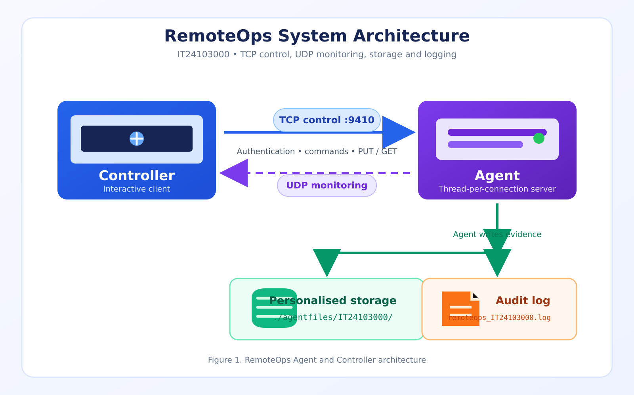

4. Concurrency Model
The Agent uses POSIX threads. After accepting a TCP connection, it creates a separate session thread for that Controller. This keeps authentication state, command processing, file transfer, and optional monitoring state independent for each client.

4.1 Multi-client evidence
The following evidence demonstrates that multiple Controllers can connect to the same Agent and operate concurrently. Insert the five screenshots or combine them into one readable figure.
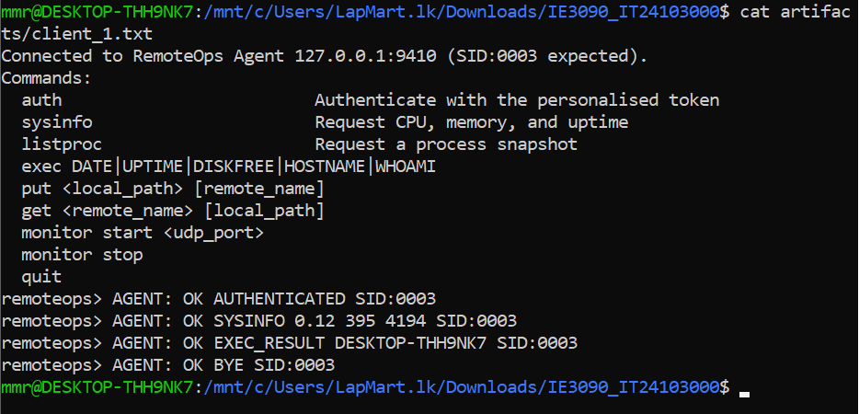Figure 2.1. Concurrent Controller 1

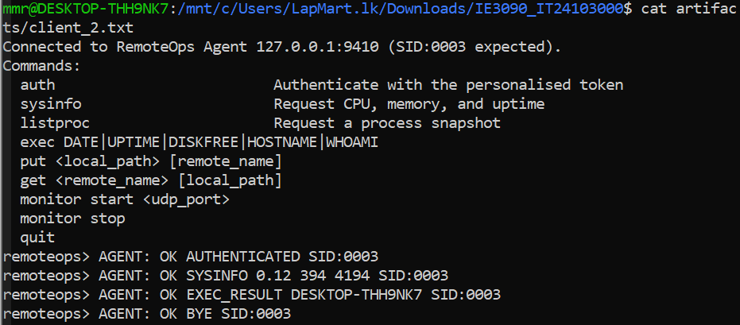Figure 2.2. Concurrent Controller 2

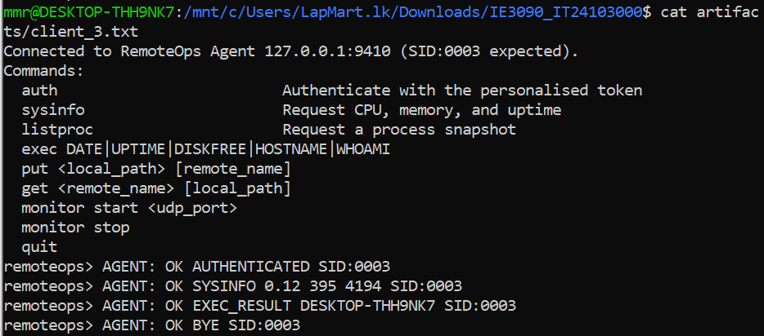
Figure 2.3. Concurrent Controller 3

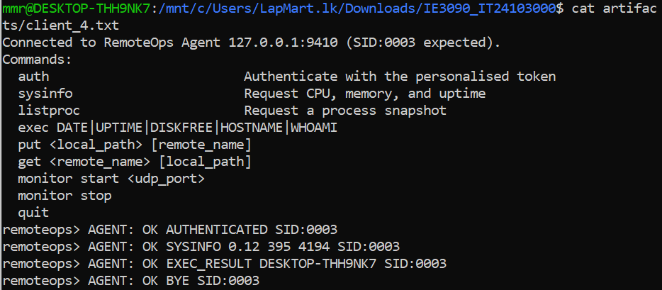Figure 2.4. Concurrent Controller 4

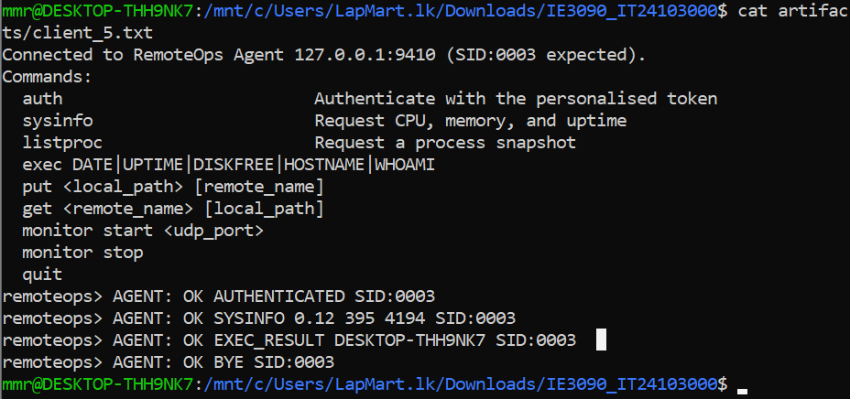Figure 2.5. Concurrent Controller 5

5. Communication Protocol
The protocol is line-oriented. Commands and text responses end with a newline. PUT and GET switch between text metadata and an exact number of raw file bytes. This prevents binary file data from being confused with later commands.

Command | Purpose
AUTH | Authenticate the Controller
SYSINFO | Return CPU, memory, and uptime information
LISTPROC | Return a process snapshot
EXEC | Run only the five allowed commands
PUT and GET | Transfer files byte-for-byte
MONITOR START and STOP | Start and stop UDP telemetry
QUIT | Close the session cleanly

6. Authentication
Authentication is required before normal commands are accepted. The Controller sends the personalised token OPS-3000. A successful response includes the personalised session tag SID:0003. Incorrect credentials are rejected with an authentication error.
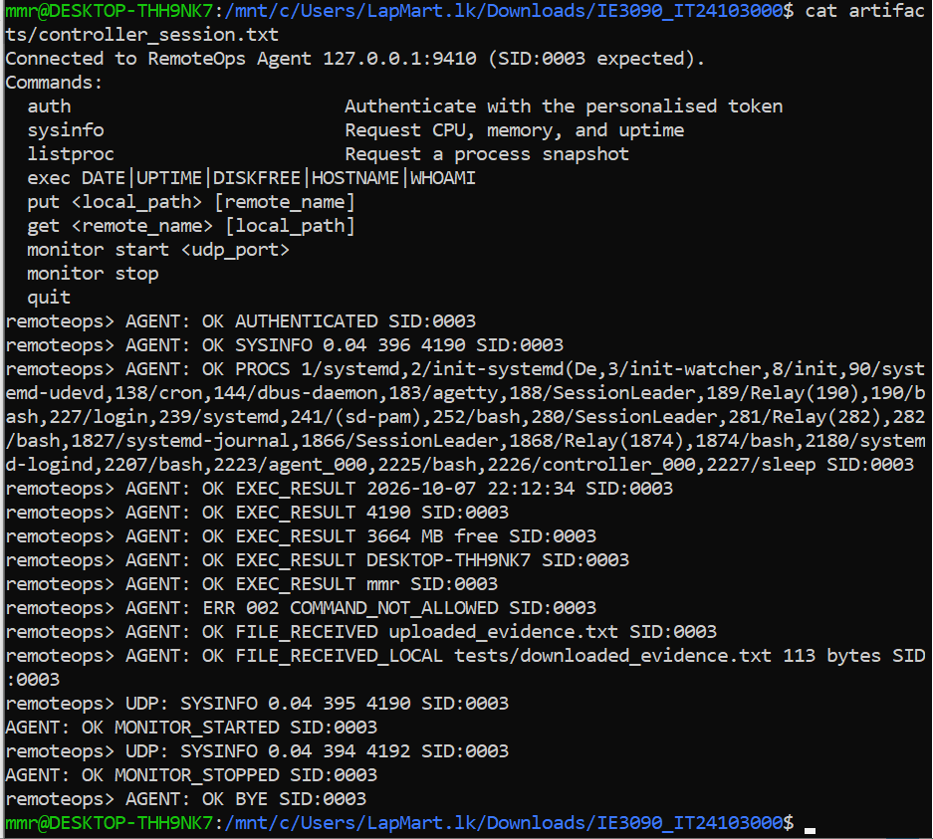
Figure 3. Successful authentication

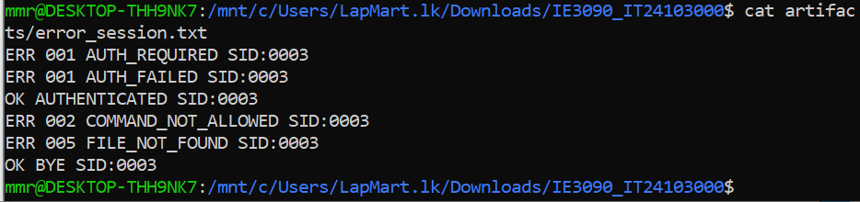Figure 4. Authentication failure

7. System Information and Process Listing
SYSINFO reads Linux system information and returns CPU, memory, and uptime values. LISTPROC returns a snapshot of running processes. These commands demonstrate that the Agent can provide monitoring information through the TCP control session.
Figure 5. SYSINFO request and response

Figure 6. LISTPROC request and response

8. Restricted Command Execution
EXEC is restricted to the five allowed commands DATE, UPTIME, DISKFREE, HOSTNAME, and WHOAMI. Arbitrary commands such as ls or pwd are rejected. This whitelist prevents uncontrolled shell command execution.
Figure 7. Allowed EXEC commands

Figure 8. Disallowed EXEC command

9. File Transfer
PUT uploads a file into the personalised Agent storage directory. GET downloads a previously uploaded file. The implementation uses exact byte counts, and the original and downloaded files are compared to confirm integrity.
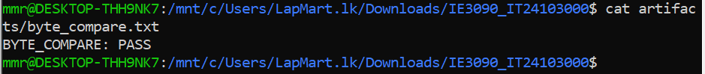Figure 9. PUT file upload

Figure 10. GET file download and byte comparison

10. UDP Monitoring
MONITOR START creates a UDP monitoring worker for the current session. The worker periodically sends a self-contained system-statistics datagram to the requested UDP port. MONITOR STOP ends the worker cleanly.
Figure 11. UDP monitoring stream

Figure 12. MONITOR STOP

11. Error Handling
The Agent returns structured error lines containing an error code, a reason, and the personalised session tag. The implementation handles wrong authentication, commands sent before authentication, unknown commands, invalid EXEC requests, missing files, and malformed commands.

Figure 13. Error handling evidence

12. Logging and Personalised Storage
The Agent writes timestamped events to remoteops_IT24103000.log. The log records connections, session identifiers, commands, file transfers, monitoring events, and disconnections. Uploaded files are stored under ./agentfiles/IT24103000/.
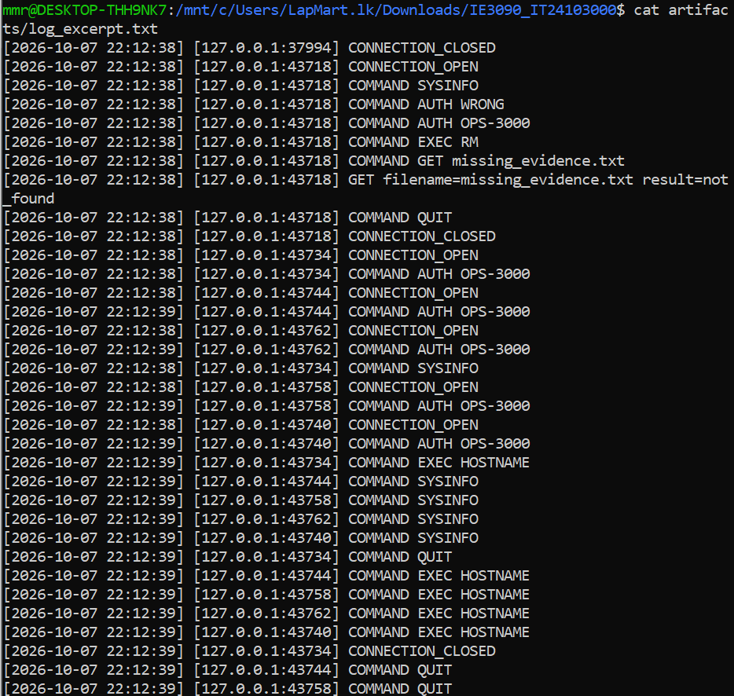Figure 14. Personalised log file

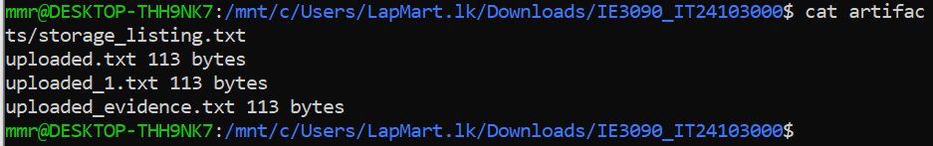Figure 15. Personalised storage directory

13. Build and Compilation
The project is built using Makefile_000. The build process compiles the Agent and Controller with GCC and the required POSIX thread and socket libraries.

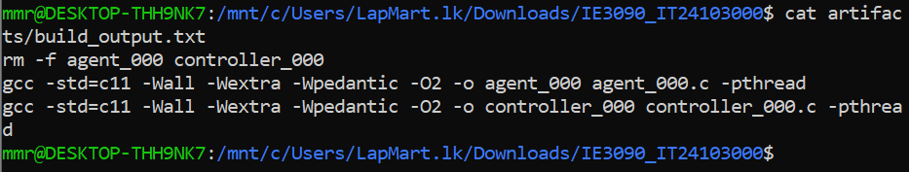Figure 16. Build output

14. Testing Summary

Test | Observed result | Status
Agent startup | Agent started successfully for IT24103000 and listened on TCP port 9410. Storage path: ./agentfiles/IT24103000/. | PASS
Correct AUTH | AGENT: OK AUTHENTICATED SID:0003 | PASS
Wrong AUTH | ERR 001 AUTH_FAILED SID:0003 | PASS
SYSINFO | Agent returned CPU, memory, and uptime information. | PASS
LISTPROC | Agent returned a process snapshot successfully. | PASS
EXEC whitelist | DATE, UPTIME, DISKFREE, HOSTNAME, and WHOAMI returned successful EXEC_RESULT responses. | PASS
EXEC rejection | Disallowed command returned ERR 002 COMMAND_NOT_ALLOWED SID:0003. | PASS
PUT | File upload returned OK FILE_RECEIVED and the file was stored by the Agent. | PASS
GET integrity | BYTE_COMPARE: PASS; downloaded bytes matched the original file. | PASS
Five Controllers | Five client session outputs completed successfully with authentication, commands, and clean disconnects. | PASS
UDP monitoring | MONITOR_STARTED, repeated UDP: SYSINFO datagrams, and MONITOR_STOPPED were observed. | PASS
Logging | Timestamped log entries were generated for connections, authentication, commands, file transfer, and disconnection. | PASS

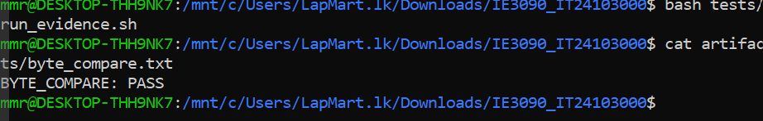Figure 17. Final end-to-end test

15. Design Rationale and Assumptions

TCP for control communication

TCP was selected because commands, responses, and file transfers require ordered and reliable delivery. The Agent listens on TCP port 9410, and each Controller receives an independent session identifier such as SID:0003. The implementation assumes that Controller commands are sent as newline-terminated messages. TCP is used for control and file transfer, but the system does not provide encryption.

UDP for monitoring

UDP was selected for periodic telemetry because each datagram is an independent snapshot and occasional loss is acceptable. The Agent sends self-contained SYSINFO datagrams containing system information and the session identifier. The monitoring service does not retransmit lost datagrams, so it is intended for lightweight status updates rather than guaranteed delivery.

Pthreads for concurrency

A thread-per-connection model gives each Controller an independent session while allowing shared logging protected by a mutex. The implementation assumes that the number of simultaneous Controllers is reasonable for the available system resources. Each client thread manages its own socket, session state, authentication status, and monitoring worker.

EXEC whitelist

Only the required commands are allowed. Arbitrary shell execution is intentionally rejected. The allowed commands are DATE, UPTIME, DISKFREE, HOSTNAME, and WHOAMI. This reduces security risks and prevents Controllers from executing unsafe system commands.

Monitoring interval

The monitoring interval is selected to provide regular updates without creating unnecessary traffic. The monitoring worker sends a system-information datagram periodically and sleeps between transmissions. The interval can be adjusted according to system requirements, but the implementation is designed for status monitoring rather than real-time monitoring.

16. Protocol and Data Framing

TCP is a byte stream, so one recv() call cannot be assumed to contain exactly one complete command. The implementation accumulates incoming data until a newline is received, then parses the complete command. This prevents partial commands or multiple commands received together from being processed incorrectly.

For PUT, the Controller first validates the local file, sends the remote filename and file size, and then transfers the exact number of raw file bytes. The Agent stores the received file in ./agentfiles/IT24103000/.

For GET, the Controller sends the remote filename. The Agent responds with the file name and declared file size, after which the Controller reads exactly that number of bytes and saves them locally. This size-based framing prevents file data from being confused with later protocol messages.

17. Source Code Structure
File or directory | Purpose
agent_000.c and src/agent_000.c | TCP Agent, authentication, commands, files, concurrency, UDP monitoring, and logging
controller_000.c and src/controller_000.c | Interactive Controller, command requests, file transfer, and monitoring output
Makefile_000 | Builds the Agent and Controller
README.md | Build and usage documentation
tests/ | Evidence and automated test scripts
artifacts/ | Test output and verification records
agentfiles/IT24103000/ | Personalised Agent storage directory
remoteops_IT24103000.log | Timestamped execution log

18. Annotated Code Evidence
Insert screenshots of the relevant source-code sections. Crop each image so the important function names and personalised values are readable.
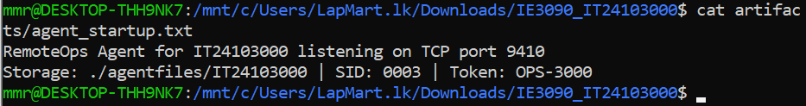Figure 18. Agent configuration and global definitions

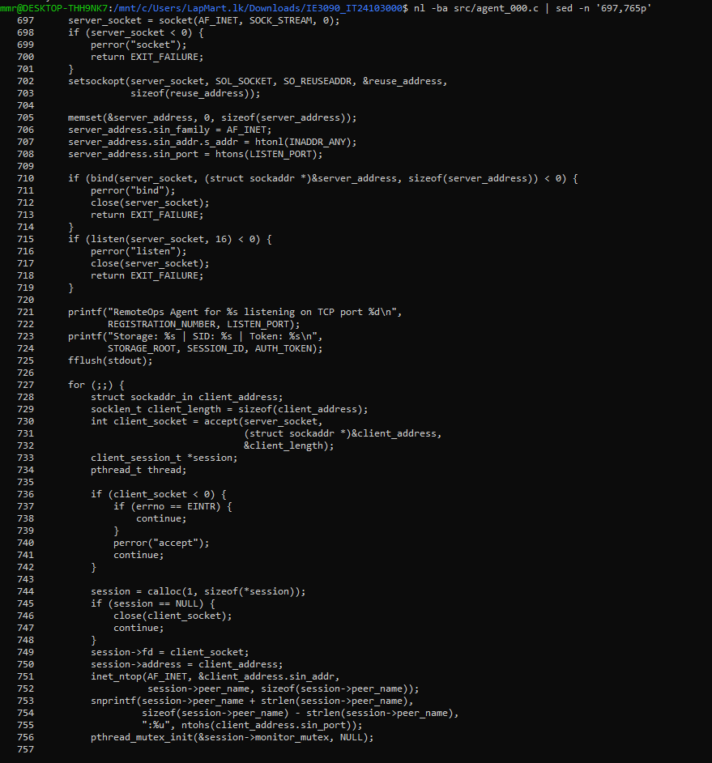Figure 19. Agent accept loop and thread-per-connection implementation

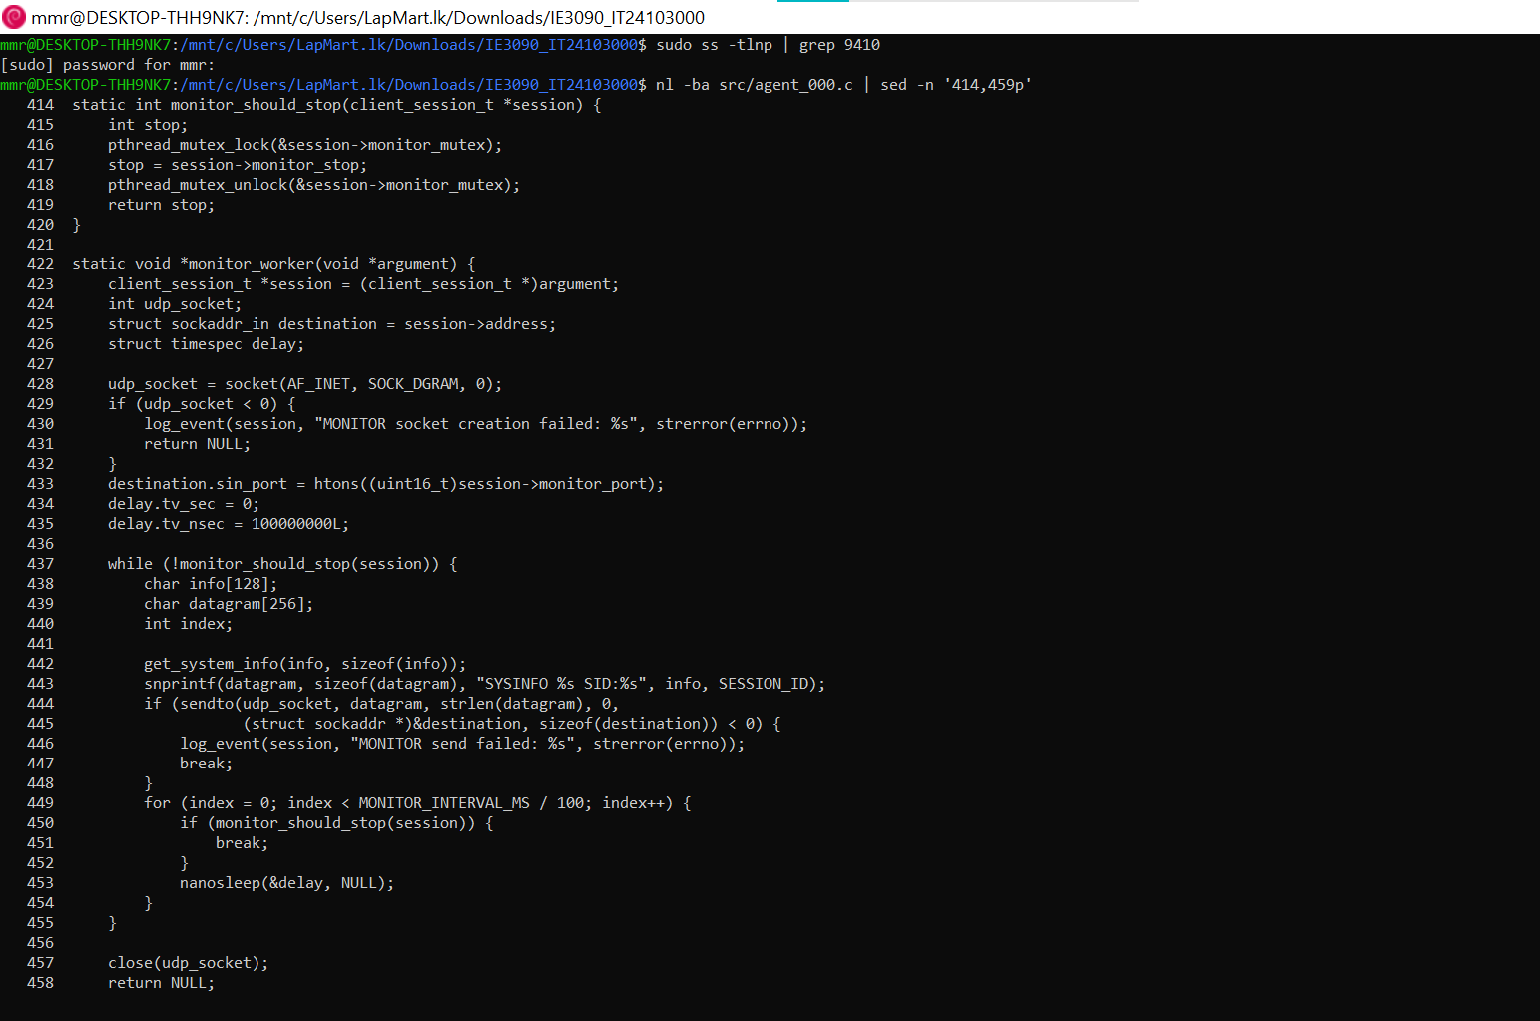Figure 21. UDP monitoring worker

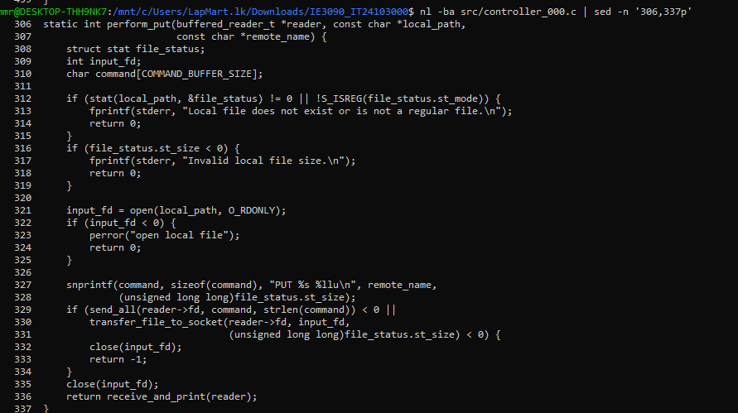Figure 22A. Controller PUT function

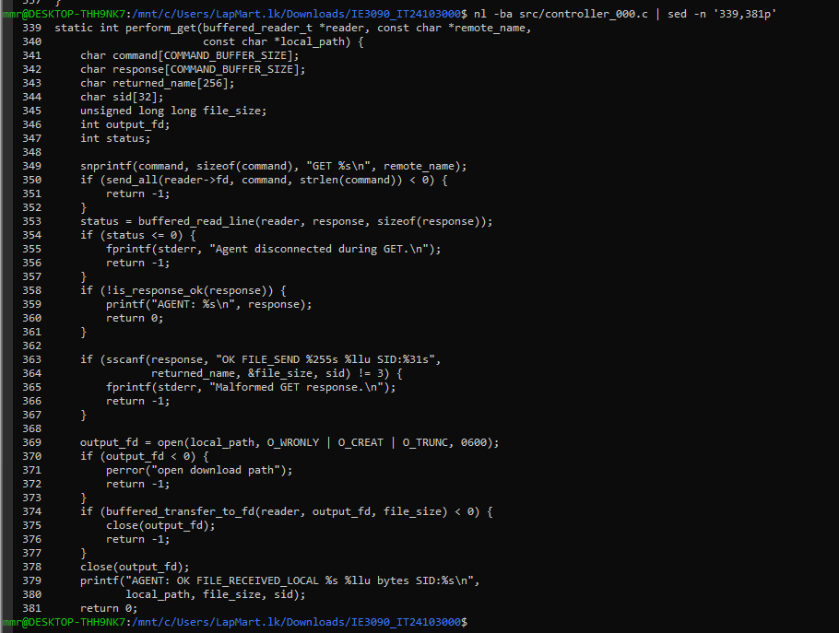Figure 22B. Controller GET function

19. Personalisation Proof
The following evidence proves that the required personalised values are present in the running system and repository.
The report should also mention the token OPS-3000, session tag SID:0003, log filename, and storage directory, and show where each value appears in the source or output.

20. GitHub Development Evidence
The source code and testing evidence were committed to the public GitHub repository below. Add the repository link and briefly explain what is included.
Repository: https://github.com/IT24103000/IE3090_IT24103000
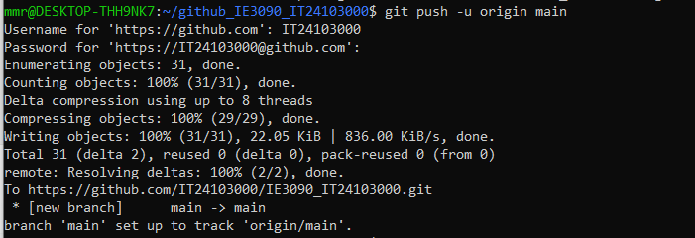Figure 24. GitHub repository and push evidence

21. Development Process
The system was developed in stages. First, the Agent and Controller socket connection was prepared using TCP port 9410. Authentication was then added using the personalised token OPS-3000, producing session identifier SID:0003 after successful authentication. The command parser and dispatch logic were implemented for SYSINFO, LISTPROC, EXEC, PUT, GET, MONITOR, and QUIT.

Next, system information and process-listing functions were tested. A restricted EXEC whitelist was added for DATE, UPTIME, DISKFREE, HOSTNAME, and WHOAMI, while unauthorised commands were rejected. PUT and GET file-transfer functions were then implemented using declared file sizes and exact-byte transfers.

After the main functions were working, the thread-per-connection model was tested using multiple Controller sessions. UDP monitoring was added using a separate monitoring worker for each session. Logging and personalised storage were then verified using remoteops_IT24103000.log and ./agentfiles/IT24103000/.

Finally, the project was compiled and tested using the evidence scripts. Authentication, error handling, file transfer, byte comparison, multiple client sessions, UDP monitoring, logging, storage, and final test results were recorded with screenshots. The source code and evidence files were then committed to the GitHub repository.

22. AI Usage
AI assistance was used to understand the assignment requirements, explain Linux and WSL commands, troubleshoot Git and environment problems, organise the report structure, and improve the wording of the documentation. AI assistance was also used to suggest explanations for the architecture and testing evidence.

The final implementation was checked using the project build process, Agent and Controller sessions, file-transfer tests, UDP monitoring tests, logging evidence, and the run_evidence.sh script. I reviewed the generated suggestions, applied the relevant changes, and used my own test outputs and screenshots as evidence. I did not treat AI-generated explanations as proof without verifying the result in the implementation.
23. Limitations and Assumptions

The implementation was tested in a Linux/POSIX environment through WSL. It was not tested as a native Windows application or on multiple physical computers. The Agent uses a thread-per-connection model, which is suitable for the tested number of Controllers but may not scale efficiently to a very large number of simultaneous connections.

UDP monitoring uses independent datagrams and does not retransmit lost packets. Therefore, occasional monitoring-packet loss is acceptable. The monitoring output provides periodic system-information snapshots rather than continuous real-time monitoring.

The system uses a shared authentication token, OPS-3000, and does not implement user accounts, encryption, or TLS. After authentication, Controllers can use the available permitted operations. Arbitrary shell commands are not supported because the EXEC command uses a fixed whitelist.

Uploaded files are stored locally in ./agentfiles/IT24103000/, and the log is stored in remoteops_IT24103000.log. The storage system does not provide cloud backup, storage quotas, or advanced file-permission management. The five client screenshots demonstrate successful client sessions, although the screenshots do not independently prove that every session started at exactly the same time.

24. Conclusion
The RemoteOps system successfully implemented an authenticated TCP Agent and Controller architecture using TCP port 9410. The system supports token authentication, system-information requests, process listing, restricted command execution, exact-byte PUT and GET file transfers, multiple Controller sessions, UDP monitoring, timestamped logging, and personalised file storage.

The implementation was verified using successful authentication results, rejected-command evidence, file-transfer results, BYTE_COMPARE: PASS, multiple client-session outputs, UDP MONITOR_STARTED and MONITOR_STOPPED messages, storage listings, log excerpts, and final testing evidence. The personalised values IT24103000, OPS-3000, SID:0003, port 9410, storage directory, and log filename were included in the implementation and supporting evidence.

