
Sri Lanka Institute of Information Technology

IT3091: Machine Learning
Year 3, Semester 1- 2026

Practical Answer Submission

Lab Sheet No: 02

Student ID | IT24103352
Student Name | AHAMED M.A.W
Campus/ Center name | SLIIT Kandy UNI
Specialization | Artificial Intelligence

Part A: Dataset Understanding
1. Load the California Housing Dataset and Display
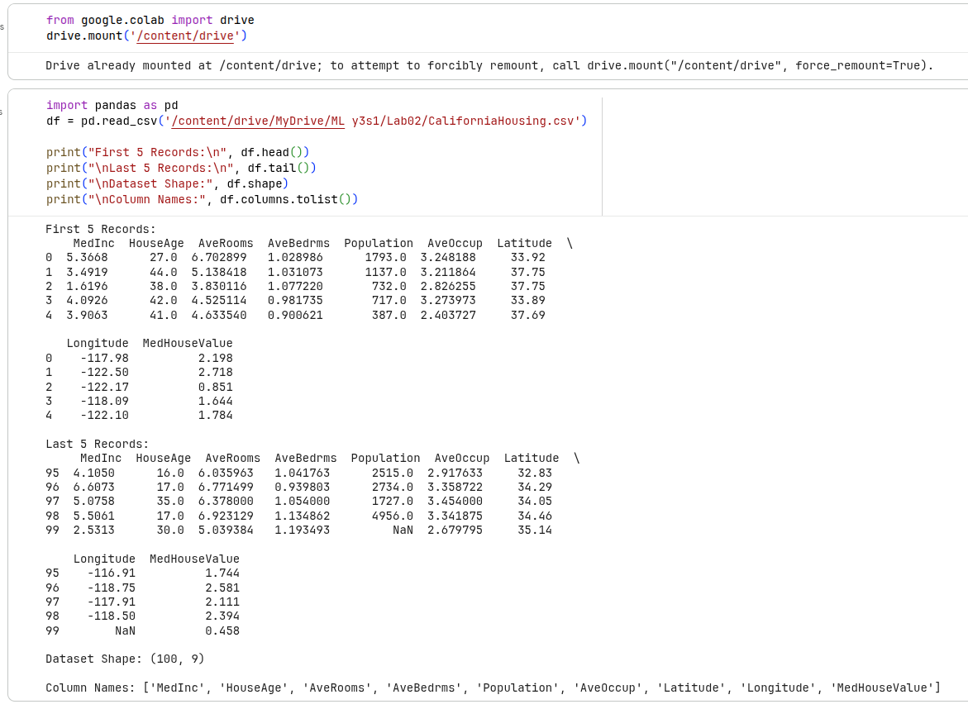

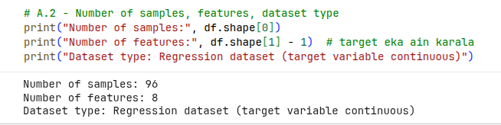

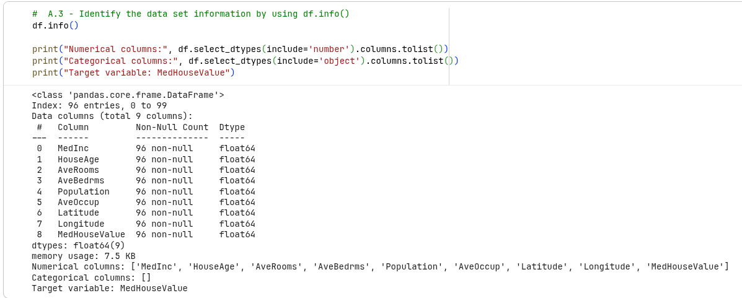

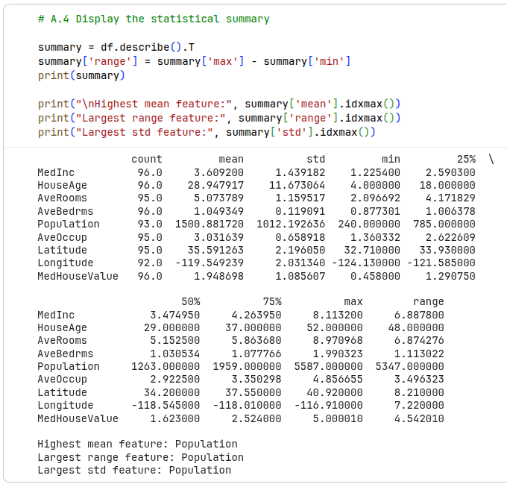

Part B: Exploratory Data Analysis
1. Check whether the dataset contains any missing values and duplicate records. (If duplicate records exist, remove them and display the updated dataset shape.)
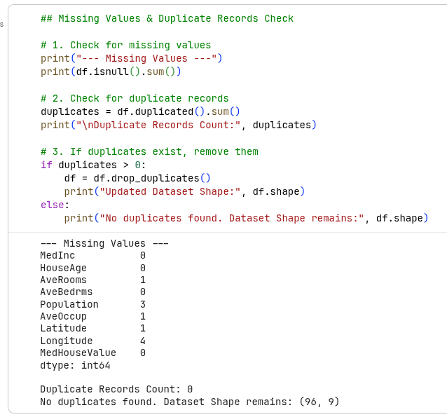

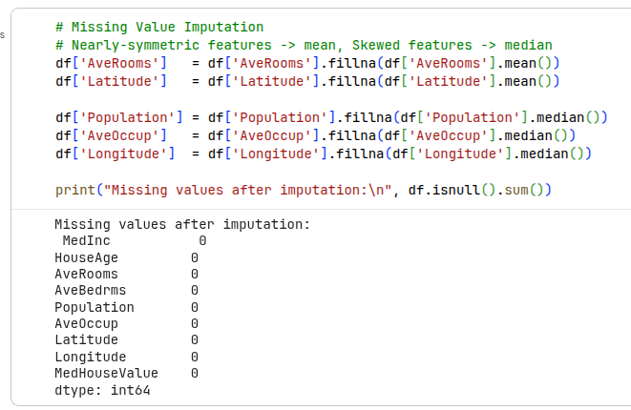

2. Generate Histograms for the variables and identify,
- Which feature looks normally distributed?
- Which feature appears skewed?
- Which feature contains the largest spread?
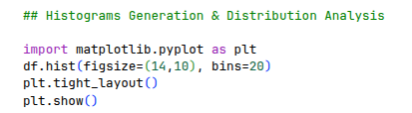

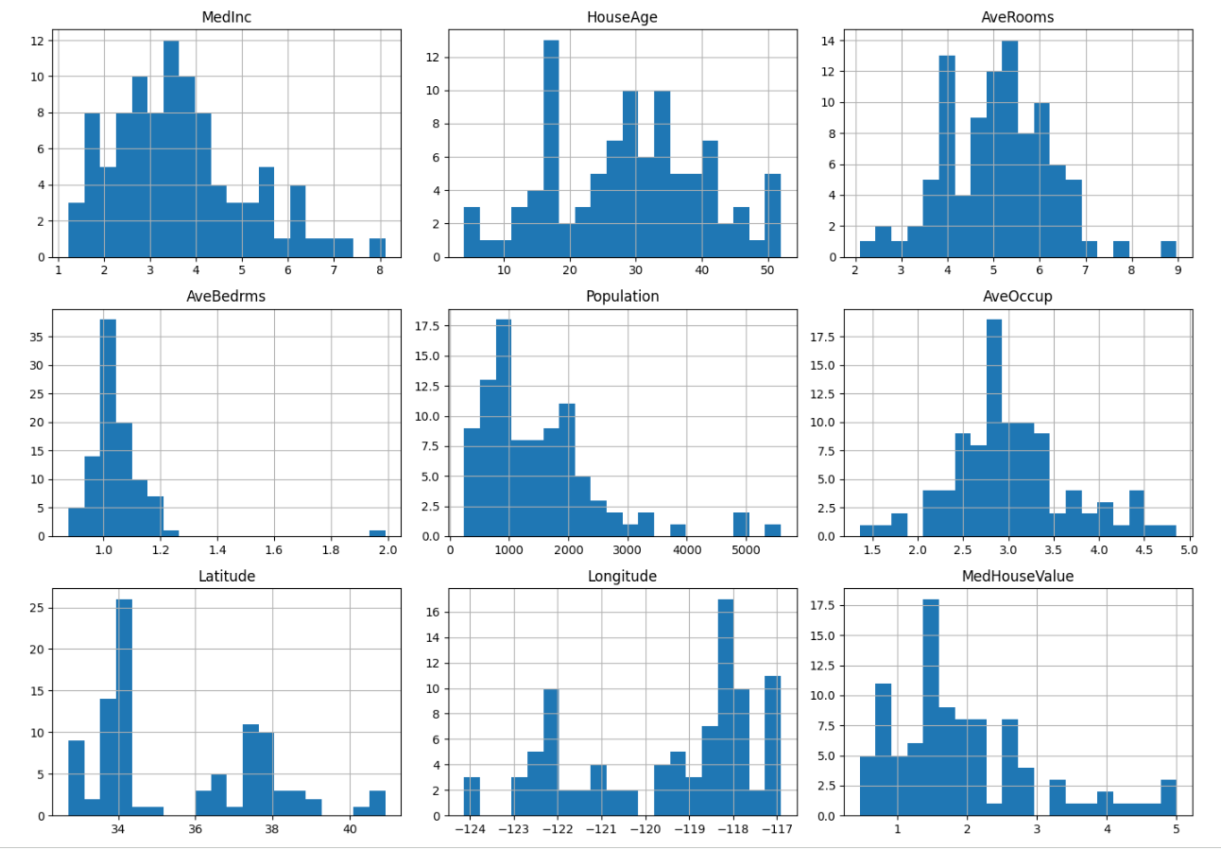

Normally distributed: HouseAge and AveRooms look the closest to a normal distribution .
Skewed features: AveBedrms is very strongly right-skewed, and Population and MedHouseValue are also right-skewed (long tail toward high values).
Largest spread: Population has the widest spread of values, consistent with it having the largest standard deviation and range.

3. Choose an appropriate missing value imputation method for each variable based on its distribution and justify your choice.

Missing values were imputed based on each variable's distribution shape: features that are nearly symmetric (AveRooms, Latitude) were filled with the mean, since it isn't distorted by outliers in symmetric data. Features that are skewed (Population, AveOccup, Longitude) were filled with the median, since it is more robust to extreme values and better represents the true central tendency of a skewed distribution.

4. Generate separate boxplots for each numerical feature and identify,
- Which features contain outliers?
- Why are outliers important in ML?
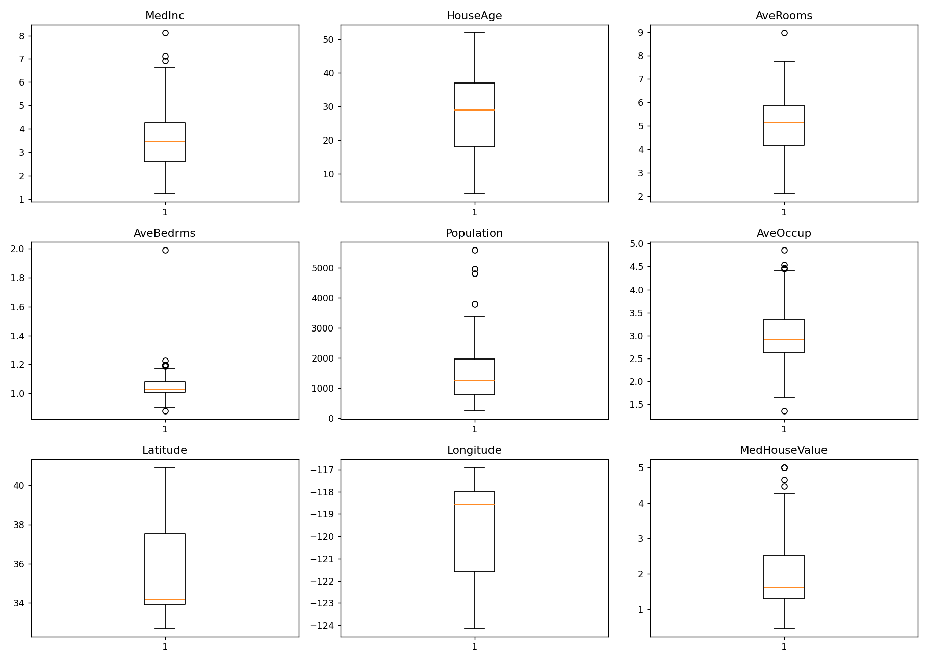

Number of outlier values detected per feature (using the IQR × 1.5 rule):
Feature | Outlier Count
MedInc | 2
HouseAge | 0
AveRooms | 1
AveBedrms | 7
Population | 5
AveOccup | 5
Latitude | 0
Longitude | 0
MedHouseValue | 5

Features with outliers: AveBedrms has the most outliers (7), followed by Population, AveOccup and MedHouseValue (5 each), and MedInc (2) and AveRooms (1). HouseAge, Latitude and Longitude show no extreme outliers under this rule.
Why outliers matter in ML: Outliers can distort statistics such as the mean and standard deviation, bias model coefficients (especially in linear models that use squared-error loss), and reduce a model's ability to generalize. Detecting them early helps decide whether to cap, transform, remove, or use robust models/scalers to handle them.
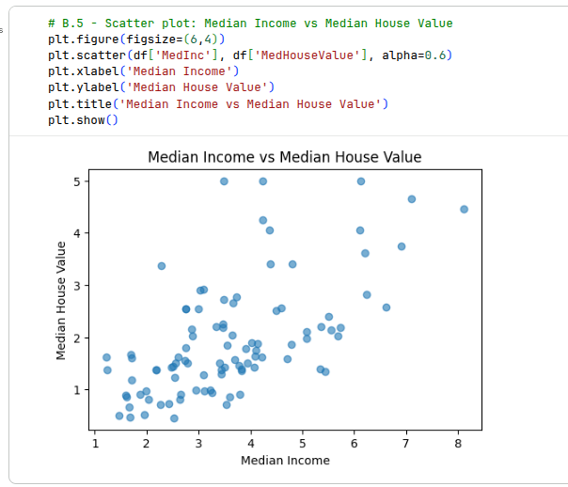

Interpretation: The scatter plot shows a clear positive relationship — as Median Income (MedInc) increases, Median House Value (MedHouseValue) tends to increase as well. This matches the correlation coefficient of about +0.60 between the two variables, making MedInc the strongest single predictor of house value in this dataset. The relationship is roughly linear but with noticeable spread, meaning income alone does not fully determine house value.
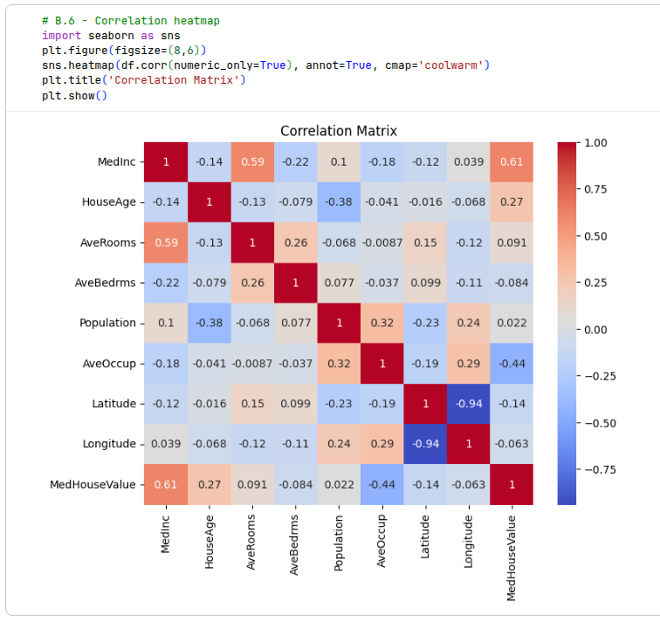

Most positively correlated with the target (MedHouseValue): MedInc (Median Income), with a correlation coefficient of +0.61. This confirms that income level is the strongest driver of house value in this dataset.
Least correlated with the target: Population, with a correlation coefficient of only +0.022 (essentially close to zero). This indicates that population count has almost no linear relationship with median house value.
Strongest correlation between two input variables: Latitude and Longitude, with a correlation coefficient of -0.94. This strong negative correlation makes geographical sense, since California's coastline and populated regions run diagonally from the north-west to the south-east — as latitude increases, longitude systematically decreases.
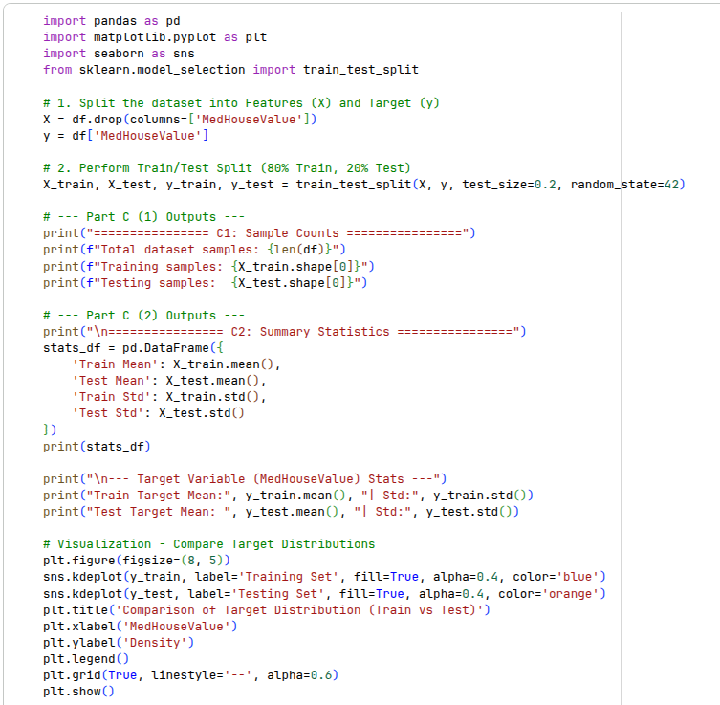
Part C – Train/Test Separation

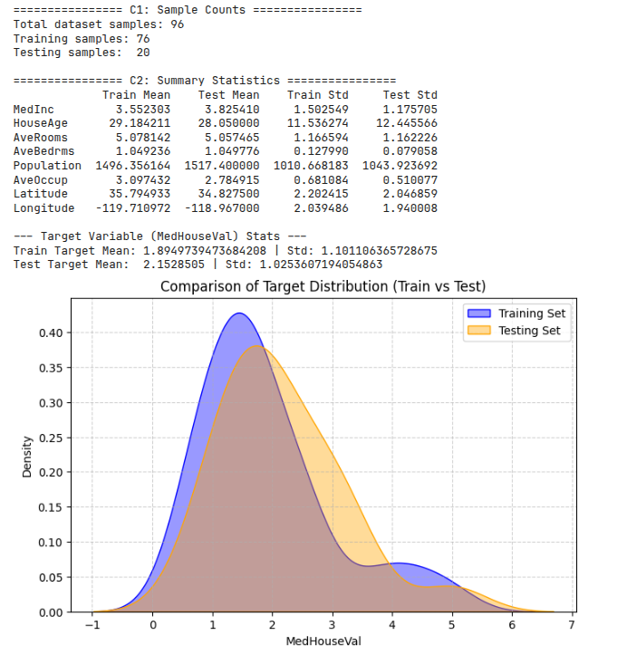

1. Sample Counts
Using train_test_split() with test_size = 0.2 and random_state = 42 on the cleaned dataset (96 samples after duplicate removal):
- Training samples: 76 (80%)
- Testing samples: 20 (20%)
2. Comparing Train vs Test Distributions
The summary statistics (mean and standard deviation) for each feature are reasonably close between the training and testing sets. For example:
- MedInc: Train mean = 3.55, Test mean = 3.83 — a small difference.
- HouseAge: Train mean = 29.18, Test mean = 28.05 — very close.
- Population: Train mean = 1496.36, Test mean = 1517.40 — close, with similar standard deviations.
- Target variable (MedHouseValue): Train mean = 1.89, Test mean = 2.15, with standard deviations of 1.10 and 1.03 respectively — fairly close.
The KDE (density) plot of the target variable further supports this: both the training and testing distributions follow the same overall shape — a peak around 1–2, a right-skewed tail toward higher values, and a similar range (roughly -1 to 7 after KDE smoothing, though the actual data lies between about 0.46 and 5.0). The two curves overlap substantially, with only minor differences in peak height and small bumps at higher values in the test set.
Conclusion: Yes, the training and testing datasets are similarly distributed. Although there are small differences in means and standard deviations across features (expected due to the small sample size of only 96 records), there is no major systematic difference or bias between the two sets. This confirms that the train_test_split with random_state=42 produced a fair, representative split, which is important for ensuring that the model is evaluated on data that resembles what it was trained on.

Part D – Understanding the concepts

1. Why is data understanding essential before training a machine learning model?

Data understanding helps identify what the dataset actually represents — its features, target variable, scale, distribution, and any quality issues such as missing values, duplicates, or outliers. Without this step, a model may be trained on flawed or misleading data, leading to poor performance, incorrect conclusions, or a model that fails to generalize to real-world data. It also guides key decisions such as which preprocessing steps, feature engineering methods, and algorithms are appropriate for the data.

2. What is the difference between univariate and bivariate analysis?
Univariate analysis examines a single variable at a time — for example, a histogram or boxplot of one feature — to understand its distribution, central tendency, and spread. Bivariate analysis examines the relationship between two variables at a time — for example, a scatter plot of MedInc vs MedHouseValue or a correlation coefficient — to understand how the two variables relate to or influence one another.
3. Why should duplicate records be removed?
Duplicate records give repeated data points extra, unearned weight during model training, which can bias the model's learned parameters toward those repeated patterns. They can also artificially inflate performance metrics if duplicates end up split across both the training and testing sets, giving a false sense of how well the model actually generalizes to new data.
4. Why can missing values reduce model performance?
Many machine learning algorithms cannot process missing values directly and will either throw an error or silently drop those rows, reducing the effective amount of training data available. If missing values are filled incorrectly (e.g., using an inappropriate imputation method), it can introduce bias or noise into the feature, distorting its true distribution and weakening the model's ability to learn accurate patterns.
5. What is data leakage? Give one example.
Data leakage occurs when information from outside the training dataset — particularly information from the test set, or information that would not be available at prediction time — is used to build or tune the model. This leads to unrealistically good performance during evaluation that does not hold up in real-world use.
Example: Scaling or imputing missing values (e.g., using the mean) on the entire dataset before splitting it into training and test sets. This causes statistics from the test set to "leak" into the training process, since the training set indirectly gains information about the test set's distribution.
6. Why must train-test splitting be performed before preprocessing?
Splitting the data first ensures that any preprocessing step that learns something from the data — such as computing the mean/median for imputation, or fitting a scaler — is learned only from the training set. The learned parameters (e.g., the training set's mean) are then applied to the test set, rather than being recalculated from it. This keeps the test set as a genuinely unseen sample, giving an honest estimate of how the model will perform on new, real-world data and avoiding data leakage.

